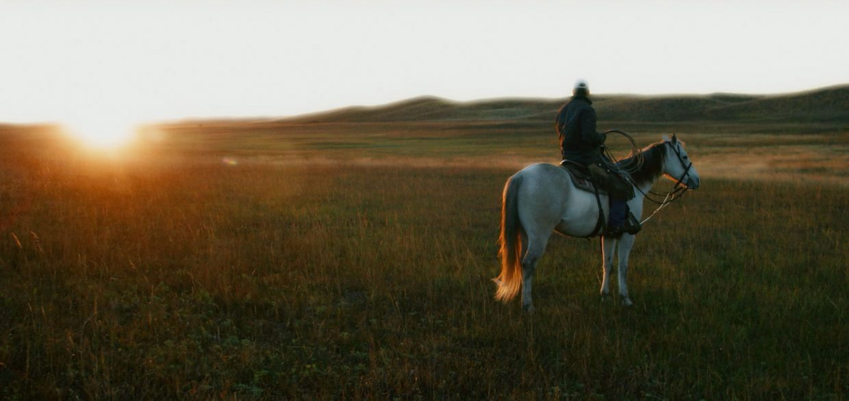

  - Community Well-Being
  - Needs Assessment
  - Data Highlights
  - April 2019

2019 Custer County Area

(Blaine, Custer, Garfield, Greeley, Loup,

Sherman, Valley, Wheeler Counties)

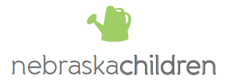

2019 Custer County Area

Community Well-Being Needs Assessment

Data Highlights

The following data were selected from the 2019 Custer County Area Community Well-Being Needs Assessment as being indicative of need or otherwise valuable to present at the April 2019 Service Array. Refer to the full report for a more complete summary of data.

Demographics

The total estimated population decreased over 2% across the 8-county region with only Wheeler County experiencing an increase in population (Table 1). The under 18 population decreased by over three times as much as the overall population. Please refer to Table 1 for numbers associated in all census data percentages and graphs in the report.

Table 1: Total and under 18 population (2010 and 2017)
 | Total population |  |  |  | Under 18 population
 | 2010 | 2017 | Percent change |  | 2010 | 2017 | Percent change
Blaine | 539 | 502 | -6.9% |  | 97 | 106 | 9.3%
Custer | 11,001 | 10,836 | -1.5% |  | 2657 | 2,521 | -5.1%
Garfield | 2,081 | 1,958 | -5.9% |  | 507 | 386 | -23.9%
Greeley | 2,542 | 2,436 | -4.2% |  | 657 | 584 | -11.1%
Loup | 635 | 537 | -15.4% |  | 143 | 104 | -27.3%
Sherman | 3,144 | 3,048 | -3.1% |  | 685 | 647 | -5.5%
Valley | 4,284 | 4,252 | -0.7% |  | 932 | 920 | -1.3%
Wheeler | 751 | 846 | 12.6% |  | 173 | 154 | -11.0%
8-County Total | 24,977 | 24,415 | -2.3% |  | 5,851 | 5,422 | -7.3%
Nebraska | 1,799,125 | 1,893,921 | 5.3% |  | 453331 | 469,819 | 3.6%

The number of total family households with children under the age of 18 also experienced a similar decrease by an estimated 2% across all counties with Valley and Sherman Counties showing an estimated increase, while all other counties saw an estimated decrease (Table 2).

Table 2: Number of family households with children under 18 (2010 and 2017)
 | 2010 | 2017 | Percent change
Blaine | 52 | 47 | -9.6%
Custer | 1,319 | 1,274 | -3.4%
Garfield | 254 | 198 | -22.0%
Greeley | 280 | 264 | -5.7%
Loup | 62 | 51 | -17.7%
Sherman | 314 | 317 | 1.0%
Valley | 452 | 544 | 20.4%
Wheeler | 81 | 66 | -18.5%
8-County Total | 2,814 | 2,761 | -1.9%
Nebraska | 217,081 | 219,928 | 1.3%

Poverty

While poverty levels were higher than the state in 2012 in most counties, by 2017, poverty levels were lower in all eight counties by 2017. Over the six years of 2012 to 2017, Blaine, Loup, Sherman and Valley experienced more years of higher poverty rates than the state (Table 3). However, please note that data on poverty fluctuate dramatically due to a wide margin of error in the data source (U.S. Census Bureau’s American Community Survey).

Table 3. Percent of population below poverty (red indicates a higher rate compared to the state)
 | 2012 | 2013 | 2014 | 2015 | 2016 | 2017
Blaine | 19.3% | 17.7% | 16.3% | 19.2% | 16.2% | 9.8%
Custer | 9.6% | 11.5% | 11.3% | 10.9% | 10.0% | 11.9%
Garfield | 13.8% | 13.0% | 12.0% | 10.2% | 7.3% | 7.2%
Greeley | 12.1% | 12.1% | 11.7% | 10.0% | 8.7% | 9.8%
Loup | 23.4% | 25.8% | 20.2% | 12.4% | 10.0% | 8.9%
Sherman | 10.3% | 13.5% | 11.9% | 13.5% | 13.3% | 10.7%
Valley | 14% | 15.2% | 13.3% | 12.9% | 12.8% | 11.5%
Wheeler | 15.3% | 16% | 13.1% | 7.2% | 5.1% | 2.6%
Nebraska | 12.4% | 12.8% | 12.9% | 12.7% | 12.4% | 12.0%

In 2017, Blaine, Custer, and Sherman Counties’ under 18 population had a higher estiamated rate of poverty than the state (Figure 1). As another measure of poverty, nine of the 16 school districts in the eight counties were above the state rate for students receiving free and reduced lunch (Figure 2).

Figure 1. Percent of the under 18 population at or below poverty (2017)

Figure 2. Percentage of students receiving free and reduced lunch (2017-2018)

Median household income is lower in all eight counties compared to the state by a range of $11,901 to $24,973 (Figure 3).

Figure 3. Median household income (2017)

Mobility

Geographic mobility (having moved within the same county, moved from a different county within the same state, moved from a different state, or moved from abroad) for those under 18 varied substantially from county to county. Blaine, Custer, Greeley, Valley and Wheeler all experienced higher geographic mobility than the state average of 15.1% (Figure 4).

Figure 4. Geographic Mobility (moved in the past year) among those under 18 (2017)

School mobility is the percentage of students within each school district that changed schools during the school year. Seven school districts out of 13 districts with available data were higher in terms of school mobility than the 11% state average (Figure 5).

Figure 5. School mobility (changed schools in the past year) (2017-2018)

Note: some data have been masked to protect the privacy of students.

Education

In all counties, the percentage of the adult population with a high school degree or higher is well greater than state average of 90.0%. Two counties (Blaine and Loup) have over 98% of the adult population with a high school degree or higher (Figure 6).

Figure 6. Percent of the population age 25 and older with a high school degree or higher (2017)

Again, the percentage of the adult population that have had some college or an Associate’s degree is higher than the average for the state across all eight counties in the service area (Figure 7). However, a lower percentage of the population in the eight county area have received a Bachelor’s degree or higher compared to the state (Figure 8).

Figure 7. Percent of the population age 25 and older with some college (no degree) or an Associate's degree (2017)

Figure 8. Percent of the population age 25 and older with a Bachelor's degree or higher
(2017)

Access to Healthcare

Table 4 indicates the shortage of health professionals in the eight counties in 2016 as designated by Nebraska DHHS.

Table 4: State designated health professional shortage areas (2016)
 | Family Medicine | Internal Medicine | Pediatrics | OB/GYN | Psychiatry | General Surgery | Dentistry | Pharmacy | Occupational Therapy | Physical Therapy
Blaine | Yes | Yes | Yes | Yes | Yes | Yes | Yes | Yes | No | Yes
Custer | Yes | Yes | Yes | Yes | Yes | Yes | Yes | Yes | No | No
Garfield | Yes | Yes | Yes | Yes | Yes | Yes | No | Yes | No | No
Greeley | Yes | Yes | Yes | Yes | Yes | Yes | Yes | Yes | No | No
Loup | Yes | Yes | Yes | Yes | Yes | Yes | Yes | Yes | Yes | Yes
Sherman | Yes | Yes | Yes | Yes | Yes | Yes | Yes | Yes | No | No
Valley | Yes | Yes | Yes | Yes | Yes | No | No | Yes | No | No
Wheeler | Yes | Yes | Yes | Yes | Yes | Yes | Yes | Yes | Yes | Yes

Pregnancy and Parenting

The majority of the counties indicated a higher than state average lack of adequate prenatal care for pregnant women (Figure 9).

Figure 9. Percent of pregnant women receiving inadequate prenatal care
(based on Kotelchuk index*) (2016)

*Using the initiation of prenatal care and the number of prenatal visits received, the Kotelchuk Index classifies care as adequate, intermediate, or inadequate
Most of the eight counties in the service area have had higher rates of children living in single parent households as compared to the state from 2012 to 2017 (Table 5). Again, note that data on children living in single parent households fluctuate dramatically due to a wide margin of error in the data source (U.S. Census Bureau’s American Community Survey).

Table 5. Percent of children living in single parent households (red indicates a higher rate compared to the state)
 | 2012 | 2013 | 2014 | 2015 | 2016 | 2017
Blaine | 17.5% | 18.0% | 34.2% | 21.7% | 16.0% | 6.6%
Custer | 13.2% | 17.0% | 17.5% | 23.4% | 25.6% | 25.4%
Garfield | 17.7% | 21.0% | 18.9% | 26.7% | 26.5% | 24.4%
Greeley | 22.2% | 21.0% | 18.2% | 18.0% | 21.7% | 16.6%
Loup | 2.1% | 6.0% | 11.4% | 18.5% | 20.0% | 9.6%
Sherman | 19.6% | 20.0% | 16.0% | 36.3% | 30.1% | 25.1%
Valley | 17.2% | 18.0% | 18.2% | 16.7% | 20.3% | 14.2%
Wheeler | 17.9% | 16.0% | 5.5% | 18.6% | 25.3% | 21.7%
Nebraska | 26.3% | 27.0% | 27.7% | 28.7% | 28.8% | 26.3%

Substance Abuse and Mental Health

Reports of alcohol use among students in the nine county Loup Basin region over time (the eight counties in the service area plus Howard County) are displayed below in Figure 10 and 11. Among 12th graders, the reported use of alcohol in the past 30 days has increased since 2010. However, as of 2016, the rates were comparable between Loup Basin and the State among 12th graders.

Figure 10. Reported use of alcohol in the past 30 days

*Loup Basin includes the eight counties in the service area plus Howard County.
Reports of cigarette use among students in the nine county Loup Basin region over time (the eight counties in the service area plus Howard County) are displayed below in Figure 10 and 11. Across the state, reported use of cigarettes is decreasing, and this trend holds true for 12th graders in the Loup Basin district. However, 10th graders reported an increase in cigarette use in the past 30 days in 2016.

Figure 11. Reported use of cigarettes in the past 30 days

*Loup Basin includes the eight counties in the service area plus Howard County.

U.S. Census Bureau, American Community Survey, 5-year estimates, Table DP05
U.S. Census Bureau, American Community Survey, 5-year estimates, Table S1101
U.S. Census Bureau, American Community Survey, 5-year estimates, Table S1701
U.S. Census Bureau, American Community Survey, 5-year estimates, Table S1701
NE Department of Education, Nebraska Education Profile
U.S. Census Bureau, American Community Survey, 5-year estimates, Table DP03
U.S. Census Bureau, American Community Survey, 5-year estimates, Table S0701
NE Department of Education, Nebraska Education Profile
U.S. Census Bureau, American Community Survey, 5-year estimates, Table S1501
U.S. Census Bureau, American Community Survey, 5-year estimates, Table S1501
U.S. Census Bureau, American Community Survey, 5-year estimates, Table S1501
NE DHHS Office of Rural Health Disciplines and Shortage Areas
NE DHHS Vital Statistics, 2016, Table 13
U.S. Census Bureau, American Community Survey, 5-year estimates, Table B09005
Nebraska Risk and Protective Factor Student Survey, 2016, Loup Basin Public Health Department
Nebraska Risk and Protective Factor Student Survey, 2016, Loup Basin Public Health Department

