How to Import Arbiter into Google Calendar:
- Within your Arbiter account, click on Schedule and then click Outlook Export.
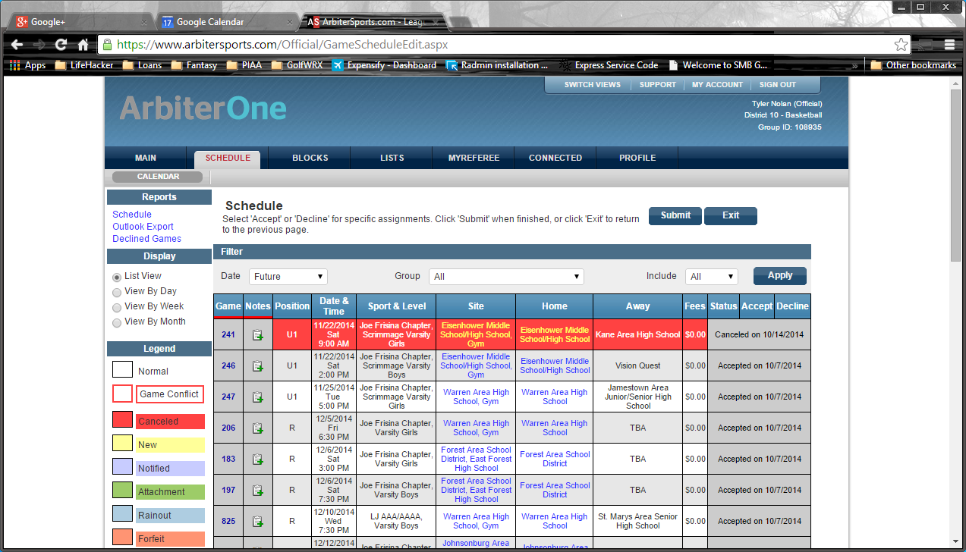
- Choose your date range and click Export. This will download an “Export.csv” file.
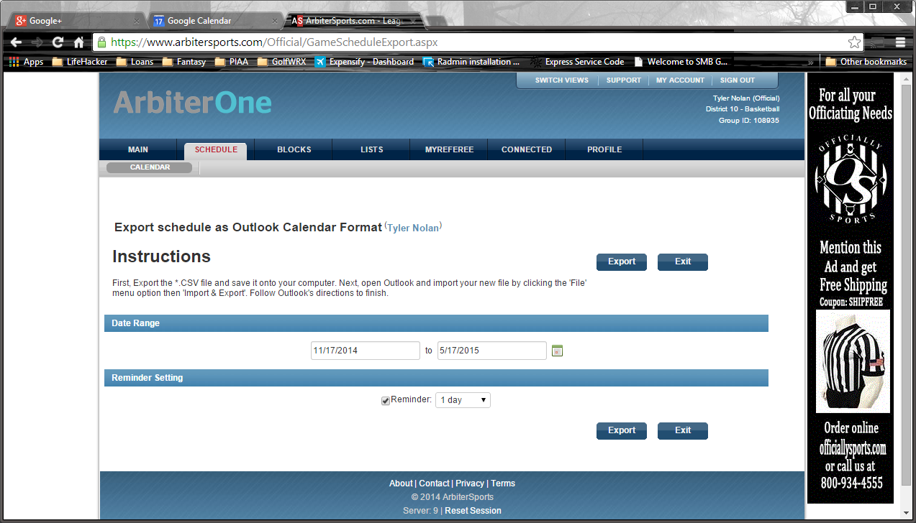
- Within your Google Calendar, click on the Settings “gear” in the upper right, and then click Settings.
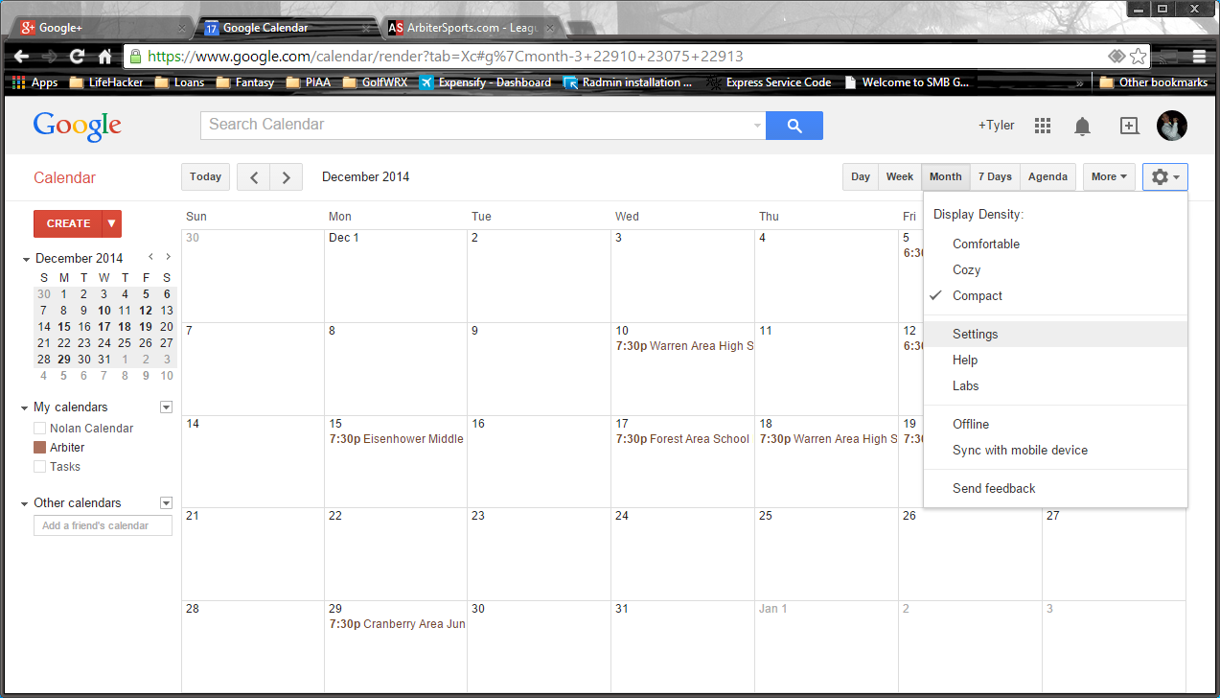
- Click Calendars, then Import calendar.
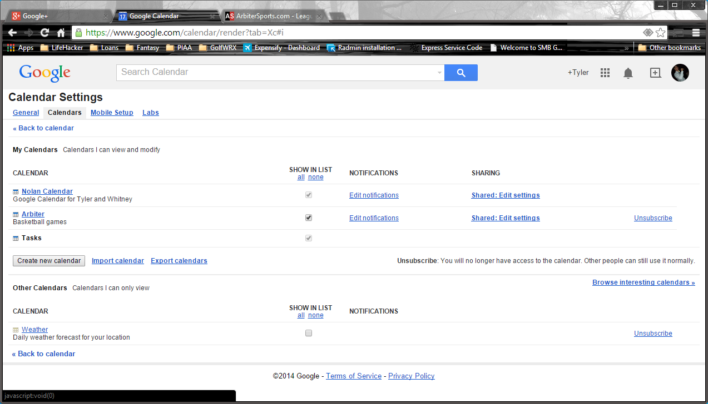

- Click Choose File to browse and find the “Export.csv” file that you exported from Arbiter and click Import.
