Infant and Child Nutrition, Inc.
Nutrition Training Manual

Fiscal Year 2018 – 2019

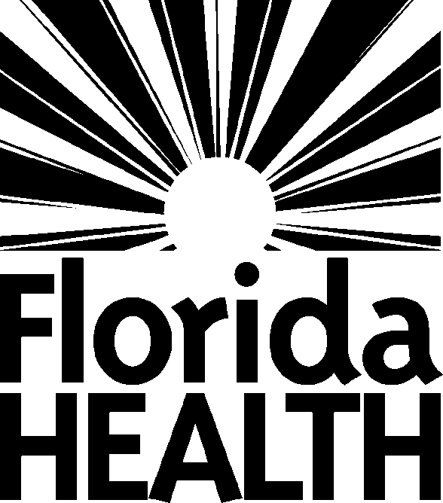

Infant and Child Nutrition, Inc.
1948 NE 28th Street
Ocala, Fl 34470
Phone 352-732-0744
Fax 352-732-2567
Web Site infantandchildnutrition.org

Excerpt from Bureau of Child Care Food Programs
4052 Bald Cypress Way
Bin#A-17
Tallahassee, Florida 32399-1727
CCFP Web Site: www.floridahealth.gov/ccfp/

June 2018

\

In accordance with Federal civil rights law and U.S. Department of Agriculture (USDA) civil rights regulations and policies, the USDA, its Agencies, offices, and employees, and institutions participating in or administering USDA programs are prohibited from discriminating based on race,
color, national origin, sex, disability, age, or reprisal or retaliation for prior civil rights activity in any program or activity conducted or funded by USDA.

Persons with disabilities who require alternative means of communication for program information (e.g. Braille, large print, audiotape, American Sign Language, etc.), should contact the Agency (State or local) where they applied for benefits. Individuals who are deaf, hard of hearing or have speech disabilities may contact USDA through the Federal Relay Service at (800) 877-8339. Additionally, program information may be made available in languages other than English.

To file a program complaint of discrimination, complete the USDA Program Discrimination Complaint Form, (AD-3027) found online at: http://www.ascr.usda.gov/complaint_filing_cust.html, and at any USDA office, or write a letter addressed to USDA and provide in the letter all of the information requested in the form. To request a copy of the complaint form, call (866) 632-9992. Submit your completed form or letter to USDA by:

(1) mail: U.S. Department of Agriculture
Office of the Assistant Secretary for Civil Rights 1400 Independence Avenue, SW
Washington, D.C. 20250-9410;

(2) fax: (202) 690-7442; or

(3) email: program.intake@usda.gov.

This institution is an equal opportunity provider.

Table of Contents
Page
Feeding Children 4
Meal Pattern for Children 5
FL WIC-Approved Cereal List 8
Creditable and Non-Creditable Grains 9
Grains/Whole Grains 11
CN Labeling/PFS 14
Sample Menu for Children 17
Menu Review Checklist 18
Family Style Meals 20
Food Safety 21
Drinking Water 22
Food Service Documentation 25
Special Needs Meals 26
Milk Substitutes 28
Meal Service Reminders 29
Feeding Infants 30
Infant Feeding Form 32
Meal Pattern for Infants 34
Creditable Infant Foods 36
Infant Menus 38
Important Infant Feeding Practices 40

Feeding Children

4

Child Care Food Program Meal Pattern for Children
The Child Care Food Program (CCFP) provides aid to child care institutions and family day care homes for the provision of nutritious foods that contribute to the wellness, healthy growth, and development of young children. Child care providers must ensure that each meal served to children contains, at a minimum, each of the food components in the amounts indicated for the appropriate age group as stated in the CCFP Meal Pattern for Children.

Child Meal Pattern Food Components: |  | Age Group and Serving Size:
 |  | 1 and 2  year olds: | 3 – 5  year olds: | 6 – 181  year olds:
Breakfast  (3 components) | Milk2  Fluid milk | 4 fluid ounces | 6 fluid ounces | 8 fluid ounces
 | Vegetables, fruits, or portions of both3  Vegetable(s) and/or fruit(s) | 1/4 cup | 1/2 cup | 1/2 cup
 | Grains*5,6,7  *whole grain, whole grain-rich, enriched  Bread  Bread product such as biscuit, roll, muffin  Cooked breakfast cereal8, cereal grain, and/or pasta Ready-to-eat breakfast cereal (dry, cold)8 | 1/2 slice 1/2 serving 1/4 cup 1/4 cup | 1/2 slice 1/2 serving 1/4 cup 1/3 cup | 1 slice  1 serving 1/2 cup 3/4 cup
 | *Meat and meat alternates may be used to meet the entire grains  requirement a maximum of three times a week.⁶ | *½ oz. (optional) | *½ oz. (optional) | *1 oz. (optional)
Lunch/Supper  (5 components) | Milk2  Fluid milk | 4 fluid ounces | 6 fluid ounces | 8 fluid ounces
 | Meat and Meat Alternates
 | Lean meat, poultry, or fish10  Tofu, soy products, or alternate protein products11 Cheese  Large egg  Cooked dry beans or peas  Peanut butter or soynut butter or other nut/seed butters Yogurt, plain or flavored, unsweetened or sweetened12 Peanuts, soynuts, tree nuts, or seeds9 | 1 oz.  1 oz.  1 oz. 1/2 egg 1/4 cup 2 Tbsp.  4 oz. or 1/2 cup 1/2 oz. = 50% | 1 1/2 oz.  1 1/2 oz.  1 1/2 oz. 3/4 egg 3/8 cup 3 Tbsp.  6 oz. or 3/4 cup 3/4 oz. = 50% | 2 oz.  2 oz.  2 oz.  1 egg 1/2 cup 4 Tbsp.  8 oz. or 1 cup  1 oz. = 50%
 | Vegetables3,4  Vegetables | 1/8 cup | 1/4 cup | 1/2 cup
 | Fruits3,4  Fruits | 1/8 cup | 1/4 cup | 1/4 cup
Grains*5,7
*whole grain, whole grain-rich, enriched
 | Bread  Bread product such as biscuit, roll, muffin  Cooked breakfast cereal8, cereal grain, and/or pasta | 1/2 slice 1/2 serving 1/4 cup | 1/2 slice 1/2 serving 1/4 cup | 1 slice  1 serving 1/2 cup
Note: Milk must be served with each breakfast, lunch and supper meal. Between a child’s first and second birthday, whole milk is required. After the child’s second birthday, it is required that lowfat or fat-free milk be served. Flavored milk cannot be served to children less than 6 years of age.
Conversions:
½ cup = 4 fl. oz. 1 pint = 2 cups
¾ cup = 6 fl. oz. 1 quart = 2 pints = 4 cups
1 cup = 8 fl. oz. 1 gallon = 4 quarts = 16 cups

CCFP Meal Pattern for Children (continued)

Child Meal Pattern Food Components: |  | Age Group and Serving Size:
 |  | 1 and 2  year olds: | 3 – 5  year olds: | 6 – 181  year olds:
Snack13  (Select 2 different components) | Milk2  Fluid milk | 4 fluid ounces | 4 fluid ounces | 8 fluid ounces
 | Meat and Meat Alternates
 | Lean meat, poultry or fish10  Tofu, soy products, or alternate protein products11 Cheese  Large egg  Cooked dry beans or peas  Peanut butter or soynut butter or other nut/seed butters Yogurt, plain or flavored, unsweetened or sweetened12 Peanuts, soynuts, tree nuts, or seeds | 1/2 oz. 1/2 oz. 1/2 oz. 1/2 egg 1/8 cup 1 Tbsp.  2 oz. or 1/4 cup 1/2 oz. | 1/2 oz. 1/2 oz. 1/2 oz. 1/2 egg 1/8 cup 1 Tbsp.  2 oz. or 1/4 cup 1/2 oz. | 1 oz.  1 oz.  1 oz. 1/2 egg 1/4 cup 2 Tbsp.  4 oz. or 1/2 cup 1 oz.
 | Vegetables3  Vegetables | 1/2 cup | 1/2 cup | 3/4 cup
 | Fruits3  Fruits | 1/2 cup | 1/2 cup | 3/4 cup
Grains* 5,7
*whole grain, whole grain-rich, enriched
 | Bread  Bread product such as biscuit, roll, muffin  Cooked breakfast cereal8, cereal grain, and/or pasta Ready-to-eat breakfast cereal (dry, cold)8 | 1/2 slice 1/2 serving 1/4 cup 1/4 cup | 1/2 slice 1/2 serving 1/4 cup 1/3 cup | 1 slice  1 serving 1/2 cup 3/4 cup
- Larger portion sizes than specified may need to be served to children 13 through 18 years old to meet their nutritional needs.
- For children age one – must be unflavored whole milk.
For children two through five years – must be unflavored low-fat (1 percent) or unflavored fat-free (skim) milk. For children six years and older – must be unflavored low-fat (1 percent), unflavored fat-free (skim), or flavored fat-free (skim) milk.
- Pasteurized full-strength juice may only be used to meet the vegetable or fruit requirement at one meal, including snack, per day.
- A vegetable may be used to meet the entire fruit requirement. When two vegetables are served at lunch or supper, two different kinds of vegetables must be served.
- At least one serving per day, across all eating occasions, must be 100% whole grain. Grain-based desserts do not count towards meeting the grains requirement.
- At breakfast, meat and meat alternates may be used to meet the entire grains requirement a maximum of three times a week. One ounce of meat and meat alternates is equal to one ounce equivalent of grains (one serving).
- Beginning October 1, 2019, ounce equivalents are used to determine the quantity of creditable grains.
- Breakfast cereals must contain no more than 6 grams of sugar per dry ounce (no more than 21 grams sucrose and other sugars per 100 grams of dry cereal).
- At lunch and supper, no more than 50% of the meat/meat alternate requirement can be met with nuts or seeds. Nuts or seeds must be combined with another meat/meat alternate to fulfill the requirement. For purpose of determining combinations, 1 ounce of nuts or seeds is equal to 1 ounce of cooked lean meat, poultry, or fish.
- The serving size for lean meat, poultry, or fish is the edible portion as served.
- Alternate protein products must meet the requirements in Appendix A of Part 226.
- Yogurt must contain no more than 23 grams of total sugars per 6 ounces.
- At snack, select two of the five components for a reimbursable snack. Only one of the two components may be a beverage.

CCFP Meal Pattern for Children (continued)

Child care providers have the unique opportunity to ensure healthy eating habits are developed early and promote wellness to all children in their care.

Fluid Milk:
- After the child’s first birthday and prior to the second birthday, whole milk must be served.
- After the child’s second birthday, lowfat (1%) or fat-free milk must be served.
- Flavored milk is not allowed for children under the age of six. Children ages six and older may be served fat-free flavored milk.
- The type(s) of milk served must be noted on the menu (fat content and if flavored).

Vegetable or fruit or juice:
- Vegetable or fruit juice must be full-strength, pasteurized, and 100% juice. Unless orange or grapefruit juice, it must also be fortified with 100% or more of Vitamin C.
- Fruit juice must not be served more than once a day.
- One cup of leafy greens counts as ½ cup of vegetables.
- Less than 1/8 cup of vegetables and fruits may not be counted to meet the vegetable and/or fruit component.
- At lunch and supper, one vegetable and one fruit or two different vegetables may be served (two fruits may not be served to meet this requirement).

Grains:
- Grain foods must be whole grain, enriched, or made from whole grain or enriched meal or flour. Bran and germ are counted as enriched or whole-grain meals or flours. Cornmeal, corn flour, plain corn tortillas/chips, and corn grits must be designated as whole or enriched to be creditable.
- At least one serving per day, across all eating occasions, must be 100% whole grain. This must be noted on the menu (e.g. “whole grain bread” or “WG Bread”).
- Only ready-to-eat and cooked breakfast cereals containing 6 grams (g) of sugar or less per dry ounce may be served (refer to the Florida WIC Approved Cereal List).
- Prepackaged grain products must have enriched flour or meal or whole grains as the first ingredient listed on the package.
- Grain-based desserts (e.g. cookies, donuts, granola bars) do not count towards meeting the grains requirements.

Meat or meat alternate:
- Commercially processed combination foods (convenience entrees – frozen or canned) must have a CN Label or manufacturer’s Product Formulation Statement stating the food component contribution to the meal pattern.
- A serving of cooked dry beans or peas may count as a vegetable or as a meat alternate, but not as both components in the same meal.
- Yogurt must not contain more than 23 g of total sugars per 6 ounces (15 g per 4 ounces or 3.8 g per ounce).
- At breakfast, meat/meat alternates may be used to meet the entire grains requirement a maximum of three times a week. One ounce of meat/meat alternate is equal to one ounce equivalent of grains (one serving).

**Please note that donated foods cannot be used to contribute to the meal pattern requirements**

Florida WIC Foods, July 2017

Breakfast Cereal

Highlighted cereals meet the 100% whole grain requirement.

General Mills
Cereals with ⬆ contain 51% or more whole grain.
GF = Gluten Free

- Cheerios  Cheerios+ 
⬆GF Ancient Grains⬆ Cheerios⬆GF Chex GF Chex GF Chex⬆
MultiGrain

- Corn  Rice  Wheat  ⬆
- Total
Whole Grain
Wheaties

■ Dora the  Berry Berry  Honey  Kix⬆
 Explorer Kix⬆ Kix⬆

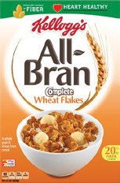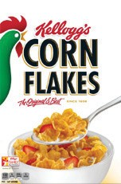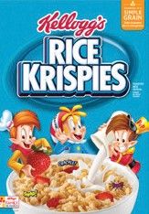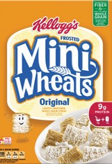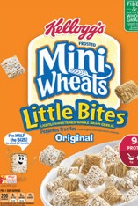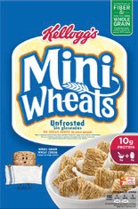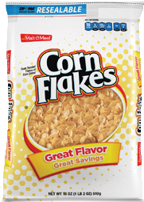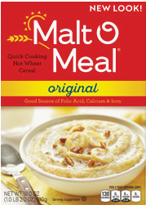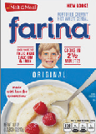
al
- All Bran  Complete  Wheat Flakes⬆ | - Corn Flakes | - Rice Krispies | Kellogg’s  Frosted Mini-Wheats:  - Original⬆  Little Bites⬆ | - Mini-Wheats  Unfrosted⬆ | Malt O Meal  - Corn Flakes  Hot Wheat Original  Farina Origin
Post

⬆
- Frosted
Mini Spooners
■
Strawberry Cream
Mini Spooners⬆

- Alpha-Bits⬆  Bran  Grape-Nuts⬆  Grape-Nuts  Honey Nut Honey Bunches of Oats
Flakes⬆ Flakes⬆ Shredded Whole Grain:
Wheat⬆  Honey  Vanilla
Crunch⬆ Bunches⬆

Quaker

- Blueberry Mini Spooners⬆  Crispy Rice GF

Sunbelt Bakery

  - Instant Grits 
Instant Oatmeal
  - Life Oatmeal Squares:  ⬆

Original Original⬆ Original⬆  Brown Sugar⬆  Cinnamon⬆
Simple Granola

Any Store Brand or Ralston Foods Brand of the following:

B & G Foods

- Bran Flakes⬆
- Corn Crisps or Bites
- Corn Flakes
- Crisp or Crispy Rice
- Crunchy Nuggets⬆
- Crunchy Oat Squares⬆
- Crunchy Wheat⬆
- Crunchy Wheat & Barley⬆
- Frosted Shredded Wheat⬆
- Frosted Strawberry Shredded Wheat⬆
- Frosted Strawberry Cream Shredded Wheat⬆
- Frosted Wheat⬆
- Happy O’s⬆
- Instant Grits Original
- MultiGrain Tasteeos⬆
- MultiGrain Toasted Cereal⬆
- Nutty Nuggets⬆
- O’s Oat Cereal⬆
- Oat Squares/Oat Wise⬆
- Original Oat Crunch⬆
- Rice Crisps/Rice Crispers/Toasted Rice (no flakes)
- Rice or Corn Biscuits/Squares
- Square-Shaped Rice/Corn
- Square-Shaped Wheat/Oat⬆
- Tasteeos⬆
- Toasted Corn
- Toasted Multi-Grain Spins⬆
- Toasted Whole-Grain Oat Spins⬆

- Cream of  Cream of Rice Rice Instant
(Crema de GF
Arroz) GF

- Cream of  Cream of
Wheat Wheat
Whole Instant
Grain⬆ Whole
Grain⬆

- Instant Oatmeal Original/Regular⬆
- Krunch Nutties⬆
- Live Life 100% Oat Cereal⬆
- Lively Oats/Live It Up!⬆
- MultiGrain Flakes
- Toasted Oats/Crispy Oats⬆
- Toasted Rollin’ Oats⬆
- Toasted Wheat⬆
- Wheat Biscuits/Squares/Crisps⬆
- Wheat & Crunchy⬆
This document has been edited for use in the Floirda Child Care Food Program.

- 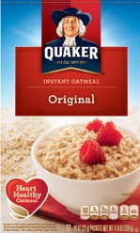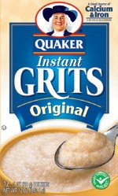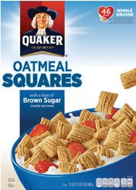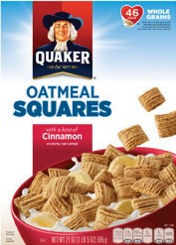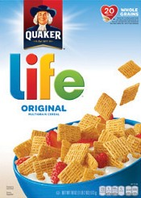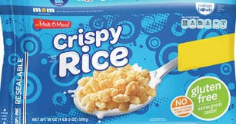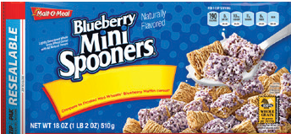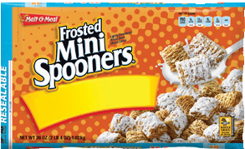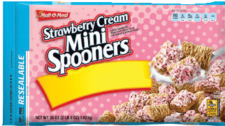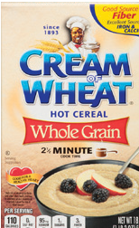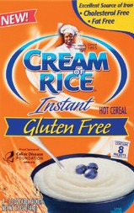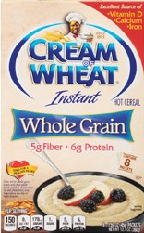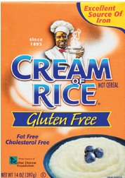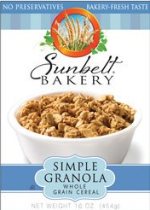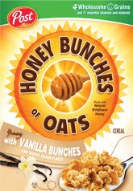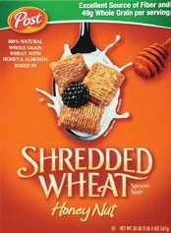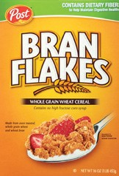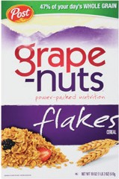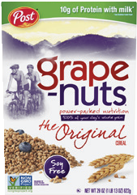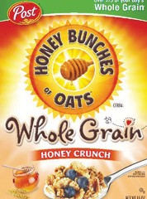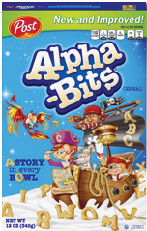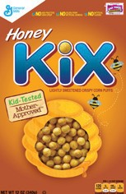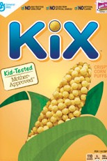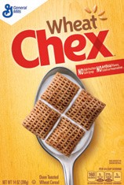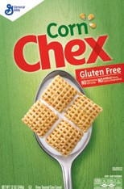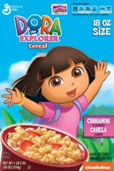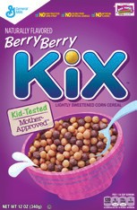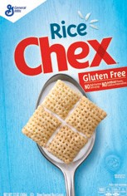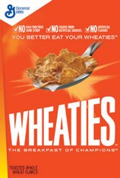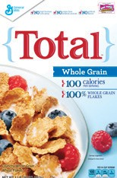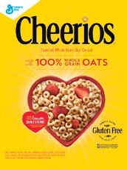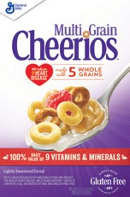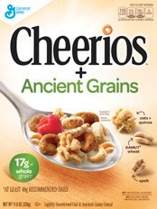MultiGrain Medley⬆
- Wheat Flakes 8

Creditable and Non-Creditable Grains
Grain-based desserts will not be creditable on the Child Care Food Program beginning October 1, 2017.
The following chart lists creditable and non-creditable grain items. Non-creditable grain items cannot contribute
towards a reimbursable meal, but may be served as an “extra” food on occasion. Creditable grain items must be in the correct portion for the age group served (refer to Exhibit A-Grains Requirement) and must be whole grain, enriched, or made from whole grain or enriched meal or flour. Prepackaged products must have whole grain or enriched flour or
meal as the first ingredient. At least one serving per day, across all eating occasions, must be 100% whole grain.

Non-creditable Grains | Creditable Grains¹
Brownies  Cake (all varieties, frosted or unfrosted) Cereal Bar/Treat  Cobbler/Fruit Crisp Cookies (all kinds) Doughnuts  Fig Bar  Fruit Turnover Grain Fruit Bar  Granola Bar (all kinds) Honey Bun  Oatmeal (more than 6 grams of sugar per dry ounce) Pastry  Popcorn Pop Tart  Potato/Vegetable Chips (or puffs/straws/sticks)  Ready-to-eat Cereal (more than 6 grams of sugar per dry ounce)  Sweet Roll/Sticky Bun Tortilla chips—flavored² Wafers (chocolate, vanilla) | Animal Crackers (plain)  Bagel/Bagel Chips  Banana Bread (or other fruit/vegetable breads) Barley  Batter or Bread Type Coating  Biscuits  Bread, Buns  Bread Sticks (hard or soft) Bulgur or Cracked Wheat Cornbread/Corn Muffin Croissants  Crepes  Crackers (savory snack crackers, plain, cheese, peanut butter) Croutons  Egg Roll Skins, Won Ton Wrappers English Muffin  French Toast (slices or sticks)  Graham Crackers (plain, all shapes) Grits  Muffins/Quick Bread  Oatmeal (with 6 grams of sugar or less per dry ounce) Pancakes  Pasta/Couscous/Macaroni/Noodles (all shapes) Pita Bread /Pita Chips  Pizza Crust  Pretzels (hard or soft) Quinoa  Ravioli  Ready-to-eat Cereal (6 grams of sugar or less per dry ounce) Rice  Rolls  Stuffing (dry) Tortillas /Arepa  Tortilla Chips/Shells—unflavored² Waffles
- 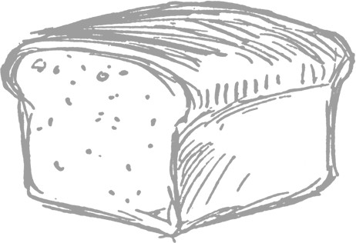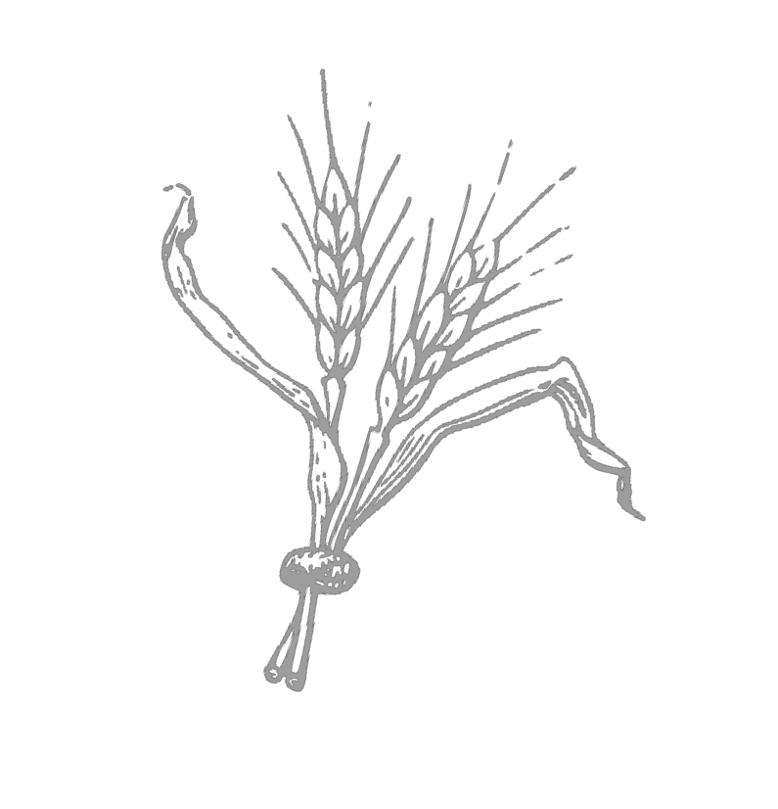Toppings and extras including brown sugar, butter, chocolate chips, cream cheese, honey, jelly, and syrup are a concentrated source of empty calories. They should be served in small portions and used minimally.
- Tortilla chips with a flavor coating are not creditable. Only plain tortilla chips may be served.

9
Revised July 2017

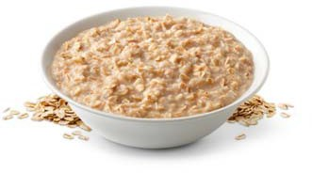
Grains
All grains must be made with enriched or whole grain meal or flour.

A serving may contain whole grain or enriched bread, cornbread, biscuits, rolls, muffins, and other bread products; or whole grain, enriched, or fortified cereal grain, cooked pasta or noodle products, or breakfast cereal; or any combination of these foods.

Whole Grains. At least one serving per day, across all eating occasions of bread, cereals, and grains, must be 100% whole grain. This must be denoted on your menu (see Documentation below).

- Breakfast cereals (including ready-to-eat cold and instant/regular hot cereals). Breakfast cereals must contain no more than 6 grams of sugar per dry ounce.

- Desserts. Grain-based desserts such as cookies, brownies, granola bars, graham crackers, etc. do not count towards meeting the grains requirement.
- Documentation. The grain item on the menu must be documented when the item is whole grain. A WG may be used in front of grain items to indicate the item is whole grain.
- Serving Size. Serving sizes for grains have not changed with the new meal pattern. Serving sizes will change slightly in 2019 with the implementation of ounce equivalents.
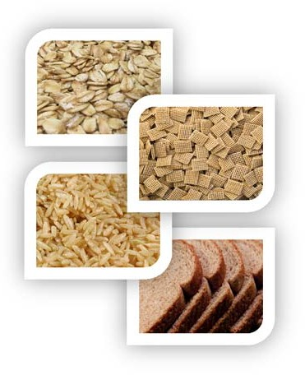

Easy Whole Grain Swaps
White rice → Brown rice
White bread → 100% Whole wheat bread
Sugary cereal → 100% Whole grain cereal topped with fruit Grits → Oatmeal
Pasta (refined/not whole grain) → 100% Whole wheat pasta Animal Crackers → 100% Whole grain crackers

Resources:

Nutrition and Wellness Tips: Build a Healthy Plate with Whole Grains: www.fns.usda.gov/tn/nutrition-wellness-tips-young-children

The Whole Grains Council: Search for 100% Whole Grain Stamped Products: https://wholegrainscouncil.org/find-whole-grains/stamped-products

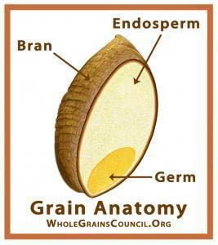
Whole Grains Adapted from the Institute of Child Nutrition
Whole grains consist of the entire grain seed or kernel. The kernel has three parts
- the bran, the germ, and the endosperm. Usually the kernel is cracked, crushed, or flaked during the milling process. If the finished product retains the same relative proportions of bran, germ, and endosperm as the original grain, it is considered a whole grain.
Identifying whole grain ingredients:
  - The word “whole” listed before a grain, such as “whole wheat” or “whole corn;”
  - The words “berries” and “groats” are used to designate a whole grain, such as “wheat berries” or “oat groats;”
  - Rolled oats and oatmeal (including old fashioned, quick cooking, and instant oatmeal); and
  - Other whole-grain foods that do not use the word “whole” in their description, such as brown rice, brown rice flour, wild rice, quinoa, millet, triticale, teff, amaranth, buckwheat, and sorghum.

Whole Grains* | Not Whole Grains
- Amaranth  - Barley (whole, hulled, or hull-less)  - Bromated Whole-Wheat Flour  - Bulgur  - Buckwheat  - Cracked Wheat  - Crushed Wheat  - Einkorn  - Freekeh  - Graham Flour  - Millet  - Quinoa  - Rice (Brown, Black, Red, Wild)  - Rye Berries (or whole rye)  - Sorghum  - Teff  - Triticale  - Wheat Berries  - Whole Corn  - Whole Durum Wheat Flour  - Whole Farro  - Whole Grain Barley  - Whole Spelt  - Whole Wheat Flour  - Whole Wheat Pasta  (Macaroni, Spaghetti, or other Whole Grains Noodles) | - All-Purpose Flour  - Bread Flour  - Bromated Flour  - Cake Flour  - Corn  - Corn Grits  - Degerminated Corn Meal  - Durum Flour  - Enriched Flour  - Enriched Rice  - Enriched Self-Rising Flour  - Enriched Wheat Flour  - Farina  - Instantized Flour  - Long-Grain White Rice  - Pearled Barley  - Phosphated Flour  - Rice Flour  - Rice (White)  - Rye  - Self-Rising Flour  - Self-Rising Wheat Flour  - Unbleached Flour  - Wheat Flour  - White Flour

*Bran and/or germ may also contribute to the whole grain requirements

How to Identify a 100% Whole Grain Food
Step 1: Is this a creditable grain (made with whole grain or enriched flour)? Check the Creditable and Non- Creditable Grain Foods List. Note: If cereal – it must meet the sugar limit.
If yes, you can serve this grain, but continue to step 2 to see if it will meet the 100% whole grain per day requirement.
If no, find another grain product. A grain must be creditable to meet the 100% whole grain requirement.
Step 2: Is this a naturally occurring whole grain like brown rice, wild rice, or oatmeal? Check the whole grains list on the previous page.
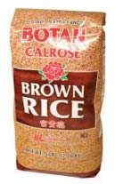
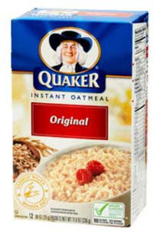
If yes, you found a 100% whole grain and it will meet your 1 whole grain for the day requirement! You don’t need to do steps 3 or 4.
If no, continue to step 3.

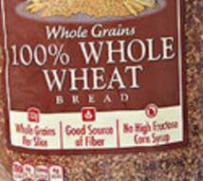
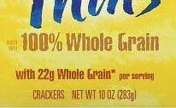
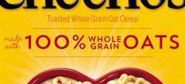
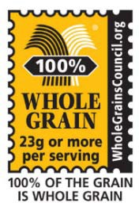
Step 3: Does the front of the package state “100% Whole Grain”, “100% Whole Wheat”, or have a 100% Whole Grain stamp?
If yes, you found a 100% whole grain and it will meet your 1 whole grain for the day requirement! You don’t need to do step 4.
If no, continue to step 4.

Step 4: There is still a chance this is a 100% whole grain product. You must check the ingredients label. All of the grain ingredients must be whole grain.

Which items are 100% whole grain based on the ingredients?
A) Bread
Ingredients: Wheat Flour, Malted Barley Flour, Soybean Oil, Salt, Honey, Wheat Starch, Thiamin, Niacin, Iron, Riboflavin, Folic Acid
B) Tortilla
Ingredients: Whole Wheat Flour, Soybean Oil, Salt, Whole Corn, Starch, Wheat Starch
C) Dry Cereal
Ingredients: Whole Corn Meal, Oats, Corn Starch, Canola Oil, Cinnamon, Brown Sugar
D) Cracker
Ingredients: Whole Grain Brown Rice Flour, Sesame Seeds, Potato Starch, Safflower Oil, Quinoa Seeds, Flax Seeds, Salt
E) Roll
Ingredients: Unbleached Enriched Wheat Flour, Sugar, Salt, Soybean Oil, Oat Bran, Yellow Corn Meal, Salt
Answer: b, c, and d are 100% whole grains because all grain ingredients are whole grain.

Child Nutrition (CN) Labeling and Product Formulation Statements (PFS)
Main dish combination products that are commercially processed such as ravioli, beef stew, spaghetti with meat sauce, egg rolls, pizza, chicken nuggets, fish sticks, etc. must contain a CN Label or Product Formulation Statement (PFS) to show that the product contains sufficient quantities of meat/meat alternate, grains, vegetables, and/or fruit to meet the meal pattern.
Otherwise, it may not be counted towards a reimbursable meal.

Example of a CN Label:
CN
000000
five .875 oz. breaded fish nuggets with APP provides 2.0 oz. equivalent meat/meat alternate and 1 serving of bread alternate for the Child
CN Nutrition Meal Pattern Requirements. (use of CN
this logo and statement authorized by the Food and Nutrition Service, USDA 08/00
CN
For a detailed explanation of CN Labeling visit the USDA Food and Nutrition Service (FNS) website at: http://www.fns.usda.gov/cnlabeling/child-nutrition-cn-labeling-program.

Manufacturer’s Product Formulation Statement (PFS):
    - Can be obtained by calling the 1-800 number on the packaging of the food item
    - A PFS on company letterhead can usually be faxed or mailed from them to you
    - Will differ from food manufacturer to food manufacturer
    - Must contain a statement about the amount of meat/meat alternate, grain/bread, and/or vegetable or fruit component per serving
    - Must be signed by an official of the manufacturer, not a salesperson

If a CN Label or PFS Cannot Be Obtained:
A processed combination food may be used if another creditable ingredient is added in sufficient quantity to meet the meal pattern.

The added ingredient must:
    - Be sufficient on its own to meet the meal pattern requirement, and
    - Be one of the ingredients already in the processed combination food or typically associated with the food being served. For example, beef chunks could be added to canned stew, ground beef could be added to spaghetti sauce, or shredded cheese could be added to pizza.

*For your use in determining serving sizes, a CN Label and PFS Calculator is available on our website (www.floridahealth.gov/ccfp).

SAMPLE Product Formulation Statement

Product Name: Fully Cooked Honey BBQ flavored chicken Strips Product Code: 012345-1234 Label Weight: 12.5lb
UPC Information : 0-1234-1234
Serving size: 1 3-oz portion (s) per serving.
Pack Information: 8/25.0 OZ BAG (s) per Case.

Product is not CN-labeled. Analysis is by Piece.
Total Weight of Cooked Product 3.0 oz Weight of Creditable Raw Meat, Variety: Chicken 1.6 oz Percent fat of raw meat: 30.0%
Weight of Meat Alternates (specify): n/a
Weight of Breading: Enriched 0.72 oz
Weight of Filling: n/a
Weight of Other Non-Creditable Ingredients: 0.67 oz Weight of Unrounded Cooked Meat/Meat Alternate: 1.72 oz

Meat/Meat Alternate per serving: 1.0 oz
Grains per serving: 0.5 per serving

I certify that the above information is accurate as presented on this date.

Nutritional Services Manager

Krista Schoen, M.S., R.D. Title HAPPY FOODS, INC. 03/20/17

Happy Foods, Inc. 1234 ABC Parkway, Nutrition, AB 12345 1‐800‐123‐4567

How to Do CN Label Calculations

What are Child Nutrition (CN) Labels?
√ Needed for commercially processed combination main dish products
√ States the meal contribution and serving size of a product
√ Found on the outer packaging of products purchased in bulk
CN
CN
051249
Four .63 oz. fully cooked, breaded chicken breast pattie nuggets with rib meat provide
1.25 oz. equivalent meat and.75 serving of bread alternate for Child Nutrition Meal Pattern Requirements. (Use of this logo and statement authorized by the Food and Nutrition Service, USDA 08/00).
CN
CN

Using the example above, how many nuggets would need to be served to each age group at a lunch to satisfy the meat component? Here are the steps for using the Calculator for Child Nutrition (CN) Labels and manufacturer’s Product Formulation Statements (PFS) on the nutrition section of our website at:
http://www.floridahealth.gov/ccfp/

Step 1: Fill in the serving size as stated on the CN label or manufacturer’s analysis sheet.
In the example above, the serving size is 4 nuggets

Step 2: In the dropdown box under meal contribution, select the appropriate meal component, and then fill in the appropriate meal contribution.
In this example, you can choose Meat/Meat Alternate and fill in 1.25 ounces as the meal contribution
OR you can choose Grain and fill in .75 servings

Step 3: Select the meal contribution you need by checking the Meal Pattern for Children by age group.
In this example, for Meat/Meat Alternate, you would fill in 1 oz. for 1-2 year olds,
  - ounces for 3-5 year olds, and 2 ounces for 6-18 year olds if these were being served at lunch.

If calculating for Grain, you would fill in .5 servings for 1-2 and 3-5 year olds and 1 serving for 6-18 year olds if these were being served at lunch.

Step 4: Click on the “Calculate” button. The serving size you need for the product will appear in the box. Remember to round up to the nearest appropriate serving size.

Age | Minimum Lunch Meal Pattern Requirement | Amount
1-2 | 1 oz | 4
3-5 | 1.5 oz | 5
6-18 | 2.0 oz | 7

Please view the online training module, The ABC’s of Child Nutrition (CN) Labels from the CCFP website.

Menu Planning Worksheet for Children
For each day of the week, write down the menus for the meal served.
Name of Child Care Facility: _Eat Wright Child Care ✓Menu Planning Age Group(s): 1 & 2 _√ 3 - 5 _√ 6 - 18 Week of: Oct. 16-20, 2017

BREAKFAST | Child meal pattern food components: | MONDAY | TUESDAY | WEDNESDAY | THURSDAY | FRIDAY
 | Milk | Low-fat milk | Low-fat milk | Low-fat milk | Low-fat milk | Low-fat milk
 | Vegetable &/or Fruit | Peaches | Applesauce | Banana | Strawberry Slices | Orange Slices
 | Grains | Cinnamon Raisin Bagel  (cream cheese) | Whole grain waffle  (turkey sausage - extra) | Cheerios cereal (whole grain) |  | Whole grain English muffin  (peanut butter & jelly)
 | Meat/Meat Alternate  optional |  |  |  | Scrambled Eggs
LUNCH | Milk | Low-fat milk | Low-fat milk | Low-fat milk | Low-fat milk | Low-fat milk
 | Meat/Meat Alternate | Baked Chicken | *Vegetable Lasagna | Pork Tenderloin | Bean and Cheese Quesadilla | *Breaded Fish
 | Vegetable | Mashed potatoes | Green peas | Sweet potato | Fiesta corn | Baked beans
 | Fruit (or Vegetable) | Broccoli | Pears | Mixed vegetables | Apple slices | Mixed greens salad (spinach, romaine, tomato, cucumber)  Low-fat Italian dressing
 | Grains | Whole wheat roll | Garlic bread | Egg noodles | Whole grain tortilla | Whole wheat bun
SNACK | Select 2 | String cheese | Grape juice | Bell pepper strips  Low-fat ranch dressing | Yogurt | Low-fat milk
 | Milk
 | Meat/Meat Alternate
 | Vegetable | Mandarin oranges | Whole grain crackers | Cheese crackers | Pineapple tidbits | Graham crackers (plain)
 | Fruit/Juice
 | Grains
MENUS MUST BE POSTED AND MAINTAINED ON FILE!
Refer to Meal Pattern for Children for serving sizes when planning menus.
*Requires a Child Nutrition Label or manufacturer’s Product Formulation Statement or standardized recipe
When a drink is not specifically listed with a snack, water is recommended as a beverage. (Note: Water is NOT a creditable food item) All milk offered is plain/unflavored. 17

New Meal Pattern Menu Checklist
Use this checklist to ensure that all CCFP meal requirements are met. All answers must be marked “Yes.”

CHILD MEAL PATTERN REQUIREMENTS

I. Breakfast: | Yes | No
A. 3 components: Fluid Milk, Vegetables and/or Fruits, Grains
B. Only ready-to-eat breakfast cereals (cold/hot) containing 6 g of sugar or less per dry oz are served (refer to the Florida WIC-Approved Cereal List).
C. Meat/Mt alternates are used to meet entire grains requirement no more than three times/week.
II. Lunch/Supper: | Yes | No
A. 5 components: Fluid Milk, Meat/Meat Alternates, Vegetables, Fruits, Grains
B. One vegetable and one fruit or two different vegetables are served (two fruits may not be served).
III. Snack: | Yes | No
A. 2 different components: Fluid Milk, Meat/Meat Alternates, Vegetables, Fruits, Grains
Note: Juice must not be served when milk is the only other component.
B. Water does not appear on the menu as one of the two required components.
IV. General: | Yes | No
A. Fruit juice does not appear on the menu more than once a day.
B. At least one grain serving per day, across all eating occasions, is 100% whole grain.
Menus must clearly identify the whole grain item (e.g. “WG bread”).
C. Grain-based desserts (e.g. granola bars, cookies) are not served as part of a reimbursable meal.
Grain-based desserts may be served as an “extra.” Plain graham and animal crackers are creditable.
D. Yogurt (milk or soy) contains no more than 23 g of total sugars per 6 oz (15 g/4 oz or 3.8 g/oz).
E. Children age one receive unflavored whole milk (unless breastfed).
F. Children ages 2 through five receive unflavored lowfat (1%) or unflavored fat-free (skim) milk.
G. Flavored milk is not served to children under 6 years of age. Flavored powder/liquid may not be added to milk (cow or soy) for children ages 1-5.
H. Flavored milk served to children age 6 years and older is fat-free (skim).
I. The menu clearly identifies the types of milk served (fat content and if flavored).
J. Commercially processed combination foods (served at any meal) have a CN label or manufacturer’s Product Formulation Statement (PFS) stating the food component contribution.
K. Pre-packaged grain products must have enriched flour or meal or whole grains as the first ingredient listed on the package. Sugar cannot be the first ingredient.
L. Meals do not include foods deep-fried on site. Providers may purchase or receive pre-fried foods but must reheat them using an alternate method (baking or pan frying/sautéing).
M. CCFP funds are not used to purchase non-creditable food items (e.g.: grain-based desserts).
N. Children with special dietary needs (not a disability): parents do not provide more than one component of the reimbursable meal. Parents may supply only one component of the reimbursable meal for children with special dietary needs. The contractor must supply all other components.
Children with documented disabilities: parents may supply one or more components of the reimbursable meal. The contractor must supply at least one component.
Reminder: tofu is creditable as a meat/meat alternate

INFANT MEAL PATTERN REQUIREMENTS

V. General: | Yes | No
A. Two different approved iron-fortified infant formulas are offered: one milk-based and one soy- based.
B. Breastmilk and/or formula is served at every meal and snack.
C. Solid foods are served to infants when they are developmentally ready for them. Solids should be introduced around 6 months of age, but may be served/claimed earlier.
D. Once an infant is developmentally ready to accept solid foods, the contractor offers them to the infant.
C. Juice is not served as part of a reimbursable meal.
D. Only ready-to-eat breakfast cereals (cold) containing 6 g of sugar or less per dry oz are served (refer to the Cereal List for Infants). These cereals may only be served at snack to developmentally ready 6-11 month olds.
E. Yogurt contains no more than 23 g of total sugars per 6 oz (15 g/4 oz or 3.8 g/oz). Soy yogurt is not creditable for infants. Yogurt must be traditional/”cold” yogurt; not baby yogurt blends that are shelf-stable. Whole milk yogurt is recommended.
F. Cheese food and cheese spread are not served/included on the menu.
G. Commercially prepared combination baby foods (e.g. chicken and rice) and baby food “desserts” are not served.
H. When eggs are served to infants, the whole egg (white and yolk) is served.
I. CCFP funds are not used to purchase non-creditable food items (e.g.: juice).
J. Children with special dietary needs (not a disability): parents do not provide more than one component of the reimbursable meal. Parents may supply only one component of the reimbursable meal for children with special dietary needs. The contractor must supply all other components.
Children with documented disabilities: parents may supply one or more components of the reimbursable meal. The contractor must supply at least one component.
Reminder: a reimbursable meal may contain breastmilk fed to baby by mother
Reminder: whole grains are not required for infants
VI. Best Practices for Children Ages One and Older (strongly recommended):
- Fresh, frozen, or canned vegetables and/or fruits should be served at least twice a week on the breakfast menu and twice a week on the snack menu.
Please note: For those centers that claim two snacks and one meal, instead of two meals and one snack, fresh, frozen, or canned vegetables and/or fruits should be served at least twice a week at each snack time.
- *Good vitamin A sources from vegetables and fruits should be served a minimum of two times a week.
- *Good vitamin C sources from vegetables and fruits or fruit juice should be served daily.
*Please refer to Fruit and Vegetable Sources of Vitamins A and C found on the CCFP website and in A Guide to Crediting Foods.

Serving Family-Style Meals in the CCFP

Family-style is a type of meal service which allows children to serve themselves from common platters of food with the assistance of supervising adults. Family-style meal service provides an opportunity to enhance the nutritional goals of CCFP by encouraging a pleasant eating environment. It also promotes mealtime as a learning experience enhancing children’s development of language, social skills, motor skills, table manners, and independence.

Family-style meals are reimbursable when each child has access to the required portion size for each meal item.

When electing to use this recommended style of meal service, the following must be followed:

A sufficient amount of prepared food must be placed on each table to provide the full required portions of each component.
This means that when food dishes are passed around the table, each child has access to at least the minimum required amount of each meal component. Enough food must also be available to accommodate any adults who will be eating with the children.

For example, there are ten 3-year old children sitting around a breakfast table and orange slices are served as the vegetable/fruit component. According to CCFP meal pattern, the minimum required amount for vegetable/fruit is ½ cup for 3-5 years old, therefore:
    - 10 X ½ = 5 cups (there should be at least 5 cups of orange slices on the table)

Children must be allowed to serve the food components themselves, with the exception of fluids, such as milk.
During the course of the meal, it is the responsibility of the supervising adults to actively encourage each child to serve themselves the full required portion of each food component. Supervising adults who choose to serve the fluids directly to the children must serve the required minimum quantity to each child.

Center staff must supervise and observe children during mealtime. Center employees should act as good role models by sitting with the children and eating the same food that they do.
In family-style meal service, children are responsible for determining the amount (if any) of a food item that they will serve themselves (or with assistance from an adult). Center staff is responsible for offering nutritious foods that meet the CCFP meal pattern and encouraging children in a positive manner to try a variety of foods.

Staff is responsible for assuring that food is handled in a safe and sanitary manner. To ensure safe food practices, food from bowls, dishes, and pitchers placed on the table may not be reused or served as a leftover at a later date or time. State and local health department sanitation and food safety requirements must be followed.

Food Safety in the CCFP

Serving safe food to children participating in the Child Care Food Program (CCFP) is as important as serving well-balanced and appetizing meals. Preventing foodborne illness must be a top priority for child care staff that prepare and serve meals to young children.

Improper food handling, preparation, or storage can cause food to become contaminated with bacteria or germs that could result in children becoming sick if the contaminated food is eaten. Bacteria multiply quickly at temperatures between 41°F and 135°F. Keeping foods out of this temperature danger zone is critical to keeping foods safe and keeping children healthy.

The following food safety resources and training modules can assist you in preventing foodborne illness at your child care site:

From the CCFP website at www.floridahealth.gov/ccfp/ click on Food Safety and Alerts from drop down box to access:
- Online module, Serving Safe Food in the CCFP, located under Child Care Food Program Resources
- Institute of Child Nutrition online course, Serving Safe Food in Child Care, also located under Child Care Food Program Resources

Please refer to www.Foodsafety.gov for the latest in food recall and safety alert information. FoodSafety.gov is the gateway to food safety information provided by government agencies. Check recalls regularly (daily is best) for information about products that could cause an allergic reaction or foodborne illness.

Drinking Water in the CCFP

Availability
Child care providers must make water available to children upon request throughout the day.
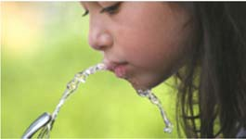
Tips: Child care providers can make water available to children in a variety of ways: having cups available next to the kitchen sink faucet, having water pitchers and cups set out, or simply providing water if it should be requested. Child care providers are not required to have water available for children to self-serve.
NEW Requirement: Child care providers must also offer water to children throughout the day. For very young children, this may require visual cues such as showing the cup or pitcher while verbally offering the water.

Safety
Most child care facilities obtain drinking water through a public water system. Public water systems are required to ensure that the water provided meets Federal and State drinking water standards. However, plumbing systems within facilities also can affect the quality of the drinking water. In some instances, the plumbing systems within facilities may expose the water to contamination, including lead.
The U.S. Environmental Protection Agency (EPA) recommends that all child care facilities routinely test drinking water for lead and perform regular maintenance to ensure that drinking water is safe. Contact your local public water provider for information about testing for contaminants. Child care providers with private well water should contact their local health department for testing. Well water should be tested at least annually.
Costs related to the purchase of water testing services would be considered an allowable use of CCFP funds if the costs are determined to be reasonable, necessary, and allocable.
In general, CCFP funds may not be used for costs that add significantly to the value of the child care facility, such as fixing plumbing. However, water filtration equipment could potentially be a reasonable and necessary cost under certain conditions. If interested, check with state headquarters.
If safe water is not readily available, purchasing water for children may be considered a reasonable and allowable cost. The facility must have documentation from their local county health department stating the facility’s tap water is unsafe.
Note: purified bottled drinking water is an allowable expense when used to mix concentrate or powdered formula in preparing infant bottles.

For more information:
EPA: Drinking water best management practices for child care facilities served by municipal water systems: http://nepis.epa.gov/Exe/ZyPDF.cgi?Dockey=P100HGM8.txt
EPA: Drinking water in child care facilities. Information for parents, childcare facilities, and activities for kids. Resources for the 3T’s (training, testing, and telling): www.epa.gov/dwreginfo/lead-drinking-water-schools-and- child-care-facilities
Department of Health: Florida well water information and testing: www.floridahealth.gov/environmental- health/drinking-water/index.html
National Drinking Water Alliance: Strategies and resources for drinking water education and promotion: www.drinkingwateralliance.org/education-earlycare
Safe Drinking Water Hotline: (800) 426-4791

Food Service Documentation

Child care providers must have adequate documentation for each meal type served and claimed for CCFP reimbursement.
To comply with the policy above, child care providers must maintain on file the following items:

Menu Planning Worksheets:
- Menus must be posted, legible, and maintained on file.
- Menus must include at least the name of the facility, dates, menu type (breakfast, lunch, snack, supper), and menu items.
- Menus must be changed to reflect any meal component substitutions that are made. These changes must be made prior to the meal service.

Meal Count Records:
Meal counts must be recorded by the end of each business day. If something other than a
CCFP Meal count Record is used to record meal counts, the recorded information must be
transferred to the

Special Needs Meals in the CCFP

Children with disabilities:
Child care providers must make reasonable modifications to meals to accommodate disabilities which restrict a child’s diet. A disability means any person who has a physical or mental impairment which substantially limits one or more “major life activities.” “Major life activities” include eating, digestion, and feeding skills. A physical or mental impairment does not need to be life threatening to constitute a disability. Examples of a disability may include diabetes, food allergy/intolerance, developmental delay, or autism.
Meals with substitutions that meet all meal pattern requirements are reimbursable. For example, the child care provider can substitute lactose-free milk in place of “regular” cow’s milk or substitute bananas for oranges. A medical statement is not needed in this case; however, a parent note should be on file.
When substitutions are made and the meal pattern is not met, a medical statement is required. In this situation, the medical statement must include the following:
  - Description of the child’s physical or mental impairment that restricts diet.
  - An explanation of what must be done to accommodate the disability, e.g., listing food(s) to be omitted and the food(s) to be substituted or any necessary adaptive feeding equipment.
  - Signature of a licensed physician, a physician’s assistant (PA), or an advanced registered nurse practitioner (ARNP).
A parent/guardian may supply one or more components of the reimbursable meal as long as the institution/facility provides at least one required meal component.

Dietary preference:
Meals with substitutions that meet all food component requirements of the meal pattern are reimbursable. No medical statement is needed; a note from the parent/guardian should be on file. For example, the child care provider can substitute meat alternates for a child who does not eat meat due to religious preference or vegetarianism.

Milk substitutions:
Soy milk
Child care providers or parents may provide a non-dairy beverage (e.g., soy milk) that is nutritionally equivalent to the fluid milk component of the meal pattern. For the meal to be reimbursable, the beverage must be listed on the current CCFP Approved Milk Substitution List for Children Ages 1 and Older on the CCFP website under Nutrition and Menu Planning/Special Dietary Needs at: www.flhealth.gov/ccfp/
The following must be maintained on file:
  - A letter from the parent/guardian requesting a nutritionally equivalent milk substitute (e.g. soy milk) is required if no medical statement is on file. The letter must state whether the parent/guardian or the center will provide the milk substitute.
If parent/guardian prefers to provide the approved soy milk, it must be in the original container and labeled with the child’s name.
All other milk substitutes (e.g., almond milk, rice milk, coconut milk):
These milks are not nutritionally equivalent to fluid cow’s milk and require a medical statement.

Sponsors and child care facilities are encouraged to contact the nutrition section at the state office at 850-245-4323 for assistance with disabilities or dietary preferences.

Child Care Food Program
Medical Statement for Children with Disabilities
Child’s Name: Date: 10/5/2017
____________________________
Name and Address of Child Care Center: Eat Right Child Care
123 Healthy Lane, Vegetable Way, FL 33333
Dear Parent/Guardian and Recognized Medical Authority:

Child care providers must make reasonable modifications to meals to accommodate disabilities which restrict a child’s diet. A disability means any person who has a physical or mental impairment which substantially limits one or more “major life activities.” “Major life activities” include eating, digestion, and feeding skills. A physical or mental impairment does not need to be life threatening to constitute a disability. Examples of a disability may include diabetes, food allergy/intolerance, developmental delay, or autism.

When substitutions are made and the meal pattern is not met, a medical statement is required and must be signed by a physician, physician’s assistant (PA), or nurse practitioner (ARNP). Please return this completed form to the child care center. If you have any questions, please contact me at
123-456-7890 . Sincerely, Healthy Hilda
Child Care Center Phone Child Care Center Director

A recognized medical authority must complete the following information.

State and describe the disability.
Allergy to cow and soy milk
How does the disability restrict the diet?
Child cannot drink cow and soy milk
List any food(s) to be omitted from the child’s diet.
No cow or soy milk
List any food(s) to be substituted.
Almond milk
Describe any textural modification or adaptive equipment required.
n/a

Ima Lean, ARNP_
10/8/2017

Signature of Physician or Recognized Medical Authority Date (For a disability – a physician, PA, or ARNP must sign)
Ima Lean, ARNP 555-444-3333
Printed Name Phone Number

Parent must complete the following information.

This facility has not requested or required me to provide special food for my child.

Parent Signature: Candi Apple Date: 10/6/2017

Printed Name of Parent: Candi Apple
Revised 7/2017 I-015-02

Milk Substitutions & Creditable Milks In the Florida Child Care Food Program
For children ages 1 and older, CCFP regulations require that each child’s breakfast, lunch, and supper must include fluid milk to be eligible for reimbursement. Fluid milk may also be served as one of the two components of a snack.

Creditable fluid milks include breastmilk, as well as pasteurized fluid types of cow or goat milk, lactose-free or lactose-reduced milk, UHT (Ultra High Temperature) milk, acidified or cultured milk, and organic milk.

Non-dairy fluid milk substitutions may be served when requested in writing the by child’s parent or guardian. The written request must identify the medical or special dietary condition that restricts the diet of the child, such as milk allergy or vegan diet. In order for the meal to be reimbursable, the non- dairy beverage must be nutritionally equivalent to fluid milk. Child care providers or parents may provide the non-dairy beverage.

For Children Ages One through Five
The following non-dairy (soy-based) beverages meet required nutritional standards for approved milk substitutions:

      - 8th Continent Soymilk Original • Pacific Ultra Soy Original
      - Great Value Soymilk Ultra-Pasteurized • Silk Original Soymilk
      - Kirkland Organic Soymilk Original • Westsoy Organic Plus Plain Soymilk

For Children Ages Six and older
The beverages listed above and the ones below meet required nutritional standards for approved milk substitutions:

        - 8th Continent Soymilk Vanilla
        - Pacific Ultra Soy Vanilla
        - Westsoy organic Plus Soymilk Vanilla

Each of the companies listed has information regarding product availability on their websites:

www.8thcontinent.com/product-finder/ www.walmart.com/ www.costco.com/
www.pacificfoods.com/retail-stores/ www.silk.com/where-to-buy www.westsoymilk.com/store-locator/

If a child care provider has any question about these or other non-dairy beverages, please contact the State office at 850-245-4323 for assistance.

Revised July 2017

Meal Service Reminders

 Child care providers participating in the CCFP must offer program meals to all children, including infants, who are enrolled for care.
 Infant Feeding Forms must be completed by parents of infants. (Not required for Head Start/Early Head Start facilities.)
 Meals containing only formula or breastmilk supplied by either the child care provider or the parent are reimbursable (from birth until infant is developmentally ready for solids).
 A center can be reimbursed for up to two meals and one snack or two snacks and one meal, per child (and infant), per day.
 The quantity of food you serve to the children can be more than the amounts indicated on the meal pattern, just not less.
 All components of the meal must be served at the same time and eaten on site, except in the case of a field trip.
 At least one hour must elapse between the end of a meal/snack service period and the beginning of the next meal /snack service period. (applies to children only, not infants).
 Each meal can last up to two hours (applies to children only, not infants).
 The supper meal must begin no earlier than 5:00 p.m. and no later than 7:00 p.m.
 The evening snack must begin no earlier than 6:00 p.m. and no later than 11:00 p.m.
 Cycle menus are encouraged; a minimum of four weeks should be planned.
 If ready-to-eat cereal is on the menu, list what type of cereal is being served.
 If juice is on the menu, list what type of juice (i.e., orange, grape, etc.)
 The type of milk must be listed on the menu (e.g. whole, low fat – 1%, fat free – skim and if milk is flavored)
 Commercially prepared tofu and soy yogurt may be creditable as a meat/meat alternate.
 Child care providers must offer and make water available to children throughout the day. Please note: Water is encouraged at snack when a drink is not specifically listed; however, water is NOT a creditable food component.

Feeding Infants

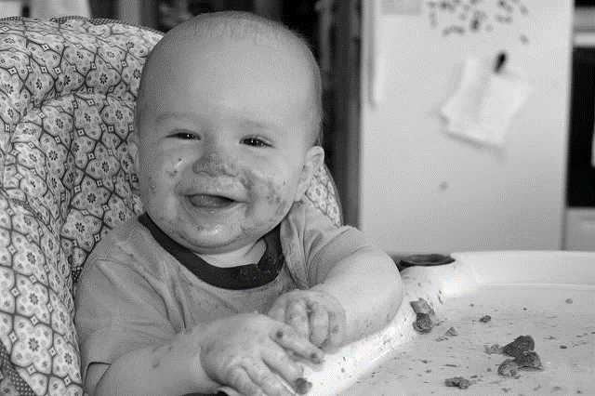

Infant Feeding Policy

One of the main goals of the Child Care Food Program (CCFP) is to safely serve nutritious meals and snacks that meet program meal pattern requirements and are appetizing to children. To help achieve this goal, there are two main policies regarding infants that child care providers must meet when participating in the CCFP.

POLICY I
Child care providers participating in the Child Care Food Program must offer program meals to all children, including infants, who are enrolled for child care.

By agreeing to participate in the CCFP, you are obligated to offer program meals to all children including infants. Offering program meals to infants must be based on whether the baby is enrolled for care – not whether the baby is enrolled for the CCFP. As long as the baby is in care during the meal service period, you are obligated to offer the baby a meal that meets CCFP requirements.

To comply with Policy I, child care providers must:

Require parents to complete the “Infant Feeding Form” (see sample on the following page). If you use anything other than the sample provided, you must have prior written approval by the Department of Health. The “Infant Feeding Form” must be kept on file at the child care facility.

PLEASE NOTE: Head Start/Early Head Start facilities are not required to provide this form to parents. Head Start facilities are required to participate in the CCFP and have more comprehensive requirements and forms.

Select at a minimum, one approved iron-fortified milk-based formula and one approved iron-fortified soy-based formula to offer formula fed babies from the Approved Formula List.

***IMPORTANT***
Refer to the Approved Formula List on our website under Nutrition and Menu Planning /Feeding Infants at: www.flhealth.gov/ccfp/

PLEASE NOTE: Head Start/Early Head Start facilities provide infants with the brand of formula they currently use at home.

Also, parents may prefer to supply their own formula.

Child Care Food Program
Infant Feeding Form

Child care facility: Please fill in facility name and formulas offered before distributing to parents.
Child Care Facility Name: | Eat Wright Child Care
*Formulas offered at this facility:  Milk-based:  Soy-based: | Gerber Good Start Gentle
 | Gerber Good Start Soy
This child care facility participates in the Child Care Food Program (CCFP) and is required to offer infant formula and food to your baby. The CCFP provides reimbursement for healthy meals provided and served to your baby while in our care. Our child care staff have been trained in infant feeding practices and offer age appropriate foods for your baby.
We welcome breastfed babies and support and encourage moms to continue breastfeeding when returning to work or school. For formula fed infants, we offer the iron-fortified infant formulas listed above to babies in our care.
To qualify for reimbursement, infant meals and snacks must include, at a minimum, the following food components at appropriate age and developmental stages:
~ Breastmilk or iron-fortified infant formula (or a combination of both)
~ Iron-fortified infant cereal
~ A variety of texture-appropriate vegetables and fruits such as sweet potato, banana, and peas
~ A variety of texture-appropriate meat and meat alternates such as chicken, yogurt, and cheese
~ Bread, crackers, Florida WIC-approved ready-to-eat cold cereals

Please be aware this child care facility:
~ Will offer all food components to each infant that is developmentally ready to accept them. Parents do not have to bring in any foods for their children.
~ Can feed solid foods to infants in a bottle only when a medical statement is provided.
~ May request parents to supply clean, sanitized and labeled bottles on a daily basis.
~ Requires the parent to label bottles of breastmilk or formula and containers of food that they provide with baby’s name, date, and time of bottle or food preparation.

Parents please complete the following:
Baby’s full name: _Baby Lulu Date of Birth: 00/00/00
Please check ✓ this box ☑ if your baby is breastfed. Please check if you plan to do one or both: Provide pumped breastmilk in a bottle ☑ Visit facility to nurse ☑
I understand that this child care facility will supply the above iron-fortified formulas for formula-fed infants up to 12 months of age and infant cereal and baby food for infants 6 months and older, according to the CCFP requirements.
I prefer to supply my own formula (write in name of *formula):

This facility has not requested or required me to provide infant formula or food.

Parent Signature: Baby Lulu’s Mommy Date: _10-1-17
Printed Name of Parent: Baby Lulu’s Mommy

*Please note: Early Head Start facilities provide the brand of formula you currently give your infant as well as all age-appropriate food Revised September 2016

POLICY II

Child care providers must ensure that each meal served to infants (birth through 11 months) meets requirements for the appropriate age group as stated in the CCFP Meal Pattern for Infants.

The CCFP Meal Pattern for Infants assures well balanced meals that supply the kinds and amounts of foods that babies require to help meet their daily nutrient and energy needs. Infant meals must contain the food components in the amounts indicated for each age group of the infant meal pattern to qualify for reimbursement.
Babies should be fed when they are hungry, not by a strict schedule. An infant meal (breakfast, lunch or supper, and snack) is reimbursable as long as the required food components and amounts are offered to the baby during the course of the day that the baby is in child care. Solid foods should be introduced around 6 months of age.

To comply with Policy II, child care providers must:

Purchase and supply all food components of the infant meal pattern with the exception of parent- provided component:
  - Parent may supply one component (breastmilk or formula or solid food)
- Offer the following food components according to the meal types and age groups required by the CCFP Meal Pattern for Infants:
  - Breastmilk, or iron-fortified infant formula, or a combination of both
  - Iron-fortified infant cereal and
  - Bread and/or crackers and ready-to-eat cereal with 6 grams of sugar/ounce or less
  - Vegetable and/or fruit (juice is not creditable)
  - Meat, fish, poultry or meat alternates (eggs, cooked dry beans or peas, cheese, cottage cheese, yogurt – must not be more than 23 grams of sugar per 6 ounces)
- Offer solid foods:
  - To infants who are developmentally ready to accept them (see bullets below)
  - Of an appropriate texture and consistency
  - After consulting with parents

Signs Baby is Ready for Solids (based on the American Academy of Pediatrics):

Infant is able to sit in a high chair or infant seat with good head control;
- Infant opens his or her mouth when food comes his or her way. He or she may watch other eat, reach for food, and seem eager to be fed;
- Infant can move food from a spoon into his or her throat; and
- Infant has doubled his or her birth weight and weighs 13 pounds or more.

**IMPORTANT**
Remember you can only be reimbursed for 2 meals and 1 snack or 2 snacks and 1 meal per child in the CCFP.
To be reimbursable, a meal and/or snack must contain the required food components and minimum amounts.

Child Care Food Program Meal Pattern for Infants
The Child Care Food Program (CCFP) provides aid to child care institutions and family day care homes for the provision of nutritious foods that contribute to the wellness, healthy growth, and development of young children. Child care providers have a powerful opportunity to demonstrate healthy habits at an early age that can serve children throughout life.
To comply with CCFP regulations, the Infant Meal Pattern lists the amount of food to be offered to children from birth through the 11th month (their 1st birthday). To support and encourage moms who breastfeed, meals containing breastmilk have different guidelines for reimbursement than meals containing formula. Food within the meal pattern should be the texture and consistency appropriate for the age of the infant and may be served during a span of time consistent with the infant’s eating habits. The infant meal must contain each of the following components in the amounts indicated for the appropriate age group in order to qualify for reimbursement.

Infant Meal Pattern Food Components: |  | Age Group and Serving Size:
 |  | Birth – 5 months: | 6 – 11 months:
Breakfast and  Lunch/Supper | Breastmilk1 or formula2 | 4-6 fl. oz. | 6-8 fl. oz.
 | *And one or more of the following: |  | *0-4 Tbsp.
Infant cereal2,3,5, meat, fish, poultry, whole egg, cooked dry beans/peas

Cheese
Cottage cheese Yogurt4
 |  |  | *0-2 oz.
 |  |  | *0-4 oz. (volume)
 |  |  | *0-8 oz. (I cup)
 | *And: |  | *0-2 Tbsp.
 | Vegetable or fruit, or a combination of both7
Snack | Breastmilk1 or formula2 | 4-6 fl. oz. | 2-4 fl. oz.
 | *And one or more of the following: |  | *0-1/2 slice
Bread3,5

Crackers3,5
Infant cereal2,3,5 or ready-to-eat cereal3,5,6
 |  |  | *0-2
 |  |  | *0-4 Tbsp.
 | *And: |  | *0-2 Tbsp.
 | Vegetable or fruit, or a combination of both7
*NOTE: A SERVING OF THIS COMPONENT(S) IS REQUIRED WHEN THE INFANT IS DEVELOPMENTALLY READY TO ACCEPT IT.
- Breastmilk or formula or portions of both, must be served; however, it is recommended that breastmilk be served in place of formula from birth through 11 months. For some breastfed infants who regularly consume less than the minimum amount of breastmilk per feeding, a serving of less than the minimum amount of breastmilk may be offered, with additional breastmilk offered at a later time if the infant will consume more.
- Infant formula and dry infant cereal must be iron-fortified.
- Beginning October 1, 2019, ounce equivalents are used to determine the quantity of creditable grains.
- Yogurt must contain no more than 23 grams of total sugars per 6 ounces.
- A serving of grains must be whole grain, whole-grain rich, enriched meal, or enriched flour.
- Breakfast cereals must contain no more than 6 grams of sugar per dry ounce (no more than 21 grams of sucrose and other sugars per 100 grams of dry cereal).
- Fruit and vegetable juices must not be served.
N-051-04

CCFP Meal Pattern for Infants Guidelines to Follow

Breastmilk and/or Infant Formula:
  - Breastmilk or iron-fortified infant formula, or portions of both, must be served to infants birth through 11 months of age.
  - Breastmilk is recommended in place of formula from birth through 11 months.
  - For some breastfed infants who regularly consume less than the minimum amount of breastmilk per feeding, a serving of less than the minimum amount of breastmilk may be offered. Additional breastmilk must be offered at a later time if the infant will consume more.
- Infant formula must be iron-fortified. Facilities must offer at least two infant formulas; one milk-based and one soy-based (Refer to the CCFP Approved Formula List).
- When a parent or guardian chooses to provide breastmilk or iron-fortified infant formula and the infant is consuming solid foods, the institution or facility must supply all other required meal components in order for the meal to be reimbursable.
- Meals in which a mother directly breastfeeds her infant at the institution or facility are eligible for reimbursement.

Fruits/vegetables:
- Fruit and vegetable juices must not be served.
- A vegetable, fruit, or combination of both must be served at snack to 6-11 month old developmentally ready infants.

Grain/bread foods:
- Grain/bread items (bread, soft tortilla, crackers, teething biscuit, ready-to-eat breakfast cereals) must be whole grain, enriched, or made from whole grain or enriched meal or flour.
- Only ready-to-eat breakfast cereals containing 6 grams of sugar or less per dry ounce may be served (Refer to the Florida WIC approved cereal list).

Solid foods:
- The gradual introduction of solid foods may begin at 6 months of age, or before or after 6 months of age if it is developmentally appropriate for the infant and in accordance with USDA/FNS guidance.
- Once an infant is developmentally ready to accept solid foods, the institution or facility is required to offer them to the infant.
- Must be of an appropriate texture and consistency and should only be introduced after consulting with the infant’s parent or guardian.
- Parents or guardians should request in writing when an institution or facility should start serving solid foods to their infant.
- Parents or guardians may supply only one component of their infant’s reimbursable meal.
- Can be either home-prepared baby foods or commercially prepared baby foods.
- Infant cereal must be iron-fortified, plain, dry.
- Do not serve honey or food that contains honey to infants less than one year of age - honey may contain botulinum spores, which can be harmful to infants.

Creditable Infant Foods
Solid foods of an appropriate texture and consistency are required when the infant is developmentally ready to accept them. An infant meal is reimbursable only if it contains creditable foods. Creditable foods are foods that may be counted toward meeting the infant meal pattern requirements for a reimbursable meal.
The following is a list of infant foods that are considered creditable and non-creditable. Please see A Guide to Crediting Foods for more information.

CREDITABLE | NON-CREDITABLE
Breastmilk  - Expressed by the baby’s mom and labeled appropriately  - Fed directly to baby by mom at the child care facility | × Cow’s milk, goat’s milk, and other breastmilk and formula substitutes (unless documented by a medical statement from the baby’s health care provider)
Infant Formula
- Must be iron-fortified – See website for Approved Formula List
Infant Cereals  - Must be iron-fortified, dry, plain, single-grain  - Wait to offer babies wheat and mixed grains cereals until 8 months and older | × Cereals with added fruit  × Jarred cereals  × Child and adult hot cereals – like grits and oatmeal
Ready-to-Eat Dry Cereals  - Must have no more than 6 grams of sugar per dry ounce  - Refer to the Florida WIC-Approved Cereal List | × Cereals with more than 6 grams of sugar per dry ounce
Bread and Crackers  - Creditable at the snack meal for babies who are developmentally ready to accept  - Small strips or pieces of dry bread, toast, plain low salt crackers, soft tortilla or soft pita bread  - Teething biscuits | × Breads and crackers with nuts and seeds and whole grain kernels  × Cookies, granola bars, corn chips, pretzels, puffs
Fruits and Vegetables  - Commercial jars of single or multiple vegetables and/or fruits – first ingredient must be a vegetable or fruit  - Home-prepared vegetables or fruits – cooked if necessary, plain (without added seasonings), pureed or mashed to an appropriate consistency. | × Commercial jars of baby food with “cereal”, “dessert”, or “pudding” on the label are not creditable (even if vegetable or fruit is the first ingredient)

Infant Menus

Child care providers must maintain menus for infants, as with older children.

Menus must be posted and contain at a minimum:
  - Name of child care provider
  - Date
  - Menu type (breakfast, lunch or supper, and snack)
  - Menu items

The Standard Infant Menu on the following page can be used in lieu of Weekly Menu Planning Worksheets for Infants (if sponsored, this must be approved by your sponsoring organization).

Parents will want to know what their baby has eaten each day along with other daily events. Child care providers are encouraged to communicate regularly with parents on how their baby’s day went.

**IMPORTANT**
Meals served to infants must be recorded on a meal count form within one hour after feeding the baby (day care homes have until the end of the day). Please note: Feed infants when they are hungry, not by a strict schedule.

Name of Child Care Facility:

Standard Infant Menu
The following iron-fortified infant formulas are offered at this facility:
Milk-based: Soy-based:

Note: Breastmilk offered when provided by parent.

Birth to 5 Months
Breakfast, Lunch/Supper, and Snack:
Breastmilk and/or iron-fortified infant formula
6 to 11 Months
Breakfast and Lunch/Supper:
Breastmilk and/or iron-fortified infant formula
*One or more of the following:
Infant cereal (dry infant cereal mixed with breastmilk and/or formula)
Variety of meats and poultry (cooked plain or from jar)
Fish (cooked plain, boneless)
Whole egg
Cooked dry beans/peas (cooked plain) Cheese regular (plain, sliced thin or thin trips) Cottage cheese
Yogurt
*A variety of vegetables and/or fruits:
Carrots Applesauce
Green Beans Bananas
Mixed vegetables Mixed fruits
Peas Peaches
Potatoes/sweet potatoes Pears Squash

Snack:
Breastmilk and/or iron-fortified infant formula
*One or more of the following:
Bread (small pieces of bread or toast)
Crackers (small pieces of unsalted plain crackers or teething biscuits) Infant cereal (dry infant cereal mixed with breastmilk and/or formula) Ready-to-eat cereal (e.g.: Cheerios, Chex)
*A variety of vegetables and/or fruits:
Carrots Applesauce
Green Beans Bananas
Mixed vegetables Mixed fruits
Peas Peaches
Potatoes/sweet potatoes Pears Squash
*A serving of this component(s) is required when the infant is developmentally read to accept it.

Menu Planning Worksheet for Infants
For each day of the week, write down the menus for the meal served.

Name of Child Care Facility: Eat Wright Child Care
- Menu Planning Age Group(s
√_0-5 mos _√_6-11 mos Week of_Oct. 16-20 2017_

BREAKFAST | Infant meal pattern food components: | MONDAY | TUESDAY | WEDNESDAY | THURSDAY | FRIDAY
 | Breastmilk/Formula | Breastmilk/ Gerber Good Start | Breastmilk/ Gerber Good Start | Breastmilk/ Gerber Good Start | Breastmilk/ Gerber Good Start | Breastmilk/ Gerber Good Start
 | Vegetable/Fruit | Peaches | Bananas | Prunes | Pears | Applesauce
 | One or more of: | Rice Cereal or Oatmeal | Rice Cereal or Oatmeal | Rice Cereal or Oatmeal | Rice Cereal or Oatmeal | Rice Cereal or Oatmeal
 | Cereal, Meat, Egg, Beans, Yogurt
*MS (SNACK) | Breastmilk/Formula
 | Vegetable/Fruit
 | Cereal/Bread/Crackers
LUNCH | Breastmilk/Formula | Breastmilk/ Gerber Good Start | Breastmilk/ Gerber Good Start | Breastmilk/ Gerber Good Start | Breastmilk/ Gerber Good Start | Breastmilk/ Gerber Good Start
 | Vegetable/Fruit | Carrots | Peas | Squash | Sweet Potato | Green Beans
 | One or more of: | Strained Beef | Beans and Egg | Cottage Cheese | Strained Chicken | Strained Turkey
 | Cereal, Meat, Egg, Beans, Yogurt
*AS (SNACK) | Breastmilk/Formula | Breastmilk/ Gerber Good Start | Breastmilk/ Gerber Good Start | Breastmilk/ Gerber Good Start | Breastmilk/ Gerber Good Start | Breastmilk/ Gerber Good Start
 | Vegetable/Fruit | Sweet Potato | Peaches | Avocado & Pears | Apple & Kale | Banana
 | Cereal/Bread/Crackers | Toast Strips | Teething biscuit | Soft Pita Bread | Cheerios | Low Salt Crackers
SUPPER | Breastmilk/Formula
 | Vegetable/Fruit
 | One or more of:
 | Cereal, Meat, Egg, Beans, Yogurt
*ES (SNACK) | Breastmilk/Formula
 | Vegetable/Fruit
 | Cereal/Bread/Crackers

Refer to Meal Pattern for Infants for serving size and appropriate foods when planning menus. MENU S MUST BE POSTED AND MAINTAINED ON FILE!
*MS = morning snack, *AS = afternoon snack, *ES = evening snack I-014-01
39

Important Infant Feeding Practices to Remember in the CCFP

Feeding time is more than just satisfying a baby’s hunger, it is a time to establish warm relationships that will allow babies to grow and develop healthy habits for life. Child care providers and parents are responsible for providing positive feeding experiences and offering the right foods to the baby. The baby is responsible for how much is eaten.

Babies develop at their own rate – not a specific time table
  - Babies should be fed when they are hungry – not by a strict schedule
  - Know baby’s hunger and fullness cues – do not force infants to finish bottles or containers of food
  - Keep baby’s head up when feeding – never prop bottles or lay infants flat to feed a bottle which could cause ear infections, choking, and suffocation
  - Bottles should be labeled with:
    - Baby’s name
    - Date
    - Time of preparation

Throw away leftover breastmilk or formula after feeding or after 1 hour unrefrigerated
  - Do not give babies honey or foods that contain honey before age one – it could cause botulism, a type of food poisoning
  - Prevent baby bottle tooth decay:
    - Do not put a baby to bed with a bottle of anything
    - Start babies drinking from a cup at about 6 months and wean from a bottle by about 14 months
    - Do not let a baby crawl or walk around with a bottle or sippy cup during the day

Prevent choking:
    - Do not leave babies alone when they are eating
    - Hold or have babies sit upright while eating
    - Solid foods should only be served when the infant is developmentally ready to accept them and must be of an appropriate texture and consistency
    - Never place solids in a bottle

Prevent allergic reactions in babies:
    - Introduce new foods one at a time at one week intervals

  - Prevent Sudden Infant Death Syndrome (SIDS) – always put babies to sleep on their backs unless instructed otherwise for medical reasons by the health care provider.

