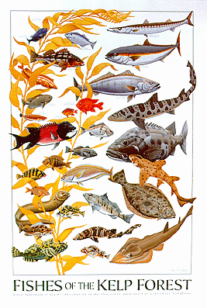
Matsu

Contacts:
Robert Burhans Ph: (858)774-2806 email: rburhans1@aol.com
Matsucollections@aol.com

Public Aquarium
California Specimen List
Marine Aquaria Receiver’s Permit, Lis.84977

Algae
*Special order specimens are those which are infrequently encountered or pose specific collecting challenges.
Photo | Common Name  Latin Name | Comments* | Size & Distribution | US$
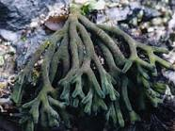 | Green Algae  Dead Man’s Fingers  Codium fragile | Dichotomous branched cylindrical branches arising from a broad spongy basal disk (delicate) | To: (40cm)  Sitka Alaska to Baja California | Small $20.00
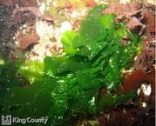 | Green Algae  Ulva spp. | Found mostly in mid to low intertidal.  No holdfasts, will need to float to release spores. | Alaska to Mexico | 10.00/ 1/2Lb.
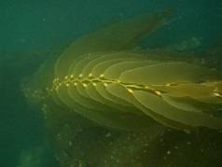 | Brown Algae  Giant Kelp  Macrocystis pyrifera | A huge kelp that grows up to 50 M is one of the largest alga. Numerous stipes with blades. | To 10 M  Alaska to Baja California | 6-12” $25.00
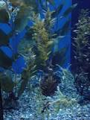 | Brown Algae  Wireweed  Sargassum muticum | Small holdfast branches repeatedly and alternates to a wiry thallus. Each branch bears small elongated blades. | To: 2M tall  Prince of Wales Island, Alaska to Baja California | 6-12” $15.00
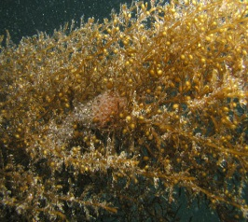 | Brown Algae  Bladder Chain Kelp  Cystoseira osmundacea | Disc shaped holdfast gives rise to a woody stipe. Flattened pinnate branches arise off the stipe, bearing small blades | To: 8m  Seaside, Oregon to Baja California | 6-12” $20.00
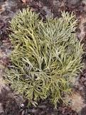 | Brown Algae  Silvetia compressa | Brown Algae  High intertidal (exposed) | To 15Cm  Shelter Cove, California to Baja California, Mexico | 15.00
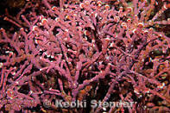 | Brown Algae  Bossiella spp. | Low intertidal, subtidal on rocks | To 20 Cm tall  Bering Sea, Alaska to Baja California, Mexico | 10.00  Ask for  bulk rate
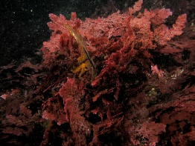 | Red Algae  Plocamium cartilagineum | Pinkish-red to rose-red.  Spread out looks like branching of a tree. | To: 25cm tall  Alaska to Baja | Clump $15.00
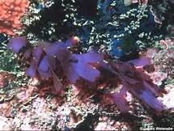 | Rhodymenia pacifica | Deep rose-red blades | To: 15cm tall  British Columbia to Baja California | $15.00
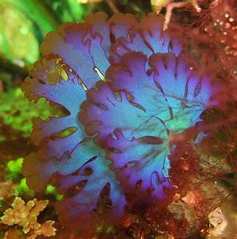 | Fauchea lacianata | Clusters of fan-shaped blades | To: 12cm high  Alaska to Baja | $15.00
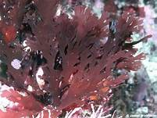 | Calliophylllis flabellulata | Flattened rose to orange-red, thin blades | To: 10cm tall  Alaska to Baja | $15.00
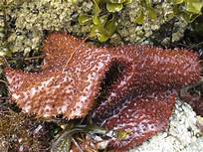 | Turkish Washcloth  Mastocarpus papillatus | Covered with knobby pumps (called papillae) | T0: 5-7cm wide  Alaska to Baja | 15.00

