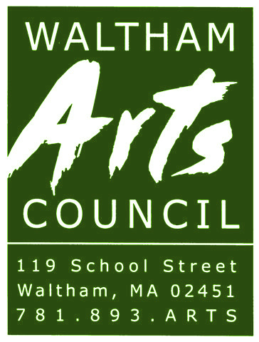

2021 Membership Application

New Membership Renewal Membership

Everett W. Erwin, Jr.
President
781-893-2787
info@walthamarts.org
www.walthamarts.org

Name:

Address:

City: State: Zip:

Phone:

Email:
Please include an email for membership updates and events ONLY. This list will not be made public.

Please check one:

□ Family $20 □ Supporter $25 □
□ Student/Senior $10 □ Patron $50 □
□ Individual $15 □ Donor $100 □

Please make all checks payable to the Waltham Arts Council.
Associate $250
Sponsor $500
Benefactor $1,000

The Waltham Arts Council is a nonprofit organization, and your membership dues are tax deductible.
Thank you.

The Waltham Arts Council was incorporated as a 501(c)(3), federally tax-exempt,

non-profit organization with by-laws showing the purpose of the council to be:
- To serve as a coordinating center for the various art programs and groups in the
community of Waltham.
- To Sponsor and exercise the development of active art programs and groups in the
community.
c) To encourage citizen's participation in and appreciation of the arts.
d) To raise and collect funds in order to provide the above services.

