RECITAL TSHIRT Order Form
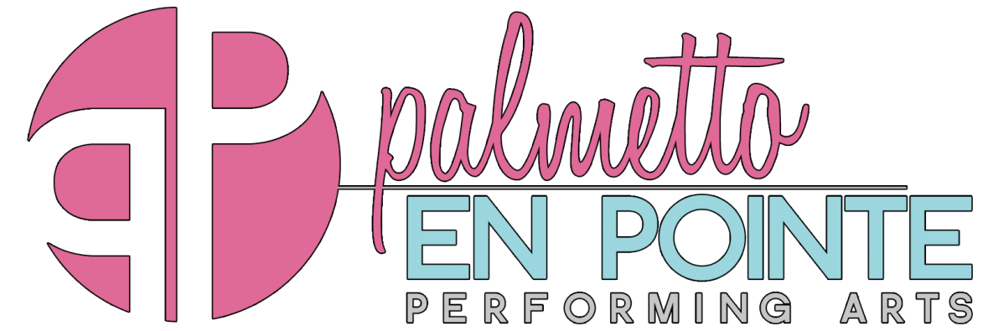
Recital T-shirt orders due by Thursday, May 10th at 7:30 PM
*Cash (exact change only), check or credit cards accepted
Youth sizes $15 (YS, YM, YL)
Adult Sizes $18 (AS, AM, AL)
$20 (AXL, AXXL)

Palmetto En Pointe RECITAL TSHIRT ORDER FORM

Date: ______________________

Student Name:____________________________________________

Please indicate quantity to the left of the size if ordering more than one shirt

Child Sizes: ___________YS ___________YM___________YL ($15)

Adult Sizes: ___________AS___________AM___________AL ($18)

___________XL___________XXL ($20)

**Shirts are ordered when full payment is received. PRE-ORDER ONLY.
Payment Method: _______________________________
Date: ________________________________________
Received By: __________________________________

*Shirts are one color (not white) with multi-color ink.

