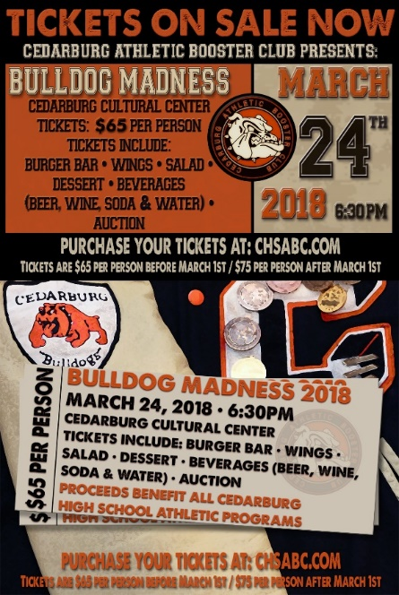
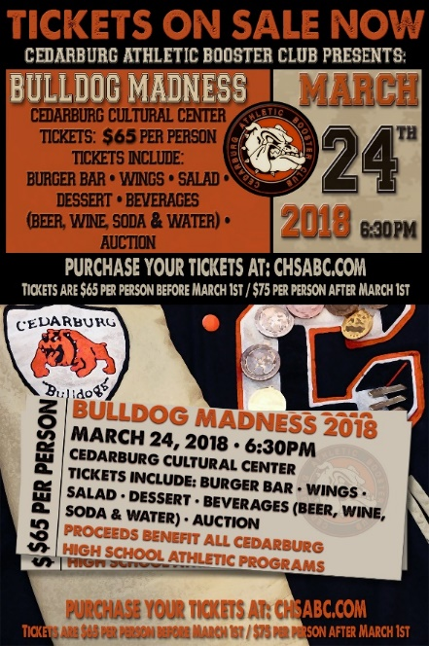
Cedarburg Athletic
Booster Club
Bulldog Madness Sponsorship Opportunities

Sponsorship  Levels Available | Title Sponsor | Dinner Sponsor | Cocktail Sponsor | VIP Sponsor | Friend of CABC
Cost | $3,000 | $1,500 | $1,500 | $500 | 100
Number of sponsorships available | 1 | 2 | 2 | unlimited | unlimited
Recognized as the Title Sponsor on all event related materials
Opportunity to distribute branded items and information at event
Name and logo prominently displayed on event promotional materials
Recognition on the CHS Athletic website
Recognition signage at event dining tables
Recognition signage at event beverage areas
Name and logo displayed on event promotional materials
Recognition on the Booster Club website
Recognition in the Booster Club newsletter
Sponsorship Level Recognition in event program
Complimentary Event Tickets available | 12 | 6 | 6 | 2 | 0

Sponsor Name: Contact Person:
Address: City State Zip
Email address: Phone number:
Sponsorship Level Requested:
Sponsors: Please send this form and your check by February 12, 2018 to:
Cedarburg Athletic Booster Club
P.O. Box 366
Cedarburg, WI 53012
Checks are payable to "Cedarburg Athletic Booster Club" or "CABC"
Title ($3,000) $
Dinner ($1,500) $
Cocktail ($1,500) $
VIP ($500) $
Friend of CABC ($100) $
Total Enclosed: $

