The No-Waste Flying Geese Method

No fabric is wasted and this method yields a total of four Flying Geese!

Begin with one large square for the “geese” and four smaller squares for the sky. Draw a diagonal line on the wrong side of all four “sky” squares.

Place two squares’ right sides together on top of the larger blue square. The smaller squares will overlap a bit and the drawn diagonal lines will act as one.

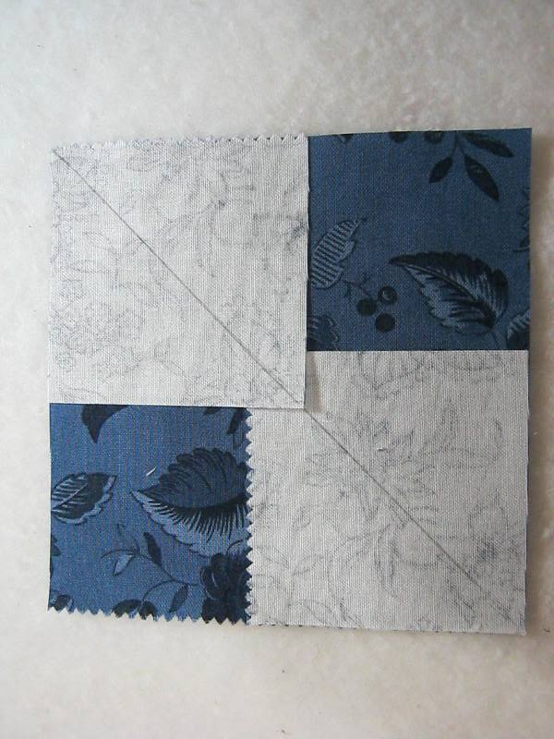

Stitch a ¼” seam on both sides of the drawn line

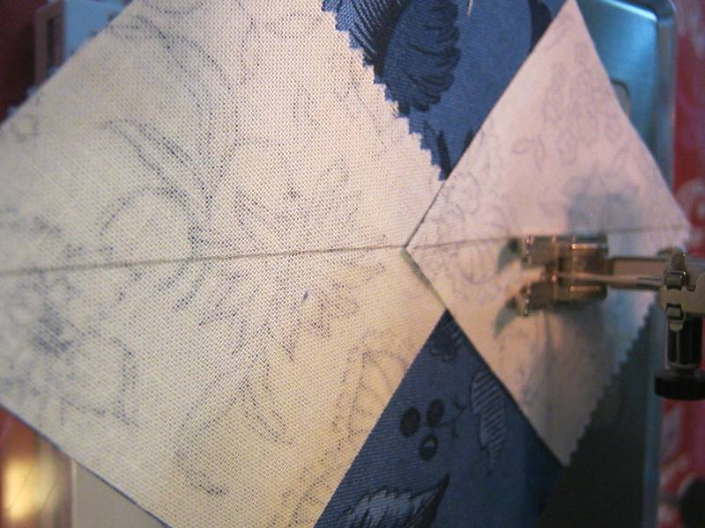

Cut the section apart using the drawn line as your guide.

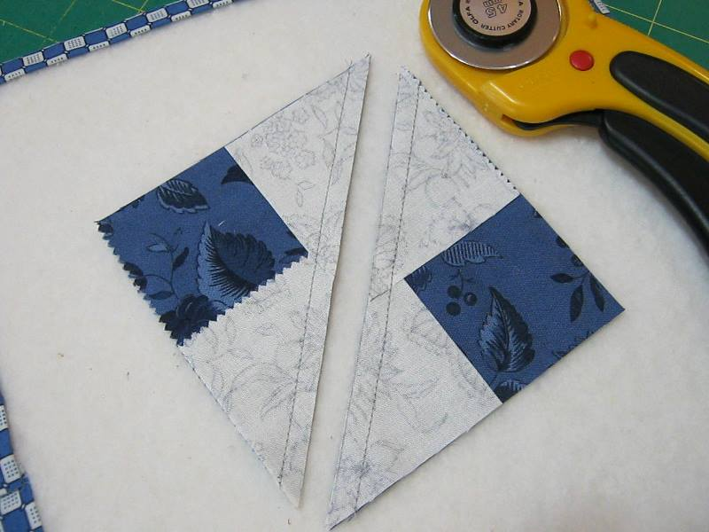

Press the “sky” fabric up. There will be two units that look like this.

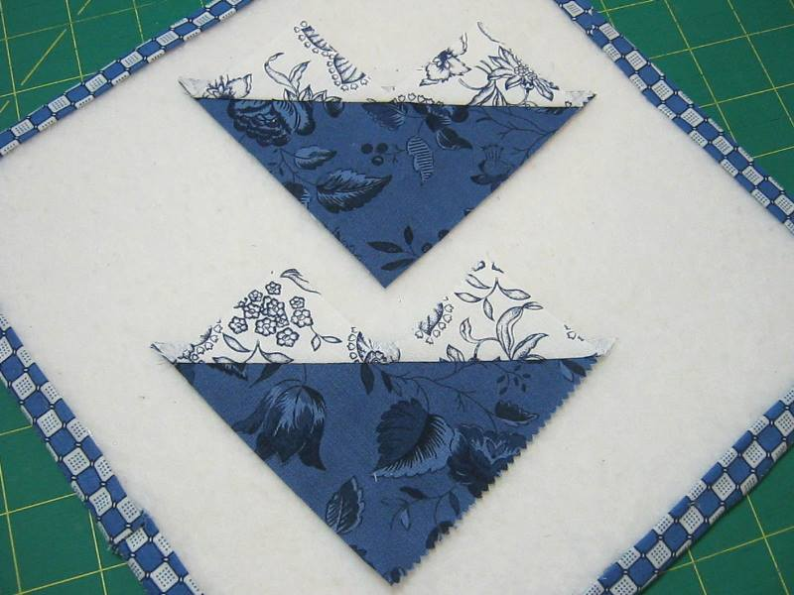

Place the remaining squares on top of each unit as shown below.

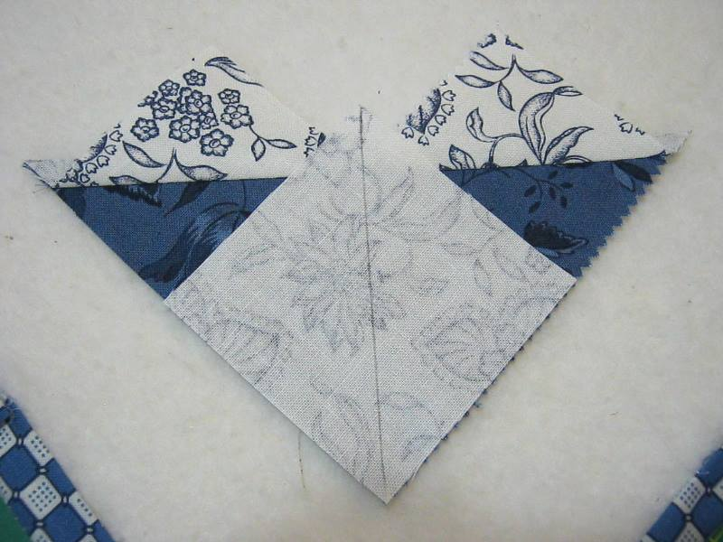7.

Stitch a ¼” on both sides of the diagonal line, cut apart on the drawn line and press.

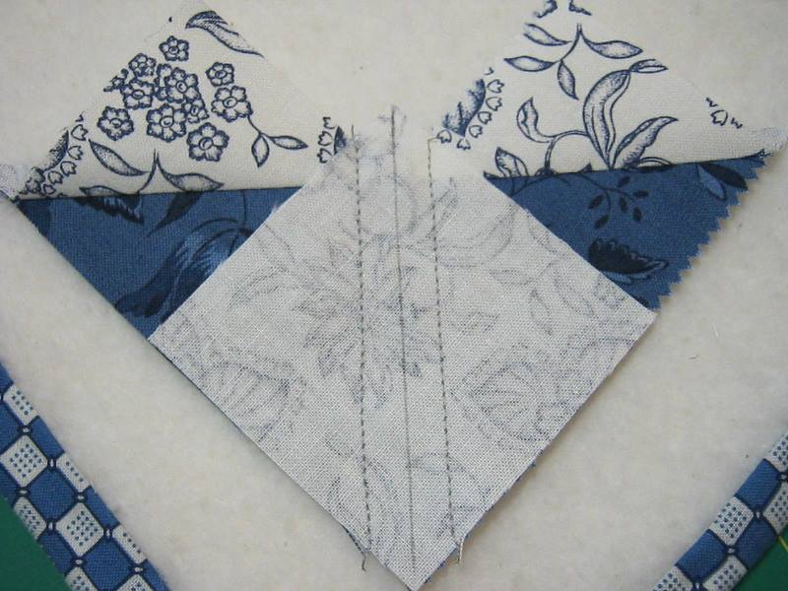

Below are four completed Flying Geese made using the no-waste method.

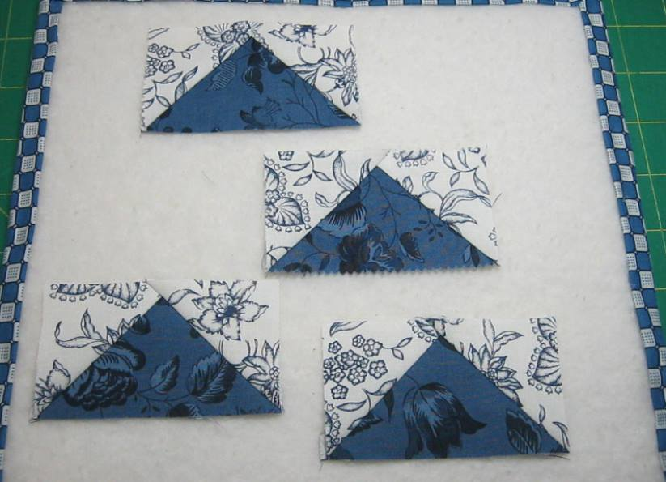

Here’s a look at a completed block taken from the Farmer’s Wife Quilt Revival. This block called Buzzard’s Roost uses both the corner triangle and the no-waste Flying Geese methods.

