How do I… submit a time away from work request?

You can access your leave information by selecting the “Work” option, then the “Time Away List” on the menu panel.
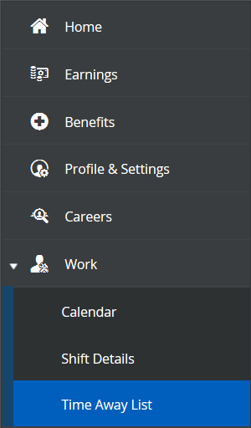
To request time off, click “Request New Time Off” at the top left of the screen.
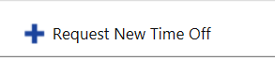

You will then be prompted to select a reason, start/end dates, and the type of request for your leave. Your real-time balances can be viewed on the right.
If needed, you may enter any comments pertaining to your leave that your manager will receive.

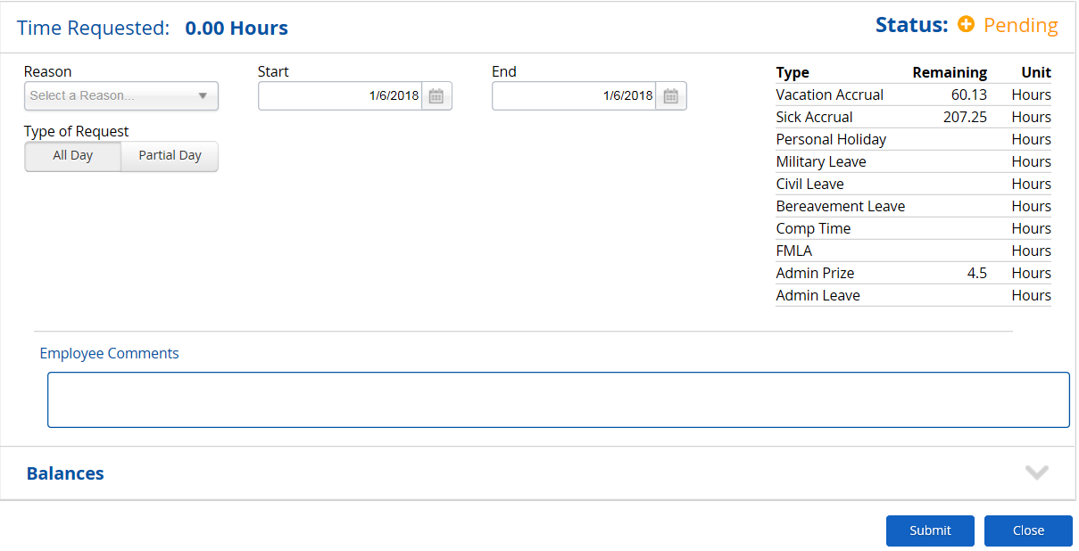

Click “Submit”
Note: Any employee with an open schedule (12am-11:59pm) must submit their Type of Request as a partial day, even if the leave is for a full day. Then manually enter the start and end times.
