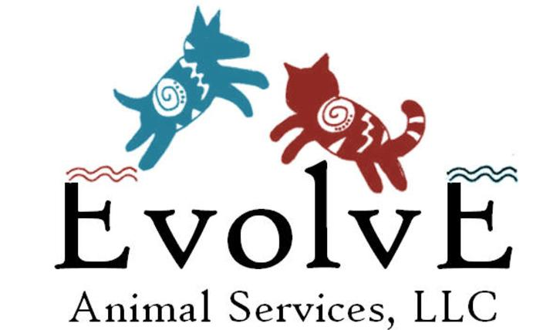
Intake Form

Evolve Animal Services, LLC
402-670-0064
evolveanimalservices@yahoo.com

*This form is fillable so click on the gray boxes to fill in your information*

Owner Contact Information:
Name:
Address:
Email:
Phone:

Pet Information:
Species: Dog: Cat: Other (specify):

Name:
Breed:
Age:
Sex:
Weight (pounds):
Do you consider your pet’s current weight to be:
About right:
Too light: By how many pounds:
Too heavy: By how many pounds:

Diet Information and Objectives:

1. Your request is for: Raw diet Cooked diet Commercial option
Don’t know, whatever is best for my pet

2. Is this diet requested to help manage an existing medical condition such as kidney or liver disease?
Yes No, my pet is healthy

3. If you selected “yes” to question 2 above, please provide me a brief history about the condition, including when it began:

4. If you selected “yes” to question 2 above, please provide contact information for your pet’s primary care veterinarian or referring veterinarian (name, clinic, phone or email):

5. Do you have recent blood work? Yes No
(please include it with this form as an email attachment)

6. Please describe your pet’s current diet, including all supplements (please be specific):

7. How much do you feed your pet daily of the diet you described in 6 (if possible use weights)?

8. What medications is your pet currently taking?

9. Please list any known foods your pet CANNOT tolerate in a diet:

10. Is there anything else about your pet or your situation that you feel will help me understand your case?

Please note that every diet I formulate is specific to your pet and your situation; therefore, reports cannot be generated in short periods of time. In most cases, due to my case load and responsibility at Iowa State University, there is a typical 2-week wait but sometimes can be a bit shorter or longer. Every diet is handled strictly by myself, I do not have staff that formulate for me so you are assured your pet will receive a diet that I would feed my own. Formulating something to work for you, your pet and your household is my objective and I never formulate a diet I would not feed my beloved “kids”.

All of my diet reports include 90 days of follow up so we can make necessary changes over time if needed as your pet’s condition changes.

Clinical diet formulations including 90 days of follow up = $150.00
Raw/cooked diet formulations (not clinical) including 90 days of follow up = $100.00
Evaluation of your current diet with suggested changes = $75.00
Phone consults/questions = $50.00

You will be invoiced when I send your report. Please indicate if you prefer to send me a check or use a credit card via Paypal.
Check (made to Evolve Animal Services): Paypal:

Thank you and I look forward to working with you and getting your pet on a stronger plane of nutrition.

Cheryl L. Morris, PhD
Owner, Evolve Animal Services, LLC

