RSAI District Meeting Minutes
RSAI NW District 3-year term expires Sept. 2020
Bob Olson
RSAI SE District 3-year term expires Sept. 2020
RSAI SW District 3-year term expires Sept. 2019
RSAI NE District 3-year term expires Sept. 2021
One At-large position expires Sept 2019 (Dennis McClain, Clay Central Everly CSD)

Northwest Region

Humboldt CSD Central Office
23 3rd Street, Dakota City
June 7, 2019 – 1 pm

Attendees:
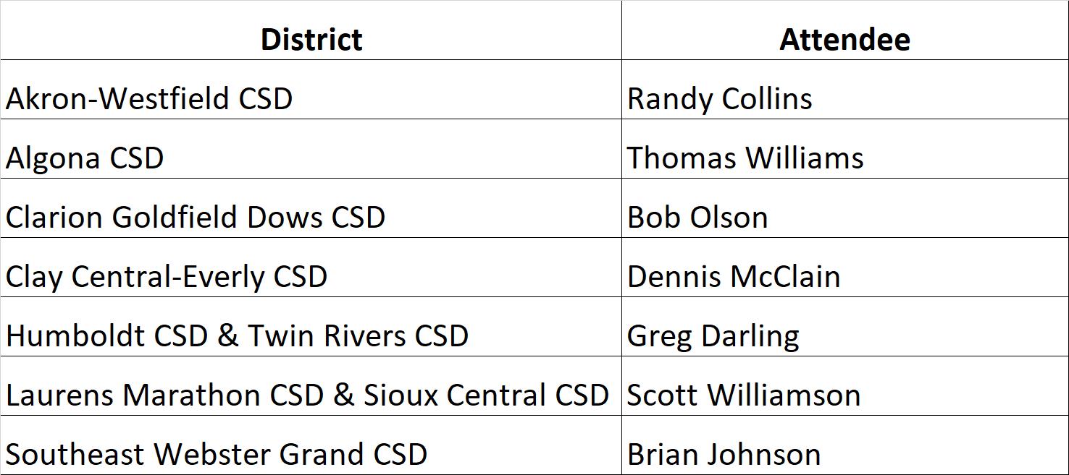
Bob Olson, Clarion Goldfield Dows CSD, convened the meeting at 1:00 pm.
- Approval of Agenda:
Dennis McClain, Clay Central-Everly CSD, moved approval of the agenda. Brian Johnson, SE Webster Grand CSD seconded. The vote was unanimously approved.
- Election of RSAI District Representative to the Leadership Group. Terms are specified in bylaws. Ongoing office is a 3-year term. No election this year.
- Election of RSAI District Liaison representing District NW to the RSAI Legislative Group (Annual Election). Thanks to Dan Frazier, Supt., Belmond-Klemme CSD, for serving in 2018-19! Rep. attends Legislative Group meeting in Des Moines at ISFIS, Aug. 9, 2019, and supports legislative advocacy during the 2020 Session.
  - Nominations:
Scott Williamson, Laurens-Marathon CSD & Sioux Central CSD, was nominated
  - by Brian Johnson, SE Webster Grand CSD. Dennis McClain, Clay Central Everly CSD seconded the nomination. There were no other nominations.
  - Election: The vote was unanimously approved.
- Consideration of Proposed Amendments to RSAI Bylaws if any (Requires 2/3 majority)
There were no amendments to the bylaws proposed.
- Review of the 2019 Legislative Session and Data Supporting Key Issues Critical to RSAI member districts: Margaret Buckton, ISFIS, reviewed the legislative action of the 2019 Session on RSAI priorities from pages 4-5 of the RSAI Legislative Digest and answered questions about RSAI Priorities and other legislative action. Questions: Concerns about transportation report now that it’s high stakes (need to show rout, activity, etc., will it increase reporting requirements or oversight?) Offer and Teach – didn’t allow early-bird physics since it wasn’t offered during the school day – how does this jive with online learning on the student’s own time? How far in advance can a district vote on WGS/reorg?
- Establish RSAI District legislative priorities for the upcoming Iowa Legislative Session to forward to the RSAI Legislative Group (Requires simple majority vote of member districts present)
- Remove – 1 cent sales tax
- Continue transportation (keep effort there until average is reached) and formula equity
- Teacher Shortage and quality instruction amend to eliminate #4 praxis and replace with 4) elimination of licensure requirements that are difficult and restrictive, such as creation of a special education generalist certification for PK-12. Educator shortage is #1 priority.
- Put MH and at-risk together as #2 priority – consider ability to request spending authority for fees waived due to FRPL participation.
- Add new – home schooling oversight and accountability
- SSA still a priority
- Move sharing incentives to bottom of the list, but keep it there so people still talk about it.
- School Safety – eliminate #1 state penny reference but keep #2 there.
- Quality PK – keep it there.

- Any other business
Discussion of eligibility criteria for athletic classification. Weighting poverty, winning %, open enrollment, tons of studies of impact, parochial/private school inequities have an impact, small rural with no big city by them.
Also discussed transportation rules, hours & days will be a problem – fewer days of instruction equals inequity for students, lengthens the summer slide, etc.
- Adjourn:
Brian Johnson, SE Webster Grand CSD, motioned for adjournment. Dennis McClain seconded. Vote was unanimously approved and the meeting adjourned at 2:58 pm.

Save the date: 2019 RSAI Annual Meeting
Oct. 16, 2019 4:30-7:30PM (includes working dinner)
FFA Enrichment Center (DMACC Campus)
1055 SW Prairie Trail Parkway, Ankeny, Iowa 50023
Conduct annual business, set Legislative Priorities, and plan for successful advocacy

