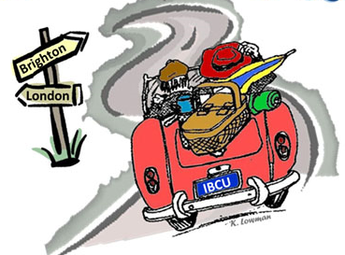
INDIANA BRITISH CAR UNION PRESENTS
2018 LONDON to BRIGHTON RUN
SATURDAY, JULY 14, 2018
On November 14, 1896, the first London to Brighton Run was held in England to celebrate raising the speed limit from 4 to 14 mph. IBCU celebrates the 122nd anniversary of this event with its annual rally/tour across Indiana, for all British cars.

Turn this page over for a special added event!
The Rally:
Participants will enjoy an approximate 110 mile drive along some interesting roads in central Indiana, answering challenging questions and taking photos along the way. Trophy plaques will be awarded to the top ten finishers.
Start:
The run will start at the Moral Township Community Center (next to the fire station), 8333 Frontage Road, Fairland, IN 46126 (Exit 103 off I-74 south of Indy). Breakfast (included in the registration!) will be served starting around 8am, with driver’s meeting at 9am and first car off at 9:30am.
End:
TBD….Please check back soon! Expect to arrive around 2pm for early dinner/late lunch (not included in registration).
Cost:
Early Bird (received by June 17th) - $15 per car (lunch is on your own)
Regular (received after June 17th and day of run) - $25 per car (lunch is on your own)
To register for the event, complete the form below and send with registration fee (payable to IBCU) to:
Greg and Susan Albers
P.O. Box 466
Zionsville, IN 46077

Driver Name: ____________________Navigator Name:
Address: ________________________________________________________
City, State, Zip: ___________________________________________________
Phone: ________________________ Email: __________________________
Car Make and Model: ______________________________________________
For more information or questions, contact Brian Henry @ (317) 522-8260 or brian.scott.henry@gmail.com

