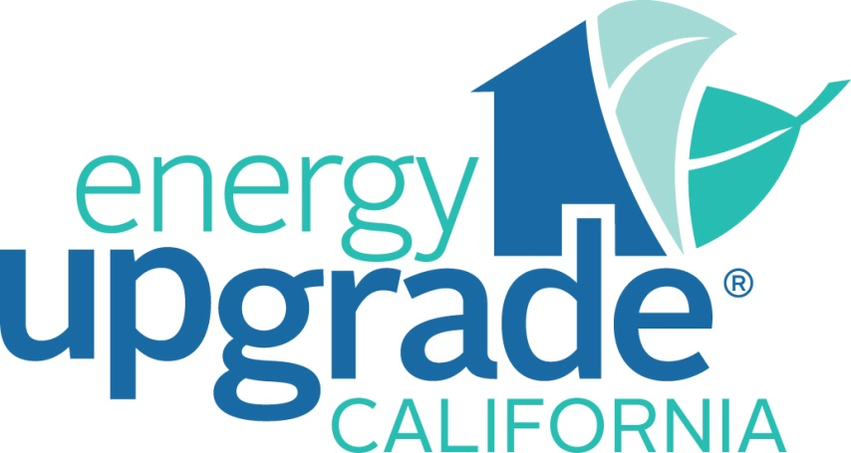

Energy Upgrade California® is a state initiative to help Californians take action to save energy and conserve natural resources, help reduce demand on the electricity grid, and make informed energy management choices at home and at work. The initiative comes as part of the Governor’s plan to lower California’s carbon emissions and raise the amount of electricity generated from renewable sources.
Please join us June 13th at the Lakewood Center Mall where your local community ambassador ACCES (Association of California Community & Energy Services) will explain how Energy Upgrade California® is your one-stop shop for tools, programs, information and rebates that can be used to make your homes and/or small business more comfortable while saving energy and money.
Two presentations will be provided at 11 a.m. and 1 p.m.
For more information about the Energy Upgrade CA initiative please visit www.EnergyUpgradeCA.org.
Association of California Community & Energy Services (ACCES) is a non-profit statewide association. ACCES provides a comprehensive network of public and private program operators, state agencies, and investor owned and municipal utilities with information to facilitate better operation and coordination of energy programs for the low-income communities of California. Our members provide energy services that include: Home Energy Assistance Programs, Weatherization, and Solar. To find out more visit us at www.acces.us.

