PUBLIC HEARING/REGULAR MEETING
SEPTEMBER 17, 2014

A Public Hearing and the Regular Meeting of the Town Board of the Town of Hampton, County of Washington and the State of New York was held at the Town Hall, 2629 State Route 22A, Hampton, New York on the 17th day of September, 2014.

PRESENT: David K. O’Brien----------Supervisor
Tamme Taran---------------Councilwoman-absent
David Jensen----------------Councilman-absent
Donald Sady----------------Councilman
Andrea Sweeney-----------Councilwoman
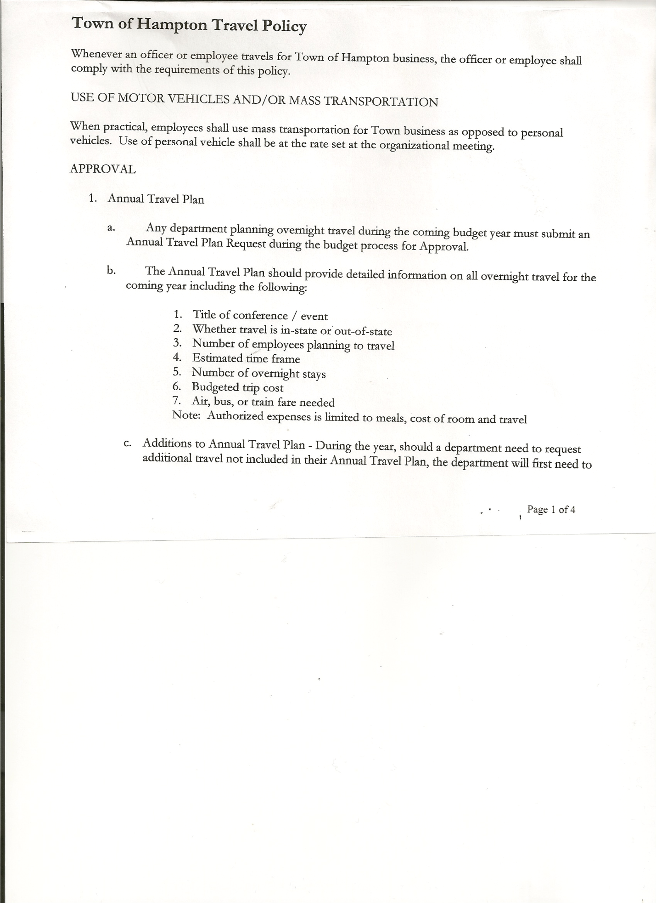
Rebecca Jones--------------Town Clerk
Camilla Shaw---------------Tax Collector/Deputy Town Clerk
Herbert Sady, Jr.------------Highway Superintendent

Planning Board Member(s): Frank Baker

Also present: See attached list

The Public Hearing was called to order by Supervisor O’Brien at 7:25pm followed by the Pledge of Allegiance. Locations of Fire Exits were given. Legal Notice of hearing was read (copy is attached). Supervisor O’Brien asked for comments on proposed Local Law No. 5 of 2014, which is to repeal Local Law No. 2 of 1989. With no one desiring to speak, Supervisor O’Brien closed the hearing at 7:26pm.

REGULAR MEETING
The Regular Meeting was called to order by Supervisor O’Brien at 7:30pm.

Supervisor O’Brien asked for a moment of silence in memory of Linda Mead.

RESOLUTION NO. 76-2014
APPROVAL OF THE MINUTES
On a motion of Councilman Sady, seconded by Councilwoman Sweeney, the following resolution was
ADOPTED: Ayes 3 O’Brien, Sady, Sweeney
Nays 0
Absent 2 Taran, Jensen
RESOLVED that the Regular Town Board Minutes for August 13th, 2014 are approved.

RESOLUTION NO. 77-2014
APPROVAL OF THE MINUTES
On a motion of Councilwoman Sweeney, seconded by Councilman Sady, the following resolution was
ADOPTED: Ayes 3 O’Brien, Sady, Sweeney
Nays 0
Absent 2 Taran, Jensen
RESOLVED that the Special Town Board Minutes for September 4th, 2014 are approved.

TOWN BOARD MEETING
SEPTEMBER 17, 2014 PAGE 2

Planning Board Report…Francis Baker, Member
- Continuing to work on mobile home campground law
- Next Planning Board Meeting will be Tuesday, September 23rd, 2014 at 7:00pm at the Town Hall

Larry Carman, Dog Control Officer submitted his report, which was read by Supervisor O’Brien…no activity… copy of report is attached for 8/12 – 9/12/2014.

Camilla Shaw,Tax Collector….no activity, zero balance.
Board Members reviewed and signed bank reconciliation statement dated August 31st, 2014.

Herbert Sady, Jr., Highway Superintendent gave his report: (a copy is attached)
- Working on dirt roads, using black road base from Hadeka Slate… Hills Pond, Hickey & Roberts Roads are done
- Cemeteries mowed, except for Warren
- Running the millings from State Rte. 22A project to Town Sand Pit, can use on dirt roads for fill. Granville is sending one truck to help in return for some of the millings.
- County to start delivering sand
- New hydraulic suction hose replaced on the loader
- Getting equipment ready for winter season
- Converted old water trailer to fit on one-ton to spray dirt roads to keep dust down.
Councilwoman Sweeney asked about raking cemeteries, Miller Cemetery in particular, and who’s John Deere mower was being used. Length of time between mowings needs to be addressed. Cemeteries should be raked if necessary. Highway Superintendent Sady will check on this and advise.

RESOLUTION NO. 78-2014
BUDGET AMENDMENT
On a motion of Councilman Sady, seconded by Councilwoman Sweeney, the following resolution was ADOPTED:
By Roll Call Vote: Supervisor O’Brien AYE
Councilman Sady AYE
Councilwoman Sweeney AYE
Councilwoman Taran Absent
Councilman Jensen Absent
RESOLVED, that the following Budget Amendment to the General Fund is approved:
Decrease Supervisor’s Personal Service A1220.1 in the amount of $778.00.
Increase Supervisor’s Contractual Expense A1220.4 in the amount of $778.00

TOWN BOARD MEETING
SEPTEMBER 17, 2014 PAGE 3

RESOLUTION NO. 79-2014
APPROVAL OF SUPERVISOR’S MONTHLY REPORT
On a motion of Councilman Sady, seconded by Councilwoman Sweeney, the following resolution was ADOPTED Ayes 3 O’Brien , Sady, Sweeney
Nays 0
Absent 2 Taran, Jensen
RESOLVED that the Supervisor’s Monthly report be accepted as submitted for AUGUST 2014.
07/31/14 08/31/14
ACCOUNT BALANCE RECEIPTS DISBURSEMENTS BALANCE
General Fund $ 70145.76 $ 1894.50 $ 6950.23 $ 65090.03
Highway Fund $ 48997.50 $ 4.01 $ 7124.24 $ 41877.27
Equipment Reserve $ 85116.86 $ 7.23 $ 0.00 $ 85124.09
Fire #1 $ 15992.50 $ 0.00 $ 0.00 $ 15992.50
Fire #2 $ 2362.00 $ 0.00 $ 0.00 $ 2362.00
Totals $ 222614.62 $ 1905.74 $ 14074.47 $ 210445.89

All Board Members present signed Supervisor’s Report.

COMMUNICATIONS RECEIVED
- Haynes House of Hope Hoe Down fundraiser is September 27th at VFW Pavilion in Granville
- Received Mortgage Tax check for $3612.97
- Reminder to register vehicles in Washington County….County receives a 12.7% retention fee for each renewal.
- Certificate of the Final State Equalization Rate for the 2014 Assessment Roll…for the Town of Hampton is 105.56
- Workers Compensation fee to be levied on 2015 taxes is $2294.00, down from 2014, which was $3617.00.
- County is working on their Budget for 2015

OLD BUSINESS:
Policies Committee….has not had a meeting yet, looking for policies from other towns and hope to have something put together by end of the year.

RESOLUTION NO. 80-2014
MOTION BY: Councilwoman Andrea Sweeney
SECONDED BY: Councilman Donald Sady

RESOLUTION AUTHORIZING THE ADOPTION OF LOCAL LAW NUMBER 5 OF 2014, A LOCAL LAW REPEALING LOCAL LAW NO. 2 OF 1989 OF THE TOWN OF HAMPTON CONCERNING AMENDING THE ORDINANCE REGULATIONS OF MOBILE HOMES AND MOBILE HOMES AND TRAILER PARKS OF THE TOWN OF HAMPTON IN THE TOWN OF HAMPTON

BE IT RESOLVED by the Town Board (the “Board”) of the Town of Hampton (the “Town”), in the County of Washington, on this 17th day of September 2014, as follows:
TOWN BOARD MEETING
SEPTEMBER 17, 2014 PAGE 4

WHEREAS, it is the intention of the Town to repeal Local Law No. 2 of 1989 of the Town of Hampton; and

WHEREAS, notice of said public hearing was duly posted and then published in the official newspaper of the Town, pursuant to and in conformance with the Municipal Home Rule Law; and

WHEREAS, said public hearing was duly held before the Town Board this 17th day of September, 2014 at 7:25 p.m. at the Offices of the Town of Hampton and all parties in attendance were permitted an opportunity to speak on behalf of or in opposition to the local law.

WHEREAS, the proposed adoption of this Local Law is an action under the New York State Environmental Quality Review Act (SEQRA). The Town Board hereby declares that this action is a Type II action pursuant to 6 NYCRR 617.5(20) and (27) and declares that the action does not have a significant impact on the environment and the action is hereby precluded from further environmental review.

NOW, THEREFORE BE IT RESOLVED by the Town Board as follows:

RESOLVED, the Town Board, upon due deliberation of the Local Law finds that the adoption of the same is in the best interests of the Town; and be it further

RESOLVED, the Local Law repealing Local Law No. 2 of 1989 of the Town of Hampton, thereby repealing the local law entitled Amending the Ordinance Regulations of Mobile homes and Mobile Homes and Trailer Parks of the Town of Hampton is hereby adopted as Local Law Number 5 of 2014, a copy of which is attached hereto and made a part hereof; and be it further

RESOLVED, pursuant to and in accordance with the Municipal Home Rule Law, the Town Clerk is hereby directed to enter this Local Law into the minutes of this meeting and file the same with the Office of the Secretary of State of the State of New York; and be it

FURTHER RESOLVED, this resolution shall take effect immediately.
DATED: September 17, 2014 Supervisor O’Brien AYE
Councilman Sady AYE
Councilwoman Sweeney AYE
Councilman Jensen Absent
Councilwoman Taran Absent

RESOLUTION NO. 81-2014
PUBLIC HEARING ON PRELIMINARY BUDGET FOR 2015
On a motion of Councilman Sady, seconded by Councilwoman Sweeney, the following resolution was ADOPTED Ayes 3 O’Brien , Sady, Sweeney
Nays 0
Absent 2 Taran, Jensen
RESOLVED, to set the Public Hearing on the Preliminary Budget for 2015 for October 15th, 2014 at 7:00pm
TOWN BOARD MEETING
SEPTEMBER 17, 2014 PAGE 5

RESOLUTION NO. 82-2014
BUDGET WORKSHOP
On a motion of Councilman Sady, seconded by Councilwoman Sweeney, the following resolution was ADOPTED Ayes 3 O’Brien , Sady, Sweeney
Nays 0
Absent 2 Taran, Jensen
RESOLVED, to set a Special Budget Workshop Meeting to be held on Thursday, September 25th, 2014 at 7:00pm

RESOLUTION NO. 83-2014
PUBLIC HEARING ON HAMPTON FIRE PROTECTION DISTRICT NUMBER 1
On a motion of Councilman Sady, seconded by Councilwoman Sweeney, the following resolution was ADOPTED Ayes 3 O’Brien , Sady, Sweeney
Nays 0
Absent 2 Taran, Jensen
RESOLVED, to set the Public Hearing to discuss the proposed contract between the Town on behalf of the Town of Hampton Fire Protection District Number 1 and the Hampton Volunteer Fire Co. for October 15th, 2014 at 6:45pm.

Still looking for someone for the Board of Assessment Review to replace David Bridges.

PUBLIC COMMENTS/COUNCIL COMMENTS
Doran Pratt…regarding wood situation…illegal to dump at Joe Williams’ residence, not designated by DEC/Mike Ritchie’s statement about Nate Saxton loading wood on Pete Hilder’s truck any consequences for that?/stated he wanted his wood back that was taken from his property/and that the six (6) month probation given to Malcolm Pratt should be dropped without a policy in place. He then handed out to Highway Superintendent and Board Members a sheet from Town Highway Superintendent Manual regarding Drug testing of employees whose job duties require a CDL (Commercial Drivers License).

Mary Holland….asked what the specific charges were against Malcolm Pratt, Hwy Superintendent Sady replied 2 counts of insubordination and personal use of town equipment…Mary responded that if there was no policy in place, there should not be a penalty/thought Malcolm should be honored for his 40 years of service to the town.

Matt Pratt…cost of civil service hearing? Supervisor O’Brien responded approximately $1000.00/ also inquired about residency policy for town employees..preference given to in town applicants?

Councilman Donald Sady commented that once policy is in place, should be reviewed annually at Organizational Meeting in January.

The Tentative Budget was presented to the Town Board.

Hampton Fire Department Contract….discussion whether the town can commit to multiple year contract or not…Justin Perry, President of Hampton Fire Department would prefer doing contract on a yearly basis.
TOWN BOARD MEETING
SEPTEMBER 17, 2014 PAGE 6

The Town Clerk’s report for August 2014 was submitted to the Board. The Town Clerk had Board Members review and sign bank reconciliation statements for the Town Clerk Account and Special Town Clerk Account dated August 31st, 2014.

RESOLUTION NO. 84 -2014

AUDIT OF CLAIMS
On a motion of Supervisor O’Brien, seconded by Councilwoman Sweeney the following resolution was ADOPTED Ayes 3 O’Brien, Sady, Sweeney
Nays 0
Absent 2 Taran, Jensen
RESOLVED that the bills have been reviewed by the Town Board and are authorized for payment in the following amounts.
General Fund No. 126 through No. 138 $ 3424.11
Highway Fund No. 96 through No. 108 $ 4227.21
Total both funds $ 7651.32

On a motion of Councilman Sady, seconded by Councilwoman Sweeney, the meeting adjourned at 9:31pm. All in favor Aye.

Respectfully submitted,

Rebecca S. Jones, RMC
Town Clerk

