REGULAR MEETING
NOVEMBER 21, 2019
A Regular Meeting of the Town Board of the Town of Hampton, County of Washington and the State of New York was held at the Town Hall, 2629 State Route 22A, Hampton, New York on the 21st day of November, 2019.

PRESENT: David K. O’Brien------------Supervisor
Tamme Taran----------------Councilwoman
Donald Sady-----------------Councilman
Andrea Sweeney------------Councilwoman - absent
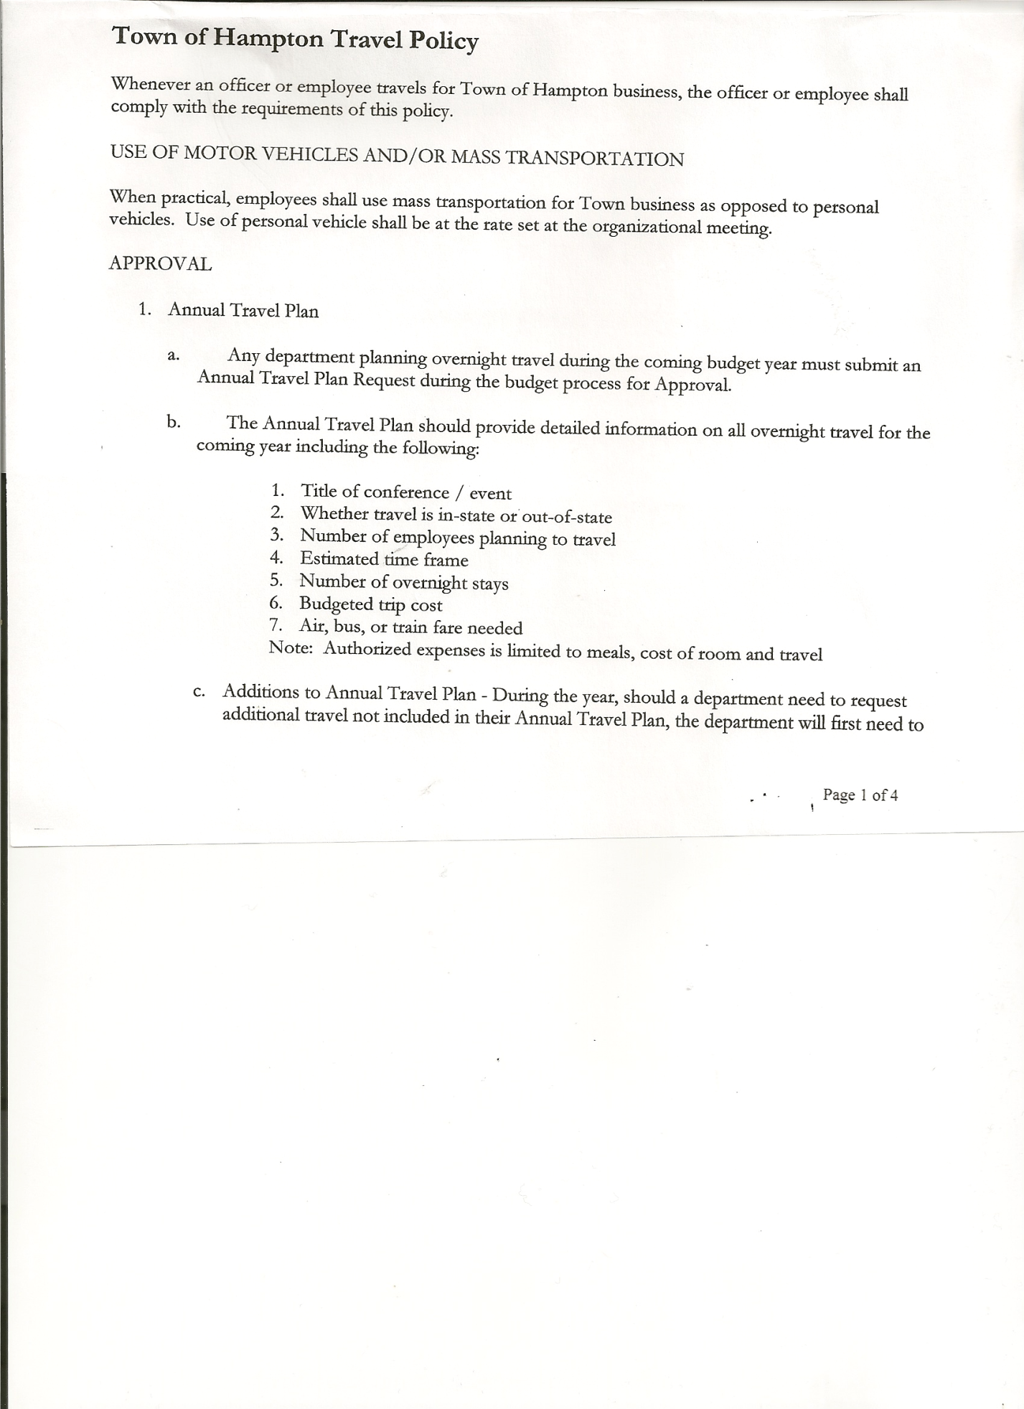
Roger Weeden---------------Councilman
Rebecca Jones---------------Town Clerk
Camilla Shaw----------------Tax Collector/Deputy Town Clerk
Herbert Sady, Jr.-------------Highway Superintendent

Planning Board Member(s): Bonnie Hawley, Chair, and Matthew Pratt

Also present: Mike Pietryka, Artie Pratt and Leonard Reed

The Regular Meeting was called to order by Supervisor O’Brien at 7:30pm, followed by the Pledge of Allegiance. Location of Fire Exits were given. Quorum of board members present.

RESOLUTION NO. 110-2019
APPROVAL OF THE MINUTES
On a motion of Councilwoman Taran, seconded by Councilman Weeden, the following resolution was ADOPTED: Ayes 4 O’Brien, Sady, Taran, Weeden
Nays 0
Absent 1 Sweeney
RESOLVED, that the Regular Town Board Minutes for October 17th, 2019 are approved.

RESOLUTION NO. 111-2019
APPROVAL OF THE MINUTES
On a motion of Councilwoman Taran, seconded by Councilman Sady, the following resolution was ADOPTED: Ayes 4 O’Brien, Sady, Taran, Weeden
Nays 0
Absent 1 Sweeney
RESOLVED, that the Special Town Board Minutes for October 31st, 2019 are approved.

Supervisor O’Brien asked for a moment of silence in memory of Audrey Vladyka and Dorothy Spilliane.

Larry Carman, Dog Control Officer submitted his report, which was read by Supervisor O’Brien, copy of report is attached for 10/15/19-11/17/19.

TOWN BOARD MEETING
NOVEMBER 21, 2019 PAGE 2

Camilla Shaw, Tax Collector - Zero balance. Submitted a Bank Statement to the Board for review and signatures.

Bonnie Hawley, Chair gave Planning Board Report…
- Continuing to work on Farm Land Ag Protection Plan. Reviewing Washington County Protection Plan.
- Next meeting will be December 11th, 2019@ 7:00pm at the Town Hall.

Herbert Sady, Jr., Highway Superintendent submitted his report, copy of which, is attached.

SUPERVISOR’S REPORT/COUNTY UPDATES/COMMUNICATIONS

RESOLUTION NO. 112-2019
APPROVAL OF SUPERVISOR’S MONTHLY REPORT
On a motion of Councilwoman Taran, seconded by Councilman Sady, the following resolution was ADOPTED: Ayes 4 O’Brien, Sady, Taran, Weeden
Nays 0
Absent 1 Sweeney
RESOLVED that, the Supervisor’s Monthly report be accepted as submitted for OCTOBER
09/30/19 10/31/19
ACCOUNT BALANCE RECEIPTS DISBURSEMENTS BALANCE
General Fund $ 51,478.93 $ 879.99 $ 5,879.67 $ 46,479.25
Highway Fund $169,677.01 $ 6.29 $ 75,460.51 $ 94,222.79
Equipment Reserve $ 29,850.65 $ 1.27 $ 0.00 $ 29,851.92
Fire #1 $ 20,808.00 $ 0.00 $ 0.00 $ 20,808.00
Fire #2 $ 3,878.00 $ 0.00 $ 0.00 $ 3,878.00
Cemetery $ 1,723.34 $ 1.12 $ 0.00 $ 1,724.46
Totals $277,415.93 $ 888.67 $ 81,340.18 $196,964.42
All Board Members present signed Supervisor’s Report.

County Budget passed….2.75% increase.
County considering going to 5 year cycle on trucks.
Mortgage Tax check received for $6659.00. Total Year To Date received $14,350.00
Court Grant approved for $4420.00, toward installing a roof over the handicap ramp.
Fire Company Grant…USDA rep was at the County, working with Fire Company for a grant.

TOWN BOARD MEETING
NOVEMBER 21, 2019 PAGE 3

Ambulance Service….CON (Certificate of Need), Cambridge and Skenesborough have this designation for Washington County. It’s a process to obtain and costly. Questions that are being looked into: Could Poultney and Fair Haven be subcontracted? Could there be a dual tone put out when there is a call for our Town?

RESOLUTION NO. 113-2019
SPECIAL MEETINGS SCHEDULED
On a motion of Councilman Sady, seconded by Councilwoman Taran, the following resolution was ADOPTED: Ayes 4 O’Brien, Sady, Taran, Weeden
Nays 0
Absent 1 Sweeney
RESOLVED, to set the End of the Year Meeting for 2019 for Monday, December 30th, 2019 at 7:00pm and to set the Organizational Meeting for 2020 for Thursday, January 2nd, 2020 at 7:00pm.

Cam Shaw let everyone know that the Hampton Little “Purple Dell” Library is set up in the entryway of the Firehouse/Post Office in memory of Larry & Millie Mashak.

The Town Clerk’s report for October 2019 was submitted to the Board. The Town Clerk had Board Members review and sign bank reconciliation statements for the Town Clerk Account and Special Clerk Account dated October 31st, 2019.

RESOLUTION NO. 114-2019

AUDIT OF CLAIMS
On a motion of Councilwoman Taran, seconded by Councilman Sady, the following resolution was ADOPTED: Ayes 4 O’Brien, Sady, Taran, Weeden
Nays 0
Absent 1 Sweeney
RESOLVED that the bills have been reviewed by the Town Board and are authorized for payment in the following amounts.
General Fund No. 142 through No. 155 $ 2,749.39
Highway Fund No. 100 through No. 116 $ 79,208.13
Total both funds $ 81,957.52

On a motion of Councilman Sady seconded by Councilwoman Taran, the meeting adjourned at 8:22pm All in favor Aye.

Respectfully submitted,

Rebecca S. Jones, RMC
Town Clerk

