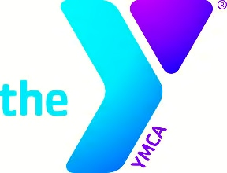The YMCA of Acadiana hosts both Before and After School Enrichment Programs Monday- Friday at your child’s school. Students receive a snack, help with homework from certified teachers as well as ULL students and participate in outdoor activities. Listed below are prices and times that each program takes place:
Before School Enrichment: After School Enrichment:
Time: One hour before school starts Time: From the time school ends until 6 p.m.
Price: $20.00 per week Price: $42.00 per week
Registration Fee: $70.00
**Financial Aid is Available upon Request**

If you are interested in having one or both of these programs at your child’s school please choose one of the options below. We thank you for your time and we look forward to being your child’s Before/After School Enrichment provider.

Before School Enrichment______ After School Enrichment_____
Before & After School Enrichment____

Please List your Child’s School:___________________________________________________

