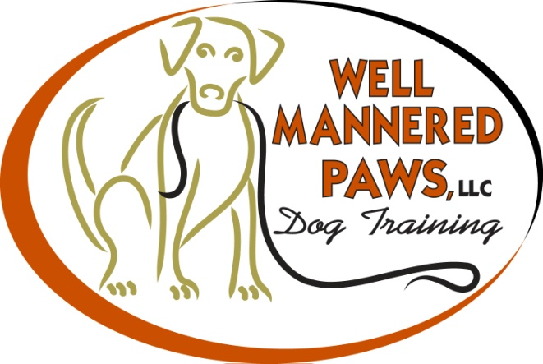

Thank you for enrolling your dog in our puppy kindergarten or basic obedience class

Here is a list of what to bring to the first class

- Completed release of liability and basic information forms (see our website www.wellmanneredpaws.com)
- A copy of immunization records
- Your puppy/dog
- 6' leash and collar
- Your pup/dog favorite treats (should be small enough to eat quickly)
- Poop bags
- Cash or check for the entire program made payable to "Well Mannered Paws"

We run a fun and informative class. If there is a specific subject you would like to discuss, please let me know.

We will be working in an outdoor fenced in area. In the event of inclement weather class will be held indoors.
If class needs to be cancelled, a call will be made to the number provided on the basic information form, no less that 1 1/2 hours prior to the start of class.
If you are unable to attend a class please contact me at 610-763-0071 as soon as possible.
See you at class!

