

March 2019

**Car Rental Reminders**

If you are going to arrive earlier or later than your reserved time, please contact dispatch so the rental agreement can be updated.

All cars must be returned within 24 hours of pickup time.

Always, always, always inspect the car prior to leaving and dropping off. Do this with the car rental agent. If there is any damage, no matter how small, make sure it is noted on the paperwork. We also suggest you take a picture of the issue as an extra layer of protection against a claim.

Fill It Up! If you choose to take the Fueling Option they charge a premium; often close to $10.00 per gallon. If you do not fill it up before returning the car, they will change this rate per gallon. This will not be covered by AAT.

Many car rental agencies may pick you up. Call ahead so they can plan their staffing.

When driving a rental car toll drivers are responsible for the tolls.

Car rental woes…A driver arrived early to pick up his car, he was told there was only a truck available. His rental went from $138 to $442. In this case the dispatcher was able to “fix” the issue but this is not always the case. AAT cannot be responsible for any up charges. Call your dispatcher!

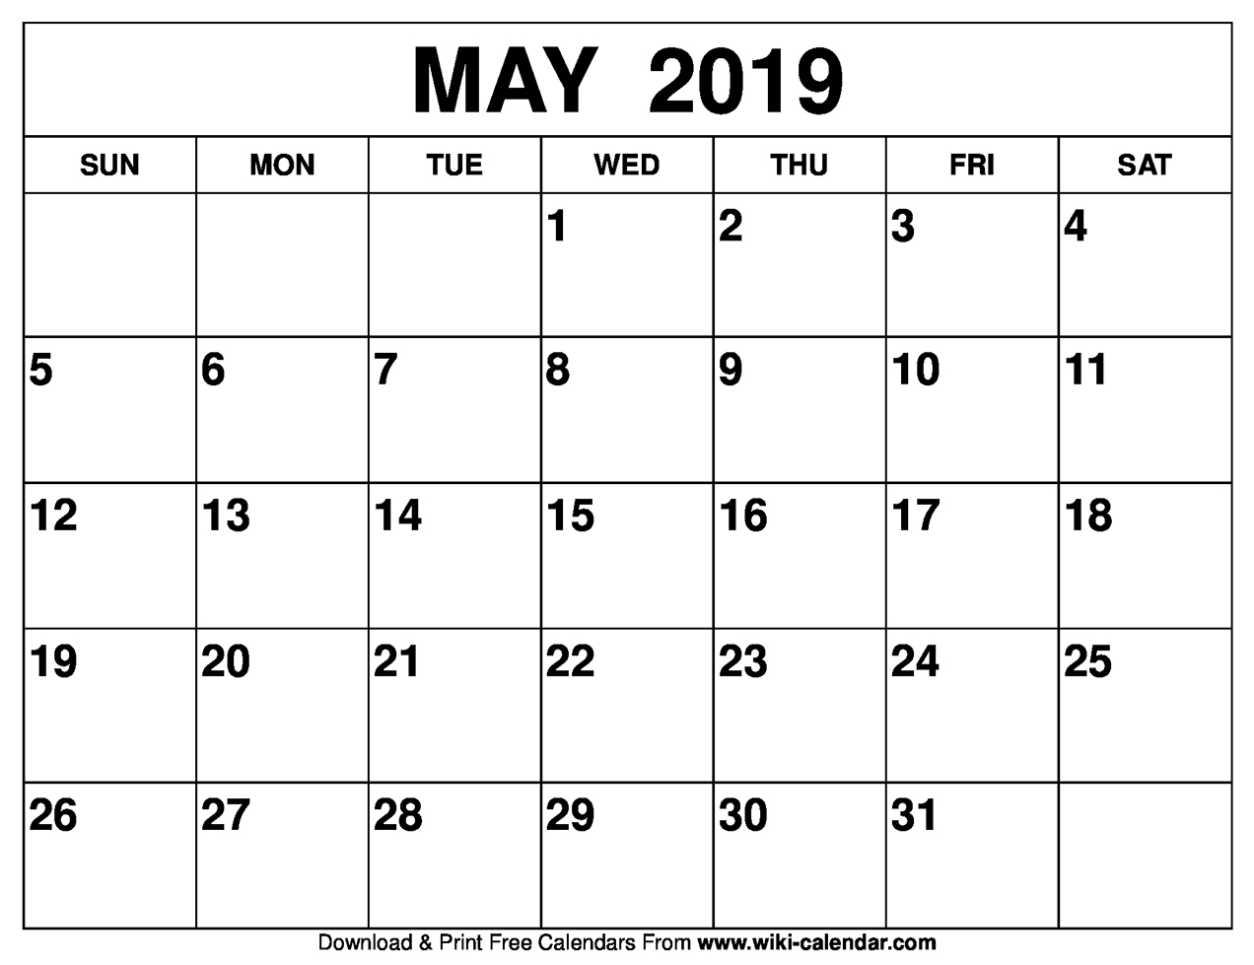

**May 4, 2019**

**Annual Drivers Meeting**

Watch for details in April newsletter.

**SAVE THE DATE!!**



**RIMS**: Check both inside and outside of the rim to make sure it is not cracked, bent or welded.

**TIRES**; Make sure there are no cuts or bubbles and that the tire is in good overall condition. Check the tire thread to make sure you have at least 4/32” on the front tires and 2/32” on the rear tires. Valve caps and stems are not missing. NO recaps on steering tires.

**HUB OIL SEAL**: Check the hub oil/grease seals along with the axle seals are not leaking.

All **LUG NUTS** must be present and securely tightened,

free of cracks and distortions.

**MUD FLAPS**—must be present and securely attached. (They cannot be attached with zip ties.)

**Pre- Trip Inspection**

***“Wheels”***





**PROPHESY**—*DO NOT DEVIATE* from the provided prophesy route unless you have spoken to your dispatcher. **NO exceptions**.

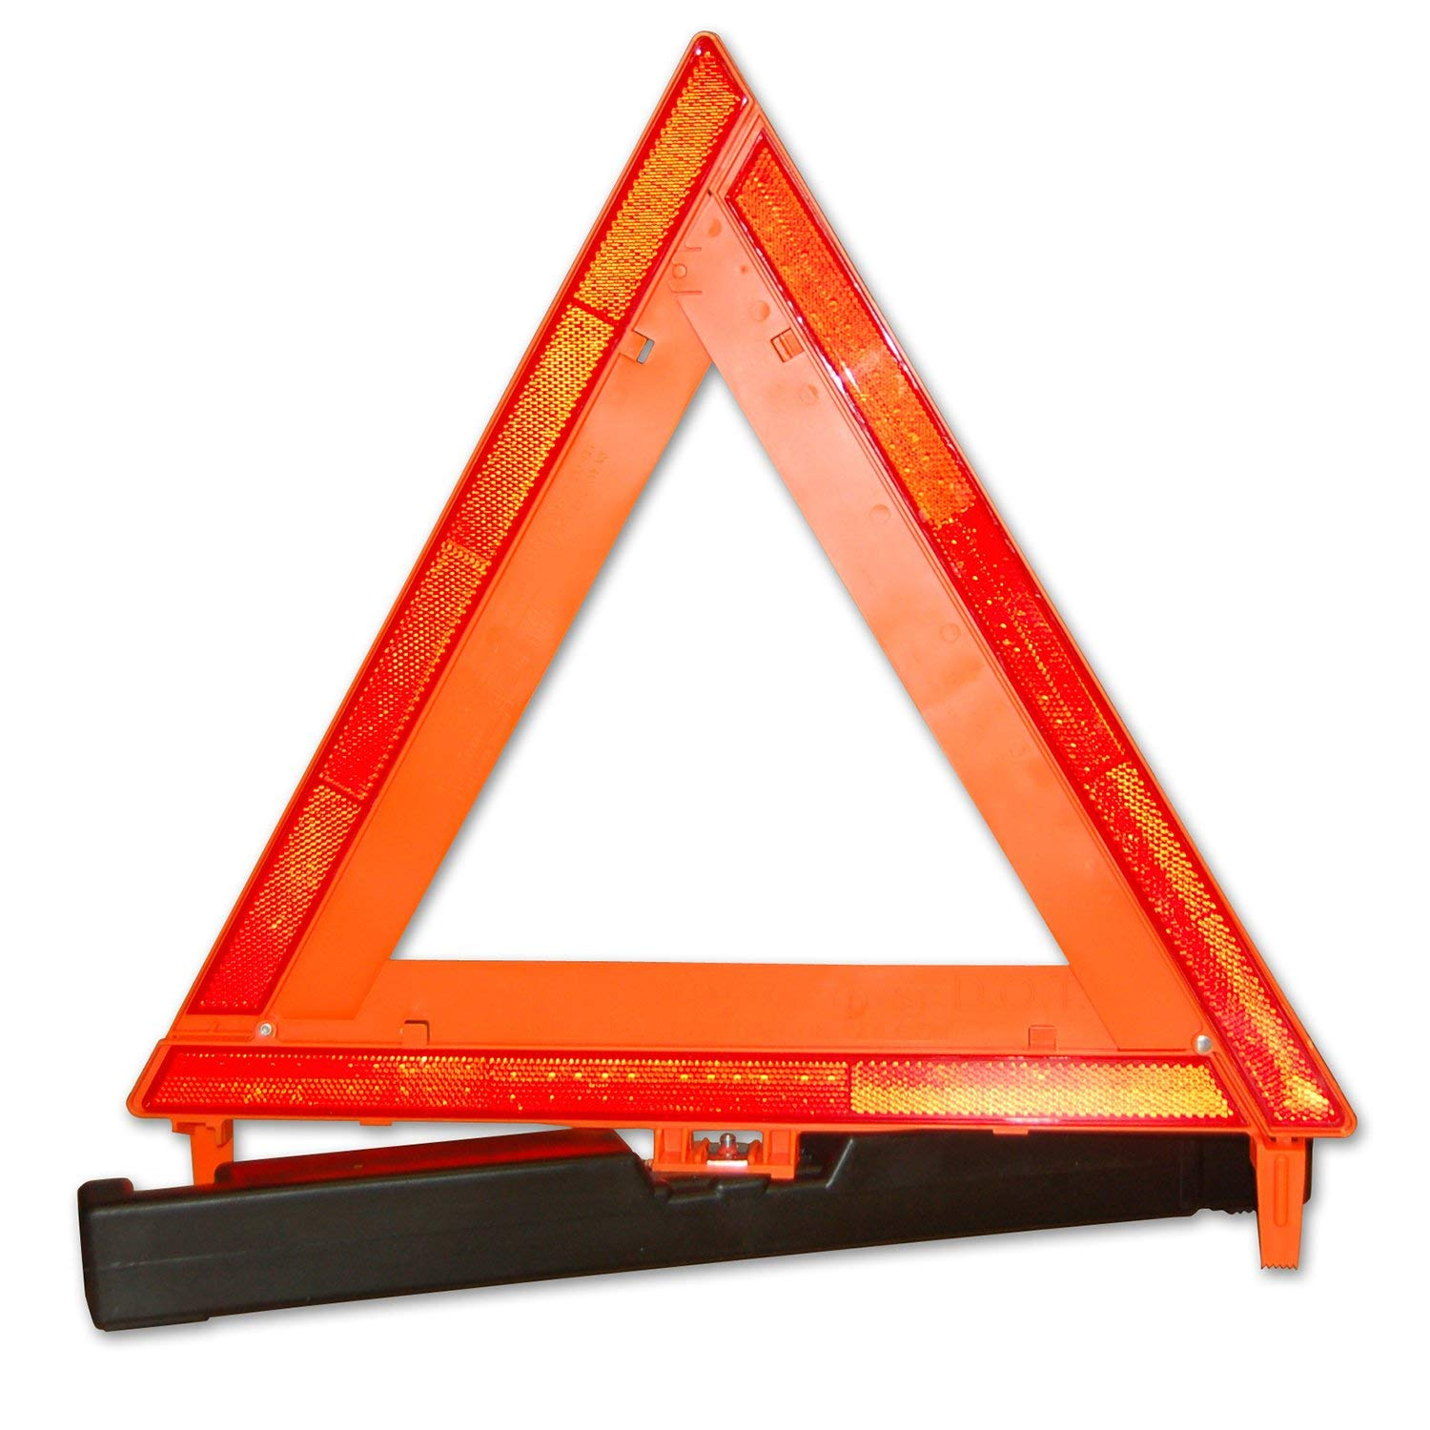

**SAFTEY VESTS** are available for all AAT contractors. If you have not received your safety vest, please see DJ.

Sometimes drivers arrive to pick up a truck and it is

in a less than desirable condition. Please

take a picture to send to dispatch and

then take a few minutes at your first

fuel stop to clean out the cab. Always

deliver with a clean cab. *Thank you.*

**TRIANGLES--** Don’t leave home without them.



**Buckle Up**

Seat belt use remains one of the cheapest, easiest, and most important means to protect commercial motor vehicle (CMV) drivers. It is also the law.

Since the inception of the FMCSA Safety Belt Usage by A Commercial Motor Vehicle Driver study in 2007, overall safety belt use for drivers has steadily increased each year from a use rate of 65% in 2007 to the current high of 86%. ***Be Safe…..Stay Buckled Up!!***

.

There are 10,000 three-leaf clovers for every four-leaf clover! The odds of finding a four leaf clover are not exaggerated. If you find one, you are truly lucky!

Enjoy March, Spring weather will be here soon.

Debra, Scott, Penney, Jackie,

DJ, Donna, Kara and Patti



Jim B., Ryan C., Dorian F., David H.,

Jim M., Allan P., Dan V. and Paul W.