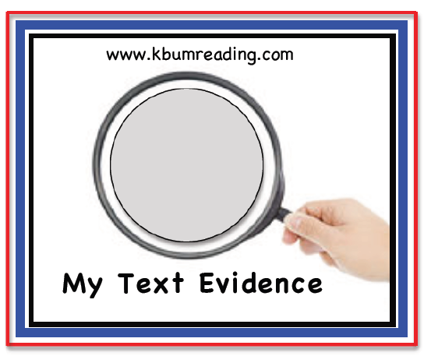

©TEXT EVIDENCE FINDERS

**My Text Evidence**

www.kbumreading.com

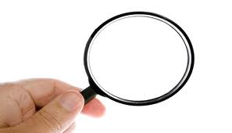

**My Text Evidence**

www.kbumreading.com



**My Text Evidence**

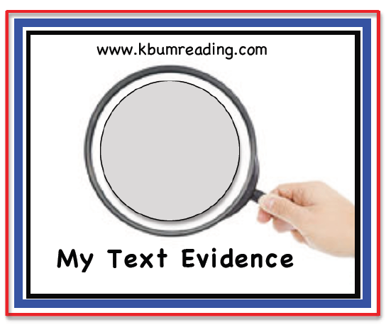

**My Text Evidence**

www.kbumreading.com

www.kbumreading.com