Along the Way: For the Birds!
Look at the birds. They don’t plant or harvest or store food in barns, for your heavenly Father feeds them. And aren’t you far more valuable to him than they are?—Matthew 6.26 (NLT)

Hooray for the birds and all they can teach us about providence and praise. Providence because as Jesus taught, they can do their part without having to worry whether God will do His. They know God can be trusted. Birds also teach us about praise because whatever the reason for their singing there is something uplifting and joyful in their melodies. A listener cannot help but want to join in.

When Granddaughter Emily and I went walking as the New Jersey Spring daily unfolded we would stop when we heard a bird sing. I would try to “answer” the bird in kind. We marveled at the variety of tunes and no matter how poor my attempts were at mimicry she would respond, “Again. Nana again!” With such an encourager how could I refuse?

Perhaps our enchantment with birdsong relates to heaven. We don’t know much about the details of heaven but we do know there will be plenty of singing. I can imagine that the sounds will be at least as varied as earthly birdsong though without any discord. Hallelujah!

This is why I praise God for ALL who contribute to the worship music at Cokesbury. Each has his or her own unique song and when blended with others we can join Emily and say, “Again!” I look forward to the growing excellence of the 9.30 Praise Team (welcome, Andre Lewis on drums), the upcoming cantata (Sunday, June 11) by the amazing choir and whatever goodness God has in store yet to be revealed. We thank God for the anonymous donor who generously paid for the repair and refurbishment of the sanctuary piano; and also for the provision of the drum shield, keyboard for the hall, and wonderful wiring work by yet others—enabling us to hear the fullness of the musical offerings. When our musicians do well let’s say, “Again! Amen!”

We are all called to sing the Lord’s song. This month try to learn one of the psalms—the prayer songs of our faith. Sing it to whatever tune God gives you knowing that you are valuable to God. Like the birds you can do your part and God will do His. You can trust God. YOU make God’s heart sing!

Blessings for the journey, Pastor CJ
Pray and participate where you can in the following ministries and opportunities for growth and service coming your way:

CHILD/YOUTH PROTECTION POLICY TRAINING:
needed by everyone working with children or youth. Next session will be SUNDAY, June 4th at 6 pm in the Library.

Vacation Bible School for Toddlers-Adults
SUNDAY - THURSDAY EVENINGS June 11-15th.
Kickoff supper of Heroes (of course!) on Sunday at 5 pm.
Program each night 6-8.30 pm.
YES: group guides for the children are still needed—volunteer today!

THANK YOU all who have sponsored needed materials for VBS. We are praying and preparing for 36 children + youth and adults. Please pray for each child to know Jesus as their HERO, Savior and Lord. Please pray for good weather, no accidents, etc.

Launch of Saturday Evening Dinner & Worship in the Round is June 17th. Weekly sharing fellowship & faith sharing over food will be led by Pastor Scott. Lauren, Shane, Peyton, & others extending warm Cokesbury hospitality to everyone in the larger community.

Willing and able to help prepare meals, spread the word, etc? Please speak to Pastor Scott. (Scott will be licensed as a Local Pastor at the Annual Conference of the Florida United Methodist Church on Saturday, 10th June, in Orlando.) THANK YOU to the anonymous sponsor who has insured his family will be able to be present!

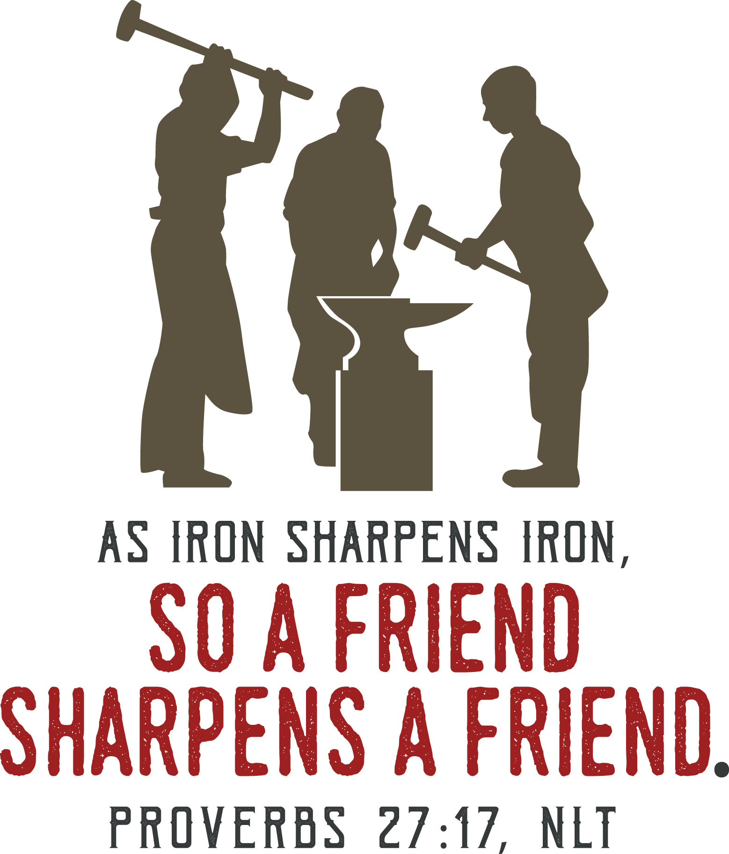

Saturday June 22nd will be the first Men’s Group Breakfast. For men of all ages and all stages of life and faith. Speak with Rev. Rich Updegraff for more information and sharing ideas. Already Pastor Rich has placed into the hands of many men a handy book called “Understanding Theology in 15 Minutes.” There are seven copies left; please see him if you would like one to read.

June 4th at 4: Next Steps with Pastor
Whether you are looking for care and support, a place to grow in your faith or an opportunity to serve the community – we want to help you find your fit and connect with others who share your interests. Want to learn more about Cokesbury? Join us for a casual gathering to explore the values and beliefs of Cokesbury and the United Methodist denomination. This is a great way to learn about different places to connect with our church family!
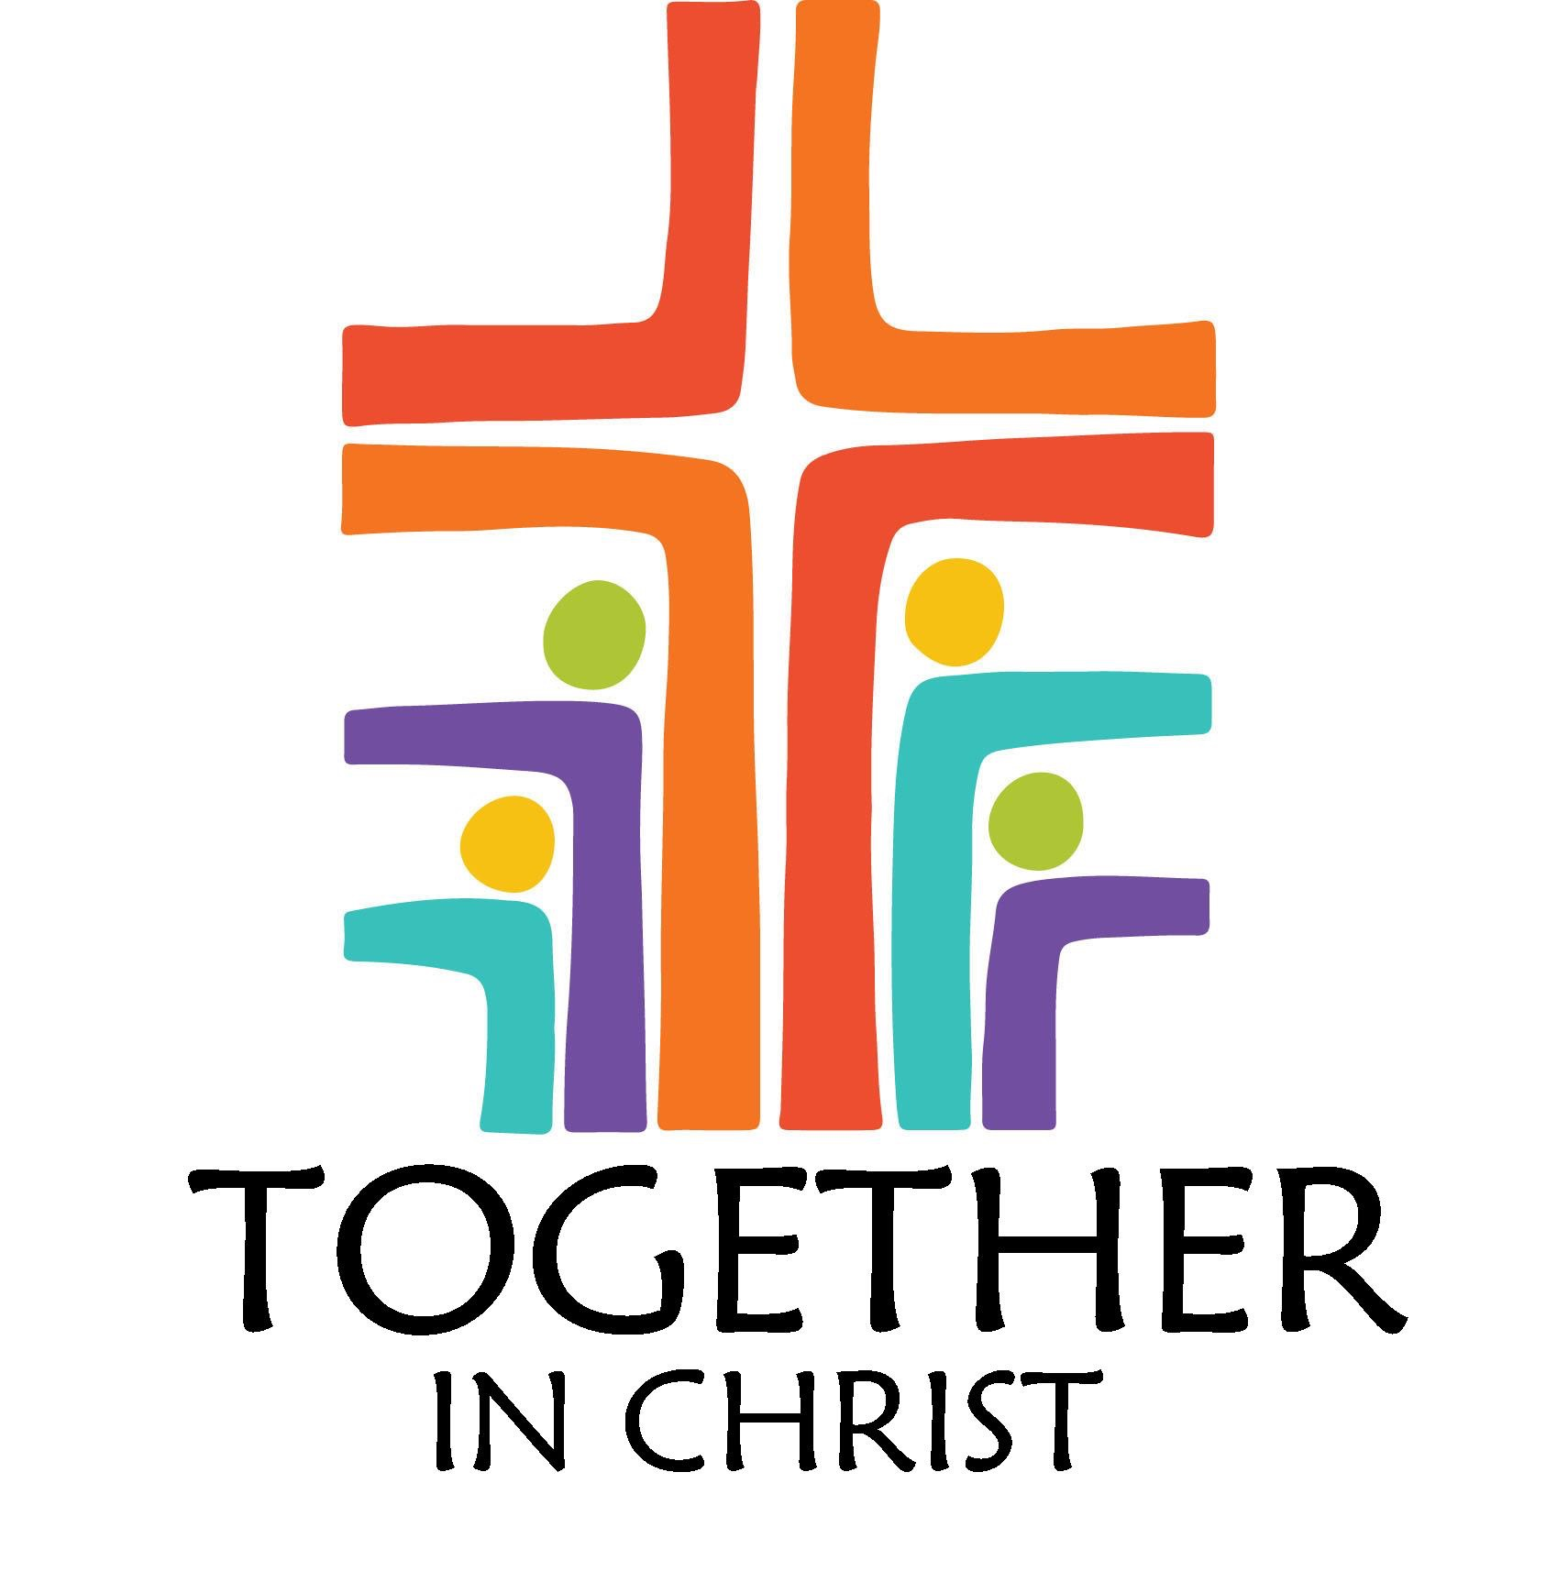
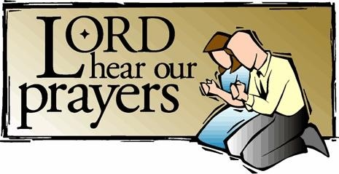
If you are considering membership at Cokesbury, the first step is to come on June 4th at 4 pm. We will gather in the Library, which is in the Church Office area. If you need child care please let us know in advance by speaking with our Church Secretary, Linda Sue, 954-972-3424. Depending on the number attending we will meet for 1-2 hours. It’s a great opportunity to get to know other and discern God’s NEXT STEP for you. ***If June 4th does NOT fit your schedule Pastor CJ is available for a personal appointment to hear your story and discern with you what God’s claim and call might be.

NEEDED: People to be the welcoming face of Cokesbury.
Many different aspects to this ministry…please speak with Pastor CJ if you are willing to serve on Sunday mornings. Thank you!

God hears and answers prayer. Each of us has the privilege and responsibility to pray for one another and ourselves. Join one of the prayer ministries today. Also know that pastors and other prayer warriors are available to pray with you and your family before surgery, or during hospitalization. Due to HIPAA regulations, hospitals do NOT call and inform us of your hospitalization. Please also pray for our church family, those serving in the military and as first responders, and those in assisted living. ALL our prayer warriors keep the concerns before the Lord in their personal prayers in addition to the methods below. Confidentiality is respected.

NOW REVIVING the PHONE PRAYER CHAIN.
Are you willing and able to receive telephone calls of urgent requests, pass on the message and pray over the concerns? We are looking for a team of eight. Please contact the Church Office and let Linda Sue know you are willing to serve in this capacity. 954.972.3424.

The email prayer link is coordinated by Joann O’Rourke. Please write her at <margateprayers@aol.com> if you would like to join the current ten members of the Prayer Link. Requests are sent to Joann at the email address and then she sends the concerns to everyone on the link.

PRAYER GROUP meets on Wednesdays at 4.30 in the sanctuary. Number of participants vary but the task is the same, to lift before God the concerns and joys written on prayer cards submitted in worship and during the week. The cards are prayed over for a month. Updates to situations are greatly appreciated!
If anyone is interested in forming a group that will meet at another time please speak to Pastor CJ. Thank you.

At Cokesbury we have used a resource called NETWORK to help people discern which spiritual gifts God has entrusted to them for the building up of His church and to His glory. While the next NETWORK seminar is tentatively scheduled for July you can get a jump start. There are several books about Spiritual Gifts in the BOWMAN LIBRARY (enter through the Church Office). Also, Pastor CJ has an assessment—taken at your own pace—that you can process. Knowing WHAT, HOW, WHERE to serve leads to both joyful and fruitful kingdom ministry that makes a difference.

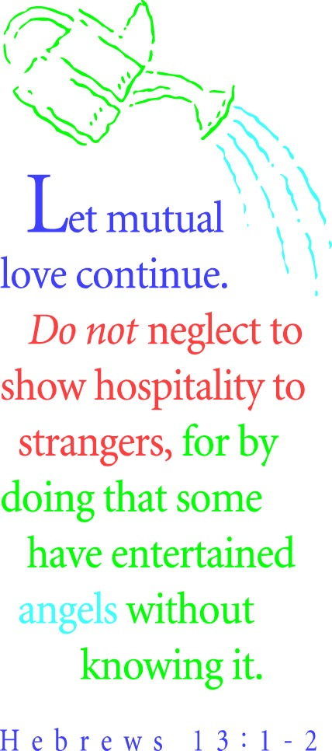
From Pastor Scott:
I was recently at South Bay Prison for Kairos Weekend #32 and many of you prayed for us, signed prayer chains, made place mats and banners and made meal donations. Thank you to everyone who supported us! It really made a huge difference! The prayer chains and banners were a huge hit! We give the 34 participants time on Saturday and Sunday night to respond to the weekend and I took notes so you could see how much your support helped and to be a part of the moment! God Bless each of you!

--“I wanted to go to Kairos for 12 years. I praise God for allowing me to finally come. This was the perfect moment for me!” (Kairos means God’s Special time)

--“I want to thank God for allowing me to see God’s love for the first time. I see the Agape (prayer chain, posters, letters) on the walls and I see real love and it makes me want to share that love on the (com-) Pound!”

--“My question was what happens when I tear down my walls. Will I be alone and defenseless? I learned this weekend that God will be there. He will get our backs!”

--“I am hard headed and I don’t believe things till I see it for myself. On Thursday I felt I had ripped open an old wound. Every hour that I am here I feel the wound healing. I have to get out on the yard and start helping others! Praise God!!”

--“I want to thank God for being here. Since I’ve come to prison I have become a man of God. By coming to Kairos it is helping us become more giving to others. The food has been so good and I am eating too much, but I am more blessed by being here and (experiencing) the love of God more.”

--“I have learned a lot these last few days. I have learned I can eat a lot of food! But, seriously I have learned I can be touched by God’s love. It’s amazing how I feel right now. I can’t even explain it. I thought I was taking advantage of the program (by coming to eat the food) but, I realized I am actually learning about God’s love.”

--“Before I came to Kairos I was going through a real tough time. I had gotten to a point where I was giving up. I came to Kairos and I know this is the turning point. God showed up for me this weekend and I feel God’s love. When I saw the volunteers eating our food on Thursday night, which is gross, I realized what real love is. God gave us love now we have to give it back. Not just for a few days but every day!”

--“I want to thank God. God has used so many tools during this Kairos it amazes me. God has used letters, posters, food, banners, prayer chains, and servants to bring us God’s love this weekend.”

--“I’m scared to talk, so if I pass out my nitro pills are in my pocket. I have never talked in public before. I just wanted to thank everyone for praying for me. I am getting better. I just wanted to thank God in public before I leave.”

--“I never heard of Kairos before coming to prison. But now these doubts are gone. God works in mysterious ways. The moment I got picked for Kairos I felt God working on my heart. I know God is using this weekend. It’s not a coincidence.”

--“I am not a Christian I am a wicken. But since I have been here I have gotten my faith for humanity restored. I learned we all need faith regardless of our religion. I believe in miracles now, because I had a life sentence, but now I have a new release date.”

--“Let me be honest, I came for the food. But, I heard you guys don’t care about that. Its ok with you as long as at least one person hears about God. Well, I heard God! I know God’s love is here and I’m going to share it!”

--“This has been a special weekend. God showed how he used people of many backgrounds to show us love through their stories.”

--“Two minutes is not enough time to tell how much love God showed us this weekend. There were many individuals that needed this weekend. They needed love and healing. I needed it because of the hope I have in Christ now. This prison makes it so hard to have hope. But seeing the volunteers show us hope from the outside, I pray this revitalizes all of us to give back what we received. I thank God for that!”

--“Thank you to God! God took my broke heart and fixed it.”

--“I hope to meet people on the outside that love us as much as you all love us!”

CALENDAR FOR SECOND HALF OF MAY and beginning of June
Other Groups Sharing the Campus:
Monday through Friday, Victory Living, 7 am- 4 pm, Rooms 2, 3, 4
Mondays, Tuesdays, Fridays, Spanish Alcoholics Anonymous, 8-10 pm, Grace’s Place (Room 4)
Monday Apr. 17 and Tuesday Apr. 25 Cub Scouts—7:00 – 8:00 pm
Wednesday and Fridays, Anglo Alcoholics Anonymous, 7-8 pm, Don Lowe Chapel
Thursdays, Spanish Al-Anon, 8-10 pm, Don Lowe Chapel
Always check with our Church Secretary about room availability before you schedule usage as there are “one-off” meetings NOT listed. Thank you.

14 9:30 & 11:00 am Worship; MOTHER’S DAY, also Sunday School & Children’s Church
9:45 am – Choir Practice – Room 7
10:30 am – Bowman Library Dedication/Reception
10:45 am – NO Adult bible Study

15 1:00 pm – Lunch Bunch – Settle Hall

16 6:00 pm – Mission & Ministry Meeting – Library

17 10:00 am – Morning Bible Study – Library
4:30 pm – Intercessors – Sanctuary
6:00 pm – Evening Bible Study – Library

18 2:15 pm – Thumbs Up – Settle Hall
7:00 pm – Digital Photo Discovery – Room 6
7:00 pm – Praise Band – Sanctuary

21 9:30 & 11:00 am Worship, with Reception into Membership also Sunday School & Children’s Church
9:45 am - Choir Practice - Room 7
10:45 am – Bible Study – Lowe Chapel

22 4:30 pm – Food Pantry – Settle Hall & Room 1
7:00 pm —SPRC—Library

24 10:00 am – Morning Bible Study – Library
4:30 pm – Intercessors – Sanctuary
6:00 pm – Evening Bible Study – Library

25 2:15 pm – Thumbs Up – Settle Hall
7:00 pm – Praise Band Practice – Sanctuary

28 9:30 & 11:00 am Worship; MEMORIAL OBSERVANCE, also Sunday School & Children’s Church
9:45 am - Choir Practice - Room 7
10:45 am – Bible Study – Lowe Chapel

29 MEMORIAL DAY – Church Office CLOSED

30 6:30 pm – Church Council Meeting – Lowe Chapel

31 10:00 am – Morning Bible Study – Library
4:30 pm – Intercessors – Sanctuary
6:00 pm – Evening Bible Study – Library
JUNE
01 2:15 pm – Thumbs Up – Settle Hall
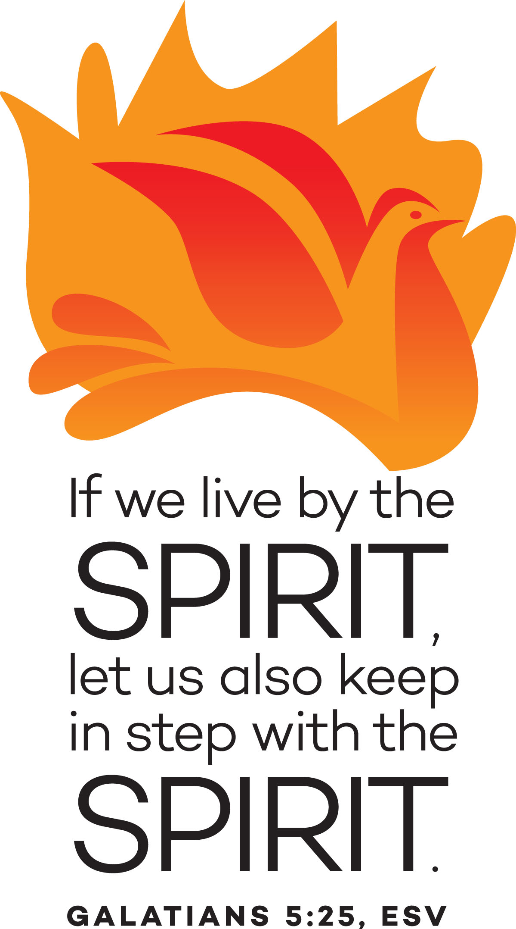
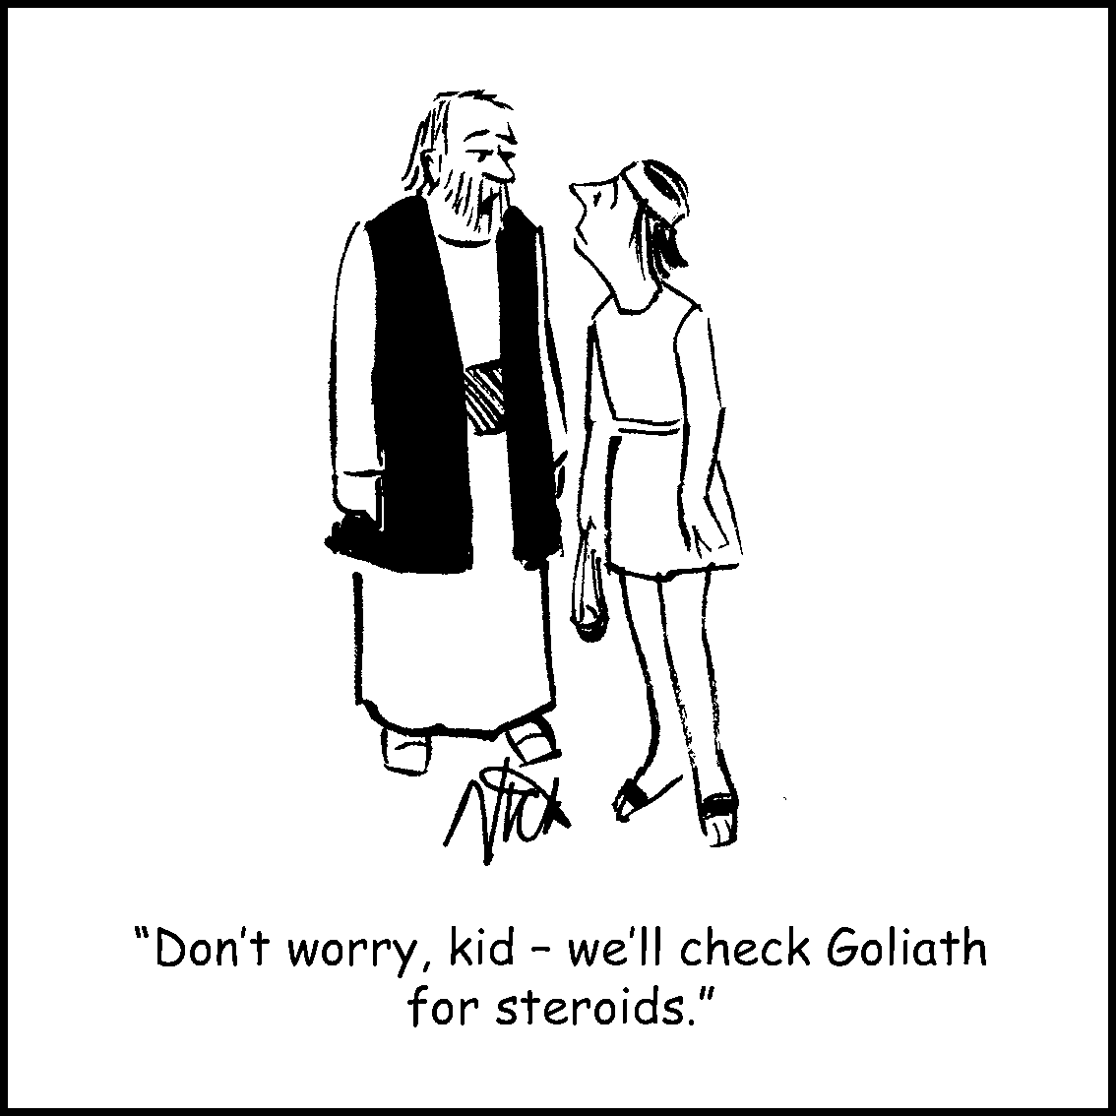
7:00 pm – Praise Band Practice – Sanctuary
7:00 pm – M.I.C.A.H. CPR Training – Settle Hall

03 10:00 am – GALS Art/Craft Fair – Settle Hall
04 9:30 & 11:00 am Worship; PENTECOST, Dedication of VBS team & Saturday worship team, also Sunday School and Children’s Church
9:45 am - Choir Practice - Room 7
10:45 am – Bible Study – Lowe Chapel
4:00 pm —Next Steps with Pastor—Library
6:00 pm— CHILD/YOUTH PROTECTION POLICY TRAINING—Library

05 7:00 pm – Trustees Meeting – Library

06 7:00 pm – Evangelism Meeting – Library

07 NO Morning Bible Study
4:30 pm – Intercessors – Sanctuary
NO Evening Bible Study

11 9:30 & 11:00 am Worship; “BY MY SPIRIT” CANTATA AT 11; also Sunday School & Children’s Church
5:00 pm HERO supper & launch of Vacation Bible School for all ages (6-8.30)
Worship Highlights
UNAFRAID: Living with Courage and Hope
In this series, we explore the most common worries and fears experienced by Americans today, consider practical steps for overcoming these fears, and reflect upon fear in the light of scripture and a faith that promises again and again that we don’t need to live in fear. Let's live with courage and hope.

May 7 Fourth Sunday of Easter: An Age of High Anxiety: Psalm 56.3-4; Isaiah 41.10; Matthew 6.25-27
May 14 Mother’s Day/Fifth Sunday of Easter: Fear of the Other: Psalm 27.1, 14; 1 John 4.18-19; Matt. 5.43-44
May 21 Sixth Sunday of Easter: Friendless and Alone? Psalm 139.5, 8-10; Genesis 2.15, 18; John 13.34
May 28 Memorial Day Observed/Seventh Sunday of Easter: Fear of Failure: Ex. 3.10, 4.13; Jos. 1.1, 5, 9; 2 Tim. 1.7
Flags of all branches of the armed services will be presented as we remember those who have died in action.

June 4 Pentecost Celebration, Pastor Scott preaching
DEDICATION of VBS team and Saturday night worship experience team
June11 “By My Spirit” Cantata at 11 o’clock service (“regular” 9.30 service)
June18 Father’s Day, special guest Dr. Guesly Dessieux
July 2 Rev. Gary Wilder, guest preacher for Independence Day Observance

