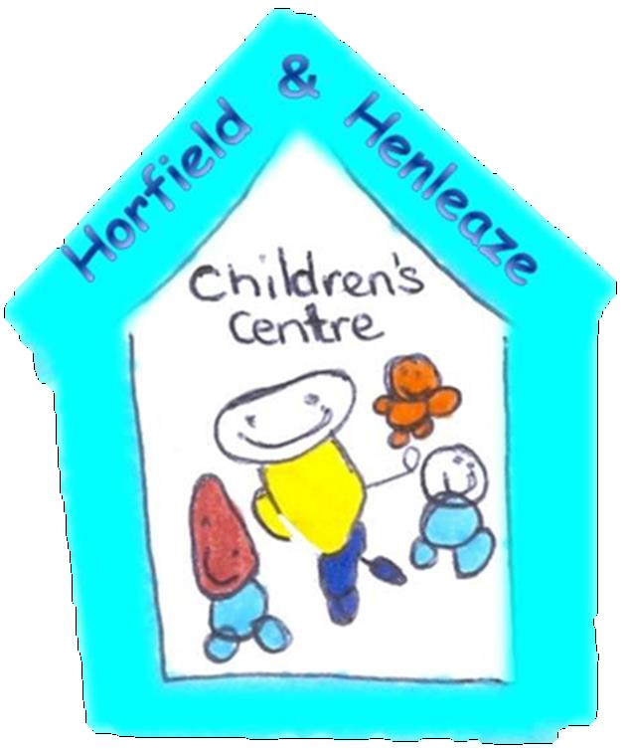
Upper Horfield Children’s Centre and Community School
Health and Safety Policy
April 2015 – April 2016

This document should be read in conjunction with Bristol City Council Statement of Health, Safety and Welfare Policy. A copy is located in the file in the Managers office.
It is the policy of the Children’s Centre to take all steps within the powers of management and staff to prevent personal injuries, health hazards and damage to property.
Upper Horfield Children’s Centre aims to achieve high standards of quality and safety and continually improve health and safety performance by implementing all necessary health and safety procedures.
The Children’s Centre has an approach to health and safety, based on systematic risk assessment procedures (see risk assessment policy for more information) to minimise injury and ill health to staff and children and any other users of the Centre.
Upper Horfield Children’s Centre staff, children and users should adopt the following standards:
- To work safely and efficiently
- Not to misuse any equipment or substance
- To use any approved protective clothing or equipment provided and to consult a senior member of staff if they feel any additional protective equipment or clothing is required
- To report any defects in equipment, machinery or electric cabling and not to attempt to repair
- To comply with all instructions issued for their safety
- To take reasonable care for the health and safety of others who may be affected by their acts or omissions at work.
The advisory board/governors will develop the appropriate setting structure and culture, that supports the concept of risk management by all members of the staff team and children where appropriate.
The Centre is committed to adequately resourcing health and safety measures including planning and implementation of any health and safety requirements.
All members of the staff team will have an understanding of health and safety, through training in health and safety requirements and risk assessment implementation.
There will be continual monitoring and evaluation of health and safety requirements in line with current legislation, including the review of all policies and practices to ensure that Upper Horfield Children’s Centre continues to improve standards of performance.
Who is Responsible?
It is the responsibility of all members of staff to ensure that health and safety regulations are adhered to and that the health and safety of the children and other members of staff are not compromised in any way.
It is the responsibility of the Children’s Centre Manager to ensure that the health and safety of the setting as a whole remains within legislative requirements and that the health and safety of all setting users, including children, staff and parents and carers is not compromised in any way.
Parents and carers are required to sign their child in and out of the setting each day. This is in accordance with health and safety and fire regulations. Daily registers are checked regularly throughout the day by management and senior staff.
Child Protection
All members of staff will receive a child protection policy and training as part of their induction. All members of staff are instructed in the specific procedure for Upper Horfield Children’s Centre, especially as regards disclosures and suspicions of child abuse. (See Child Protection Policy for further information)
Supervision of Children whilst on the Children’s Centre Premises
It is intended that children attending the Children’s centre will remain under the supervision of an appropriate adult throughout their session. Correct ratios will be maintained at all times in the Children’s learning environment – both indoors and outdoors. Careful consideration must be given to the placing of any outdoor play equipment. All appropriate safety equipment must be in place before the children are allowed to use the equipment.

Supervision must be constant and vigilant.

Accidents and Incidents
All members of staff receive first aid training as part of their induction training; in addition all members of staff are instructed in the correct procedures for dealing with accidents and incidents including completion of documentation. The setting has separate accident and incident procedures which are used to document each accident and incident that takes place in the setting. (See Accident and Injury and Incident Policies for further information).
Fire Emergency Procedure
- The smoke and heat alarms will be tested each week to ensure they are in working order. Records to be kept in fire log book.
- Fire extinguishers in compliance with the local Fire Prevention Officers recommendations will be provided and sired safely and appropriately on the School and Children’s Centre premises. These will be checked annually.
- All external doors and fire escape routes will remain clear of obstruction at all times.
- Staff will familiarise themselves with the fire exits, approved routes to the assembly and their responsibilities if evacuation becomes necessary.
- Fire-safety will be included in staff induction training and in on-going training sessions.

Illnesses
In accordance with Upper Horfield Children’s Centres registration and booking policy children will not be admitted into nursery if they are showing signs of an illness or ailment which may be contagious. The Children’s Centre uses guidance from Health Protection Agency to determine the exclusion guidance for contagious illnesses.
If a child becomes unwell during the course of the session, members of staff will ensure that the child is comfortable but does not pose any risk to the other children in the setting. The member of staff will contact the child's parent or carer and observe the child closely until they are collected.
Administration of Medications
All administration of medications are strictly controlled and done in accordance with the Medicine Administration Policy and Procedure.
Risk Assessment of Activities, Trips and Outings
All activities that take place both within the confines of Upper Horfield Children’s Centre and surrounding the premises have been assessed for risk and controls have been put in place to ensure that any hazards have been minimised. (See Risk Assessment Policy for further information).
Trips and outings are planned and the Outings Policy and Risk Assessment procedures are followed.
Personal Hygiene
All members of staff and children are encouraged to maintain an acceptable level of personal hygiene, and procedures are in place to ensure that standards are met. (See Personal Hygiene Policy for further information)
Maintenance and Storage of Equipment
Upper Horfield Children’s Centre has a wide variety of equipment and materials that are used by the children in the course of their play and learning at the setting. Most equipment is bought with consultation with the children from approved suppliers and is checked to ensure compliance with the British Safety Standards. All equipment is well maintained and checked on a regular basis to ensure that it presents to risk to the health and safety of the children. Equipment and materials which do pose a hazard but which have an evidenced benefit on the development of children are used under constant supervision and stored securely after use.
New equipment being introduced to the Centre is assessed using the Risk Assessment. Equipment that is donated to the Centre is also risk assessed, thoroughly cleaned and checked by the Caretaker of the site
The Premises
The premises that Upper Horfield Children’s Centre operates from are regulated by the OfSTED and are regularly inspected. In addition to this the premises have also been inspected by the Health and Safety Executive and a fire risk assessment has been completed to ensure that it complies with relevant legislation. The nursery carries out a yearly building maintenance check and members of staff check the premises each day to ensure that there are no risks or hazards that would compromise the health and safety of the children, parents and carers or staff. At the end of the session members of staff ensure that the premises are left clean, safe, tidy and secure.
Safety and Security
Upper Horfield Children’s Centre feels that the safety and security of the children, parents and carers and staff are paramount to the running of the setting. A secure entry system is in place to ensure that only persons with a legitimate reason for being on the premises have access. Internal door security is also in place. Parents must sign their children in and out of the nursery daily.
Visitors, other than parents and carers collecting their children must pre-arrange their visits and carry identification; all visitors must make themselves known to a member of staff upon entry, stating their name and reason for visiting. Visitors are required to sign themselves in and out of the building and must be accompanied by a member of staff at all times.
Smoking
Upper Horfield Children’s Centre operates a strict no smoking policy, this means that there is no smoking:
• On setting premises
• During setting time
• During preparation time
• During clear up time
• At staff training days
• At staff meetings
• At any gathering organised by the setting (unless it is a social gathering outside of setting time and off the premises).
All staff breaks are arranged with team leaders to ensure that the care of the children is not compromised. If a member of staff wishes to smoke during these times they are required to leave the premises and the grounds of the setting and remain out of sight of the children.
The no smoking policy also applies to parents, carers and visitors to the setting; Upper Horfield Children’s Centre believes that this is in the best interests of the children and staff.
Health and safety: staff responsibilities
- To read and adhere to all nursery policies.
- To ensure a safe environment, keeping entrances and exits clear at all times.
- To check all equipment is in good order, appropriately safe and clean, before use, on a daily basis and dispose of or repair any damaged equipment (inform nursery manager).
- To complete the outside check and complete form before taking children outside.
- Any spillages to be mopped or swept up appropriately.
- To be good role models for children when using equipment.
- To encourage children to take appropriate risks by assessing and managing risks effectively. Help the children to learn for themselves and be involved in health and safety issues.
- To ensure all children are encouraged to wipe their noses or help them to do this depending on their age, disposing of tissues appropriately.
- To ensure all staff wash their hands before meals or food preparation and regularly throughout the day when necessary.
- To ensure all children wash their hands before meals and wash their hands and faces after meals.
- To ensure bathrooms and eating areas of rooms are regularly cleaned during the day.
- To use appropriate cleaning materials (storing them in child proof cupboards when not in use) and appropriate cloths. Red/bathroom, green/kitchen, food Blue/play areas.
- To ensure appropriate safety at meal times, food at correct temperature , appropriate behaviour of children, handling cutlery safely, etc.
- Record any accidents of children or staff on appropriate forms and administer the necessary first aid, informing carer at the end of the day or sooner, via the manager, if necessary.
- To be aware of and carry out security procedure for answering the door.
- To be aware of the emergency evacuation procedure.
- To be aware of location of first aid boxes and firefighting equipment.
- To take all reasonable care of their own and others' personal health and safety when carrying out nursery activities.
Up

