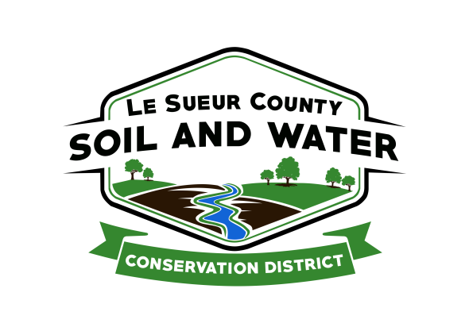

Le Sueur County Soil & Water Conservation District

Le Sueur County SWCD Tel. (507) 419-0365
181 W Minnesota St Website: www.lesueurswcd.org
Le Center, MN 56057

Minutes from June 8, 2021 regular meeting of the Le Sueur County SWCD Board of Supervisors. Le Sueur County Justice Center, Le Center, MN.

Meeting was called to order by Vice-Chairman Entinger at 9:00 am.

Members present: Chairman, Jim Struck (virtually)
Vice-Chairman, Greg Entinger
Secretary, Earle Traxler
Treasurer, Cletus Gregor
PR&I, Glendon Braun

Others present: District Manager, Mike Schultz
Ditch Specialist, Nik Kadel
Program Specialist, Sue Prchal
BWSR, Jen Mocol-Johnson (virtually)

The Pledge of Allegiance was recited.

May 11, 2021 Secretary’s report was read and approved.

May 31, 2021 Treasurer’s report was read. Motion by Traxler, second by Braun to approve as read and to pay bills.
Affirmative: All
Opposed: None
Motion carried

Motion by Struck, second by Traxler to sign the lease with the USDA for $16.50/sq ft. The lease period begins August 1, 2021 and extends through July 31, 2024.
Affirmative: All
Opposed: None
Motion carried

Mike informed the board the Clubhouse is looking for a larger space.

Dawn Ruhland signed an agreement to continue janitor services through June 30, 2022 at $625.00/month.

Farmfest is being held this year from August 3-5, 2021.

The Outstanding Conservationist tour will be held after next month’s board meeting, July 13, 2021.

Motion by Struck, second by Traxler to sign Bob Krocak MAWQCP certification.
Affirmative: All
Opposed: None
Motion carried

Mike explained to the board the process of becoming ag water quality certified.

There is a Cannon 1W1P meeting on July 7, 2021, Struck will attend.

The Lower Minnesota 1W1P plan was submitted to BWSR on June 7, 2021.

Mike discussed the awarded CPL grant with the board. The grant is for $34,903.00 and will be restoring a wetland and enhancing vegetation on the Murphy Wildlife Management Area in Waterville township Section 8. Motion by Traxler, second by Struck to allow Mike Schultz to oversee the grant.
Affirmative: All
Opposed: None
Motion carried

Nik gave a county ditch update. He discussed spraying and mowing, removing trees, beaver dams, plugged tile, cleanouts and repairs.

Jen gave the board a quick update on BWSR academy, the Governor’s budget, and elink.

Vouchers were reviewed and filled out.

There being no further business, meeting adjourned at 10:06 am.

______________________ ___________________________________________
Date District Secretary

