The offside rule really comes down to two things: a player’s position and whether that player’s position is involved in active play. Let’s take a closer look at these to get a better understanding of the offside rule.
Position
A player is in the offside position if the player is nearer to the opponents’ goal line than both the ball and the last defender.
So what does “nearer to the opponents’ goal line” mean? If any part of your head, body or feet is nearer to the opponents’ goal line than both the ball and the last defender, then you are in an offside position. A player’s arms are not considered.
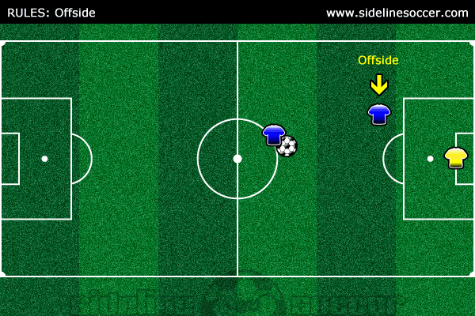
The above diagram shows that the player is in an offside position because the player is nearer to the opponents’ goal line than the ball.
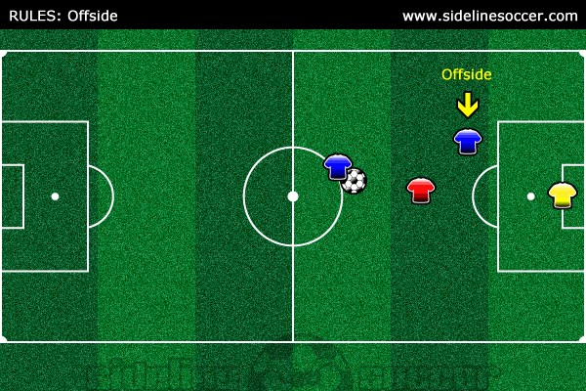
The above diagram shows that the player is in an offside position because the player is nearer to the opponents’ goal line than the last defender.
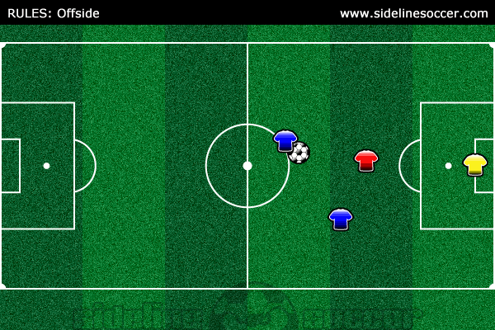
The above diagram shows that the player is in an onside position because the last defender is nearer to the goal line.
A player can only be in an offside position in the opponents’ side of the field.
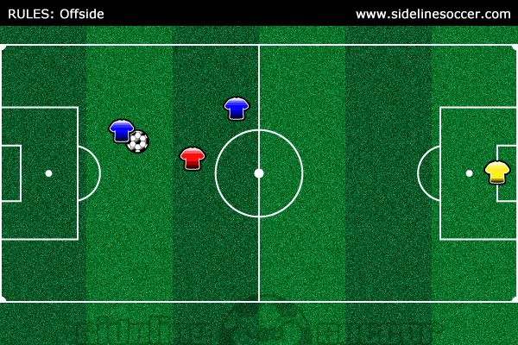
The above diagram shows that the player is NOT in an offside position because the player is not in the opponents’ side of the field.
Involved In Active Play
Once it has been established that a player is in an offside position, it is then decided whether the player is involved in active play by interfering with play, interfering with an opponent or gaining an advantage by being in that position.
So what does “interfering with active play” mean? If you play or touch the ball when it has been passed or touched by a teammate then you are interfering with active play.
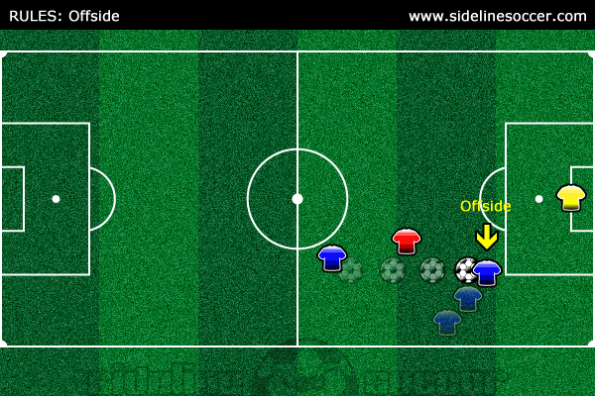
The above diagram shows that the player is offside because the player touched a ball that was passed by a teammate while in an offside position.
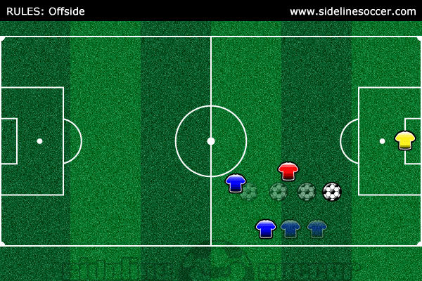
The above diagram shows that the player was in an offside position, however, the player was not involved in active play so an offside call would not be made.
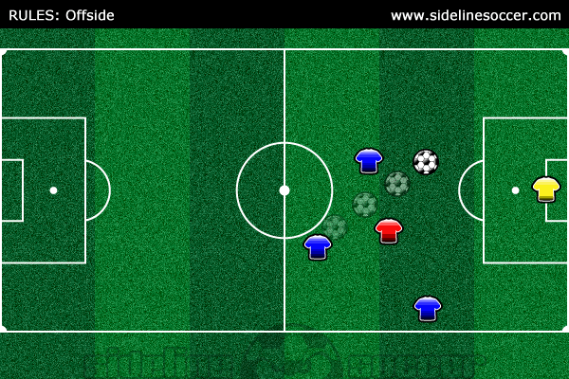
The above diagram shows that one player was in an offside position, however, the ball was played to another player that was NOT in an offside position. So an offside call would NOT be made.
So what does “interfering with an opponent” mean? If you prevent an opponent from playing or being able to play the ball by obstructing the opponents’ line of vision or movements or by making a gesture or movement which deceives or distracts the opponent, then you are interfering with an opponent.
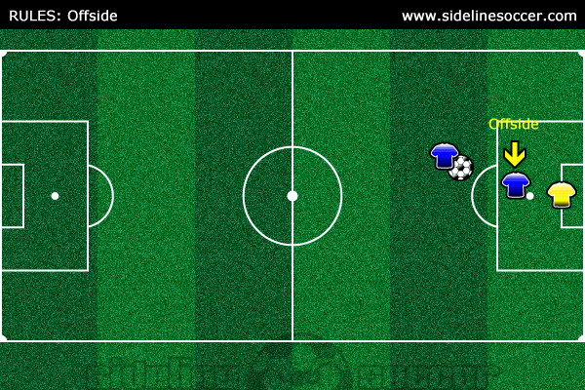
The above diagram shows that the player is obstructing the goalie’s line of vision while in an offside position. So an offside call would be made.
So what does “gaining an advantage by being in that position” mean? If you play a ball that rebounds off a post or the crossbar after having been in an offside position or play a ball that rebounds off an opponent after having been in an offside position, then you are gaining an advantage by being in that position.
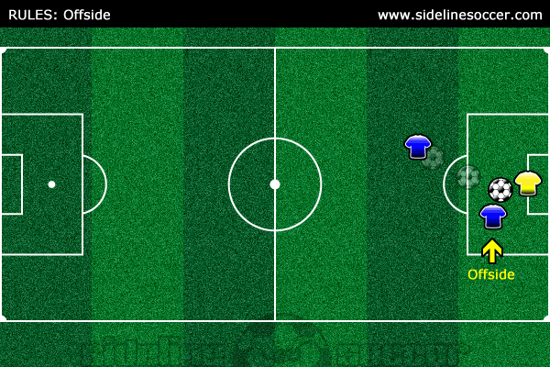
The above diagram shows that the player received the ball from a rebound off the goalie while in an offside position, which is why an offside call would be made.
A couple last things to keep in mind about the offside rule. If an offside call is made, an indirect free kick is awarded to the opposing team, which needs to be taken from the place where the offside occurred. A player is NOT offside if the ball is received directly from a goal kick, throw in or corner kick.

