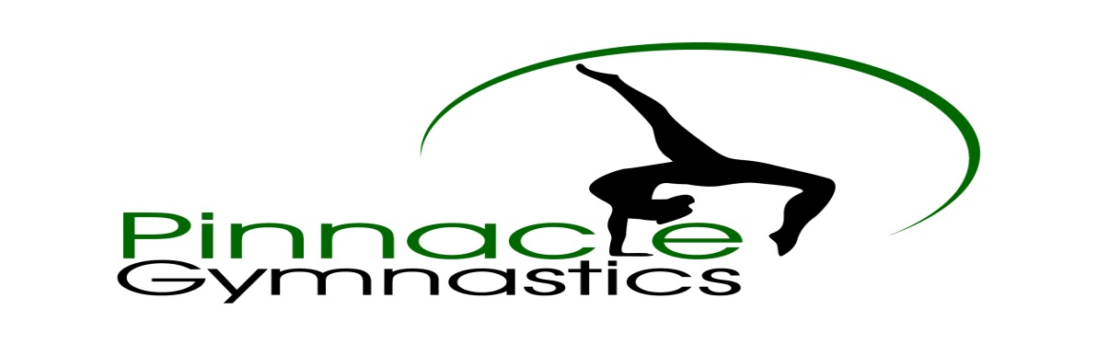
Advertising Fundraiser 2018-2019
Pinnacle Gymnastics is beginning third competitive season. We are located at 904 N. Rock Street in Sheridan, and currently have 300 students enrolled with ages ranging from 2 to 18 years. The 2018-2019 Pinnacle Gymnastics U.S.A.G team consists of 60 girls. These girls train between 3-12 hours per week. This requires a huge time and financial commitment. The team girls and coaches are raising money to help alleviate some of this burden. 100% of all money raised goes directly to our competitive teams.
We would like to offer local businesses advertising in our facility. We are offering 4 levels of sponsorship. We would like to offer local businesses and individuals the opportunity to have their name on the back of our competitive shirts. This is our Bronze Sponsorship. We are selling signs that are 2 ft. x 4 ft. for Silver Medal Sponsorship; 3 ft. x 4 ft. for Gold Medal Sponsorships; and 4 ft. x 6 ft. for Platinum Medal Sponsorships. The signs will be professionally made and will hang in the gym from August 1, 2018 – July 31, 2019. Your name will also be on shirts if you do a Silver-Platinum Sponsorship.
Bronze Medal Sponsorship- $75.00
Silver Medal Sponsorship - $200.00
Gold Medal Sponsorship - $350.00
Platinum Medal Sponsorship-$500.00
Please make checks payable to Pinnacle Team. Forms need to be returned to Pinnacle Gymnastics no later than August 15th.
Your support will make all the difference and is greatly appreciated.

Sponsor Contact Name ________________________ Phone _______________________
Company Name________________________________ Childs Name_________________________
Pinnacle Gymnastics contact person: Mandie Stevens Phone (870) 942-0890
Please email logo or design to pinnaclegymnastics@yahoo.com or attach business card or logo.

