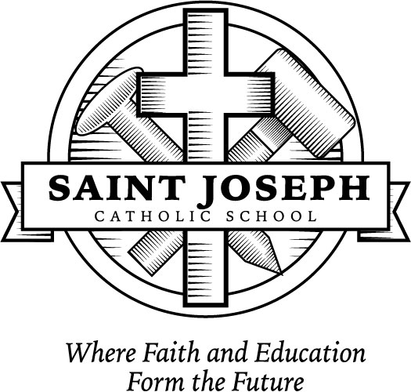
79 Chapel Street Fr. Chris Jesudhason
Monroeville, OH 44847 Pastor

Phone: 419-465-2625 Dcn. Michael Wasiniak
Fax: 419-465-2170 Principal

Email: sjs@msjcs.org Amanda Dixon
Website: www.msjcs.org Administrative Assistant

Registration Information
2022-2023 School Year

Dear Parents,

Choosing the right school for your child is an extremely important decision. Here at Saint Joseph School, we believe our school is a wonderful place for children. We are alive with academics and faith values because of the rich heritage of our past. We are here today because of pioneer spirits who recognized that faith is at the very basis of everything one accomplishes in life. As I continue to see local businesses and parishioners give to us in our Annual Fund, I know that they give because they believe strongly that our school is meant to be here as the clearest sign of evangelization.

You are the parents who yearn for the very best for your children. You are convinced that we can extend to your children the vision that these pioneers had. So you entrust us with the mission of education that we take very seriously. When have we needed the message of the Gospel more than right now?
Each year the tuition scale is developed that reflects good stewardship of the parish and school resources. The school subsidy received from the parish is extremely generous and is in addition to the profits realized from the annual festival and internal school fundraisers. When you look at the tuition that we ask for, it is not even half of the cost of educating a child. How do we do it? It continues to be a walk of faith and trust in God. It is by His grace, and the provision of so many, that we are able to move forward spiritually and academically.
If you are in need of financial assistance, please use the attached form for the next school year. This form is also available in the school office or on our website. Please also be aware that scholarships (EdChoice Expansion and Traditional plus Northwest Ohio Scholarship Fund out of Toledo) are available. Please call me at school for more information. No student will be turned away needing financial assistance. Please ask us and we will find a way!
Lastly, please call Fr. Chris or myself or stop in for a visit if we can be of any assistance. My door is always open to you and I am praying with and for you. The most important gift that we can give our children is a deepening of their faith which is more needed in this world today than any material gift you can give. Thank you for choosing St. Joseph School!
Sincerely,
Michael Wasiniak, Principal

The St. Joseph Catholic School admits students of any race, color, national and ethnic origin to all rights, privileges, programs, and activities generally accorded or made available to students at the school. It does not discriminate on the basis of race, color, national and ethnic origin in administration of its educational policies, admissions policies, scholarship and loan programs, and athletic and other school-administered programs.

Co-Curricular and Extracurricular Activities

- Weekly school Liturgy as the center of our Catholic identity.
- Generous contributions to local, national, and international mission projects.
- Sacramental preparation program…Holy Eucharist, Penance, Confirmation,
- Option C online grade and communication program.
- Full accreditation by the Ohio Catholic School Accrediting Association.
- Spelling and Geography Bee participation.
- A state licensed Early Childhood program.
- Religion teachers who have acquired “Growing in Faith” certification.
- Kindergarten through grade 8 music instruction with a state-certified teacher.
- Reinforcement of reading skills with an Accelerated Reading Program.
- Field trips to extend the performing arts and science curriculums.
- A comprehensive technology program with wireless connectivity, laptop computers, & classroom active boards.
- Participation in History & Science Fairs.
- Family Groups activities include students K-8.
- Remedial and tutoring programs for all grade levels.
- Full school year athletic program with Monroeville Public Schools.
- Middle school Academic Challenge competition.
- Computer tablets or Chromebooks for Preschool through grade 8.
- Algebra and Spanish available through Monroeville Public High School.
- Anti-Bullying programs in every grade.
- Toledo Diocesan Virtus Program for Grades K to 8
- Children’s Choir open to Grades 3 to 8
- Christmas and Spring Programs
- MAP (Measures of Academic Progress) Testing
- ARK (Assessment of Religious Knowledge) Testing
- College Credit Plus Available

---------------------------------------------------------------------------------------------------------------------------------------

St. Joseph Financial Aid Request

Family name: __________________________________

Address: ______________________________________ Phone # ______________

How much is your tuition this upcoming year: $____________

How much financial aid are you requesting: $____________

What is the reason for requesting this financial aid? __________________________

____________________________________________________________________

Parent signature: ______________________________________________________

Please return to Fr. Chris Jesudhason at the Parish office.

Saint Joseph School Tuition 2022-2023

Preschool -- Parishioners & Non-Parishioners
Tuition Snack Reg Fee Total
Preschool-- 3/4 yrs- $1,200.00 $75.00 $50.00 $1,325.00
Pre-K-- 4/5 yrs- $1,375.00 $95.00 $50.00 $1,520.00
Snack & drink will be provided daily for the mandatory fee listed above.

Days & Times
P3: Tuesday, Wednesday, Thursday 8:15am – 10:45am
PK: Monday, Tuesday, Wednesday, Thursday 12:15pm – 2:45pm

Tuition assistance does not apply to Preschool.
Available spots will be filled on a first come first serve basis.
Preschool includes $100 continuation fee for Preschool and $150 continuation fee for Pre-Kindergarten.
This fee will be deducted from your tuition as your child reaches Kindergarten and First Grade.

Kindergarten – Grade 8 St. Joseph & St. Alphonsus Parishioners (BEFORE 5/31/22)*
Tuition** Registration* Total Due
One Child $2,775.00 $50.00 $2,825.00
Two Children $5,040.00 $100.00 $5,140.00
Three Children $6,945.00 $150.00 $7,095.00
Four Children $7,835.00 $200.00 $8,035.00

Kindergarten – Grade 8 St. Joseph & St. Alphonsus Parishioners (AFTER 5/31/22)*
Tuition** Registration* Total Due
One Child $3,775.00 $50.00 $3,825.00
Two Children $6,040.00 $100.00 $6,140.00
Three Children $7,945.00 $150.00 $8,095.00
Four Children $8,835.00 $200.00 $9,035.00

Please note: The cost to educate a child at St. Joseph School is approximately $6,800.00; our tuition is less than half.

Kindergarten – Grade 8 Non-Parishioner Tuition:
If you are not a parishioner of St. Joseph or St. Alphonsus, we ask you to set up an appointment in our office to discuss tuition rates.

*Registration Fee $50.00 per student & is non-refundable. **Multiple children rates do not apply to Preschool.

Tuition Assistance is available. Please fill out the financial aid request and forward to the Fr. Chris at the parish office.

You may pay your tuition as follows:
- In full by May 31, 2022 to avoid the late fee listed above.
- School loan through Croghan Colonial Bank. You are eligible to receive a St. Joseph school tuition loan through Croghan Colonial Bank when you register at our school. This must be completed by May 31, 2022.
- Contact Mary Ivory, business manager, at 419-465-4142 to set up other payment arrangements. This must be completed by May 31, 2022 to avoid the late fee listed above.

St. Joseph Financial Aid Request

Date: _______________

Family name: __________________________________

Address: ______________________________________ Phone # ______________

How much is your tuition this upcoming year: $____________

How much financial aid are you requesting: $_________________________

What is the reason for requesting this financial aid? __________________________

____________________________________________________________________

Parent signature: ______________________________________________________

Please return this form to Fr. Chris Jesudhason, Parish office.

-------------------------------------------------------------------------------------------------------------------

Office notes: financial aid $ _________________

Approval: _____________________

New statement mailed: ______________

