Fee Structure and Pattern of Delivery 2021-2022

At Brenchley Pre-School we believe in open communication with all parents/carers and staff and are therefore presenting this fee structure in order to ensure that every fully understands our charging.

Fees are payable termly in accordance with the rates in force at the time. Fees are reviewed annually in September of each year or in the event of any changes to the Code of Practice. Any changes to current rates will be advised in writing, at least one term in advance.

Nursery & Lions Class £6.25 per hour

Morning Session 8.45am to 11.45am

Lunch Club 11.45 – 12.45am

Afternoon Session 12.45 – 3.45pm

For those children who are staying for both the morning and afternoon sessions and wish to have lunch, Lunch Club will be charged at the hourly rate and invoiced termly in September – January and April. Lunch Club will not be covered by the funding entitlement.
Please note you will have to provide a packed lunch for your child. If your child is staying for both morning and afternoon sessions and you do not wish to pay for Lunch Club then you will have to collect your child at 11.45am and return them at 12.45pm

Breakfast Club: 7.30am onwards £7.95 per session including food
Twilight Club: Up to 6pm £7.45 per hour with light tea.

30th June 2020

Dear Parents

I am writing to inform you of the new Pre-school fees from September 2020.

I am conscious that this is the second increase within this calendar year and going forward we will reviewing fees annually at the beginning of each academic year (September).

We have tried to keep the increase to a minimum but do need to cover incremental costs to ensure the sustainable running of the Pre-school.

Effective from the beginning of the Autumn term:

Hourly fees: £6.10 per hour
Breakfast Club: £7.75 per session including food
Twilight Club: £7.25 per hour with light tea.

Thank you for your continued support

Best Regards

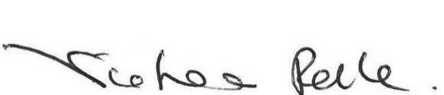

Victoria Relle
Chairperson

