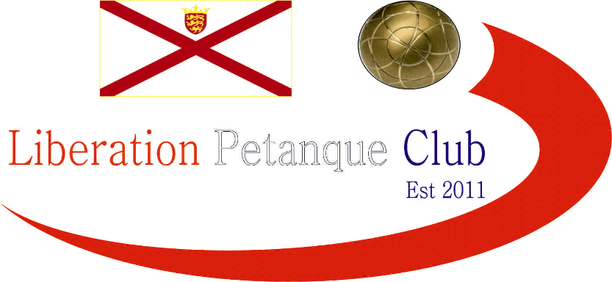

# Summer 2017 Season

# Week 15

# 5th July 2017

# Melee 3

# JPA ISLAND CHAMPIONSHIP – OPEN TRIPLES

# Venue – Weighbridge – Saturday 8th July 2017

# LIBERATION CLUB SINGLES CUP

# Wednesday 12th July 2017

# Email club to enter

# A

# 

***NEXT WEEK***

**Club Singles Cup – Start Time 5.45pm**

**WEBSITE** [**www.liberationpetanque.co.uk**](http://www.liberationpetanque.co.uk)

**EMAIL** [**liberationpc@gmail.com**](mailto:liberationpc@gmail.com)

**Kind Regards**

**Report Editor**

**Liberation Petanque Club**

# SPONSORED BY

# http://nebula.wsimg.com/135a1bd6338e1b589a50cdec98bd84d1?AccessKeyId=C6E923731F1A482DD910&disposition=0&alloworigin=1