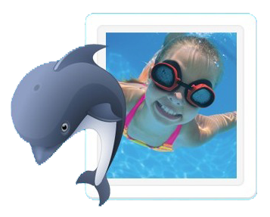**Queensborough Swim Club**

**1138 Miller Ave., San Jose, CA 95129**

**Between Rainbow & Bollinger**

**Pool Hours:**

**Sun - Thurs 7:00 am - 9:00 pm and Fri and Sat 7:00 am - 10:00 pm**

**Lifeguards on duty in the summer Mon-Fri from 1 pm - 5 pm.  
  
This is a fun family oriented neighborhood non-profit pool (since 1964!), safe, very clean, HEATED year round, remodeled patio and pool, bathroom/showers, barbecue, not crowded, and lots of parking!**

**Next** **Membership/Swim Lesson** **Registration Times:**

**Saturday April 23 10 am – 12 pm OR**

**drop off application/check or cash in the Club House door mail slot OR**

**visit QPOOL.ORG OR email** [**info@qbpool.org**](mailto:info@qbpool.org) **for the 2016-2017 Membership Application**

**Memberships are for following 12 months after signup.**

**Family (2 adults & up to 3 children) $495, Single Parent (1 unmarried adult & up to 3 children) $325,**

**Senior (2 adults only, both over 62 years old) $275 (each additional child over 3 children is $25 each)**

**Membership includes REDUCED RATES on: Swim Lessons, Kid's Night Out, and Club House Rentals**

**Swim lessons!**

**Private and semi-private lessons: Adults and children – 2 years to 99 years.**

**1/2 hour or hour sessions are offered Apr 1 thru Oct 31**. **Let us know what day(s) and time(s) work for you**.

**Fees: Private (1 lesson): Members $30/half hour, $50/hour Non-members: $40/half hour, $70/hour**

**Semi-Private (1 lesson): Members $20/half hour, $30/hour Non-members $25/half hour, $40/hour**

**Group lessons: Children 3 years – 13 years**

**Beginner, Advanced Beginner, Intermediate and Advanced lessons.**

**Weekly sessions (Mon-Fri): Jun 13-Aug 12, Half hour lessons in the morning 9 am – 12 pm**

**Fees: (5 lessons): Members $45 Non-members: $85**

**Nine Saturday sessions: Jun 11-Aug 13 (not on July 2), Half hour lessons in the morning 10:30 am – 12 pm**

**Fees: (9 lessons): Members $85 Non-members: $150**

**Kid’s Night Out is back!**

**Friday 6:00-9:30 pm: Apr 29, May 13, June 3, June 17, July 8, July 22, Aug 5**

**KNO includes lifeguarded SWIMMING (weather permitting), pizza, drinks, crafts and a movie!!**

**Fees: Members: one child: $20; each addtl child: $15, Non-members welcome for $5 more per child.**

**Clubhouse rental:** **Members: $75 for 3 hours ($25 each additional hour and $3 each guest swimmer),**

**Non-members: $30 per hour, minimum of 3 hours ($30 each addtl hour and no swimmers)**

**Ice Cream Socia**l: Come join us **Sunday, June 5 from 1-4 pm** and see what we are about!

**For Complete Registration Info, visit QPOOL.ORG, email** [**info@QBPool.org**](mailto:info@QBPool.org) **or call/leave message at 408-446-3921**