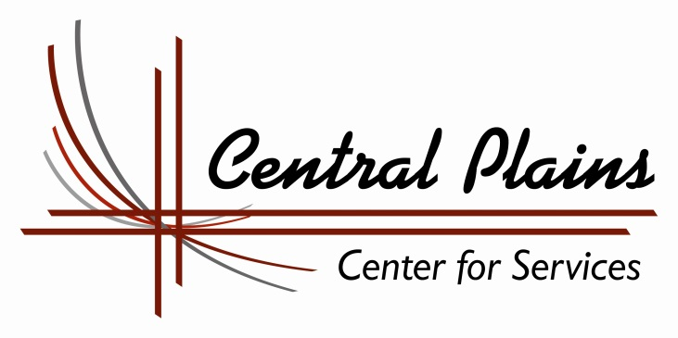

Central Plains Center for Services Staff Listing
NAME WORK ADDRESS PHONE EMAIL ________
Co-Executive Directors
Nancy Ferguson Central Plains Center for Services Office: (308) 872-6176 centralplains6176@msn.com 1138 North C Street Cell: (308) 870-4246 Fulltime
Broken Bow Ne 68822 Fax: (308) 872-6596

Doug Lenz Central Plains Center for Services dlenz@central-plains.org
4521 Leavenworth Street, Suite 2 Cell:(402) 312-3550 Fulltime
Omaha, NE 68106 Fax (402) 932-5188

Ann Kawata Central Plains Center for Services Office: (308) 872-6176 centralplains6176@msn.com Adm. Assistant 1138 North C Street Cell: (308) 870-1273 Parttime
Broken Bow Ne 68822 Fax: (308) 872-6596

TRANSITIONAL PROGRAMS
Omaha / Eastern Service Area
PALS
A Preparation, Transition and Independent Living Program

Doug Lenz Central Plains Center for Services dlenz@central-plains.org
(Director) 4521 Leavenworth Street, Suite 2 Cell: (402) 312-3550 Fulltime
Omaha, NE 68106

Vacant Central Plains Center for Services Cell:
PALS Specialist 4521 Leavenworth Street, Suite 2 Fulltime Omaha, NE 68106

Mallory Asay Central Plains Center for Services Cell: (402) 979-6252 masay@central-plains.org
PALS Specialist 4521 Leavenworth Street, Suite 2 Fulltime
Omaha, NE 68106
Lisa Hartman Central Plains Center for Services Cell: (402) 812-1929 lhartman@central-plains.org
PALS Specialist 4521 Leavenworth Street, Suite 2 Fulltime
Omaha, NE 68106
Kris Hook Central Plains Center for Services Cell: 492-968-1559 khook@central-plains.org
PALS Specialist 4521 Leavenworth Street, Suite 2 Fulltime
Omaha, NE 68106

Jeff Smith Central Plains Center for Services Cell: (402) 714-5089 jsmith@central-plains.org
PALS Specialist/ 4521 Leavenworth Street, Suite 2 Fulltime
Supervisor Omaha, NE 68106

Lincoln / Southeast Service Area
PALS
A Preparation, Transition and Independent Living Program

Vacant Central Plains Center for Services Cell:
PALS Specialist 643 South 25th Street, Suite 7 Fulltime
Lincoln, NE 68510
Molly Smith Central Plains Center for Services Cell: (402) 332-8461 msmith@central-plains.org
PALS Specialist 643 South 25th Street, Suite 7 Fulltime
Lincoln, NE 68510

Sara Shalon Central Plains Center for Services Cell: (402) 270-0807 sshalon@central-plains.org
PALS Specialist 643 South 25th Street, Suite 7 Fulltime
Lincoln, NE 68510

Northern Service Area
PALS
A Preparation, Transition and Independent Living Program

Kam Schroeder Central Plains Center for Services Cell: (402) 887-7713 kschoeder@central-plains.org
PALS Specialist 51707 Hwy 275 Fulltime
Clearwater, NE 68726

Jane Kasik Central Plains Center for Services Cell: (402) 429-5451 jkasik@central-plains.org
PALS Specialist/ 222 E 21st Street Fulltime
Supervisor Schuyler, NE 68661

Dean Norris Central Plains Center for Services Cell: (712) 490-1043 Contractor
PALS Contractor 1103 Megan’s Way
Correctionville, IA 51016

Central Service Area - PALS
A Preparation, Transition and Independent Living Program

Troy Chandler Central Plains Center for Services Cell: (308) 395-8422 tchandler@central-plains.org
PALS Supervisor 2307 West Charles Fulltime
Grand Island, NE 68803

Camille Ohri Central Plains Center for Services Cell (402) 340-8247 cohri@central-plains.org
PALS Specialist 6108 T Avenue Fulltime
Kearney, NE 68847

Matt Gruszczynski Central Plains Center for Services Cell (308) 870-3691 mgruszczynski@central-plains.org PALS Specialist 155 West 3rd - P.O. Box 337 Fulltime
Long Pine, NE 69217

Mark Jensen Central Plains Center for Services Cell (402) 462-4679 mjensen@central-plains.org
PALS Specialist 615 Crane Avenue
Hastings, NE 68901

Cathy Minnick Central Plains Center for Services Cell: (308) 870--3180 cminnick@central-plains.org
PALS/OPP Specialist 1138 North C Street Fax: (308) 872-6596 Fulltime
Broken Bow, NE 68822

Western Service Area
PALS
A Preparation, Transition and Independent Living Program

Samantha Ady Central Plains Center for Services Cell: (308) 530-4964 sady@central-plains.org
PALS Specialist 815 South Ash Fulltime
North Platte, NE 69101

Kris Christian Central Plains Center for Services Cell: (308) 641-2914 kchristian@central-plains.org
PALS Specialist 850 P Street Fulltime
Gering, NE 69341

Zachary Preble Central Plains Center for Services Cell: (308) 631-2480 zpreble@central-plains.org
PALS Specialist 511 W. 40th Street Fulltime
Scottsbluff, NE 69361

EDUCATION PROGRAMS
ETV
Education and Training Voucher Program
Provided Statewide

Andra White Central Plains Center for Services Office: (308) 872-6595 awhite@central-plains.org
Director of Education 1138 North C Street Cell: (308 ) 870-2421 Fulltime
Programs Broken Bow, NE 68822 Fax: (308) 872-6596

Jessi Chandler Mason Central Plains Center for Services Office:( 308) 749-2580 jmason@central-plains.org
ETV Coordinator 1138 North C Street Cell (402) 875-3168 Parttime
Broken Bow, NE 68822 Fax: (308) 872-6596

Ann Lenz Central Plains Center for Services Cell: (402)990-3296 alenz@central-plains.org
Education Coach 4686 Hickory Street Halftime
Omaha, NE 68106

LEAP
Omaha and Lincoln
Learn and Earn to Achieve Potential – Education Program

Tanya Smith Central Plains Center for Services Cell: (402) 679-3352 tsmith@central-plains.org
LEAP Specialist 4521 Leavenworth Street, Suite 2 Fulltime
Omaha, NE 68106

Felipe Longoria Central Plains Center for Services Cell: (970) 310-3025 flongoria@central-plains.org
LEAP Specialist 643 South 25th Street, Suite 7 Fulltime
Lincoln, NE 68510

SIXPENCE
EARLY EDUCATION PROGRAMS /
Sixpence Office (308) 872-2503 ext.324

Mary Vaughan Central Plains Center for Services Office: (308) 872-6176 mmvaughan@hotmail.com
Supervisor 1138 North C Street Cell: (308) 870-0458 Parttime Broken Bow Ne 68822 Fax: (308) 872-6596

Deena Gibson Central Plains Center for Services Office: (308) 872-6176 dgibson@central-plains.org
Early Childhood 1138 North C Street Cell: (308) 643-7035 Fulltime
Educator Broken Bow NE 68822

Jackie Chandler Central Plains Center for Services Office: (308) 872-6176 chandlermjj@hotmail.com
Early Childhood 1138 North C Street Cell: (308) 749-2283 Parttime
Educator

Love & Logic Parenting Program
Deena Gibson Central Plains Center for Services Office (308) 872-6176 dgibson@central-plains.org
1138 North C Street Cell (308)643-7035
Broken Bow, NE 68822

Super Kids Club AfterSchool and Summer Program – Broken Bow
After School Program Phone – 308 870-5661 / Megan’s #308 870-5658

Megan Crawford Central Plains Center for Services Office:( 308) 872-6176 mcrawford@central-plains.org
Program Director 1138 North C Street Cell: (308) 870-5658 Fulltime
Broken Bow, NE 68822 Fax: (308) 872-6596

Mary Rundell Central Plains Center for Services Office :(308) 870-5661 Parttime
Site Director 1138 North C Street
Broken Bow Ne 68822

Shawnda Werts Central Plains Center for Services Office :(308) 870-5661 Parttime
Education Aid 1138 North C Street
Broken Bow Ne 68822

Christine Chalupa Central Plains Center for Services Office :(308) 870-5661 Parttime
Education Aide 1138 North C Street
Broken Bow Ne 68822

( High School Students not listed) Updated: November 2018

