**Heart in Hand Natural Healing & Training Center**

2850 45th Street Suite B Highland, IN 46322

**Heart in Hand Natural Health LLC**

**Pamela Kozy**

Eden Energy Medicine Certified Practitioner, Reiki Master Teacher

Phone: 219-923-2050

Email: heartinhand4@sbcglobal.net

Website: heartinhandhealing.com

**Whole Life Counseling Services with** **Jennifer Willhoit**

Licensed Clinical Social Worker

Phone: 219-923-2050

Email: [jenfw@sbcglobal.net](mailto:jenfw@sbcglobal.net)

Website: wholelifecounselingservices.com

**Practitioners**

**Dorian A. Walsh**

Massage Therapist, Bodyworker, Reiki Master Practitioner

Phone: 219-614-8834

dorian82@yahoo.com

**Sheryl Kozy**

Licensed Esthetician, Shamanic Practitioner

Phone: 219-313-8532

skozy930@gmail.com

**Angela M. Lucas**

CranioSacral Therapy Practitioner, Reiki Master Practitioner

Phone: 219-671-1770

angielukas@gmail.com

**Choosing Joy**

**“Find out where joy resides and give it a voice far beyond singing. For to miss the joy is to miss all”**

**Robert Louis Stevenson**



**Services and Classes**

**June/July 2022**

**MENTAL & EMOTIONAL THERAPIES** with Jen Willhoit, LCSW

The counseling department is willing to work with your Insurance Company. If you do not have insurance,

the cost is:

per visit for individual 100.00

per visit for couples 150.00

**THERAPEUTIC MASSAGE** with Dorian Wash, MT/RMP

Deep Tissue Massage (1 hour) 75.00 / (90 minutes) 105.00

Therapeutic/Swedish Massage (30 minutes) 35.00 / (1 hour) 70.00 / (90 minutes) 100.00

Hot Stone Massage (1 hour) 65.00 / (90 minutes) 95.00

CBD Massage (30 minutes, half body) 45.00 / (1 hour) 75.00 / (90 minutes) 105.00

Reflexology (30 minutes) 35.00 / (45 minutes) 45.00 / (1 hour) 55.00

Auricular Therapy (30 minutes) 25.00

Cupping (30 minutes) 30.00

Reiki (30 minutes) 30.00 / (45 minutes) 45.00 / (1 hour) 60.00

**Additional Services Include:**

2 Local Deep Tissue areas (if necessary)

Aromatherapy

Reflexology - additional $10

Cupping - additional $10

Auricular Therapy (ear seeds) - additional $10

Hot Stones - additional $10

Essential Oils - additional $5

CBD Oil (2 specific areas only) - additional $10

Reiki - additional $5

**ESTHETIC SERVICES** and **SHAMANIC HEALINGS** with Sheryl Kozy

Facials 65.00 - 75.00

Glycolic Peels 80.00

Eyezone Therapy 35.00

Waxing Prices Vary

**Shamanic Services** offered cost 75.00 for 1-hour session

Shamanic Journey Chakra Balancing

Wax Extraction Power Animal Retrieval

Lympia Cleanse Shamanic Reiki

Soul Retrieval

**ENERGY MEDICINE** with Pamela Kozy, CEEMP

Energy Testing Evaluation (Initial visit 1 hour) 65.00

Energy Medicine Treatment (1 hour) 60.00

Energy Medicine/Reiki Session (1 hour) 60.00

Brazilian Toe & Black Pearl Session 50.00

**EDEN ENERGY MEDICINE CLASSES** with Pamela Kozy, CEEMP

Energy Medicine Class 101 140.00

Energy Medicine Class 102 100.00

**REIKI SESSIONS** with: Pam, Dorian, Angie, and Sheryl

Reiki (30 minutes) 30.00

Reiki (45 minutes) 45.00

Reiki (1 hour) 60.00

Reiki/Reflexology (45 minutes) with Pam 60.00

Reiki with Guided Imagery (1 hour) with Pam 55.00

Chakra Balancing 45.00

**REIKI SPECIALS**

Six 45-minute sessions 140.00

Cancer Patient Reiki Discount (30 minutes) 15.00

Cancer Patient Reiki Discount (1 hour) 25.00

Jen’s Patients 30 minutes 30.00

**REIKI CLASSES** with Pamela Kozy, RMT

Reiki Level One 115.00

Reiki Level Two 150.00

Reiki Master (A.R.T.) Level 180.00

Reiki Master Teacher 198.00 This class can only be

taken after the Master (A.R.T.) Level and one year of study with Pam

*All classes are two days, except Reiki Kids Workshop & Master Level

________________________________________________

**SPIRIT OF ENERGY CHAKRA CLASS** with Pamela Kozy, RMT

7 Week Class 100.00 Pam

**TIBETAN BOWLS PRIVATE SOUND HEALING** with Pamela Kozy

30 minutes 25.00

1 hour 50.00

_____________________________________________________

**CRANIOSACRAL THERAPY** with Angela Lucas

Craniosacral Therapy (1 hour) 70.00

Craniosacral for Kids (30 minutes) 40.00 / (45 minutes) 50.00



**Heart in Hand Services and Price List**

**Reiki Classes**

**with Pamela Kozy, RMT, EEM-CP**

**Reiki Level II** Friday June 10th 5:30pm to 9:30pm &

Sunday June 12th 9:00am to 3:30pm

**Reiki Master Class** Saturday June 18th 9:00am-3:30pm

**\*\*\* NO CLASSES IN THE MONTH OF JULY\*\*\***

**Reiki Level II** Friday August 12th 5:30pm-9:30pm &

Sunday August 14th 9:30am-3:30pm

There is a **$20 deposit** due one (1) week in advance

**Level I Cost**: $115

**Level II Cost:** $150

**Master Class Cost: $180**

*Lunch is provided on day two of Level I and II

If interested in taking the Master class, please call Pamela at **219-923-2050**

**Current** **Classes**

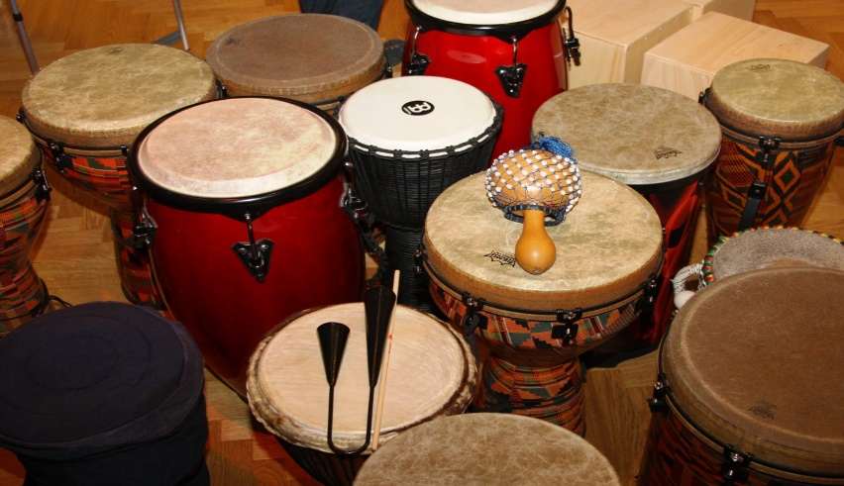

**Drumming Circle with Sheryl Kozy**

**Date:** Second Tuesday of every

month

***Time****: 6:00 - 8:00 p.m.*

**Make a Habit of …**

**Choosing Joy**

\***Gift Certificates** are available and may be purchased directly through the practitioner that will be rendering the service.

Please note that practitioner hours and office hours will vary. Each practitioner sets their own schedule. If you have any questions, you can call the office at **219-923-2050**. If you do not get an answer, please leave a message and we will return your call as soon as possible. You may also contact the practitioner directly at the numbers provided.

**SHOWING YOUR JOY**

Smile, pump your fist, do a backflip (somewhere that offers a soft landing!), shake your rump… whatever does it for you, take a moment to express your joy. Don’t keep it inside- what good is it to you there?

**CELEBRATING YOUR JOY**

Whether it’s your happy moment or someone else’s, take time to celebrate it. The celebration could be a hug or a card with some encouraging words, or it could be a party for a hundred of your closest friends! The point is that unless you make an occasion of things that are worth celebrating, they will generally pass you by- along with their significance in the progress of your life.

Savor positive experiences by doing the following.

**TALKING ABOUT YOUR JOY**

When someone asks you how you are or how your day was, remember to talk about the little happy things. The compliment you received on your outfit, the encouragement you received from your boss on this month’s sales figures—these things count as the fabric of your life. They give it color. And if you don’t celebrate the color when it’s there, you run the risk of only seeing gray.

**REMEMBERING YOUR JOY**

If you’re facing a difficult time, you have the choice to remember times when you felt better than you are feeling now. Keep a Joy List handy—a list of events, moments, and experiences that make you smile when you remember them. Draw from this list when you need a dose of delight in your day.

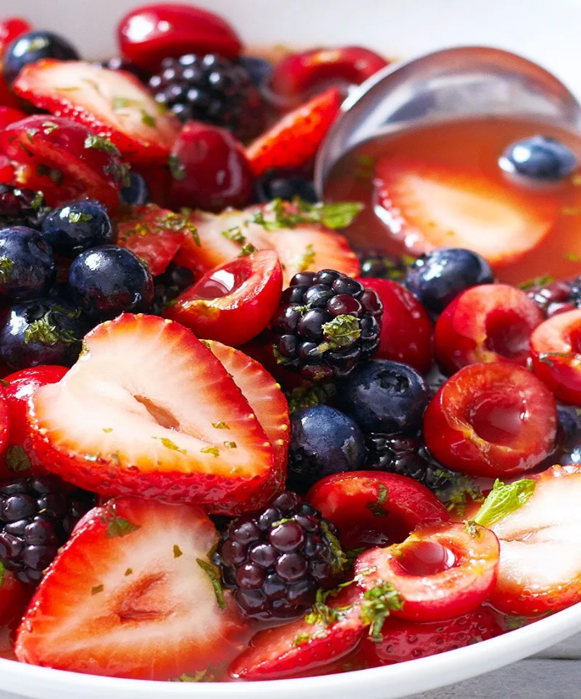

**Instructions**

1. Add all fruit to a large mixing bowl and gently toss together
2. In a separate bowl of mason jar, mix honey, mint, and lime juice. Drizzle the salad with the dressing, to taste. Cover and refrigerate for 3-4 hours before serving. Serve chilled.

**Ingredients**

* 1-pint strawberries, hulled and quartered
* 1-pint blueberries
* 1-pint cherries, pitted and halved
* 1-pint blackberries

**Honey Lime Dressing**

* 1/4 cup honey
* 1/4 cup fresh lime juice
* 1/4 cup chopped fresh mint

**Berry Fruit Salad with Honey-Lime Dressing**