**BRIMPSFIELD PARISH COUNCIL**

**ANNUAL MEETING OF THE COUNCIL**

**TO BE HELD AT 7PM ON 17TH MAY 2022**

**IN THE VILLAGE HALL**

|  |  |
| --- | --- |
|  | **Welcome and introductions – by the present Chairman** |
|  | **Election of Chairman – signing of acceptance of office papers** |
|  | **Election of Vice-Chairman – signing of acceptance of office papers** |
|  | **Attendance to be -** |
|  | **Apologies to be recorded** |
|  | **Declaration of Interest for matters on the agenda to be invited-** |
|  | **Public Participation will be invited (for a period of 5 minutes or as determined by Chair of meeting)** |
|  | **Report received from County Councillor Harris (this may be deferred to the Parish Assembly which immediately follows this meeting)** |
|  | **Report received from District Councillor Judd (this may be deferred to the Parish Assembly which immediately follows this meeting)** |
|  | **Minutes of the previous Parish Council Meeting held on 14th April 2022 to be approved** |
|  | **Council to review structure of committees/working groups and any delegation of authority to those committees** |
|  | **Council to review delegation to Clerk of authority to make submission of comments on planning matters where no meeting of the Council is able to be held** |
|  | **Council to consider if changes are required to standing orders or financial regulations** |
|  | **Council to consider if any changes are required to the asset register** |
|  | **Council to review representation on outside** |
|  | **Council to consider if any changes are required to insurance policy for the coming year** |
|  | **Council to consider if any changes are required to banking mandate** |
|  | **Council to consider if any changes are required to its Complaints, Freedom of Information or Data protection policies procedure** |
|  | **Council to confirm it wishes to continue with its standard contracts for grass cutting and payroll** |
|  | **Council to confirm it wishes to renew its subscription to GAPTC** |
|  | **Council to approve the financial reports and payment list as attached** |
|  | **Council to approve its AGAR completion and delegate to the Chair of Council to sign the appropriate forms** |
|  | **Council to agree that its meeting schedule shall remain as 3rd Tuesday of May, July, September, November, January, March commencing at 7.30pm** |
|  | **Meeting to be closed** |

**Draft Minutes of Extra Brimpsfield Parish Council meeting**

**held on 14th April 2022 at 7.30pm**

**In the Village Hall**

|  |  |
| --- | --- |
|  | **Welcome and introductions** |
|  | **Attendance recorded as Parish Councillors Tom Overbury, Roger Lock, Michael McWilliam**, **Jane Parsons, Heather Eaton, Claire Jardine** & 1 member of the public |
|  | Apologies for absence received – Parish Councillor Archie Larthe & District Councillor Judd  County Councillor Joe Harris did not attend |
|  | **Declaration of interests on matters on the agenda were invited -none** |
|  | **Public session – no comments at this stage as member of the public wished to speak on item 8** |
|  | **Minutes of the previous meeting approved and minor amendments were approved by Council** |
|  | **An opportunity was given for District and County Councillors to speak to the meeting regarding the proposed Boundary Review and its possible implications – not in attendance** |
|  | **Council considered and approved its response to Boundary review consultation – details distributed via email and as attached - Discussion points**  **Following 2 roadshows /information sharing by CDC, Council considered the boundary relating to Brimpsfield Parish area**  **There are some dwellings which are close geographically to Birdlip**  **It was noted that Birdlip & Cowley Parish Council is intended to split**  **Public consultation and the lack of communication by CDC and the member of public noted that he was not informed on the matter until received the agenda of this meeting. He asked for his disappointment in the lack of consultation and publicity for this review**  **The member of public felt that the original map lines were not correctly drawn on CDC documents**  **Members of the Parish Council had contacted the “effected” homeowners on the evening of the roadshow to make sure that they were aware.**  **CDC officer discussion point was raised by Parish Councillor as one of the quoted feedback was disputed**  **Deadline date for feedback was discussed as the CDC meeting in May 2022 is due to make a decision.**  **Effect on electoral roll and individual contributions to annual precept was noted**  **Effect on postcode /house valuations was discussed**  **The Council specifically looked at Blue dotted line and accepted that this dwelling to move to Birdlip**  **Other properties discussed as listed on post-it note**  **Gowanslea/Black Lanes Farm House – no expressed in Birdlip**  **Haregrove /Levettes**  **Church View Bungalow, Blacklaines House, Cranmore**  **Blacklaines Cottages 1, 2- expressed interest in Brimpsfield**  **Blacklaines Farm**  **Boundary within NDP’s (future) was noted**  **Council agreed this map as preferred boundary (as per SD email 13/4/22)** |
|  | **Council approved letter to property owners/contractors at Woodfield, Caudle Green to repair tracks across Brimpsfield PC owned common land -Cllr Claire Jardin** |
|  | **Any other business for the purpose of information sharing as no decisions can be made at this point**  21/03856/FUL The Mill House additional information available -noted |
|  | **Date of next meeting noted as 17th May 2022 at 7.00pm- AGM and 8pm for Parish Assembly**  **Village website to be asked to publicise. Agenda for Parish Assembly to be distributed 14 days before hand. Village Hall Committee Chair to be invited to present a report,** |
|  | **Close of meeting 20.17** |

**Year- end financial reports to 31/3/22**

**Cash book**

|  |  |  |  |  |
| --- | --- | --- | --- | --- |
| **Date** | **Detail** | **Chq no** | **Payment/receipts** | **balance** |
|  |  |  |  |  |
| 01.04.21 | opening credit bal (TREASURERS C/A) |  |  | 4029.17 |
| 22/04/2021 | precept |  | 4743.00 | 8772.17 |
| 26/04/2021 | b j holder salary | so | 194.18 | 8577.99 |
| 17/05/2021 | b holder expenses | 580 | 59.61 | 8518.38 |
| 17/06/2021 | hmrc | 584 | 149.40 | 8368.98 |
| 19/07/2021 | b holder expenses | 585 | 68.81 | 8300.17 |
| 01/09/2021 | came & co | 586 | 374.50 | 7925.67 |
| 25/05/2021 | b j holder salary | so | 194.18 | 7731.49 |
| 25/06/2021 | b j holder salary | so | 194.18 | 7537.31 |
| 25/07/2021 | b j holder salary | so | 194.18 | 7343.13 |
| 25/08/2021 | b j holder salary | so | 194.18 | 7148.95 |
| 25/09/2021 | b j holder salary | so | 194.18 | 6954.77 |
| 23/09/2021 | precept |  | 1581.00 | 8535.77 |
| 14/10/2021 | hmrc j,a,s | 587 | 149.60 | 8386.17 |
| 14/10/2021 | pata | 588 | 23.85 | 8362.32 |
| 14/10/2021 | dicon roberts | 589 | 385.00 | 7977.32 |
| 16/10/2021 | b holder expenses | 590 | 67.99 | 7909.33 |
| 16/10/2021 | I selkirk | 591 | 105.00 | 7804.33 |
| 19/10/2021 | hmrc o,n.d | 592 | 149.60 | 7654.73 |
| 01/12/2021 | I partridge | 593 | 1290.00 | 6364.73 |
| 25*10/21 | b holder salary | so | 225.48 | 6139.25 |
| 25/11/2021 | b holder salary | so | 225.48 | 5913.77 |
| 25/12/2021 | b holder salary | so | 225.48 | 5688.29 |
| 17/01/2022 | pata | 594 | 23.85 | 5664.44 |
| 28/01/2022 | b holder salary | so | 225.48 | 5438.96 |
| 28/02/2022 | b holder salary |  | 225.48 | 5213.48 |
| 18/01/2022 | b holder expenses | 595 | 13.74 | 5199.74 |
| 20/01/2022 | wayleave | receipt | 28.98 | 5228.72 |
| 28/03/2022 | b holder salary | so | 225.48 | 5003.24 |
| 09/03/2022 | pata | 596 | 94.20 | 4909.04 |
| 08/03/2022 | b holder expenses | 597 | 13.54 | 4895.50 |
| 10/03/2022 | t overbury website fees | 598 | 195.60 | 4699.90 |
| 22/03/2022 | b holder backpay | 599 | 41.64 | 4658.26 |
| 31/03/2022 | hmrc jfm | 600 | 160.00 | 4498.26 |

**Payment list for approval at May meeting**

**Expenses**

**HMRC £50.60**

**GAPTC subscription £74.04**

**PATA Payroll annual fee £95.40**

**Bank reconciliations**

|  |  |  |  |  |
| --- | --- | --- | --- | --- |
| **BANK SUMMARY** |  |  |  |  |
|  | o/bal 1/4/21 |  | 4029.17 |  |
|  | payments TO 28/12/21 |  | 5883.89 |  |
|  | receipts TO 28/12/21 |  | 6352.98 |  |
|  | **Closing balance28/3/22/22** |  |  | **4498.26** |
| **BANK RECONCILIATION** |  |  |  |  |
| treasurers | bank statement 28/3/22 |  |  | 4658.26 |
|  | unpresented cheque | 600 | 160.00 |  |
|  |  |  |  | 4498.26 |
|  |  |  |  |  |
|  |  |  |  |  |
|  |  |  |  |  |
|  |  |  |  |  |
|  |  |  |  |  |
|  | **current account** |  |  | **4498.26** |
|  | deposit account |  |  | 3146.86 |
|  | BANK BALANCE |  |  | **7645.12** |
|  | reconciled balance |  |  | 7645.12 |

**Reserves at year end**

|  |  |  |  |  |
| --- | --- | --- | --- | --- |
|  |  | 2021 | 2022 |  |
|  | reserves brought forward | 6479 | 7176 |  |
|  | general reserves | -1273 | 520 | Council budgeted for £900 overspend but achieved £1377 underspend |
|  | earmarked DEFIB grant | 625 | 625 |  |
|  | earmarked equipment | 1500 | 1500 |  |
|  | contingency fund | 6324 | 5000 | Ideally = 1 yr precept |
|  | at year end bank balance | 7176 | 7645 |  |

**Council to approve distribution of reserves at year end.**

**Council to consider charges for contested elections to be imposed by District Council and to consider if some of the contingency fund should be vired to new “election” earmarked reserve**

**Budget against actual at year end**

|  |  |  |  |
| --- | --- | --- | --- |
|  | BUDGET | income/ expenditure 31/3/22 | BALANCE |
| **INCOME** |  |  |  |
| Precept | 6324 | 6324 | 0 |
| Interest | 1 | 0 | 1 |
| VAT refund | 0 | 0 | 0 |
| Wayleave | 30 | 29 | 1 |
| other | 0 | 0 | 0 |
| **TOTAL INCOME** | **6355** | **6353** | **2** |
| **EXPENDITURE** |  |  |  |
| Clerks Salary | 2910 | 3044 | -134 |
| Admin / Expenses | 360 | 348 | 12 |
| Payroll Management | 100 | 142 | -42 |
| Insurance | 365 | 375 | -10 |
| Audit | 120 | 105 | 15 |
| Grass cutting Brimpsfield | 500 | 500 | 0 |
| Grass cutting Caudle Green | 1000 | 790 | 210 |
| Meeting Room hire | 200 | 0 | 200 |
| Subscription | 80 | 0 | 80 |
| Training | 0 | 0 | 0 |
| legal/specialist Advice | 150 | 0 | 150 |
| Maintenance & repairs | 800 | 385 | 415 |
| Grants / Donations | 200 | 0 | 200 |
| FROM RESERVES |  | 0 | 0 |
| Equip & Assets | 0 | 0 | 0 |
| Web- site | 176 | 196 | -20 |
| Sect 137 | 0 | 0 | 0 |
| Village hall Grant | 300 | 0 | 300 |
| **EXPENDITURE TOTALS** | **7261** | **5884** | **1376** |
| **Anticipated from reserves** | **906** | **471** | **Actual underspend** |
|  | **6355** | **6355** |  |

**AGAR forms to be approved and signed**

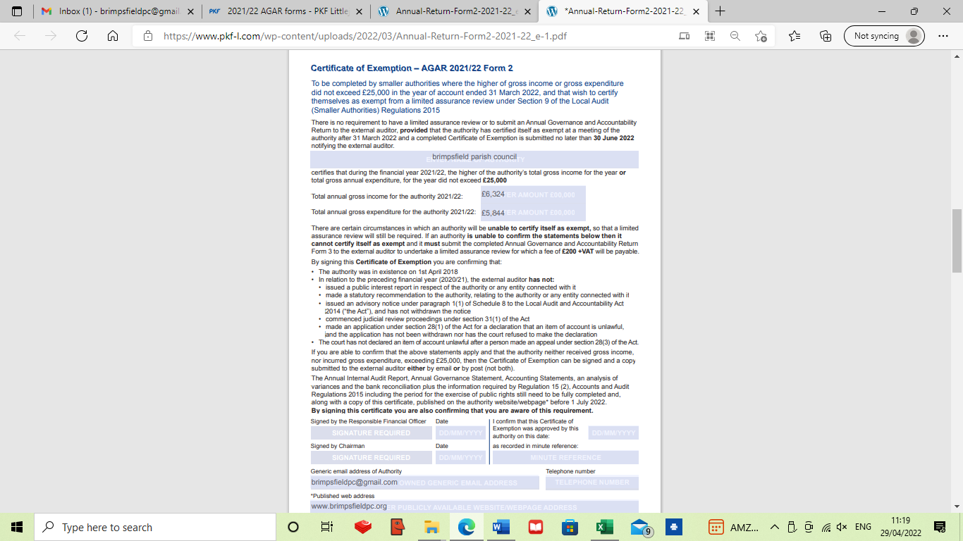

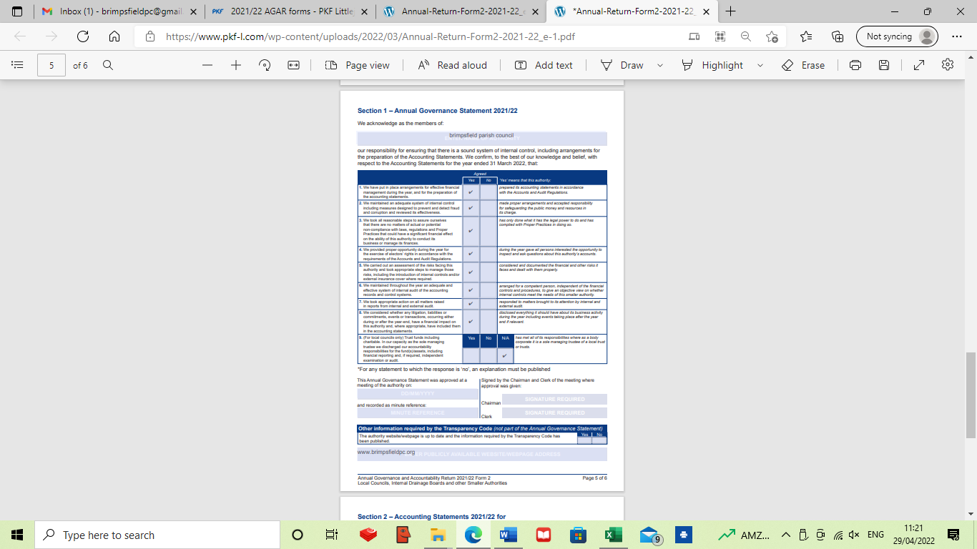

**Annual financial statement**

