Description of class:
Hawaiian Lomilomi is an ancient, multi-faceted concept that involves the movement of energy through bodywork. With the right understanding and training, the practitioner can communicate through the soft tissues of the body, deep into the bones of the individual.
Traditionally, the training to become a Lomi practitioner could take years. A student not only had to learn bodywork, but also grasp the many concepts of Lomi. The student had to exhibit mental, emotional and spiritual balance, before he/she was allowed to treat anyone.
During our time together, we will touch on Hawaiian history to understand how Lomi came to be where it is today. We will discuss Ho’opono’pono, the ancient tradition of bringing yourself into alignment/balance. We will see what the Hawaiian system of Ahupua’a has to teach us in today’s world.
During this workshop you will learn a full body, fundamental Lomi routine. Through discussion of Hawaiian traditions and learning some simple chants, you will acquire a ‘feel’ for this work, and begin to understand it’s depth.
Consider joining us for this fun, educational, healing experience.
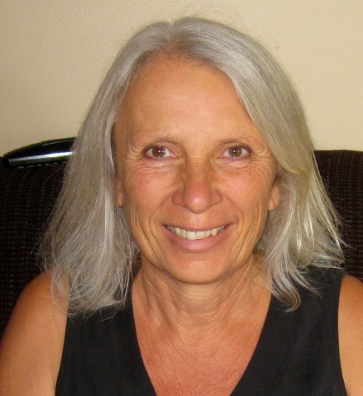
Bio:
Angela has been a licensed massage therapist in Hawaii since 1995. She began her teaching career 5 years later at her alma mater, The Hawaiian Islands School of Massage (a 1,000 hour program). She taught beginning and advanced classes in therapeutic, medical massage. She went on to develop a massage program for Japanese students, culminating in a class in Tokyo, Japan.
In 2006 Angela founded The Aloha Massage Academy in Kona, Hawaii, which offers a 570 hour, Hawaii State licensing curriculum. It continues to serve the local and visitor community.
She was certified to teach Lomilomi I by her Kumu (teacher), Maka'ala Yates in 2006, after studying with him for several years. He has since trademarked his style as Mana Lomi©. Maka'ala is a highly respected Kanaka Maoli (of Hawaiian ancestry) and a student of the renowned Aunty Margaret. His life work is studying, practicing and teaching Lomilomi.
On a fun note, Angela just published her first book: The Way of Love on the Camino de Santiago - a memoir of her 500 mile pilgrimage across Spain in 2016.

