WELCOME–ANNOUNCEMENTS Mary Fulton
JOYS AND CONCERNS
OPENING PRAYER Pastor Rod Brower
PRELUDE Jenny Claybaugh, Jane Wildermuth
SONG LEADER Diane Lewis

Please stand as able. Liturgist: Tracey Notestine
*CALL TO WORSHIP (responsive) Based on Galatians 5:16-18 ,22-23 &25
NIV modified
Leader: So I say, let us walk by the Spirit and we will not gratify the desires of the flesh.
People: For the flesh desires what is contrary to the Spirit, and the Spirit desires what is contrary to the flesh.
Leader: They are in conflict with each other, so that we are not to do whatever we want.
People: But if we are led by the Spirit, we are not under the law.
Leader: Seeds sown from the Spirit produce love, joy, peace, forbearance, kindness, goodness, faithfulness, gentleness, and self-control. Against such things there is no law.
All: Since we live by the Spirit let us keep in step with the Spirit.

HYMNS Holy Ground X2 #2272 FWS Jesus Calls Us #398 UMH

*UNISON PRAYER – O God, we want to be made new in
Christ. At times we know the changes will be so radical they seem miraculous, while other times the changes will be so subtle, we’ll hardly be able to detect any change. We ask for your Holy Spirit to change our values, our motives, and the way we respond, so they will know you are working in our lives in an amazing way. Amen. (itumc Bulletin 4-22)

SCRIPTURE: Acts 4: 5-12

PRAYERS OF THE PEOPLE Diann Gault
THE LORD’S PRAYER
Our Father who art in heaven, hallowed be thy name. Thy kingdom come, thy will be done on earth as it is in heaven. Give us this day our daily bread, and forgive us our trespasses
as we forgive those who trespass against us. Lead us not into temptation, but deliver us from evil. For thine is the kingdom, and the power, and the glory forever. Amen

HYMN I Surrender All #354 UMH

WORSHIPING GOD WITH TITHES & OFFERINGS
*DOXOLOGY – Praise God, from Whom All Blessings Flow #95
*PRAYER OF THANKFULNESS – Accept these gifts, O God, as testimonies of our love for you and our desire to serve you. Let these offerings be an affirmation that we are bound to one another as your people. In your generous name we pray. Amen

Prayer for Illumination (in unison)
Holy Creator, we understand we reap what we sow. Therefore, we are asking you to plow up and prepare the fleshy soil within us and plant the life-saving seeds of your Spirit. Saturate us with the Light of Your Word (which creates new life) that these seeds may germinate with deep roots which ultimately produce a Holy, Bountiful, and Fruit-filled harvest. Amen

Scripture Reading Hosea 10:12
Message: The Irrefutable Law Pastor Rod Brower Response to the Word: As the Holy Spirit Leads

HYMN Give Thanks X2 #2036 FWS

BENEDICTION

THOSE ASSISTING WITH OUR SERVICE:
Musicians: Jenny Claybaugh, Jane Wildermuth
Sound Andy Wildermuth, Kathy Berg
Ushers: Don Lewis, Bill Fulton, Denny Stryker, Lynne Snipes, Mike Brunson, Jason Brunson
Prayer Chain: Julia Armstrong: 937-844-7964 or
Lorna Brunson: doone53@centurylink.net
Bulletin Items: Rosemary LeVan: 937-722-7935 or
rlevan1338@gmail.com
Internet Logins: Church Building: ltumcfourU
Community Center: JCLVSyou1
Changing Tables: Church Building: Upstairs in the Nursery
Community Center: in each restroom
Adult Sunday School Class/Lay Leader: Mary Fulton
Sunday School Superintendent/VBS/God’s Team: Diane Lewis

STRAWBERRY FESTIVAL APRIL 26, 2024 5 – 7 p.m.
Pie Shortcake Ice Cream Sandwiches Sides

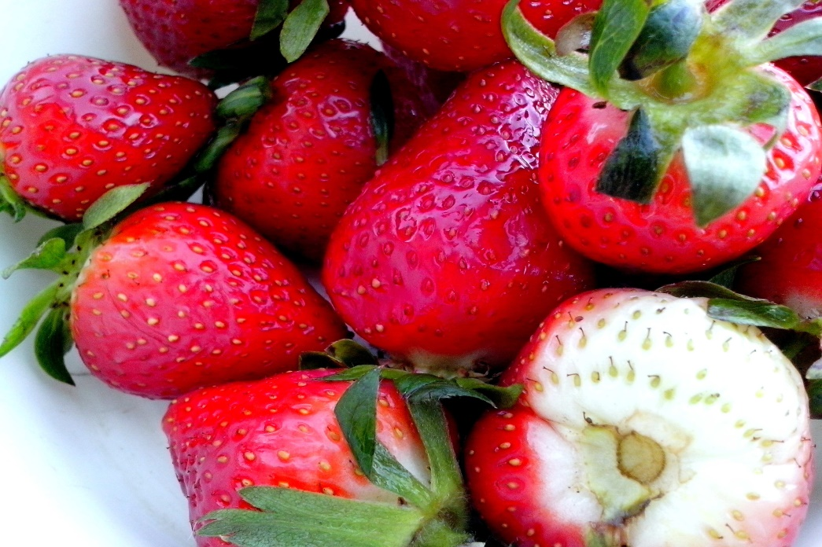

LEWISTOWN-TRINITY UNITED METHODIST CHURCH
740-727-9999 – pastorrodb@gmail.com
April 21, 2024
In-Person Worship Service – 11:00 - 8088 CR 54, LewistoNEW ADDRESS: P.O. Box 90, Russells Point OH 43348
Worship with us on Facebook

