|  |  |  |  |
| --- | --- | --- | --- |
| Pleasant Township Index | **Pleasant Township**  **Zoning Commission Minutes**  **1035 Owens Rd W.**  **Marion, Ohio 43302** | | |
|  | | | |
| Meeting called by: | Scheduled | Type of meeting: | Regular Monthly |
| Chairperson: | Mr. Holler | Secretary: | Tim Michael |
| Timekeeper: |  | Date: June 18, 2020 | Time 7:30 pm |
|  | | | |
| Call to Order by: | Mr. Holler Moment of silence followed by the pledge to the flag. | | |
| Roll Call: | Scott Ballenger, Jack Dean, Harry Holler, Tom Leib, Dwight Williams  Tim Michael Secretary / Alternate | | |
| Minutes: | Read and approve minutes from previous meeting. (May pass out earlier)  Motion to approve minutes by: Mr. Leib Seconded by: Mr. Williams Roll call: All approved | | |
| **Attendees Address Board:** Have sign in sheet on desk by door. | | | |
| **Type in attendees and addresses:**  . | | | |
| **----- Agenda Topics -----** | | | |
|  | | | |
| **Business** | | | |
| Zoning Reports: | Zoning Inspector goes over reports and provides copy to board. | | |
| Unfinished: |  | | |
| New: |  | | |
| Announcements: | Next meeting will be: July 16, 2020 | | |
| Adjournment: | Motion to adjourn by: Mr. Williams Seconded by: Mr. Ballenger all in favor: all approved | | |

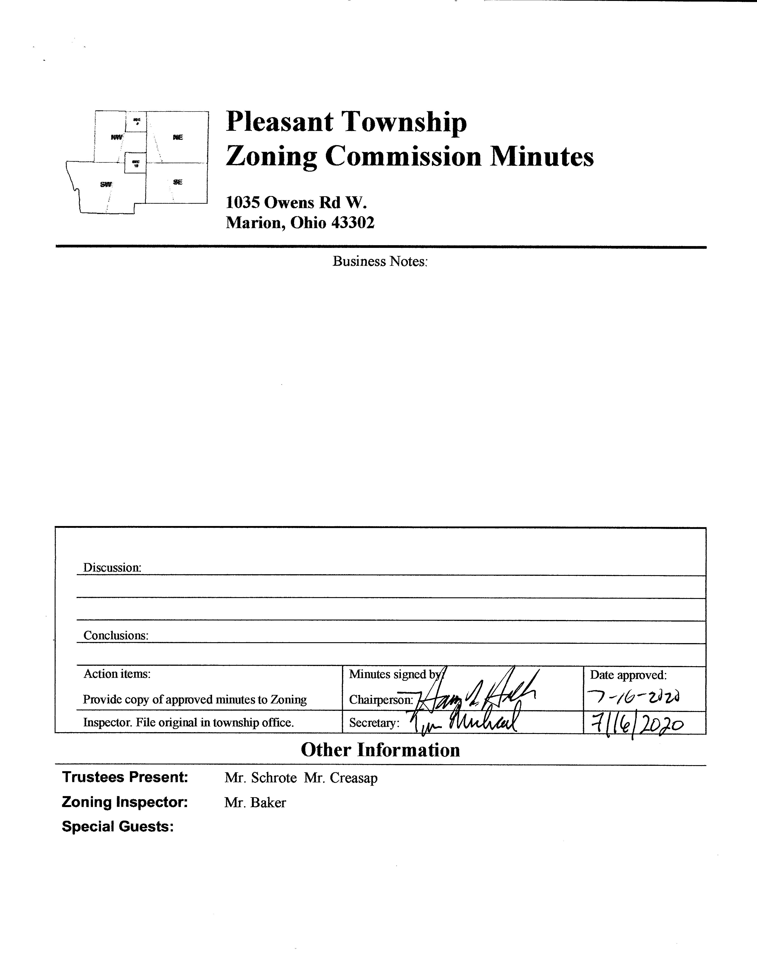

Minutes

|  |  |  |  |  |  |  |
| --- | --- | --- | --- | --- | --- | --- |
| |  | | --- | | 1. The Pleasant Township Zoning Commission met for their regularly scheduled monthly meeting on June 18th 2020 at the Pleasant Township Senior Center. Zoning Commission Board members present were: Mr. Ballenger, Mr. Dean, Mr. Leib, Mr. Williams, Chairperson Mr. Holler, Secretary Mr. Michael, and Township Zoning Inspector Mr. Baker. | | 1. Minutes were read from the May 21st 2020 regularly scheduled Zoning Commission meeting. There being no stated corrections a motion to approve the minutes was made by Mr. Leib and seconded by Mr. Williams. All members present agreed to passage of the minutes. | | 1. Mr. Tom Baker Pleasant Township Zoning Inspector submitted the following inspection report for the month of May 2020: there was 1 permit for a new home, 1 permit for a sign, 3 permits for accessory buildings, 2 permits for fences, 4 permits for decks, 4 permits for porches, 1 permit for a concrete patio, 4 permits for pools, 2 business permits, and 2 driveway permits. Dollar amount for new construction totalled $382,990.00, with income from permits totalling $1,800.00, and income from appeals totalling $300.00. | | 1. Ms. Evelyn Warr-Cummings of the Marion County Regional Planning Commission is to provide an updated version of the draft model language document covering solar energy for inclusion in the Pleasant Township Zoning Resolution based on discussions held during the June Zoning Board meeting. As of the time these minutes were published this update has not been provided. The update when provided will be emailed to the Zoning Board members for discussion during the July 2020 meeting. | | 1. There being no additional business for discussion Mr. Williams made motion to adjourn, seconded by Mr. Ballenger all Zoning Board Members in attendance agreed and the meeting was adjourned. The next scheduled Zoning Board Meeting will be held on July 16th 2020 at 7:30 PM. | |  | |
|  |
|  |
|  |