WINDLESTONE PARISH COUNCIL

7 Front Street, Bishop Middleham, County Durham. DL17 9AJ Tel: 07808062525 Email: karenyoung311@yahoo.com / kyounghusband@ferryhill.gov.uk

ORDINARY MEETING

Time: 5.45pm Private Section of Meeting Date: Tuesday, 2nd April 2024 Venue: Hutton House, Chilton 6.00pm Public Section of the Meeting

Dear Councillor, you are hereby summoned to attend the above meeting at which the following business will be transacted.
AGENDA

- Welcome by the Chair
The Chair to open the meeting and make any necessary announcements.

- Apologies for Absence
To receive apologies for absence

- Declarations of Interest
To notify of items that appear on the agenda in which Members may have an interest.

- Exclusion of Press and Public
Members are requested to move the following motion:
“That in accordance with the provision of Section 1 of the Public Bodies (Admission to Meetings) Act 1960, as amended by Section 100 of the Local Government Act 1972, the Council do now exclude the public and press for the item 5 on the Agenda by reason of the confidential nature of the business to be transacted since publicity would be prejudicial to public interest.”

- Casual Vacancy
To consider an application received for the Casual Vacancy position of Councillor with Windlestone Parish Council.

- Minutes
To Approve the Minutes of the Ordinary Meeting of Windlestone Parish Council held on 5th March 2024 as an accurate record (attached).

- Matters Arising from the Minutes
To clarify or provide an update regarding any matter recorded in the Minutes of the Meeting held on 5th March 2024.

- Public Participation
To invite representation from Members of the Public.

- Correspondence
To consider and report any correspondence received.

- Update RE: Windlestone Hall
To receive an update regarding Windlestone Hall

- Update RE: Eden Arms
To receive an update regarding the Eden Arms

- Update RE: Rushyford Roundabout
To receive an update regarding DCC Proposals for Rushyford Roundabout

- Date & Time of Next Meeting
To agree the date and time of the next Meeting
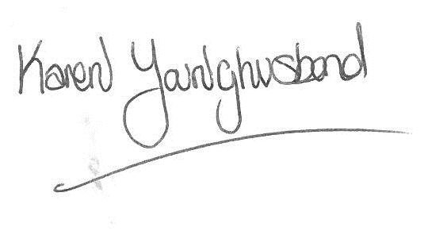
Karen Younghusband
Clerk Windlestone Parish Council

