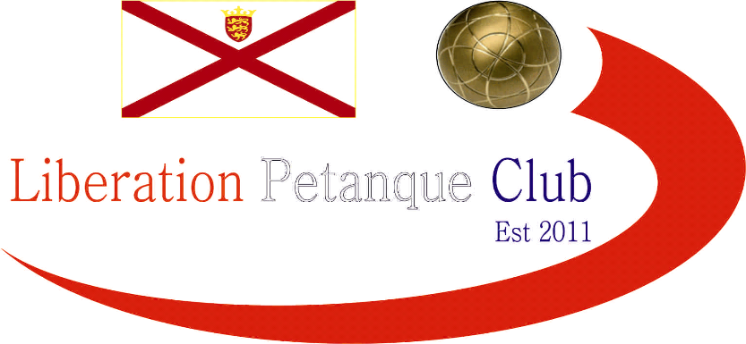
LIBERATION DOUBLES OPEN
24th March 2012
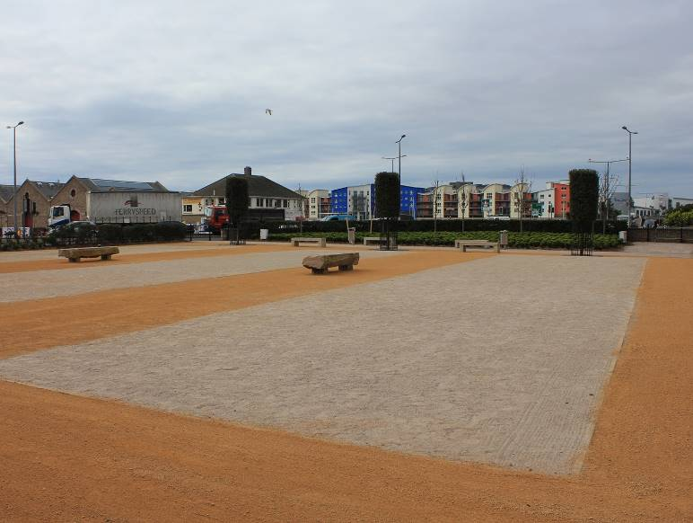
Liberation Petanque Club held its first ever open competition on Saturday 24th March 2012 with an impressive 26 teams from all the clubs in the Island taking part, hoping to take the inaugural doubles title.
Group 1 saw two of the islands best players in Matt Pinel and Jeremy Grigg win all three group games with +17 to ease into the quarter finals.
Group 2 was closer with Carrefour Petanque Clubs best two teams trying to prove they could take the title. Keith Boleat & Helene Retrosi out did their counterparts Neil Selby & Michel Morel, with both losing one match each.
Group 3 saw Liberations Summer 2011 league and cup doubles winners Toby Northern & Andrew Le Breton win all four matches +27 with Karen & Eamonn Bougeard finish second with 3 wins + 20.
Group 4 saw another top Liberation team win all 3 matches in Matt Ryan & David Ibitson knocking out a strong JPC team in Tom Glennie & Fred Paisnel.
Group 5 saw the group performance of the day in Colin Myers & Steve Simpkin as they won all four matches also against other top players from the island.
Group 6 was won by JPC stalwarts Ian & Penny Foster with Ross Payne & Brian Harris finishing second and Andrew Bellamy & Callum Stewart finished bottom losing all three matches -13.
With the Group winners automatically going through to the quarter finals, this left 2 best placed runners up spots, which went to Karen & Eamonn Bougeard with 3 wins +20 and Neil Selby & Michel Morel.
Quarter Finals were as follows:
The quarter finals were pre drawn before the competition started so it was a fluke that again Neil & Michel played Keith & Helene, but this time Neil & Michel made light work of their fellow club members.
Toby & Andrew, couldn’t beat Matt & Jeremy but did give them a scare tied at 8-8. Matt & David hit top gear showing their title credentials with an easy win over Karen & Eamonn. Penny & Ian holding up the flag for the Jersey Petanque Club.

Neil Selby & Michel Morel | 13 | V | 1 | Keith Boleat & Helene Retrosi
Toby Northern & Andrew Le Breton | 8 | V | 13 | Matt Pinel & Jeremy Grigg
Karen & Eamonn Bougeard | 3 | V | 13 | Matt Ryan & David Ibitson
Colin Myers & Steve Simpkin | 5 | V | 13 | Penny & Ian Foster

So with all three of the main clubs represented in the semi finals, it was going to be a battle to get through to the final.
Matt & Jeremy show great composure to beat Neil & Michel 13-5, but the second semi final was much closer as Ian & Penny ended up one point short of a final spot losing 13-12 to Matt & David.
Well a turn up for the books as David’s excellent placing out doing Jeremy Grigg’s on almost every end as Matt & David won convincingly 13-2 for a Liberation team to retain its own club trophy.

We hope you all enjoyed the day, thank you for being part of our competition.

Winners pictured below

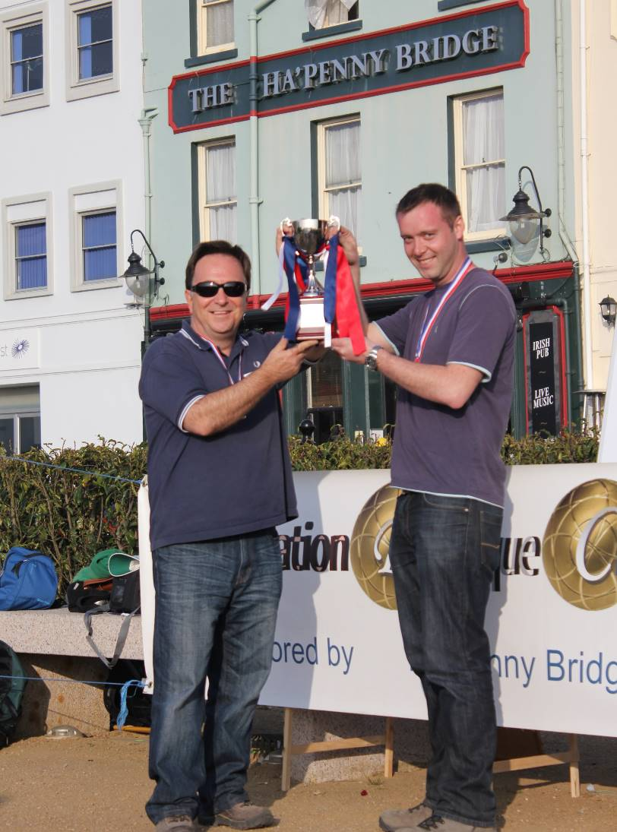

CLUB SPONSORS

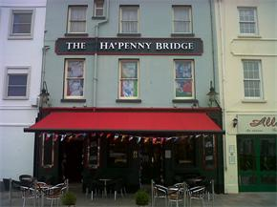

Look forward to seeing you all back again next year!

Kind Regards
Toby Northern
Chairman
Liberation Petanque Club

