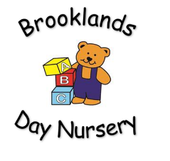

We believe that every child deserves the best possible start in life and support to fulfil their full potential. The welfare, safety and protection of all children in our care is paramount.

At Brooklands Nursery we aim to:

* To provide the highest quality of care and education for the children possible through play and interaction.
* To treat each child as an individual (free from any form of discrimination) and show respect for a child’s culture, ethnic origin or religion.
* To treat all parents/ carers with respect, courtesy and friendship.
* To provide learning opportunities through enjoyable stimulating and exciting surroundings. We will encourage a child’s learning by meeting the interests, needs and abilities of all age groups within Brooklands Nursery.
* To encourage children to be independent and provide freedom of choice.
* To work strongly in partnership with parents/carers and professionals within and outside the nursery.
* To educate children in our care about the society and world we live in through holding Strong British Values
* To establish and maintain happy and positive relationships with all children in our setting.
* To encourage a child’s expression of emotion, such as; anger, frustration, sadness, excitement and happiness, whether it be with peers of staff members.
* To create a happy, safe and stimulating environment and atmosphere where the children can express themselves and develop their character without being judged.

At Brooklands Nursery, we pride ourselves in being extremely committed to the continued professional development of our staff team and we hold high expectations of all that form part of the Brooklands team. We have a tight vetting and recruitment procedure to ensure that our standards remain high and that your child/children remain in good hands.

**AIMS OF THE NURSERY**

**Brooklands Private Day Nursery**