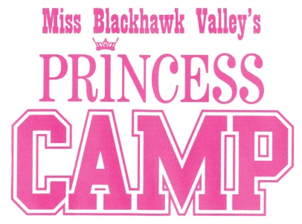

Princess Program Enrollment Form, 2020
Print the name of the Princess, her parents and sponsors exactly as you want it to appear in the
Miss Blackhawk Valley Program Book.
Princess Name: __________________________ Age: _______ Birth date ______
Sponsor(s): __________________________________________________________
(Grandparents, Parents, Business, etc.)
Parent/Guardian Information:
Names: _____________________________________________________________________
Relationship: ________________________________________________________________
Mailing Address: _____________________________________________________________
City: ___________________________________________ State: _____ Zip: _____________
Cell Phone: ______________________ Email: _____________________________________

T-Shirt Size: (Please check one.)
[ ] Youth Small [ ] Youth Medium [ ] Youth Large
[ ] Adult Small [ ] Adult Medium [ ] Adult Large
Send this enrollment form to Kaitlyn Wehr 4440 N. Wolcott Ave. #209, Chicago IL 60640 on or before December 15, 2019 along with:
- $100 enrollment fee with the name of the sponsor
- Digital photograph in .jpg format, head shot
- Copy of birth certificate

I hereby give the Miss Blackhawk Valley Scholarship Program permission to use my daughter’s picture and name for publicity in newspapers, Web pages, TV and radio.
_____________________ ___________________________ _______________
Princess name Parent/Guardian name Date
Revised 9/2019

