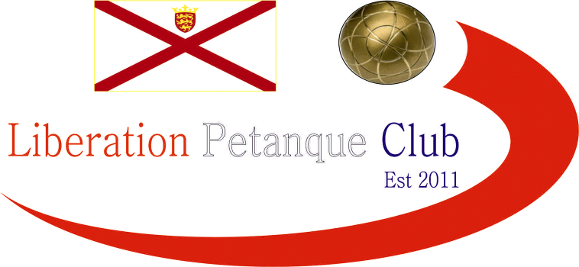

**SUMMER 2024 SEASON**

**WEEK 24 – 11th September 2024**

**DOUBLES LEAGUE**

# The penultimate Doubles League week as we near the end of the season.

# All to play for in the Premier League with several teams fighting it out for the prestigious Premier League title.

# Andrew & Callum needed to beat JPA league compatriots Alan & Joey to keep their hopes alive which they only just managed winning game one 13 – 12! Whilst Neil & Ross played Laurent & Jean who needed a win to move clear of relegation. A big 13 – 3 win in game one for Neil & Ross before they lost 13 -0 in the second game for a draw!

# Leaders Geoffroy & Matt played Graeme & Keith knowing a win would give them an advantage going into the final week but could only draw, their fourth of the season so with Andrew & Callum having matches in hand they could move top if they can win them both.

# Keith & Mo already relegated so Alex & Brian needed to beat them to have any chance of rescuing their top flight status, but Keith & Mo finally got their first win of the season.

# Relegation double header between Gary & Wendy and Daniel & Toby postponed.

# A number of catch up matches still to play also.

# The Division 1 title went to James & Ross despite their game against Cassie & Chris. Being postponed. Congratulations to the two of them.

# Two teams aiming for promotion in Colin & Steve and John & Nick, drew with each other as did Daniel & James against Alan & Mike.

# *Outstanding Matches*

# Division 1

# Cassie & Chris Stewart-Le Gallais v James Rondel & Ross Churchill

# Premier League

# Jean Stewart & Laurent Pellaton v Alan Oliveira & Joey Le Clech

# Jean Stewart & Laurent Pellaton v Callum Stewart & Andrew Bellamy B

# Graeme Follain & Keith Pinel v Callum Stewart & Andrew Bellamy B

# Graeme Follain & Keith Pinel v Neil Selby & Ross Payne

# NEXT WEEK - SINGLES LEAGUE

# Club email address - [liberationpc@gmail.com](mailto:liberationpc@gmail.com)

# Club Website - [www.liberationpetanque.co.uk](http://www.liberationpetanque.co.uk)

# Kind Regards

# Toby Northern

# Chairman

# Liberation Petanque Club