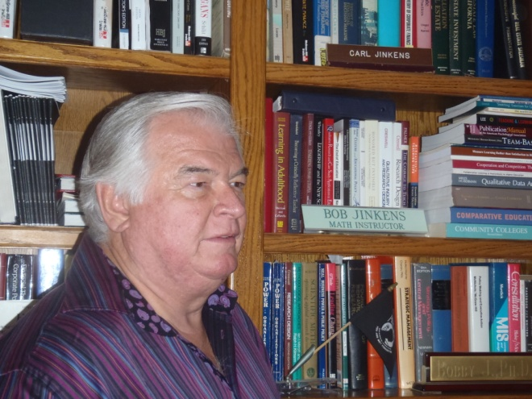

Robert C. Jinkens, PhD, CPA

jinkens@hawaii.edu

http://jinkens.info

Dr. Jinkens began his professional carrier with four years of public accounting after completing a BS in Accounting and a BA in Mathematics at the University of Southern California. During this time he also obtained a California CPA and a California Real Estate Broker’s License. He then managed a grocery store for 10 years while simultaneously teaching accounting at a community college, as well as obtaining an MBA from the University of California at Irvine; managing commercial real estate, syndicating commercial real estate investments; building two homes; and because of his love for education, starting a PhD at the University of Southern California. Dr. Jinkens was not able to complete this PhD because of family demands following the death of his father, and instead earned a master’s degree in Finance, but he continued to teach, and finally completed a PhD in Education with a concentration in accounting education at the University of Hawaii at Manoa, and a Post Doctorate in Accounting and Finance at the University of Florida at Gainesville. In total he has over 35 years of experience in education and over 15 years of applied experience in business, as well as 6 degrees from prestigious universities, 10 teaching credentials, a California CPA, a Hawaii CPA, and a California Real Estate Broker’s License.

