TERZEPATIDE AND SEMAGLUTIDE CONSENT

Terzepatide and Semaglutide is a human-based glucagon-like peptide receptor agonist prescribed as an adjunct to a reduced calorie diet and exercise for chronic weight management in adults with an initial body mass index (BMI) that is considered outside a healthy range. Terzepatide and Semaglutide can help your body regulate blood sugar and decrease how much food you eat. Studies have shown that Terzepatide is more effective than Semaglutide for weight loss, but only Semaglutide is approved for weight loss.

While using Terzepatide or Semaglutide, it is highly recommended that you:
- Eat a fibrous diet. Focus on fruits and vegetables that are high in fiber.
- Eat small high-protein meals as digestion is slowed down while on this medication.
- Avoid foods high in fat as they take longer to digest.
- Limit alcohol intake to prevent side effects of nausea.
- Drink at least 32 oz of water a day to avoid constipation.

Do not take this medication if:
- You have a personal or family history of follicular thyroid carcinoma (Thyroid Cancer)
- Multiple Endocrine Neoplasia syndrome type 2
- You are pregnant or plan to become pregnant while taking this medicine.
- You are diabetic and taking medication that lowers your blood sugar levels. Taking Terzepatide or Semaglutide with your diabetes medication may increase your risk of hypoglycemia (low blood sugar).
- You have a history of acute/chronic pancreatitis.
- You have a history of kidney failure.
- You have a history of diabetic retinopathy and diabetic macular edema.
- You have a history of severe anxiety, depression, or suicidal thoughts.
- You are allergic to Terzepatide or Semaglutide or any other GLP agonist such as Adlyxin®, Byetta®, Bydureon®, Ozempic®, Rybelsus®, Trulicity®, Victoza®, Wegoby®;
- If you have other allergies. This product may contain inactive ingredients, which can cause allergic reactions or other problems. Talk to your pharmacist for more details. Before using this medication, tell your doctor/pharmacist your medical history.

Possible drug interactions:
Anti-diabetic agents, specifically Insulin and Sulfonylureas (e.g., glyburide, glipizide, glimepiride, tolbutamide) due to the increased risk of hypoglycemia (low blood sugar). Do not take with other GLP agonist medicines such as: Adlyxin®, Byetta®, Bydureon®, Ozempic®, Rybelsus®, Trulicity®, Victoza®, Wegoby® (THIS IS NOT AN ALL-INCLUSIVE LIST). For other medications used in diabetes, please tell your provider about any medications that may lower your blood sugar.

Possible side effects:
Severe stomach problems that won’t go away. Severe stomach problems have been reported with Terzepatide and Semaglutide. A delay in stomach emptying can cause severe vomiting, dehydration, and constipation. Tell your healthcare provider if you have stomach problems that are severe or will not go away.

Gastrointestinal Side Effects: Because Semaglutide slows down the digestive process, it can cause gastrointestinal side effects that you might not be used to. Some of the most common side effects of Terzepatide and Semaglutide include nausea, diarrhea, vomiting, constipation, abdominal pain, headache, fatigue, dyspepsia, dizziness, abdominal distension, belching, hypoglycemia, flatulence, mild gastroenteritis, and gastroesophageal reflux disease. In studies, most nausea, vomiting, and diarrhea events occurred while the dose of Terzepatide and Semaglutide was being increased. These events decreased over time.

To Reduce Gastrointestinal side effects: Eat smaller meals. Avoid fat or fatty foods. Stop eating when you feel full. Try eating bland foods like toast, crackers, or rice. Over-the-counter medicines like Pepcid-AC for reflux or Lomotil for diarrhea can be helpful.

Low Blood Sugar (Hypoglycemia): Signs and symptoms of low blood sugar may include dizziness or light-headedness, sweating, confusion or drowsiness, headache, blurred vision, slurred speech, shakiness, fast heartbeat, anxiety, irritability, or mood changes, hunger, weakness, and feeling jittery. If you have hypoglycemia symptoms, do the following: Eat or drink 15 to 20 grams of fast-acting carbohydrates. These are sugary foods or drinks without protein or fat that are easily converted to sugar in the body. Try glucose tablets or gel, fruit juice, regular (not diet) soda, honey, or sugary candy.

Thyroid Cancer: Tell your healthcare provider if you get a lump or swelling in your neck, hoarseness, trouble swallowing, or shortness of breath. These may be symptoms of thyroid cancer.

Inflammation of your pancreas (pancreatitis): Stop using Terzepatide or Semaglutide and call your healthcare provider immediately if you have severe pain in your stomach area (abdomen) that will not go away, with or without vomiting. You may feel the pain from your abdomen to your back.

Subcutaneous Injections: common injection site reactions characterized by itching and burning at the administration site with or without skin thickening (welting). If you notice other side effects not listed above, contact your doctor or pharmacist.

Gallbladder problems. Gallbladder problems have happened in some people who
use Terzepatide and Semaglutide. Tell your healthcare provider immediately if you get symptoms of gallbladder problems, including pain in your upper stomach (abdomen), fever, yellowing of skin or eyes (jaundice), and clay-colored stools.

Kidney problems (kidney failure). In people with kidney problems, diarrhea, nausea, and vomiting may cause a loss of fluids (dehydration), which may cause kidney problems to get worse. You need to drink fluids to help reduce your chance of dehydration.

A severe allergic reaction to this drug is rare. However, get medical help immediately if you notice any symptoms of a severe allergic reaction, including rash, itching/swelling (especially of the face/tongue/throat), and very rapid heartbeat, severe dizziness, feeling faint, trouble breathing. Report adverse side effects to your doctor or pharmacist. In the event of any emergency, call 911 immediately.

I agree to obtain and be cared for by a primary care physician during my treatments and to report to him or her any side effects, physical and emotional.
Choosing the injection site:
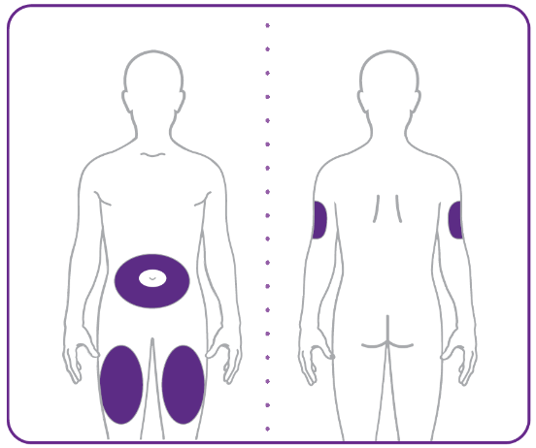

• Your healthcare provider can help you choose the injection site that is best for you.
• You or another person can inject the medicine into your stomach or thigh.
• Another person should give you the injection in the back of the upper arm.

IF YOU HAVE ANY QUESTIONS AS TO THE RISKS OR HAZARDS OF THIS TREATMENT OR QUESTIONS CONCERNING THIS TREATMENT OR OTHER POSSIBLE TREATMENTS, ASK THE STAFF NOW BEFORE SIGNING THIS CONSENT FORM.

By signing, I certify that I have read and understand the contents of this form. I know the possible side effects and drug interactions and consent to treatment. I have informed the medical staff of any known allergies to drugs or other substances and any past adverse reactions I’ve experienced. I have informed the medical staff of all medications and supplements I’m currently taking. I understand other ways and programs can assist me in my desire to decrease my body weight and acknowledge that no guarantees have been made to me concerning my results.

I understand and agree that all services rendered to me are charged directly to me and that I am personally responsible for payment. I further agree, in the event of non-payment, to bear the cost of collection or Court costs, and reasonable legal fees, should this be required.

I agree that this constitutes full disclosure and that it supersedes any previous verbal or written disclosures. I certify that I have read and fully understand the above paragraphs and that I have had sufficient opportunity for discussion and to ask questions. I consent to the Semaglutide/Terzepatide cosmetic treatment today and for all subsequent treatments.

______________________________________ ___________
Patient Signature Date

______________________________________ ___________
Witness Signature Date

