Where Are They Now?

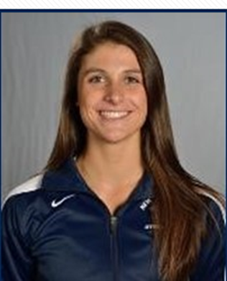
Jennifer King
A 2013 SSI Gymnast who have continued gymnastics at D1 University of New Hampshire – Team NJ’s Jen King. Jen had strong performance at the Senior Showcase meet finishing in the top 5 overall. She has continued her winning ways as UNH Wildcats earning EAGL Championship ring in her first season for the blue & white.
King, from Freehold NJ’s Freehold HS placed 4th overall in the 2013 SSI meet with a 37.825 and helped Team NJ earn 3rd place overall. As a Kinesiology /Exercise Science major at UNH she has made 2 appearances on the NACGC/W Scholastic All- America Honors roll and is also a 2 time member of the EAGL All- Academic team. As a freshman she posted career high scores of 9.825 on vault vs. Yale and 9.75 on bars vs. Towson and William & Mary. Although recovering from surgery in 2014-15 King returned to the bars line up mid- season. She improved her scores at each meet finally besting her bars record with a 9.80 at the 2015 EAGL championship. Her favorite skill is the Jaeger on bars.

