**Cornhole Open**

**Boards Available**

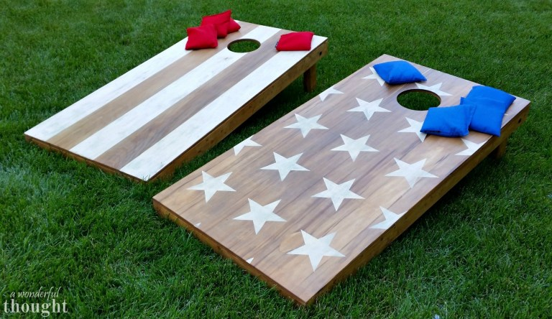

**No tournament for 2023 Fall Fest**