OUR HISTORY
The Roy I. Rhodes Chapter 306, Inc. of the Vietnam Veterans of America, located in Morgantown, WV has been established as a Chapter for over 25 years. During those years, our numbers have increased and decreased but our Members and our Associate Members have worked together for many causes, fundraising events and support to each other while remaining “in service to America” and our community.

OUR MEETINGS
The Roy I. Rhodes
Chapter 306 meets
the first Monday of every month at 7:00 PM at:
The Elks Lodge #411
1138 Chestnut Ridge Road Morgantown, WV 26508

OUR WEBSITE
For more information please visit our newly updated
website at:

www.VVA306.org

R & R EVENTS

Please bring your ideas for an
R & R event to the attention of the Leadership via email or at the next meeting.
We look forward to planning the 2019 R & R events with you. Please watch your email for updates.

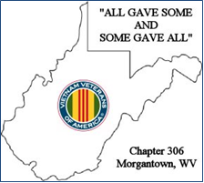

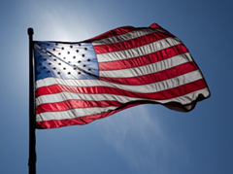

FLAG DAY
CELEBTRATION
Thursday, June 14, 2018
6:00PM
Elks Lodge

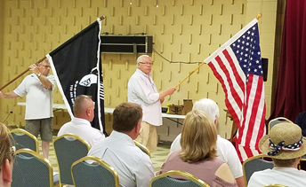

The Chapter participated in the Flag Day Event with the Elks Lodge. This event is always open to the public. It is a very informative ceremony as the history of our nation’s flag is given.

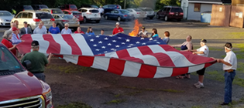

Following the ceremony, a dignified flag disposal was held by VVA Chapter 306. After the flag disposal was completed, the group gathered as refreshments were served.
Thank you to the AVVA ladies for dessert! Plan to attend the 2019 Flag Day event!

2018 PARADES!

The Chapter will participate in the Veterans Day Parade on High Street, Morgantown, WV in November. Please watch your emails for information on the date and time of this parade. Please plan to join us!

We appreciate help carrying the Chapter Banner and the Colors.
You are welcome to ride along in a vehicle, too!

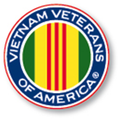

The Special Offer
of $100.00 for
LIFETIME
MEMBERSHIP
continues
for both the
VVA and AVVA
Members!

HAPPY July 4th!

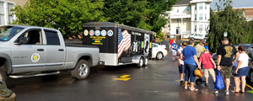

In spite of a quick thunderstorm, and a possibility of canceling the July 4th Parade down High Street, VVA Chapter 306 participated in the July 4th parade in Morgantown, WV. We are pleased to see our extended families join us.

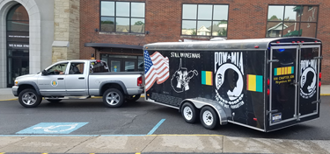

Thank you to the Members and their families who have helped make repairs and do the upkeep on the Trailer so the Chapter always looks great in a special event! We appreciate you!

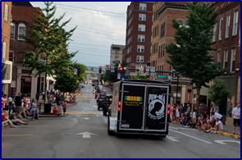

July 7, 2018
VVA Chapter 306
R & R Event at
BLACK BEARS STADIUM

Our July meeting date was changed, but later canceled.

Members of the Chapter, AVVA, along with extended family enjoyed our R&R Event at the Black Bears Stadium.

We had excellent seats in the shady side of the stadium! Thank you to Doug G.! To the surprise of the younger members of our group, we had a few visits from Cooper, the Black Bear mascot, too.

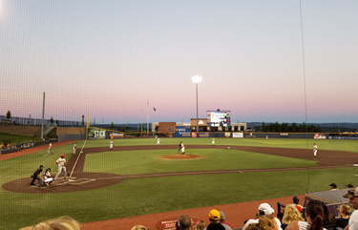

Plan to join us next season!

Veterans Affairs
Town Hall Meeting
August 17, 2018
1:00PM - 3:00PM
This meeting will be held at the Morgantown Elks Lodge, #411.
The meeting is open to the public.

SEPTEMBER 25th is
GOLD STAR
MOTHER DAY!
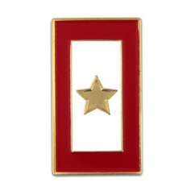

SPECIAL NOTICE!

Due to a lack of interest, the R& R trip to the
Outer Banks has been canceled for now.

This trip may be considered in the future as an
R & R event.

Please watch your email!

Chapter MEETING

SEPTEMBER 18, 2018
Tuesday at 9:30 AM

The VVA Monthly Meeting for September will be at Shoney's in Sabraton.
See you there!

2018 BUCKWHEAT FESTIVAL
Kingwood, WV

September 26 to 30, 2018

The VVA Chapter Trailer setup will be on Wednesday, September 26. Our Trailer will be there during the Festival from the 27th through the 30th.

Please contact the Chapter leadership and watch your email as we appreciate your help.

Workers are needed.

WEST VIRGINIA STATE COUNCIL MEETING

SEPTEMBER 22, 2018

Congratulations!

To Ralph Steelwell, your name is in "The Veteran"
as a new Life Member of VVA.

October 1st and 2nd
R & R Event

An R & R Event has been planned to the Apple Valley Theater and Sight and Sound Theater in Lancaster, PA. along with additional activities.

NOTE:
This trip may be complete full.
It is a time sensitive trip which includes hotel and bus tickets. So check with Doug G. if you are interested.

Special thank you to Cindy S. and others in making this trip possible!!

MEETING LOCATION
PLANS
for FUTURE MONTHS

The Chapter will return again to the Elks for our October and November meetings.

During the inclement weather months of December, January, and February, we would entertain daytime meeting hours such as breakfast and or brunch activities for our meeting.

Please watch your email for upcoming details!

The members of the VVA and the AVVA of Chapter 306 extend our deepest sympathy to
the Ogden Family in the loss
of their loved one,

George Ogden

THANK YOU for
YOUR SERVICE!

At the August 3, 2018 Chapter Meeting, President Gary Burch shared that with his medical issues and problems, he thanked the Chapter, but this was going to be his last meeting to serve as President.

First Vice President Mike Harsh will assume the duties.
Gary will remain with the Chapter and active within.

To Gary, the Chapter and the AVVA expresses, “MANY THANKS for YOUR YEARS of LEADERSHIP.”

The Chapter and the AVVA extends to Mike, “BEST WISHES and THANK YOU for STEPPING UP as CHAPTER PRESIDENT.”
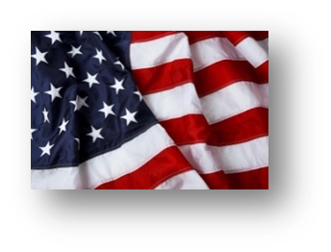

Respectfully Submitted by
VVA Chapter 306
Morgantown, WV

Janet. L. Finerfrock
Activities & Media Reporter
Gary W. Burch
President
Mike Harsh
First Vice President
Jamie Welch
Second Vice President
Doug Geary
Secretary
Don Davis
Treasurer

