

Comparison of Adiprene®/Vibrathane®/Duracast® Hot Cast Urethanes to Common Rubbers
Adiprene®/Vibrathane®/Duracast® hot cast polyurethane elastomers are firmly established as preferred or alternate
materials in many industrial applications where various types of rubbers have held sway for a long time. Various types of
polyurethanes, ranging from very hard grades [75 D durometer] to very soft [20 A durometer] and below are commonly used
in a wide variety of applications. “Hardness Ranges” sizes range from giant paper machine rolls and wheels, containing more
than 7,000 pounds [3200Kg.] of polyurethane to very small parts used in office machines, which may contain only a few
grams of material. Some of the reasons for choosing Adiprene®/Vibrathane®/Duracast® hot cast polyurethane elastomers
over the various rubbers are:
•
•
•
•
•
•
•
•
•
Better abrasion resistance
Better cut and tear resistance
Good physical properties over a wide range of hardnesses
Excellent oil and environmental resistance
Excellent dynamic performance at high load and speed
Ability to fine-tuning of properties for specific applications
Lower set up cost (machines, molds etc)
Liquid castability allows molding by a variety of techniques
Non-marking, non-staining
Most Adiprene®/Vibrathane®/Duracast® hot cast elastomers are processed as two-part liquid systems. Unlike most diene
elastomers (SBR, nitrile, natural rubber, etc.), where the desired elastomer properties are achieved by extensive
compounding of a base stock material, with castable urethanes, compounding ingredients such as fillers, plasticizers and
accelerators are generally not used except in special cases. When a different set of properties is required, the usual course is
to change to a different prepolymer or curative system.
The elastomeric properties of most diene rubbers are due to the cross linking produced in a vulcanization process. This cross
linking allows the flexible segments to extend when the elastomer is stretched, but also provides memory to allow return to
the original dimensions when the force is removed. In castable urethanes, the elastomeric properties are primarily due to the
phase segregation of hard and soft segments in the structure. For this reason polyurethane elastomers are often referred to
as segmented block polymers.
There are many different structures available in Adiprene®/Vibrathane®/Duracast® hot cast elastomers, and each of these
structures provides certain characteristics that can be used to tailor the elastomer to the specific properties needed for the
application. Each polyurethane elastomer consists of a so-called soft segment (based on a polyol) and a hard segment
(consisting of the diisocyanate reacted with a curative). The soft segments can be various polyethers, polyesters and other
polyols, while the hard segments can be various diisocyanates (TDI 1, MDI2 and others) cured with various diamines or diols.
For detailed description of the various structures, please refer to Chemtura Corporation’s Adiprene®/Vibrathane® product
selector guide (can be found on the customer CD or Chemtura Corporation’s website).
.
1
2
1
2
tolylene diisocyanate
4,4’-diphenylmethane diisocyanate
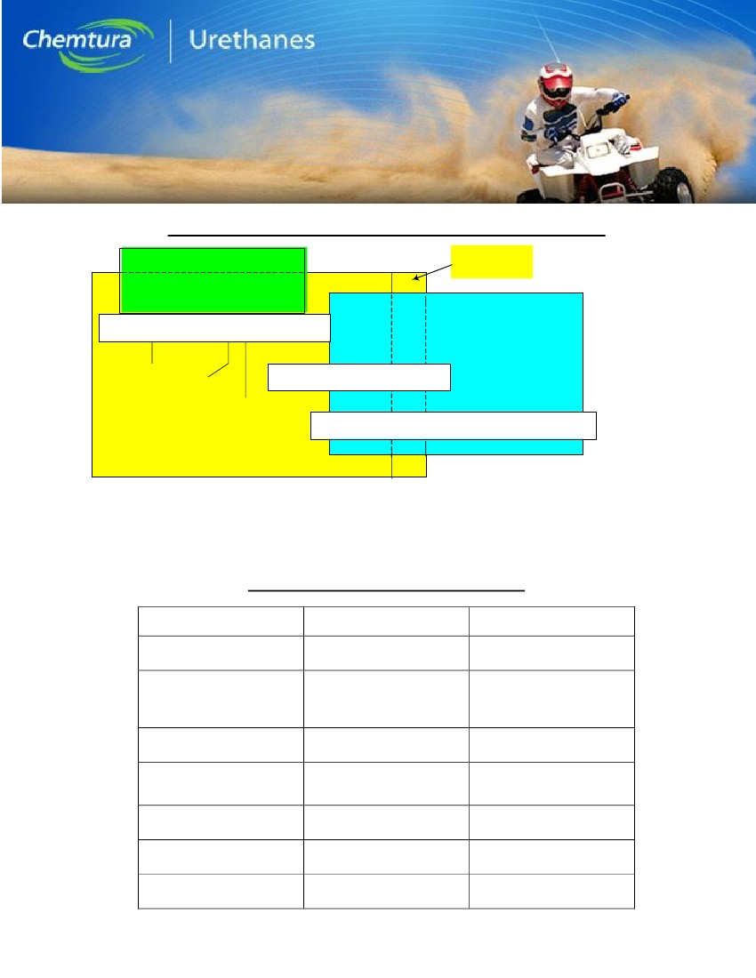
In many applications, polyurethane elastomers compete against various rubbers. Listed earlier are the main advantages of
cast polyurethane elastomers compared to the diene rubbers as a group: These characteristics allow, among other things, for
the parts to stay within desired tolerances for a longer time and extend intervals between replacements. In addition, most
Adiprene®/Vibrathane®/Duracast® hot cast urethanes have natural colors ranging from completely clear to opaque white or
amber. Their ready acceptance of a wide variety of pigments and dyes also permits coloring ranging from black to brilliant
fluorescent oranges, reds and greens. This is especially useful in color-coding of parts. Even when colored black, there is so
little pigment in the polyurethane that the compounds do not leave marks on other surfaces.
Since urethane compounds usually contain no additives that are not tied into the molecular structure (except when plasticized
for hardnesses below about 57 Shore A), there can be no migration of materials out of the elastomer to deposit on other
surfaces. Diene rubbers are subject to ozone cracking, particularly around electrical equipment where ozone concentrations
can be high. Adiprene®/Vibrathane®/Duracast® hot cast urethanes have virtually no ozone-cracking problem. The fact that
urethanes are pourable and castable results in cheaper tooling and fabrication of large parts.
Most rubber compounds when compounded up to 90 or 95 Shore A durometer have sacrificed a good deal of their physical
properties. On the other hand, polyurethane elastomers in the 85 to 95A durometer range are at the peak of their properties
and give extremely good performance at these hardnesses. When possible, urethane parts should be designed to take
advantage of this hardness range. Often, when using urethane for a part that has traditionally been made from a 60-70A
rubber, rather than seeking a urethane of the same hardness it is better to use urethane in the 85-95A range by making the
part thinner, smaller, or by implementing some other design change. This not only results in use of an optimum polyurethane
formulation but results in cost savings to the customer due to reduced material consumption. Table 1 shows some typical
applications for Adiprene®/Vibrathane®/Duracast® hot cast urethanes.
Polyurethane elastomers are available up to about 75 Shore D hardness, and although they begin to resemble hard plastics
in this range, they still have elastomeric properties. There are castable polyurethanes that go as high as 85 Shore D and are
used in a variety of applications, but their properties are more like nylon, polyacetal, epoxy and other plastics and they can no
longer be considered elastomers (Figure 1). On the other hand, polyurethane elastomers that are actually off the low end of
the Durometer A scale are made, and have uses in special applications. Polyether-based Adiprene®/Vibrathane®/Duracast®
hot cast elastomers are particularly resistant to molds, fungi and other microorganisms, making them useful in agricultural,
sewage treatment and tropical applications. While ultraviolet resistance of amine cured polyurethanes in general is good,
darkening usually occurs with outdoor exposure. Therefore, for continuous outdoor exposure, dark colors or pigments are
often used, sometimes in combination with UV-stabilizer packages. Chemtura Corporation also produces special formulations
of Adiprene® prepolymers that are light stable (aliphatic Isocyanates cured with non aromatic curatives are used).
Adiprene®/Vibrathane®/Duracast® hot cast elastomers, particularly the polyester types, are highly resistant to swelling and
deterioration by oils, greases and other non-polar solvents. Finally, the versatility of cast polyurethane elastomers is
unmatched by any other type of rubber. It is often possible to modify one property while holding others more or less
constant. For example, it is possible to formulate higher durometer elastomers with low rebound, lower durometer materials
with high rebound, and vice-versa. Similarly, it is possible to maximize flex life or tear resistance without sacrificing much
compression set over a wide range of hardness. Comparison of the general properties of Adiprene®/Vibrathane®/Duracast®
hot cast polyurethane elastomers with some common rubbers is shown in Table 2. Other important properties, such as
dynamic heat build-up and specific solvent and chemical resistance are not shown, but are available from Chemtura
Corporation. Please contact the technical service team at 1-800-243-2650.
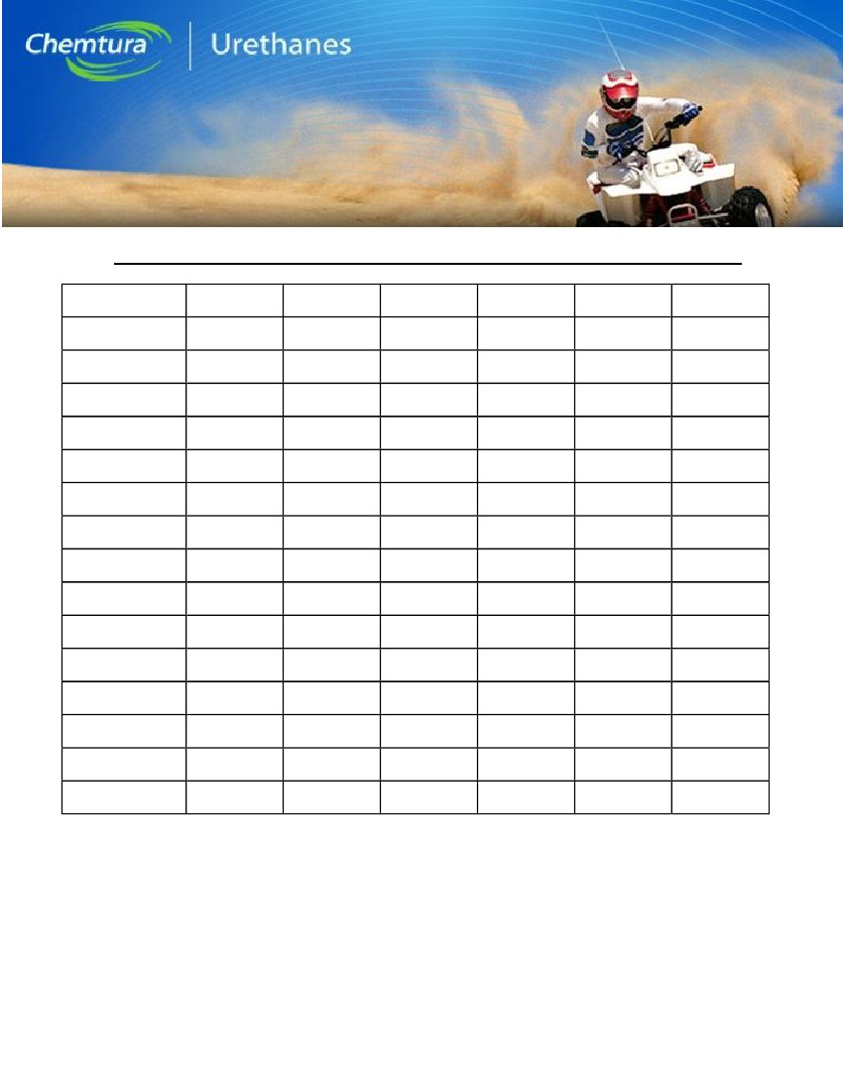
Hardness Ranges – Various Elastomers and Plastics: Figure 1
RUBBERS
CAST POLYURETHANE ELASTOMERS
s
n
o
b
ra
c
o
ro
u
lF
55
65
DUROMETER D
CAST
POLYURETHANE
PLASTICS
20
30
40
50
60
70
80
90
95
DUROMETER A
e
n
e
ly
p
o
rp
y
lo
P
75
85
PLASTICS
e
n
e
ry
ts
y
lo
P
s
n
o
ly
N
s
c
ily
rc
A
s
c
ilo
n
e
h
P
Rubber
Band
45
Auto
Tire
Tread
Mens'
Shoe Heel
50
70
90
100
110
ROCKWELL R
120
130
140
150
Table 2 shows some typical physical properties for various elastomers compared to urethane. Table 3 compares properties
of various Chemtura urethane formulations. For additional information, consult the technical data sheets of
Adiprene®/Vibrathane®/Duracast® hot cast elastomers. These data sheets can be found either on Chemtura Corporation’s
website or on the Adiprene®/Vibrathane® Customer CD.
Typical Urethane Applications: Table 1
Application
Industrial Wheels & Tires
High-Speed Amusement
Park Rides
Power Transmission Belts
Paper Mill Rolls
Office Machine Parts
Oil & Gas Pipeline Pigs
Mining Screens
Polyurethane Type
Adiprene® LF TDI Ester
Duracast® Caprolactone
Adiprene® PPDI Ethers
and Esters
Duracast® Ethers and
Caprolactones
Adiprene TDI® Ethers
Duracast® Ether
Adiprene® LF TDI
Vibrathane® MDI Ester
Vibrathane® TDI Ester
Duracast® Ester
Vibrathane® TDI Ester
Duracast® Ester
Basis of Choice
High load bearing, cut &
tear resistance
Dynamic properties, wear &
abrasion resistance
High load bearing, long
wear life
Hydrolysis, resistance,
hardness stability, dynamic
performance
Long-term environmental
resistance, wear resistance
Abrasion resistance,
petroleum resistance
Long wear, impact
resistance
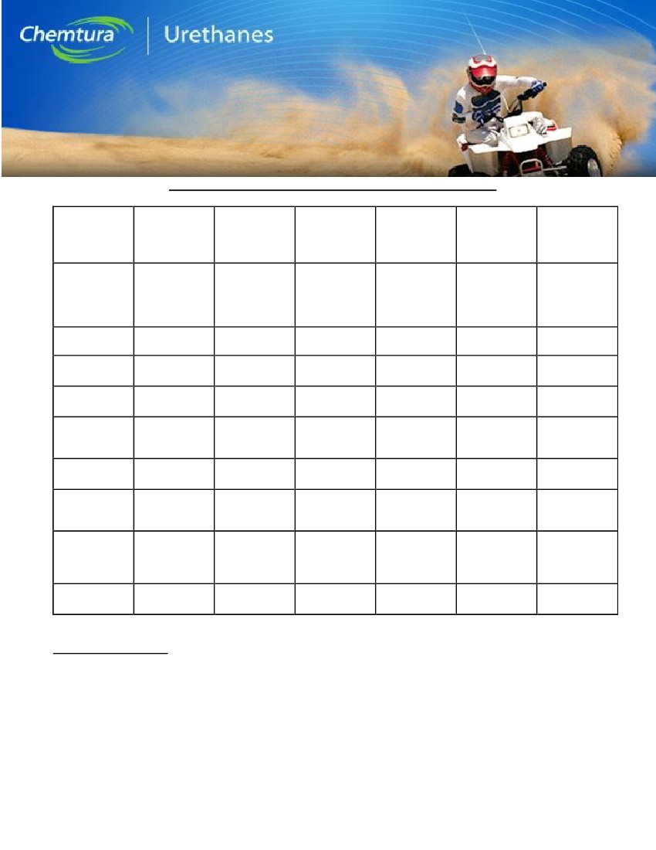
General Comparison of Polyurethane Elastomers with Various Rubbers: Table 2
Property
Tensile Strength
(MPa)
Durometer
Specific Gravity
Tear Resistance
Abrasion Resistance
Compression Set
Rebound
Gas Permeability
Acid Resistance
Aliphatic
Hydrocarbons
Aromatic
Hydrocarbons
Oil and Gas
Resistance
Oxidation Resistance
Ozone Resistance
Low Temp.
Resistance
Polyurethane
20.7 to 65.5
0A to 85D
1.10 to 1.24
Outstanding
Outstanding
Good
Very high to
Very low
Fair-Good
Fair-Good
Excellent
Fair-Good
Excellent
Outstanding
Outstanding
Excellent
Nitrile
13.8+/
40 to 95A
1.0
Fair
Good
Good
Medium
Fair
Good
Excellent
Good
Excellent
Good
Fair
Good
Neoprene
20.7+/
40 to 95A
1.23
Good
Excellent
Fair-Good
High
Low
Excellent
Good
Fair
Good
Excellent
Excellent
Good
Natural
20.7+/
30 to 90A
0.93
Good
Excellent
Good
Very High
Fair
Fair-Good
Poor
Poor
Poor
Good
Fair
Excellent
SBR
13.8+/
40 to 90A
0.94
Fair
Good-Exc.
Good
Medium
Fair
Fair-Good
Poor
Poor
Poor
Good
Fair
Excellent
Butyl
13.8+/
40 to 75A
0.92
Good
Good
Fair
Very low
Very low
Excellent
Poor
Poor
Poor
Excellent
Excellent
Good
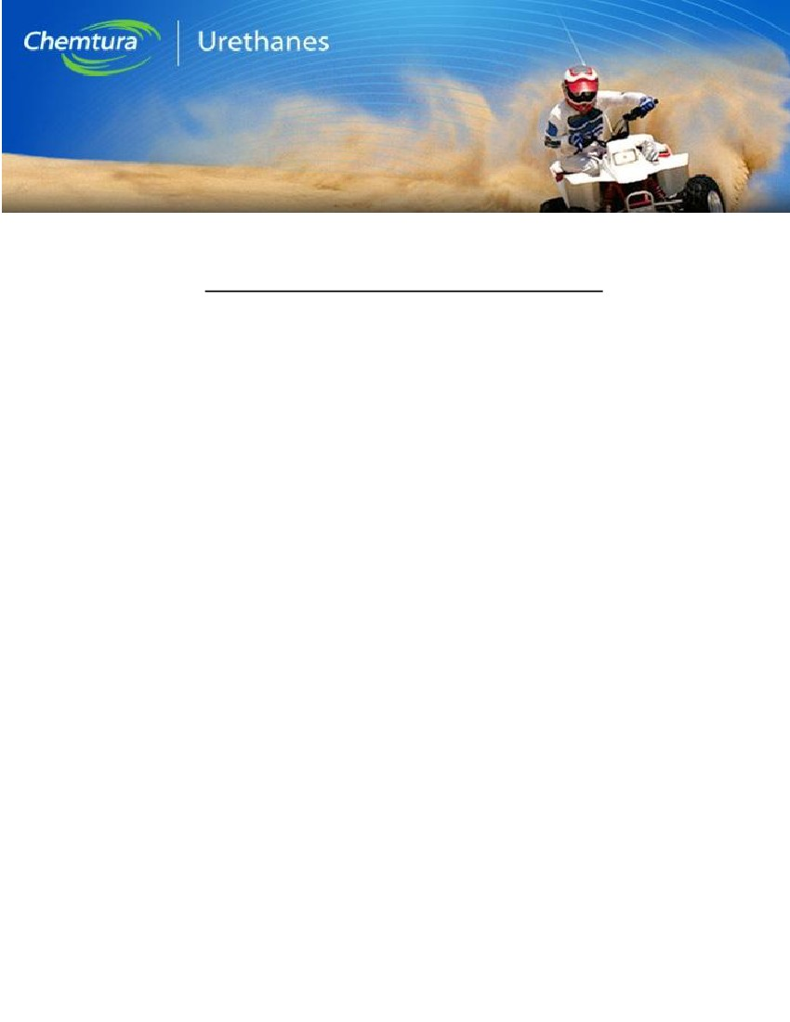
Physical Properties of Typical Polyurethanes: Table 3
Adiprene®/
Vibrathane®
TDI
Polyether
General
Purpose,
Dynamics
Polyurethane
Type
Vibrathane®
TDI
Polyester
General, High
Cut/Tear/
Abrasion
resistance
83A
7100 [48.9]
700 [4.8]
Vibrathane®
MDI Polyether
Adiprene® TDI
Polyether
Duracast®
Polyether
Duracast®
Polyester
Major
Applications
High Resilience,
Hydrolysis
Resistance
High Rigidity,
Wear
Resistance
Dynamics, high
temperature,
hydrolysis
resistance
90A
5600 (39)
100 (7.6)
Dynamics, high
temperature
abrasion
resistance
90A
5700 (39)
1000 (6.9)
Durometer
Hardness
Tensile Strength,
PSI [Mpa]
100% Modulus,
PSI [Mpa]
300% Modulus
90A
4500 [31.0]
1100 [7.6]
85A
5400 [37.2]
820 [5.6]
75D
7500 [51.7]
5500 [37.9]
6599 [44.8]
(@200%)
230
2100 [14.5]
1400 [9.7]
1300 [19.1]
1400 (9.7)
1400 (9.7)
Elongation, %
Tear Strength,
ASTM D-470,
lb/in [kN/m]
Compression
Set, Method B
(22 h@158º
F[70ºC], %
Bashore
Resilience, %
450
600
460
790
650
75 [13.1]
125 [21.9]
80 [14]
145 [25.4]
140 (29.5)
135 (23.7)
27
35
29
1.1 (Method A)
27
47
45
31
64
47
65
55
Manufacturing Methods
Since polyurethane cast elastomers are usually processed as two-part liquid systems, they lend themselves to a wide variety
of molding methods. The working life of the various systems varies from more than an hour to less than a minute, with the
harder grades having the shorter working life. The systems with long working life are usually hand batched (mixed in a
container, and then poured into the molds). Materials with shorter working life must be processed through a high-speed
centrifugal batch mixer or through an automatic meter-mix machine, which prepares, meters and mixes material components
on a continuous basis. With new systems such as Adiprene® Duracast® a variety of processing techniques (hand batching,
tank mixing and machine mixing) can be employed.
Essentially any method for holding a liquid in a certain configuration until it solidifies can be considered a molding method.
Since the molding methods are usually low-pressure and low-temperature. Table 4 lists various methods that can be used
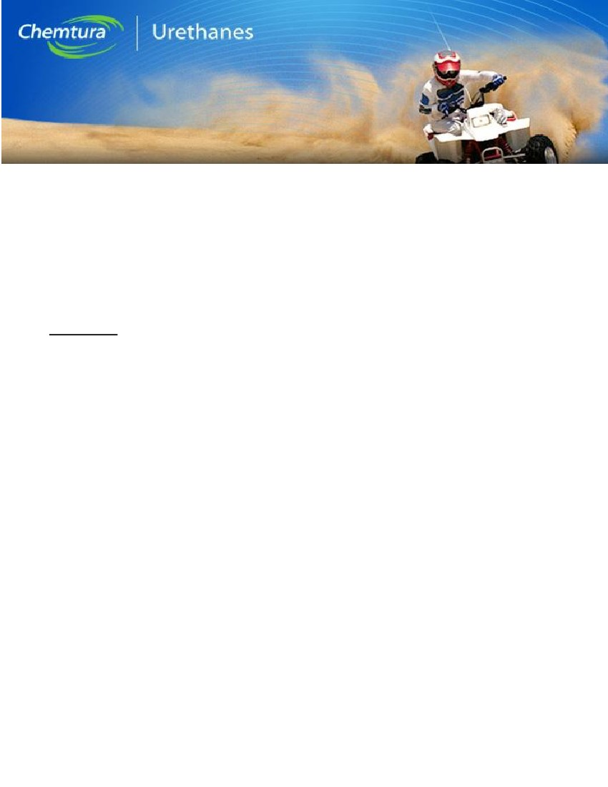
commercially. Some of these will be familiar to the rubber molder. Indeed, in some cases existing rubber molds can be used
to make urethane parts. This is usually a temporary situation however, because lighter and cheaper molds made from a
variety of other materials can be made to replace the heavy, high-pressure rubber molds.
Various Ways to Mold Urethane Prepolymers: Table 4
•
•
•
•
•
•
•
•
•
•
•
•
•
Open Casting (most common, easiest, cheapest)
Compression Molding (precision parts)
Transfer Molding (multiple precision parts)
B-Staging (when molds can’t hold hot liquids)
Rotational Molding (makes hollow items)
Centrifugal Molding (pipelining, sheet goods, multi-cavity molds)
Vacuum Casting (wire of fiber inserts in item)
Pressure Casting (pressure chamber to prevent voids)
Liquid Injection Molding (low pressure, bottom fill)
Reaction Injection Molding (high pressure impingement mixing)
Spraying (high pressure solventless & low pressure solvented)
Ribbon Flow® Moldless Casting (for rolls, etc.)
Solvent Casting (low viscosity for fabric penetration)
Open casting is the most common and usually the most economical method since there is little equipment needed other than
an oven or hot table to maintain processing temperature. Additionally there is no pressure applied to the mold. Molds can be
made from many types of materials, including polished steel, aluminum, fiberglass/resin composites, silicone rubber, hard
plastics and castable polyurethane itself. In short, almost any material that can withstand the modest molding temperatures
in the range of 100 to 140 ºC (212 to 284 ºF), which is not porous and does not retain moisture, can be considered as a
potential mold material.
The centrifugal molding technique consists of using centrifugal force to move the material into place and hold it there until
sufficient cure has taken place. It is an excellent method for lining metal, fiberglass or other types of rigid pipe with an
abrasion-resistant polyurethane interior surface. The process consists of introducing the liquid material into the pipe, which
has been prepared with a suitable adhesive, and spinning the pipe at a speed sufficient to distribute the material uniformly on
the walls of the pipe. Spinning is continued until the material is cured enough to stay in place, usually ½ to 1 hour. It is also
widely used to make sheet goods with good dimensional tolerances and surface appearance. In this process, a large heated
drum is used, and the resulting cylinder is slit and placed on a table while still, “green” and allowed to relax into a flat
rectangle.
Vacuum casting is used where air entrapment is a problem. Typical applications are where intricate detail or undercuts in the
mold make air removal difficult. Another important situation is where the casting contains fiber reinforcement or fine wire
windings. The entire mold is placed in a chamber, which is then evacuated. The material is dispensed from the outside
directly from a meter-mix machine or from a supply vessel containing a pre-mixed batch. Degassing is accomplished during
the molding cycle. Pressure casting is used for similar purposes.

Compression molding is a technique borrowed from conventional rubber processing. It is used to make parts to close
tolerances and which must have finished surfaces on all sides. It is also a technique where prototype parts or small
production runs can sometimes be made from polyurethane elastomers using existing rubber molds. The technique consists
of pouring the mixed material into the mold and allowing it to gel to a high viscosity state such that internal pressure is
generated in the mass when the press is closed. With a little experience an operator can learn when to close the press to get
high quality parts every time. Disadvantages of this method are: a), It requires a press with heated platens; b), it does not
lend itself to continuous processing because of the press cycle time, and; c), molds must be of heavy metal construction to
withstand the pressures generated.
For further information on replacing rubber with polyurethane, contact Chemtura’s Adiprene®/Vibrathane® technical service
at 1-800-243-2650.
References:
1)
Adiprene® L 100, Adiprene® LF 1800A and Vibrathane® B 625, Product Bulletins, Chemtura Corporation,
Middlebury, CT.
2)
3)
“Upper Limits: High Temperature Urethanes for Harsh Environments”, M.P. Ferrandino, et al, Chemtura Corp.
“Compounding and Testing for Performance”, Rubber Technology, 1st edition, John S. Dick, Editor, Hanser
Gardner Publications; ISBN: 156990278X, Chapter 9 (2001).
4)
Polyurethanes: Chemistry and Technology, Vol. I and II Interscience, Division of John Wiley and Sons, New
York, NY (1962).
5)
H. Ulrich, Kirk-Othmer: Encyclopedia of Chemical Technology, Volume 23, Third Edition, John Wiley & Sons,
New York, NY, pp. 576-608 (1983).
6)
K.A. Pigott, K.A., “Polyurethanes”, Encyclopedia of Polymer Science and Technology, John Wiley and Sons,
New York, (1989).
7)
8)
C. Hepburn, Polyurethane Elastomers, Elsevier Applied Science, London and New York, (1992).
C. Schollenberger, Rubber Technology, Morton, M. (Ed.) Van Nostrand Reinhold Co., New York (1987).
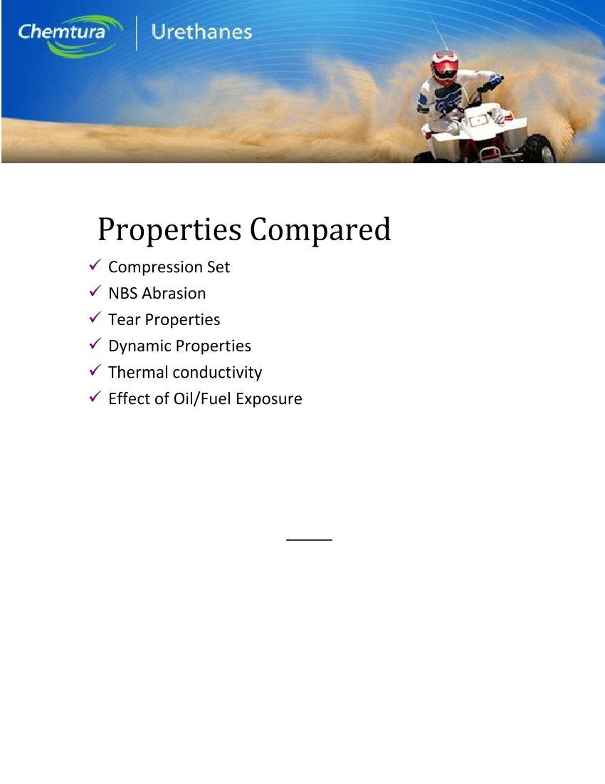
Appendix
More detailed data is included in this section. Figure 2 lists six specific characteristics that were measured in lab tests,
comparing 6 or more polyurethane systems with several different rubbers. Figure 3 compares compression set values.
Compression set can be helpful in evaluating elastomers in sealing applications. Some PU systems are better than
most rubbers. Figure 4 compares NBS abrasion indices. Polyurethanes are usually better than all rubbers except the
tread rubber. Figure 5 shows that polyurethanes generally have higher tear values and Figure 6 shows polyurethanes
have low heat buildup in dynamic applications. While rubber has slightly higher thermal conductivity, their values are
much different from polyurethane, Figure 7, Figures 8 – 11 show polyurethane’s advantages in fuel and oil
environments. All cast polyurethanes compares quite favorably with a variety of rubbers.
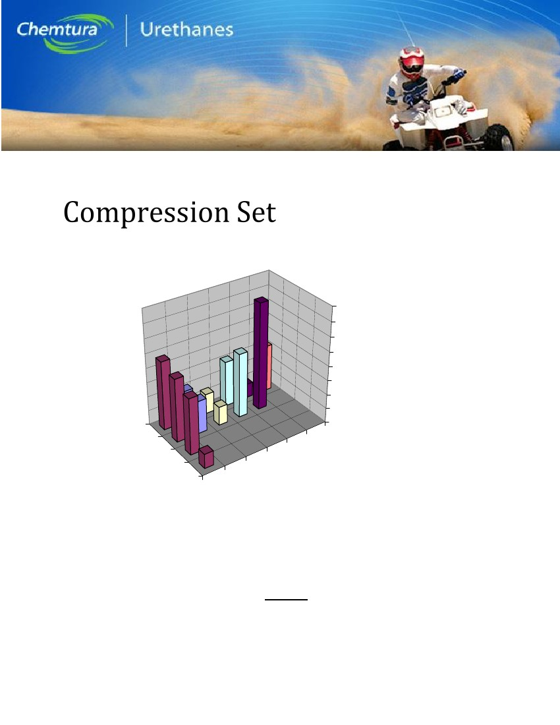
Figure 2
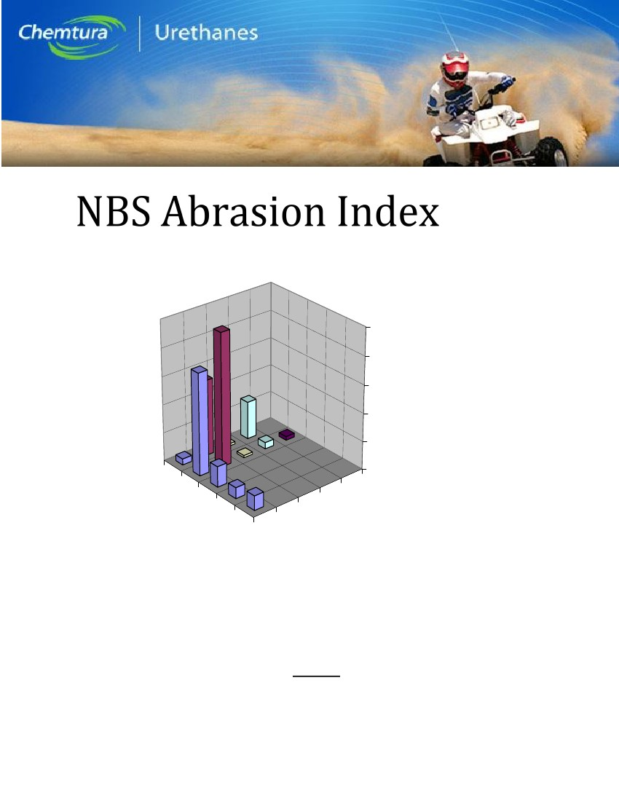
Compression Set by Method B @70C, 20%
Rubber
1) 86A Natural Rubber
2) 62A E-SBR?Cisdene
3)63A NR/CIS BR
4) 52A EPDM
High Modulus PU
1) Duracast S900
2) Duracast C930
Low Modulus Ether
1) PTMEG MDI/ptmeg@95%
2) PPG MDI/bd-tmp-ppg@100%
Low Modulus Ester
1) Ester TDI/MOCA@95%
2) Duracast S700
Low Modulus Ester MDI
1) Ester MDI/ester-bd@99%
2) Ester MDI/bd-ester@98%
80
70
60
50
40
30
20
10
0
Lo Mod Ester MDI
% Set
2
3
hi mod PU
Lo Mod Ester TDI
Lo Mod Ether
4
Rubber
Material Category
Figure 3
91A Caprolactone MDI
1
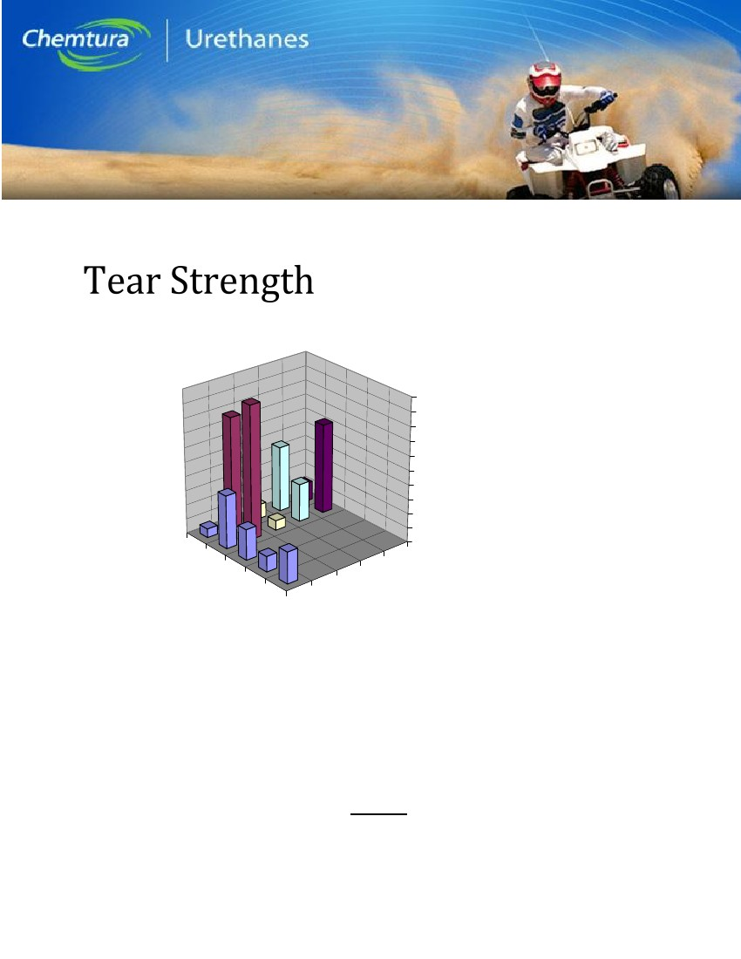
NBS Abrasion Index- Higher Is Better
Index
2500
Rubber
1)86A NR-Rim Flange Stock
2)62A E-SBR/Cisdene- Tread Stock
3)63A NR/CIS BR- Sidewall Stock
4)52A EPDM- Engine Mount Stock
5)70A Nitrile- wheels and belts
High Modulus PU
1) Duracast S900
2) Duracast C930
Low Modulus Ether PU
1) 62A PTMEG MDI/ptmeg@95%
2) 66A PPG MDI/bd-tmp-ppg@100%
Low Modulus esters (70A systems)
1) Duracast S700
2) 72A Ester TDI/MOCA@100%
Low Modulus Ester MDI
1) 65A Ester MDI/ester-bd@99%
2) 76A Ester MDI/bd-ester@98%
2000
1500
1000
500
0
1
Low Modulus Ether
3
Rubber
5
Material Categories
High Modulus PU
4
Figure 4
Low Modulus Ester (70A
systems)
2
Low Modulus Ester MDI
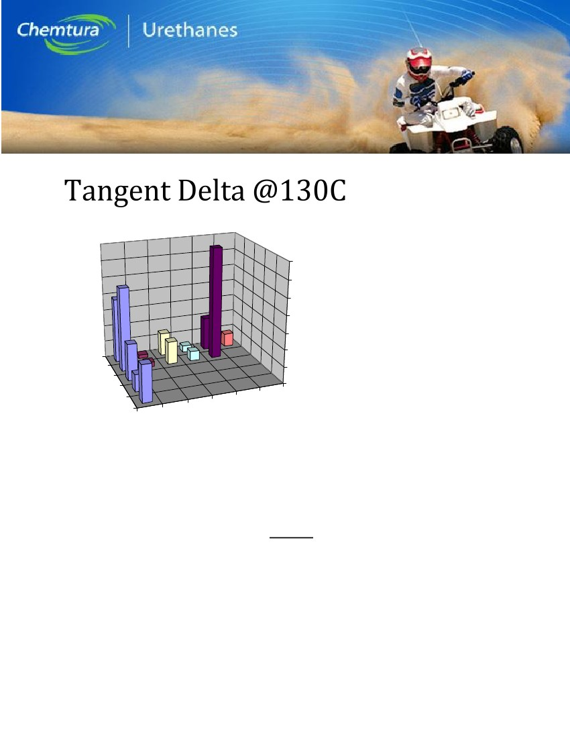
Tear Strength- ASTM 1938
pli
500
450
400
350
300
250
200
150
100
50
0
1
2
Rubber
1)86A NR-Rim Flange Stock
2)62A E-SBR/Cisdene- Tread Stock
3)63A NR/CIS BR- Sidewall Stock
4)52A EPDM- Engine Mount Stock
5)70A Nitrile- wheels and belts
High Modulus PU
1) Duracast S900
2) Duracast C930
Low Modulus Ether PU
1) 62A PTMEG MDI/ptmeg@95%
2) 66A PPG MDI/bd-tmp-ppg@100%
Low Modulus esters (70A systems)
1) Duracast S700
2) 72A Ester TDI/MOCA@100%
Low Modulus Ester MDI
1) 65A Ester MDI/ester-bd@99%
2) 76A Ester MDI/bd-ester@98%
Rubber
5
Material Categories
High Modulus PU
4
Low Modulus Ether
3
Figure 5
Low Modulus Ester (70A
systems)
Low Modulus Ester MDI
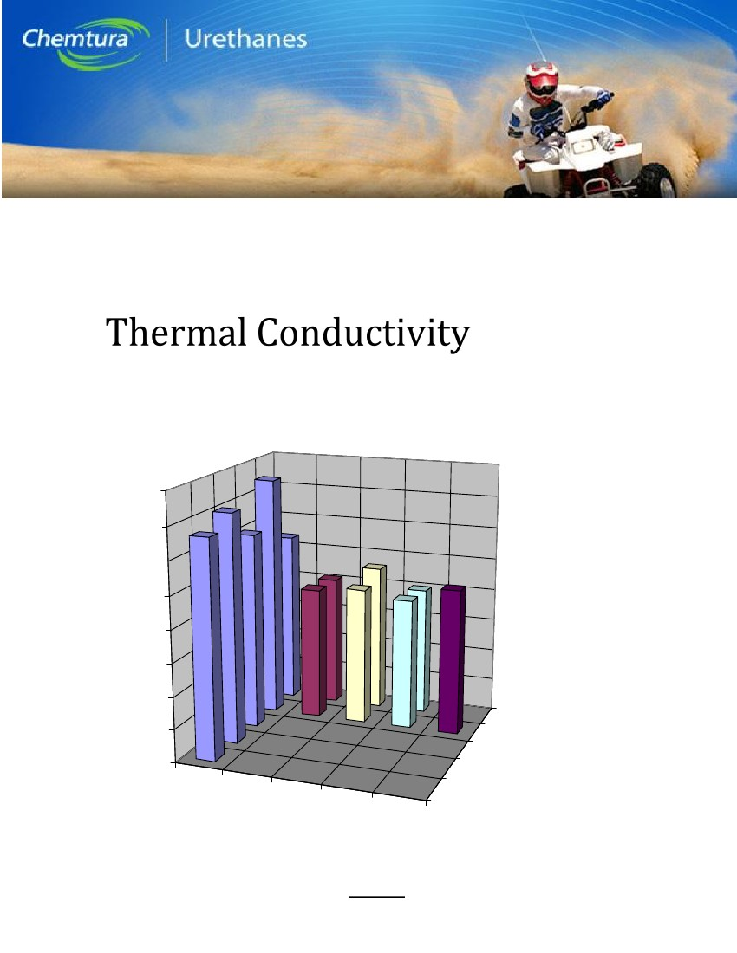
Tangent Delta
0.35
0.3
0.25
0.2
0.15
0.1
1
0.05
3
Low Modulus Ester TDI
Low Modulus Ester MDI
Caprolactone MDI
Rubber
1)86A NR-Rim Flange Stock
2)62A E-SBR/Cisdene- Tread Stock
3)63A NR/CIS BR- Sidewall Stock
4)52A EPDM- Engine Mount Stock
5)70A Nitrile- wheels and belts
High Modulus PU
1)89A PTMEG TDI/MOCA@95%
2)93A Ester TDI/MOCA@100%
Low Modulus Ether PU
1)62A PTMEG MDI/ptmeg@95%
2)66A PPG MDI/bd-tmp-ppg@100%
Low Modulus Ester TDI
1)72A Ester TDI/MOCA@95%
2)72A Ester TDI/MOCA@100%
Low Modulus Ester MDI
1)65A Ester MDI/ester-bd@99%
2)76A Ester MDI/bd-ester@98%
Caprolactone MDI
1)91A Caprolactone MDI/bd
0
5
High Modulus PU
Rubber
Low Modulus Ether
Figure 6
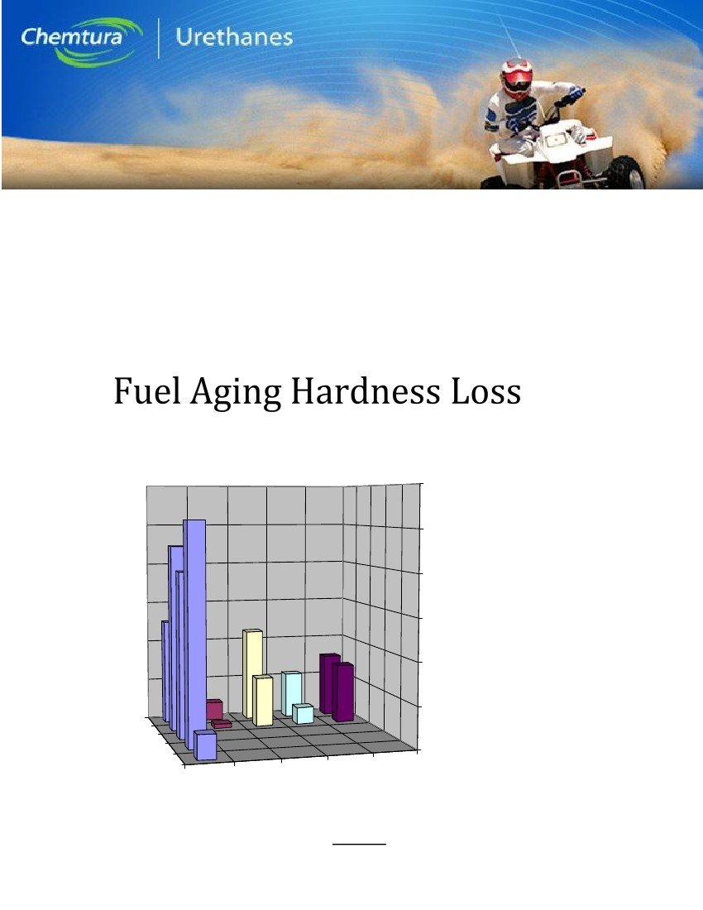
0.4
0.35
0.3
Rubber
1)86A NR-Rim Flange Stock
2)62A E-SBR/Cisdene- Tread Stock
3)63A NR/CIS BR- Sidew all Stock
4)52A EPDM- Engine Mount Stock
5)70A Nitrile- w heels and belts
High Modulus PU
1)89A PTMEG TDI/MOCA@95%
2)93A Ester TDI/MOCA@100%
Low Modulus Ether PU
1)62A PTMEG MDI/ptm eg@95%
2)66A PPG MDI/bd-tm p-ppg@100%
Low Modulus Ester TDI
1)72A Ester TDI/MOCA@95%
2)72A Ester TDI/MOCA@100%
Low Modulus Ester MDI
1)65A Ester MDI/ester-bd@99%
2)76A Ester MDI/bd-ester@98%
0.25
0.2
0.15
0.1
1
0.05
3
2
Thermal Conductivity (W/mK)0
Rubber
High
Modulus
PU
5
Low
Modulus
Ester TDI
Low
Modulus
Ester MDI
4
Low
Modulus
Ether
Figure 7
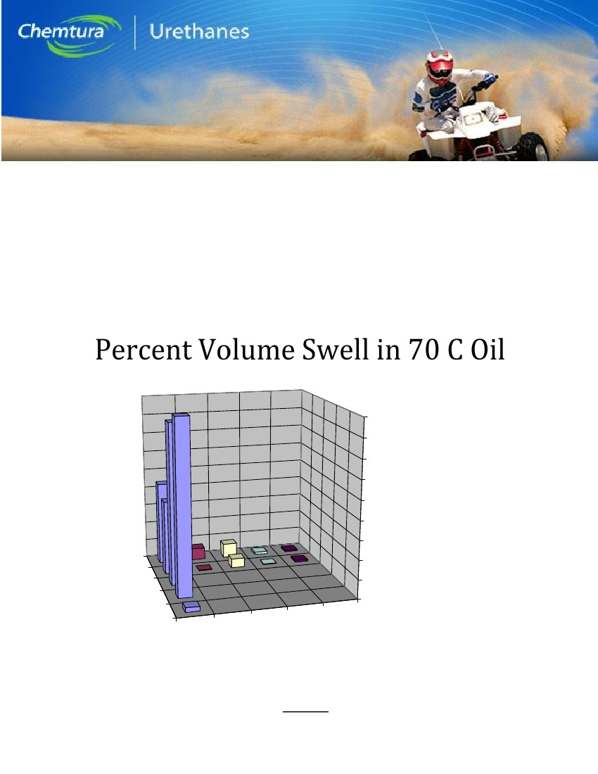
60
% Shore A Loss after 24
Hours
Rubber
1)86A NR-Rim Flange Stock
2)62A E-SBR/Cisdene- Tread Stock
3)63A NR/CIS BR- Sidew all Stock
4)52A EPDM- Engine Mount Stock
5)70A Nitrile- w heels and belts
High Modulus PU
1)89A PTMEG TDI/MOCA@95%
2)93A Ester TDI/MOCA@100%
Low Modulus Ether PU
1)62A PTMEG MDI/ptmeg@95%
2)66A PPG MDI/bd-tmp-ppg@100%
Low Modulus Ester TDI
1)72A Ester TDI/MOCA@95%
2)72A Ester TDI/MOCA@100%
Low Modulus Ester MDI
1)65A Ester MDI/ester-bd@99%
2)76A Ester MDI/bd-ester@98%
50
40
30
20
10
1
3
0
5
Rubber
High
Modulus PU
Low
Modulus
Ether
Low
Modulus
Ester TDI
Low
Modulus
Ester MDI
Figure 8
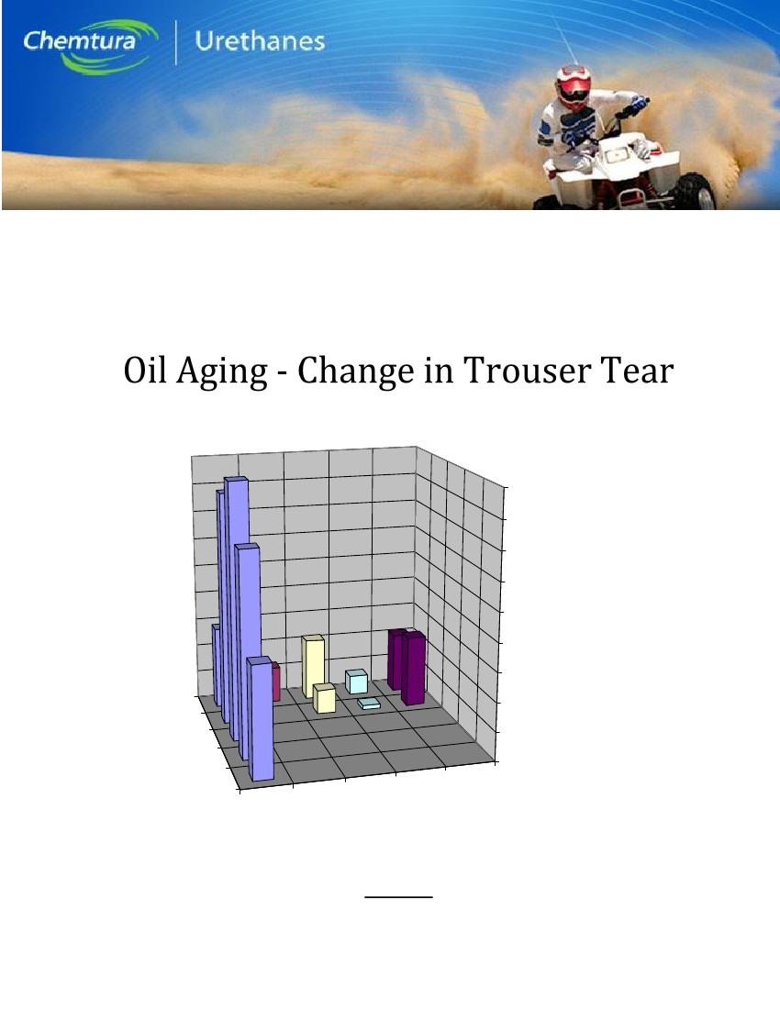
% Volume Swell
90
80
70
60
50
40
30
1
3
20
10
0
5
Rubber
High
Modulus
PU
Low
Low
LowModulus
Modulus
ModulusEster MDI
Ester TDI
Ether
Low Modulus Ester TDI
1)72A Ester TDI/MOCA@95%
2)72A Ester TDI/MOCA@100%
Low Modulus Ester MDI
1)65A Ester MDI/ester-bd@99%
2)76A Ester MDI/bd-ester@98%
Low Modulus Ether PU
1)62A PTMEG MDI/ptm eg@95%
2)66A PPG MDI/bd-tm p-ppg@100%
Rubber
1)86A NR-Rim Flange Stock
2)62A E-SBR/Cisdene- Tread Stock
3)63A NR/CIS BR- Sidew all Stock
4)52A EPDM- Engine Mount Stock
5)70A Nitrile- w heels and belts
High Modulus PU
1)89A PTMEG TDI/MOCA@95%
2)93A Ester TDI/MOCA@100%
Figure 9
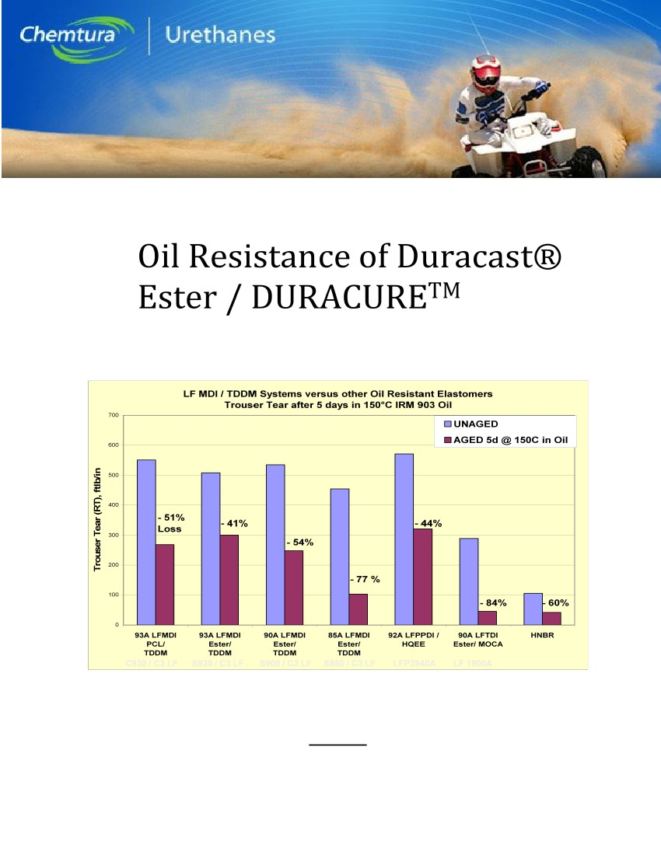
% Change
Aging 24 Hours in Oil/Fuel
90
80
70
60
50
40
30
1
2
3
4
5
Rubber
High
Modulus
PU
Low
Modulus
Ether
Low
Low
Modulus
Modulus
Ester MDI
Ester TDI
10
0
Low Modulus Ester MDI
1)65A Ester MDI/ester-bd@99%
2)76A Ester MDI/bd-ester@98%
20
Rubber
1)86A NR-Rim Flange Stock
2)62A E-SBR/Cisdene- Tread Stock
3)63A NR/CIS BR- Sidewall Stock
4)52A EPDM- Engine Mount Stock
5)70A Nitrile- wheels and belts
High Modulus PU
1)89A PTMEG TDI/MOCA@95%
2)93A Ester TDI/MOCA@100%
Low Modulus Ether PU
1)62A PTMEG MDI/ptmeg@95%
2)66A PPG MDI/bd-tmp-ppg@100%
Low Modulus Ester TDI
1)72A Ester TDI/MOCA@95%
2)72A Ester TDI/MOCA@100%
Figure 10
Figure 11

