**WELCOME TO HOLY SPIRIT LUTHERAN CHURCH**

A Member of the Evangelical Lutheran Church in America, New Jersey Synod

1220 Bayshore Rd., Villas, NJ 08251

609-886-2414

holyspiritlutheran@comcast.net

holyspiritvillas.com

facebook.com/holyspiritvillas

Vicar Vince Piekarski can be contacted at any time through call or text at

412-225-0287 or through email at vpie8282@gmail.com.

**4TH SUNDAY OF ADVENT**

**SUNDAY, DECEMBER 22ND, 2024**

**10:30AM WORSHIP SERVICE WITH HOLY COMMUNION** 



We, the Evangelical Lutheran Church of the Holy Spirit, are People of God, who

are called by the Holy Spirit to pray, worship, joyfully proclaim Jesus Christ,

and compassionately witness and serve others in Christian Love.

**AN ESPECIALLY WARM WELCOME TO OUR VISITORS**

We are glad that you joined us for Worship today! Thank you for enriching our time together! We would like to get to know you better, and we would like for you to get to know us better too. Brochures, welcome gifts, prayer shawls, Bibles, and other items are available at our welcome areas. Church members are happy to show you around and share about our ministries. Please don’t hesitate to speak up and ask questions. Please make sure you sign-in on our clipboard on the podium in the lobby.



We continue conducting our Worship Services in coordination with our Conference Call. Join us at our # 657-390-7423. If that does not allow you to gain access, please utilize our other # 701-802-5170 and access code 8221190, then hit the # key. You may need to dial 1 first, depending on your phone plan. After you log-in, please announce your name. Feel free to talk with others until we start our service.

**ARE YOU INTERESTED IN CANDLE MEMORIALS?**

Candles cost $10 each, and can be dedicated in memory of someone.

The Sign-up sheets are located on the bulletin board between the church offices.

Please feel free to see Vicar Vince with any questions.

**SANCTUARY CANDLE**

December’s is given to the Glory of God & in memory of

JOHN KIROW by Rose Lang, Vicar Vince & Heather Piekarski.

**ALTAR CANDLES**

December’s are given to the Glory of God & in memory of

SAM BRYAN & SANDRA CONOVER by Wanda Bryan.

**CONFERENCE CALL CHECK-IN**

(Roll Call and Attendance)

**WELCOME & ANNOUNCEMENTS**

(Offered by Vicar, Assistant, and Congregation.)

**INTRODUCTION**

A. Cradle and cross are inextricably connected on the fourth Sunday of Advent.

Between a lovely tribute to the little town of Bethlehem and Mary’s magnificent

song of praise, the letter to the Hebrews reminds us in no uncertain terms that

Christ’s advent is for “the offering of the body of Jesus Christ once for all.” It is the

kind of tension in which the church always lives as when in holy communion—

with high delight—“we proclaim the Lord’s death.”

**PRELUDE**

(Music offered by our Organist before the start of our Worship Service.)

**A Medley for Christmas**

**CHIMES**

(Music offered by our Organist before the start of our Worship Service.)

**Emmanuel**

V. We invite you to stand if you are able.

**CONFESSION & FORGIVENESS**

(All may make the sign of the cross, the sign that is marked at baptism.)

V. Blessed be the holy Trinity, ☩ one God,

alive in the world,

reviving creation,

arriving soon.

**C. Amen.**

V. Let us confess our sin in the presence of God

and of one another.

(Silence is kept for reflection.)

V. God of mercy,

**C. we confess that we have sinned.**

**We trust earthly powers and human authority alone.**

**We grow fearful. We cling to false comforts.**

V. God of might,

**C. we confess that we have sinned.**

**We have turned away from our neighbors.**

**We have trusted false promises.**

V. God in our midst,

**C. we confess that we have sinned.**

**We plead: come to us.**

**Bring your mercy to birth in us.**

V. A righteous branch springs forth:

it is Christ the Lord, our Savior,

in whom we have forgiveness, life, and mercy.

By the power of the Holy Spirit,

receive the grace and forgiveness of God

through ☩ Christ Jesus,

whose day draws near.

**C. Amen.**

(We invite you to remain standing if you are able.)



**GATHERING HYMN**

(We invite you to sing along with the music offered by our Organist.)

With One Voice—Blue Book

**632—The Angel Gabriel from Heaven Came**



**APOSTOLIC GREETING**

V. May the grace of our Lord Jesus Christ, the love of God,

and the communion of the Holy Spirit be with you all.

**C. And also with you.**

**KYRIE**

V. In peace, let us pray to the Lord.

**C. Lord, have mercy.**

V. For the peace from above, and for our salvation, let us pray to the Lord.

**C. Lord, have mercy.**

V. For the peace of the whole world, for the well-being of the church of God,

and for the unity of all, let us pray to the Lord.

**C. Lord, have mercy.**

V. For this holy house, and for all who offer here their worship and praise,

let us pray to the Lord.

**C. Lord, have mercy.**

V. Help, save, comfort, and defend us, gracious Lord.

**C. Amen.**

**HYMN OF PRAISE**

C:\Users\vpie8\Downloads\LBW Setting Two Glory (Melody).tif



**PRAYER OF THE DAY**

V. The Lord be with you.

**C. And also with you.**

V. Let us pray,

Stir up your power, Lord Christ, and come. With your abundant grace and might,

free us from the sin that binds us, that we may receive you in joy and serve you

always, for you live and reign with the Father and the Holy Spirit, one God, now

and forever.

**C. Amen.**

V. We invite you to be seated for our Readings and Psalm.

**FIRST READING**

The prophet Micah, having pronounced judgment upon Judah, speaks of a future

shepherd-king who, like David, will come from the small town of Bethlehem.

(Ephrathah refers to the area around Bethlehem.) This king will restore Israel and

bring peace. New Testament writers understood this passage to be referring to

Jesus.

R. Our First Reading is from the 5th Chapter of Micah (Verses 2-5a).

R. 2 But you, O Bethlehem of Ephrathah,

   who are one of the little clans of Judah,

  from you shall come forth for me

   one who is to rule in Israel,

 whose origin is from of old,

  from ancient days.

 3 Therefore he shall give them up until the time

  when she who is in labor has brought forth;

 then the rest of his kindred shall return

  to the people of Israel.

 4 And he shall stand and feed his flock in the strength of the Lord,

  in the majesty of the name of the Lord his God.

 And they shall live secure, for now he shall be great

  to the ends of the earth,

 5a and he shall be the one of peace.

R. This is the Word of the Lord.

**C. Thanks be to God.**

**PSALM**

R. Our Responsorial Psalm is from the 1st Chapter of Luke (Verses 46b-55).

**C.** **You, Lord, have lifted up the lowly.** (Lk. 1:52)

R. 46b My soul proclaims the greatness of the Lord,

   47 my spirit rejoices in God my Savior,

  48 for you, Lord, have looked with favor on your lowly servant.

   From this day all generations will call me blessed:

  49 you, the Almighty, have done great things for me

   and holy is your name.

  50 You have mercy on those who fear you,

   from generation to generation.

**C. You, Lord, have lifted up the lowly.** (Lk. 1:52)

R. 51 You have shown strength with your arm

   and scattered the proud in their conceit,

  52 casting down the mighty from their thrones

   and lifting up the lowly.

  53 You have filled the hungry with good things

   and sent the rich away empty.

  54 You have come to the aid of your servant Israel,

   to remember the promise of mercy,

  55 the promise made to our forebears,

   to Abraham and his children forever.

**C. You, Lord, have lifted up the lowly.** (Lk. 1:52)

**SECOND READING**

The author of Hebrews uses the image of religious sacrifice to convey the

significance of Christ’s coming. Through obedient acceptance of God’s will, Christ

allows his own body to become the greatest sacrifice of all, one through which we

are made a holy people.

R. Our Second Reading is from the 10th Chapter of Hebrews (Verses 5-10).

R. 5 Consequently, when Christ came into the world, he said,

  “Sacrifices and offerings you have not desired,

   but a body you have prepared for me;

  6 in burnt offerings and sin offerings

   you have taken no pleasure.

  7 Then I said, ‘See, I have come to do your will, O God’

    (in the scroll of the book it is written of me).”

8 When he said above, “You have neither desired nor taken pleasure in sacrifices

and offerings and burnt offerings and sin offerings” (these are offered according

to the law), 9 then he added, “See, I have come to do your will.” He abolishes the

first in order to establish the second. 10 And it is by God’s will that we have been

sanctified through the offering of the body of Jesus Christ once for all.

R. This is the Word of the Lord.

**C. Thanks be to God.**

V. We invite you to stand if you are able, and I invite you to announce the Gospel

Acclamation with me.

**GOSPEL ACCLAMATION**

**C. Alleluia. Here I am, the servant of the Lord; let it be with me according to**

**your word. Alleluia.** (Luke 1:38)

**GOSPEL READING**

Elizabeth, John’s mother, and Mary, the mother of Jesus, are two women filled

with the Holy Spirit and with faith. In Elizabeth’s inspired greeting and Mary’s

song of praise we hear of a saving God who remembers, scatters, lifts up, and

fulfills all things.

V. The Holy Gospel According to St. Luke, the 1st Chapter (Verses 39-45 [46-55]).

**C. Glory to you, O Lord.**

V. 39 In those days Mary set out and went with haste to a Judean town in the hill

country, 40 where she entered the house of Zechariah and greeted Elizabeth.

41 When Elizabeth heard Mary’s greeting, the child leaped in her womb. And

Elizabeth was filled with the Holy Spirit 42 and exclaimed with a loud cry,

“Blessed are you among women, and blessed is the fruit of your womb. 43 And

why has this happened to me, that the mother of my Lord comes to me? 44 For

as soon as I heard the sound of your greeting, the child in my womb leaped for

joy. 45 And blessed is she who believed that there would be a fulfillment of what

was spoken to her by the Lord.”

[46 And Mary said,

  “My soul magnifies the Lord,

   47 and my spirit rejoices in God my Savior,

  48 for he has looked with favor on the lowly state of his servant.

   Surely from now on all generations will call me blessed,

  49 for the Mighty One has done great things for me,

   and holy is his name;

  50 indeed, his mercy is for those who fear him

   from generation to generation.

  51 He has shown strength with his arm;

   he has scattered the proud in the imagination of their hearts.

  52 He has brought down the powerful from their thrones

   and lifted up the lowly;

  53 he has filled the hungry with good things

   and sent the rich away empty.

  54 He has come to the aid of his child Israel,

   in remembrance of his mercy,

  55 according to the promise he made to our ancestors,

   to Abraham and to his descendants forever.”]

V. This is the Gospel of the Lord,

**C. Praise to you, O Christ.**

(We invite you to be seated.)

**SERMON**

(Delivered by Vicar Vince Piekarski.)

(Following the Sermon, we invite you to stand if you are able.)

**HYMN OF THE DAY**

(We invite you to sing along with the music offered by our Organist.)

Lutheran Book of Worship—Green Book

**34—Oh, Come, Oh, Come, Emmanuel**

**APOSTLES’ CREED**

V. God has made us his people through our Baptism into Christ. Living together in

trust and hope let us confess our faith together using the Apostles’ Creed.

**C. I believe in God, the Father almighty,**

**creator of heaven and earth.**

**I believe in Jesus Christ, God’s only Son, our Lord,**

**who was conceived by the Holy Spirit,**

**born of the Virgin Mary,**

**suffered under Pontius Pilate,**

**was crucified, died, and was buried;**

**he descended to the dead.**

**On the third day he rose again;**

**he ascended into heaven,**

**he is seated at the right hand of the Father,**

**and he will come to judge the living and the dead.**

**I believe in the Holy Spirit,**

**the holy catholic church,**

**the communion of saints,**

**the forgiveness of sins,**

**the resurrection of the body,**

**and the life everlasting. Amen.**

**PRAYERS OF INTERCESSION**

(The prayers are prepared locally for each occasion.)

V. As we prepare for Emmanuel, God-with-us, let us pray for all people and places

that long for God’s presence.

(A brief silence.)

A. God our uniter, increase communication and cooperation in our relationships with

those of other traditions and religions. Root your church in the radical message of

your incarnation, and enable us to pursue your justice in the world. Lord, in your

mercy,

**C. receive our prayer.**

A. God our creator, we praise you for the beauty that surrounds us. Awaken in us a

renewed sense of care for the wildlife in our communities. Form us into faithful

stewards of what you have made. Lord, in your mercy,

**C. receive our prayer.**

A. God our sovereign, Mary proclaims a new way of life that lifts up the lowly and fills

the hungry with good things. Nurture in local governments and municipalities a

desire to care for all who are overlooked and ignored. Lord, in your mercy,

**C. receive our prayer.**

A. God our beacon, as the northern hemisphere begins its slow turn toward more

daylight, remind us that even in the deepest nights, you are there. Comfort the

lonely and bereaved. Hold closely the frightened, anxious, depressed, and ill;

especially:

Betty Lang (Church Member)

BettyAnn Rich-White (Church Member)

Chip Hand (Church Member)

Lynn Bargstadt (Church Member)

Frank Brunner (Church Member)

Audrey Kinka (Church Member)

Sharon Ford (Church Member)

Carol Amundsen (Church Member)

Kim McGinley (Church Member)

Marie Hand (Church Member)

Frank Ford (Church Member)

Eric Dishman (Church Family)

Joan Sommerman (Church Family)

Megan Pratz (Betty Lang’s Friend)

Patty Cioce (Betty Lang’s Friend)

Carla Wagner (Betty Lang’s Family)

Tom McNamara (Audrey Kinka’s Family)

Beth & Bill Knapp (Betty Lang’s Family)

Bill Kanass (Betty Lang's Family)

Ed Borse (Betty Lang’s Friend)

James Kershaw (Audrey Kinka’s Friend)

Kali Poe (Betty Lang's Family)

Linda Dressic (Carol Detweiler's Family)

Suzie Clark (Rose Lang's Friend)

Evy (Betty Lang's Friend)

Amelia Skyrm (Audrey Kinka's Family)

Cindy Irana (Betty Lang’s Friend)

Ed Watson (Betty Lang's Friend)

Francis Clock (Dianna DeNote’s Family)

Andrew Hudak (Rose Lang’s Friend)

Fred Lang (Betty Lang’s Family)

Viena Murtha (Bob Fritsch’s Friend)

Christine Schneider (Audrey Kinka’s Family)

Jackie Churchman (Audrey Kinka’s Family)

Sharon Waicus (Skip & Bonnie Millard's Friend)

Karen O'Brien (Paul Bowker's Friend)

Dustin Irizzary (Mary Melnicoff's Family)

Linda Smith (Rose Lang's Friend)

Joan Brown (Betty Lang's Friend)

Donna Bradley (Betty Lang's Friend)

Theresa Marioti (Betty Lang's Friend)

The Bryan Family (Wanda Bryan's Family)

Ernie Kinzler (Marie Hand & Doreen Kinzler’s Family)

Craig Brearey (Judy Brannan & Mary Melnicoff's Friend)

Sarah Dutton (Frank & Sharon Ford's Family)

Christina McNasby (Fran Green’s Family)

The Kinkson Family (Judy Brannan's Friends)

Mark Stephen Dennis (Diana DeNote's Family)

Cathy Snyder (Audrey Kinka's Family)

Dellie Valcourt (Skip & Bonnie Millard's Family)

Joyce (Betty Lang's Family)

Hannah (Betty Lang's Family)

Donna Lee (Betty Lang's Friend)

Bill Lodge (Skip & Bonnie Millard's Friend)

Patrick & Denise Brannan (Judy Brannan's Family)

Ron Anderson (Bill Kelly's Friend)

Jerry P (Wanda Bryan's Friend)

Pat Labrae (Kathy Poehler's Friend)

Bud Brearey (Judy Brannan & Mary Melnicoff's Friend)

Mary Skain (Kathy Poehler's Friend)

Bill Rand (Wayne & Eleanor Rand's Family)

Kevin Naylor (Vicki Rinier's Friend)

Robert Chaplin (Mary Melnicoff's Friend)

Joseph C (Mary Melnicoff's Friend)

Jack Wieckouski (Theresa & Kim McGinley's Family)

Diane Weiss (Kathy Poehler's Friend)

Rick (Carol Amundsen’s Friend)

Vera (Carol Amundsen's Friend)

Carolyn Santarpio (Bob Fritsch's Friend)

Cathy Hines (Rose Lang’s Friend)

Ken Mortensen (Del McKenna’s Family)

Harry (Judy Brannan's Friend)

Janet K (Philomena Noak's Friend)

Michael Hart (Diana DeNote's Friend)

Rocco Leonard DeNote (Diana DeNote's Family)

Spencer Oditt (Butch Poehler's Family)

Mary Melnicoff (Church Member)

Julie Schlereth (Diana DeNote's Friend)

Jorge Martin (Kathy Poehler's Family)

Tina Crull (Vicki Rinier's Family)

(Additional Names Added Prior to the Worship Service.)

A. Lord, in your mercy,

**C. receive our prayer.**

A. God our guide, shepherd the leadership of this congregation. Bless the council

and staff in discerning future ministry and open their hearts to the voices of the

community. Lord, in your mercy,

**C. receive our prayer.**

A. God our life, you remember the promises you have made to your people. In

gratitude for those who have died, we praise you for your faithfulness throughout

history. Lord, in your mercy,

**C. receive our prayer.**

(Here other intercessions may be offered.)

V. Watch over all of us who are worried and suffering, and especially those whose

names we now say aloud or within our hearts (pause). Lord, in your mercy,

**C. receive our prayer.**

V. Savior of the nations, come, and receive these prayers and the pleas of our

hearts, in the name of Jesus Christ.

**C. Amen.**

**SHARING OF THE PEACE**

V. May the peace of the Lord be with you always.

**C. And also with you.**

V. Let us share God’s Peace with one another.



(Please remain in your pews and offer the sign of peace with a peace sign or wave.)

V. We invite you to be seated.

**ANTHEM**

(Special Music for Everyone to Enjoy.)

**Still, Still, Still**

**OFFERING**

V. We now worship God with our tithes and offerings, wine and bread for use in holy

communion, and monetary gifts to support our ministry for service in God’s name.

Our Ushers will be around to your pews to pass the Offering Plates.

(Ushers come forward to get the Offering Plates from the Assistant.)

(Vicar and Assistant prepare the Altar for Communion.)

**OFFERING SONG**

(We invite you to sing along with the music offered by our Organist.)

C:\Users\HSLC\AppData\Local\Temp\Temp1_STANZA_1343 Melody.zip\What Have We to Offer (Melody).tif

(Usher(s) brings the Tithes and Offerings up front to the Assistant.)

V. We invite you to stand if you are able.

**OFFERING PRAYER**

V. Let us pray,

Creator God,

you made the whole world,

even the farthest stars,

and you draw near to feed us.

We praise you for these gifts of bread and wine.

Strengthen us with this food

that we may live in expectation

for the advent of your Son, Jesus Christ our Lord.

**C. Amen.**

**GREAT THANKSGIVING**

V. The Lord be with you.

**C. And also with you.**

V. Lift up your hearts.

**C. We lift them to the Lord.**

V. Let us give thanks to the Lord our God.

**C. It is right to give him thanks and praise.**

V. It is indeed right and salutary that we should at all times and in all places offer

thanks and praise to you, O Lord, holy Father, through Christ our Lord; who rose

beyond the bounds of death and, as he promised, poured out your Spirit of life

and power upon the chosen disciples. At this the whole earth exults in boundless

joy. And so, with the Church on earth and the hosts of heaven, we praise your

name and join their unending hymn:

**SANCTUS**

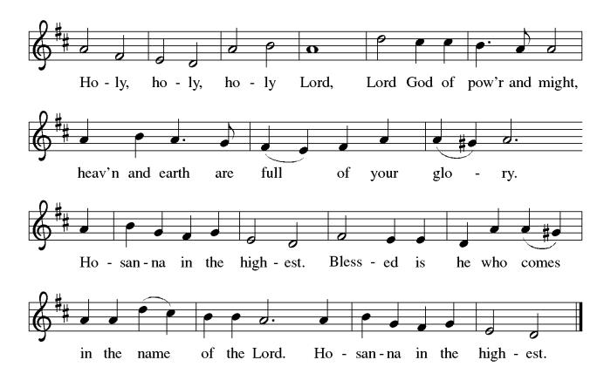

**THE EUCHARISTIC PRAYER**

V. Blessed are you, Lord of heaven and earth, in mercy for our fallen world you gave

your only Son, that all those who believe in Him should not perish, but have

eternal life. We give thanks to you for the salvation you have prepared for us

through Jesus Christ. Send now your Holy Spirit into our hearts that we may

receive our Lord with a living faith as He comes to us in His holy supper.

**C. Amen. Come, Lord Jesus.**

V. In the night in which he was betrayed our Lord Jesus took bread,

he gave thanks; broke it, and gave it to his disciples, saying:

*Take and eat; this is my body, given for you.*

*Do this for the remembrance of me.*



V. Again, after supper, He took the cup, he gave thanks,

and gave it for all to drink, saying:

*This cup is the new covenant in my blood,*

*shed for you and for all people for the forgiveness of sin.*

*Do this for the remembrance of me.*



**THE LORD’S PRAYER**

(We ring the bell throughout the Lord’s Prayer at all services to

invite those in the community to join in praying the Lord’s Prayer.)

V. May we now join with one another and pray together as Jesus has taught us.

**C. Our Father, who art in heaven, hallowed be thy name, thy kingdom come,**

**thy will be done, on earth as it is in heaven. Give us this day our daily**

**bread; and forgive us our trespasses, as we forgive those who trespass**

**against us; and lead us not into temptation, but deliver us from evil. For**

**thine is the kingdom, and the power, and the glory, forever and ever.**

**Amen.**

**LAMB OF GOD**

**C:\Users\Vince and Heather\Downloads\Lamb of God, ELW Setting Four (Melody).tif**

V. We invite you to be seated.

**HOLY COMMUNION**

V. Communion here is pretty simple, and all who believe in Jesus Christ are

welcome at this very table. We utilize bread (or wafers), and we also have the

option of individually wrapped gluten free wafers. We have pre-filled red wine or

white grape juice cups in the Communion Tray to choose from.

The Usher will offer the option to leave your pew, and you can proceed forward

on the right side of the aisle to the steps between the Communion Rail. Following

Communion, please process back on the left side of the aisle and place your

empty cups in the basket before returning to your pew. Children who have not

had their First Communion instruction, and adults who do not wish to receive

Communion, are welcome to come forward and give me a sign to obtain a

special blessing.

If you are unable to leave your pew for health or other related reasons, please

inform the Usher of your desire to remain in your pew and have us come to you.

**INVITATION TO COMMUNION**

V. God feeds us with tender mercy.

Come to the table.

**C. Amen.**

(Distribution of Holy Communion)

**COMMUNION HYMN**

(Please enjoy various music offered by our Organist during your

quiet time, prayer, and reflection following Holy Communion.)

(Vicar and Assistant remove Communion Vessels from the Altar.)

V. Let us stand as we are able.

**POST COMMUNION BLESSING**

V. May the body and blood of our Lord Jesus Christ strengthen us and keep us

always in His grace.

**C. Amen.**

**POST COMMUNION CANTICLE**





**PRAYER AFTER COMMUNION**

A. Let us pray,

Generous God,

we thank you for the gift of life,

for the bread of salvation.

We thank you for coming among us,

for leading us into peace.

We thank you for showering us with mercy,

for sending us into the world.

Come, Lord Jesus, and go with us

as we feed the hungry in your name.

**C. Amen.**

**BLESSING**

V. God of endings and beginnings,

God in the darkness and the light,

God, our hope for the journey,

☩ bless and keep you now and forever.

**C. Amen.**

(We invite you to remain standing if you are able.)



**SENDING HYMN**

(We invite you to sing along with the music offered by our Organist.)

With One Voice—Blue Book

**744—Soon and Very Soon**

(Assistant extinguishes the Altar Candles half way through the Sending Hymn.)

(Vicar processes out once the Altar Candles have been extinguished.)

(We invite you to be seated.)

**BIRTHDAYS, ANNIVERSARIES,**

**& ADDITIONAL ANNOUNCEMENTS**

(Offered by Assistant and Congregation.)

**BIRTHDAYS & ANNIVERSARIES**

None

**DISMISSAL**

A. Go in peace. Prepare the way for Emmanuel.

**C. Thanks be to God.**

**POSTLUDE**

(Music offered by our Organist as we depart following our Worship Service.)

**While Shepherds Watched Their Flocks By Night**



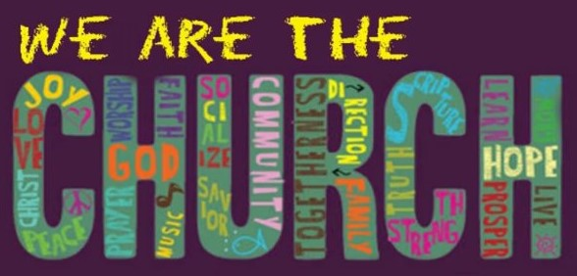

**LICENSES & EXPIRATION DATES**

Worship Service Content is used via permission through Augsburg Fortress Liturgies Annual License #SB144368. The next Subscription Renewal Date is 2/28/2025.

Our Hymns and Worship Music are used via permission through CCLI One License #11327166. The next Subscription Renewal Date is 1/31/2025.



**NEWSLETTER**

**Grab your copy of the Winter Publication TODAY!** We will continue on with our seasonal publications. Information, stories, pictures, and committee reports can be submitted at any time to Vicar Vince in-person or via email at vpie8282@gmail.com.

**SUNDAY SCHOOL & CONFIRMATION**

The Program went through a bit of a restructuring process. Most of the young folks that have been attending over the years have now made it to the age in which they will be preparing for Confirmation. As a result, Vicar Vince spoke with a few Pastors and reviewed various curriculum and programs for this. “Here We Stand” is a program that will allow our young folks to go through a 2-year process while focusing on the Bible and Luther’s Small Catechism. We will continue the program on **Sundays from 9-10AM**. Of course, there still will be snacks, games, arts & crafts, and other fun things. See Heather, Bonnie, & Vicar Vince for more information.



The most important thing we do each week is gather together as God's people to worship. God is the center and focus of everything we do. Participating in worship is active. Liturgy means the work and actions of the people gathered. Everything we do during the week to prepare for worship, and everything we do as we assist in leading worship is important. We are thankful for all the wonderful work being done. If you are interested in any position let Vicar Vince know so a training can be set-up.

Sign-up sheets are located on the bulletin board between the church offices.



**PREACHING AT BROOKDALE**

Vicar Vince spoke with the residents and found that many of them will be home, and actually have no plans with family or friends for church on Christmas Eve. Vicar Vince offered to arrange something. However, in order to make this happen it had to be cleared with Reverend Glenn Schoenberger and the Activity Director at Brookdale. Thankfully, it was cleared and they were thankful for the idea. So, Vicar Vince will be Preaching at Brookdale Senior Living in Cape May Court House on **Christmas Eve, December 24th, at 1PM**.

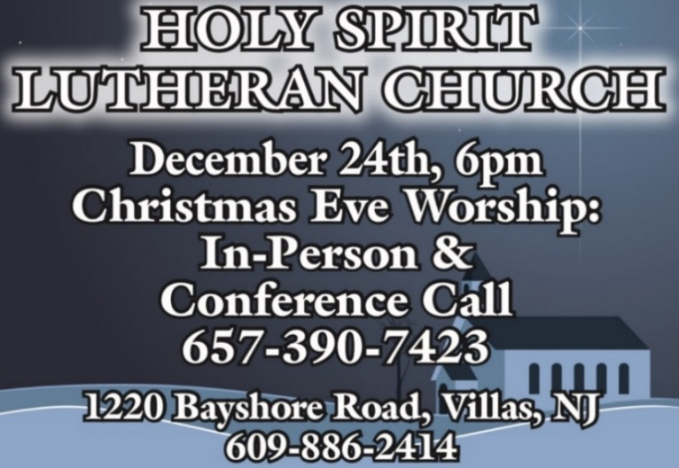

Advent began on Sunday, December 1st, and ends on **Tuesday, December 24th**, when we will join one another for our **Christmas Eve Worship Service at 6PM**. Please make note of the time change from the traditional time slot of 7PM.

**If you would like some invite cards they are on the podium in the Narthex.**

**TITHES, OFFERINGS, & ENVELOPES**

**2025 Offering Envelopes will be available in the back of the church starting on Christmas Eve.** We do indeed worship God with our tithes and offerings. We hear this in scripture, “Each of you must give as you have made up your mind, not reluctantly or under compulsion, for God loves a cheerful giver.” (2 Corinthians 9:7) Feel free to drop your envelopes in the offering plate, mail them to the church, or drop them off in the locked mailbox. Thank you for your continued support in the mission of our church, its ministries, the New Jersey Synod, and other needs!

**FOOD PANTRY & COMMUNITY DELIVERIES**

**Open every Thursday**, and the **last Saturday of every month**, from **10AM to 1PM**. 83 people were served in November. 1,010 people have been served in 2024. Donations can be dropped in the basket in the Narthex, placed in the outdoor drop-box by the Church Office door, placed in the money jug in the back of the Church, mailed into the Church Office, or placed in the Offering Plate. Volunteers are needed each week. Sign-up sheets are located on the bulletin board between the church offices. If you have questions or need training see Heather, Vicar Vince, or Bonnie.

|  |  |  |
| --- | --- | --- |
| **Thursday, 12/26** | **Saturday, 12/28** | **Thursday, 1/2** |
| Garnet & Tori | Vicki & Bonnie | Cathie & Tori |

Our local North Cape May Acme & Big Lots provide us with Expiring Soon, Recently Expired, and Slightly Damaged Foods & Items weekly. Kathy helps those in need by delivering items each Saturday in the community. Kathy then brings leftover items to the Church for church members in need, and those who visit the food pantry during the week. Additional items are then taken over to the Branches Outreach in Rio Grande. A special thanks to all who donate, pray, & help in any way!

**BULLETIN ENTRY DEADLINE**

The Bulletin is Printed on **Thursdays** during Church Office Hours. Changes need to be submitted to Vicar Vince or Heather no later than **Thursday by 4PM**. Thank you!

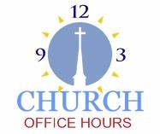

Open **Thursdays from 6PM to 8PM** to serve the Congregation, the Community,

and to continue handling the business of the Church. Feel free to stop in to talk,

pick-up or drop off something, pray in the Sanctuary, or for whatever reason.

**DONATION STATION**

Get on the train and place all purchased items in the specified project donation bins located on the counter by the front doors. See Heather for more information.



**EXECUTIVE COUNCIL MEETING**

Vicar Vince, Mary, Judy, Bonnie, and Vicki will be gathering at Skip & Bonnie’s residence on **Friday, January 3rd, at 10AM** to prepare for the upcoming Annual Congregational Meeting and to review the Budget and other things.

**SOUND SYSTEM UPDATE**

Oliver Phillips at Not the DJ, LLC confirmed being able to locate a 16-channel mixer and 4 new speakers. Oliver told the former owner who upgraded their systems that he could refurbish them and use them at our church and it was decided to donate them instead of selling them. Oliver is currently refurbishing them. He was able to determine how much time, wire, and other supplies would be needed. An estimate for the set-up was provided at a cost of $2,200. We budgeted $5,000 for this, and could not have gotten any luckier that things lined up. The $1,100 deposit has been paid and we are hopeful that work will be scheduled in the near future. We are now on the schedule for these upgrades on **Monday January, 6th**.

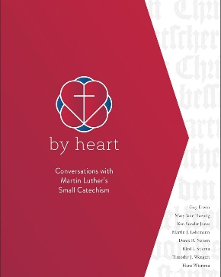

**BIBLE STUDY & FAITH DISCUSSIONS**

​​​​​Bible Study & Faith Discussions was started in order to focus on various readings,

books, Bible verses, people of faith, and other general topics. Group Members offer

various points of view while reviewing the Bible and various aspects of faith while

being respectful and supportive of each other. Join us **when we resume our studies in “by heart” following our December Church Council Meeting and the holidays in the New Year on Tuesday, January 7th, at 6PM**.

**COFFEE HOUR**

The Women of the Church will be hosting the next monthly Coffee Hour on **Sunday, January 12th**, following our Worship Service. See Judy or Kathy for more info.

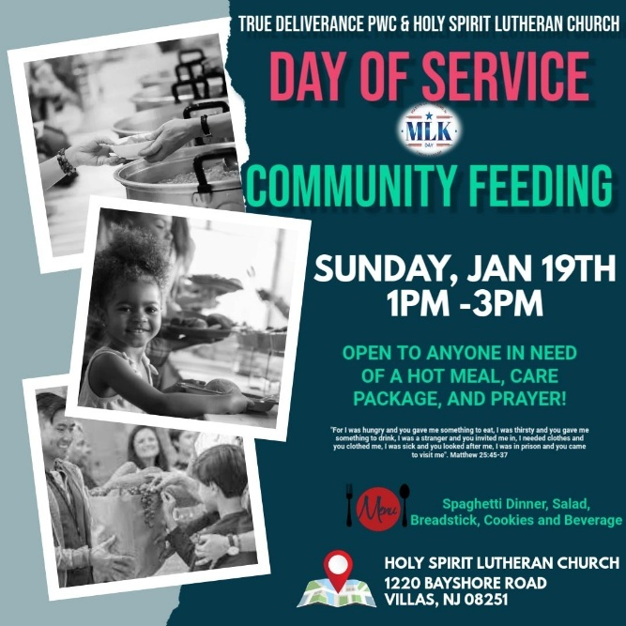

True Deliverance Praise & Worship Center will be hosting the event in conjunction with Holy Spirit Lutheran Church on **Sunday, January 19th, from 1PM—3PM.** Various community agencies will be informed of the event to promote those in need in the community to come on out and join us for a Spaghetti Dinner, to receive Care Packages, and for Prayer. Please consider helping out leading up to and on the day of the event. Let’s show love and support to our neighbors!

**CHURCH COUNCIL**

Share your comments, concerns, questions, or joys with one of our Church Council Members who can bring them back to our meetings. Visitors are always welcome to attend and listen to what is going on in and around the church. Join us In- Person or on our Conference Call at our next Meeting on **Tuesday, January 21st, at 6PM**.



**S’MORES & SCRIPTURE TO SOUP & SCRIPTURE**

Did you ever look forward to sitting around a fire in the church yard hanging out with some folks, enjoying s’mores, and studying scripture? We will shift this Fellowship time to **Soup & Scripture** and be **indoors** following the holidays. **Join us on Saturday, January 25th, at 6PM**. Ask Heather or Vicar Vince for info.



Our 75th Anniversary will be occurring in 2025! How awesome is that?!?! The Synod has been contacted, and we have been placed on the Bishop’s Calendar for **Sunday, October 19th, 2025**. This congregation is a legacy that we have all lived in and through over all of these years, or maybe just for a short time. However, it is a legacy that we hope and desire to continue to carry on and move forward for those people that will be able to gather and worship with us and following us as well. We are the church carries a strong mentality with it, and it does not just mean within these very walls. We need to celebrate those 75 years of being part of this community, and all that has led up to the very start of this church body as well. I encourage you all to start thinking how we are going to celebrate this legacy as we begin preparations and **gather a committee together soon**.

**ANNUAL CONGREGATIONAL MEETING**

As 2024 winds down we will be wrapping up the books and reports in preparation for a new year. 2025 will bring about several new things and changes I am sure, but one thing is for certain, we will be meeting as a Congregation for our Annual Meeting. We will discuss and review things, as well as vote on a new budget. I know it is rather early to think about things, but please start compiling your committee reports and make sure **Sunday, February 9th** is on your calendars, in your planners, or in your phones to meet after our Worship Service together.

**COMMUNITY RESOURCE DAY**

The 3rd Annual Community Resource Day will be hosted by Tabernacle United Methodist Church, at 702 Seashore Rd, Cape May, on **Saturday, February 15th, 2025, from 10AM—2PM**. There will be 75+ Social Service focused organization available for you to get information from and connected with. Please consider coming to check things out. Our church will be there again this year informing folks about our food pantry, and the church as well. For more info see Vicar Vince.

**CHURCH DIRECTORY**

The 2024 Church Directory is by the Church Office on the bookshelves. We continue to keep it updated throughout the year. Undoubtedly, we probably missed a few changes, and have made a few errors. The printed church directories have spaces for changes in information, new people’s information, notes, and your favorite Bible verses. If you have any changes or updates, please make it a point to inform the Church Office to keep us most up to date. **Our 2025 Church Directory will be made available to you following our Annual Congregational Meeting**.

**WOMEN OF THE CHURCH**

The Women of The Church will be taking time off during the Winter months and

their next monthly meeting will be held on **Monday, March 3rd, at 6PM**.

New members are always welcome to attend! Contact Judy for more information.



Vicar Vince was introduced to Milestones Ministries weekly guides for faith-filled studies and conversations through a Seminary class. A decision was made to pass these along to you. If you missed a week, or lost your insert, check our website for past issues. Feel free to ask questions and provide feedback to Vicar Vince.

**HOME COMMUNION MINISTRY**

A Minister is available if you have a loved one, or if you desire services. We look forward in sharing the Word and Holy Communion! Please inform Vicar Vince, Kathy, or the Church Office so plans can be made for visits.

**FAVORITE HYMNS**

Carol is willing to play some of your favorite hymns for the Prelude & Postlude each Sunday during our Worship Service. Feel free to let her know of your suggestions.

**PRAYER LIST**

Our Prayer List continues to lengthen and we realize the important need for prayers and healing. Sometimes the unfortunate result is that someone has passed away, and the words “The Family & Friends of” appear before someone’s name. However, sometimes we forget names are still on the list and their health has improved or the they are no longer struggling, and they can be removed. Please share the good and bad stories as we continue to pray for strength and healing. Names can be added or removed from the list on the clipboard in the Narthex prior to the Worship Service, by calling the church office, or addressing it on the Conference Call. Please let us know the relation to the person(s) you listed so we can be more mindful with our prayers. Names will stay on the list until removed by the person(s) who requested prayer.

**PRAYER SHAWL MINISTRY**

Prayer Shawls, Lap Quilts, Scarves, and other items have been made with love for those in need. Blessed items are located in the Narthex, and are free for anyone. Members of the group continue working at home on new stitches and patterns. We are blessed to be able to continue collecting newly made items. We currently have a donation station of yarn and other items located in the Narthex. Make sure you check it out and find some new supplies for your next creation!

**INTERESTED IN BECOMING A NEW MEMBER**

Have you been attending our church for a while? Have you just recently returned to church after being away for a bit? Maybe you transitioned from another church,

or just started to recently attend our church. We are glad to have you, and would love to have you as a member of our Congregation. See Vicar Vince for more info.



We are a church whose unity is in Jesus Christ, who gathers us around word and water, wine and bread. Baptism is a significant part of our faith journey as we come from the baptismal waters to live a new life as children of God. Our baptism sets us out on a lifelong journey that is characterized by our relationship to God, our relationship to our faith community, our relationships in our community and the wider world. Living our baptismal covenant means living a life of growth in the faith practices of discipleship. Please see Vicar Vince for more information.



Although no particular age for first communion is prescribed by The Use of the Means of Grace, one guideline is offered. Because admission to the Sacrament is by invitation of the Lord to the baptized, "baptized children begin to commune on a regular basis at a time determined through mutual conversation that includes the pastor/vicar, the child, and the parents or sponsors involved, within the accepted practices of the congregation.” Each congregation is encouraged to ask the question of readiness for first communion, establish their own policies regarding age and practice, and accompany that practice with catechesis appropriate to the age of the communicant. If anyone has questions, please see Vicar Vince.

**LIBRARY**

New books are added to our library from time to time. Several are borrowed and read and exchanged. Who knows, you might find one particularly interesting and share that with someone as well. Reading is a great way to pass spare time, learn, and explore. You may find some fresh ideas for prayer, ways to grow more spiritually, ways to grow closer to God, or some opportunities to understand our faith more. Visit the library between the church offices and see what books are there!

We also have a hidden extended library located in Vicar Vince’s office on the large green shelves. There are Bibles of various translations, books from his personal collection, books inherited from Pastor Leah, movies, past Bible Study Curriculums, and so much more. Feel free to ask Vicar Vince to be able to check things out!

**PROPERTY USE**

​​​​​Do you know anyone interested in utilizing our Fellowship Hall for a Party or Event?

It is a suggested $50 refundable security deposit, and $250 for facility use. There is no alcohol or games of chance permitted due to ELCA policy. Please contact Vicar Vince or the Church Office with questions, for info, or to reserve a date and time.

**ED GREEN CAPITAL IMPROVEMENT FUND**

We continue raising money for unforeseen costs or repairs.Kathy sells Wawa Tickets for $6, the donation bin is in the back of the church, and we have our Annual Church Rummage Sale. Thanks for your continued donations, prayers, and support!

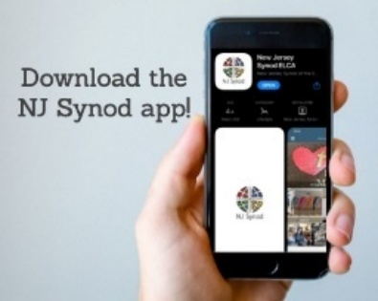

Jersey Jottings is a weekly e-newsletter that connects our synod together with weekly prayer, upcoming events, synod and churchwide activities, mission stories, congregational activities, and more. You can also sign up by going to https://www.njsynod.org/stay-connected and filling out the form! You can also get the app on your smartphone in the Apple App Store or on Google Play on your android.



**VICAR APPOINTMENT ON MARCH 19TH, 2023**

A Memorandum of Understanding on the Matter of Pastoral Appointment

In Theological Education for Emerging Ministries (TEEM) Candidacy

TO: Congregation Council, Holy Spirit Lutheran Church, Villas

FROM: The Rev. Tracie L. Bartholomew, Bishop, New Jersey Synod

Dear Brother and Sisters in Christ,

This memorandum is in support of your discussions with Vincent Piekarski as pastor of Holy Spirit, Villas. Because this is not the usual pattern for completing the educational and candidacy requirements for ordination, it is my hope that this memorandum will both provide guidelines and engage in conversation with those who are invested in this process.

I would say at the outset that because Vincent is an outstanding candidate for the Ministry of Word and Sacrament, we will all want to do whatever is necessary to assure that his placement serves the mission of the church in the best possible fashion.

The following notes reflect my own understanding of this matter:

(1) The appointment for Vincent will begin on April 1, 2023. At this time, Vincent

will assume all responsibilities of a regularly called pastor, including presiding at

the Sacrament of Holy Communion and Baptism at Holy Spirit, Villas.

(2) A pastoral appointment in the TEEM process is an option for completing

seminary educational requirements and the steps of the candidacy process.

Upon completion of the candidacy process and seminary education, the

candidate may receive and accept a call to ordained ministry from the

congregation where the appointment is being served.

(3) This appointment is jointly supervised by the Office of the Bishop and the TEEM

pastor’s seminary. A mentoring relationship with a local pastor is required for the

length of this appointment.

(4) The synod of candidacy origin will be responsible for the approval process.

(5) Upon approval for ordination, the congregation would be expected to extend a

call to the pastoral appointee.

(6) Compensation for the TEEM pastor will be according to the guidelines of the New

Jersey Synod. All normal forms of compensation should be in place for the term

of the appointment, including stipulation that base salary and housing shall be in

accord with synod guidelines for first call at time of ordination.

(7) The ELCA Portico benefit plan for lay persons in full-time church service should

be used for the pastoral appointee up to the time of ordination, whereupon the

benefit package is to be converted to the plan for ELCA clergy.

(8) A decision for Pastoral Appointment is made with the agreement of a synod and

its candidacy committee, and the ELCA, normally represented by the regional

staff person of each in consultation with the seminary and its Director for

Contextual Education.

(9) Pastoral Appointment in a TEEM Candidacy is an option that is to serve the

mission of the Church in a particular and vital way and is not to be viewed or

used as a means to circumvent the normal candidacy process and/or first call

placement process.

In the specific case of Vincent, the New Jersey Synod remains responsible for the candidacy and approval process, and has agreed to this proposal for Appointment at Holy Spirit, Villas.

Continued blessings to both Holy Spirit and Vincent Piekarski as you embark on this journey of mutual ministry. As partners in ministry, we walk with you and rejoice in this new relationship.



A day of rest can have physical, mental, and spiritual benefits. “Mittwoch,” German for mid-week, or Wednesday, is the day that Vicar Vince will use to recharge and do some other things. Please do not hesitate to reach out if there is an emergency!

**VICE PASTOR UPDATE**

Pastor William Hodgetts continues to attend our monthly Church Council Meetings. Pastor William continues to provide Supervision and Direction for Vicar Vince.

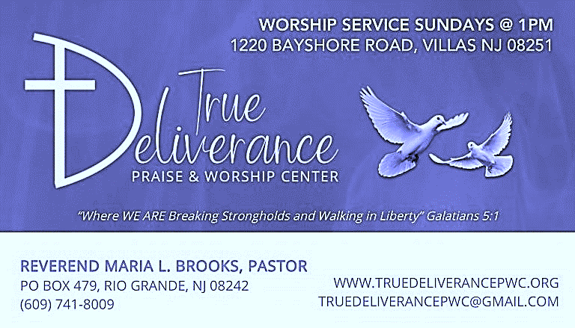

Reverend Maria Brooks and True Deliverance Praise & Worship Center utilize our facilities from 1-4PM on Sundays. TDPWC helps with the Food Pantry and hosts or assists with other events throughout the year. TDPWC hosts a Prayer Line on Mondays, Thursdays, & Fridays at 5PM on their Conference Call # 1-657-390-7957.

|  |  |
| --- | --- |
| **2024 FINANCIAL STANDING** | |
| **NOVEMBER INCOME** | $4,303.00 |
| **NOVEMBER SPENDING** | $8,240.46 |
| **NOVEMBER GAIN OR (LOSS)** | ($3,937.46) |
| **2024 INCOME** | $105,866.67 |
| **2024 SPENDING** | $115,591.38 |
| **2024 GAIN OR (LOSS)** | ($9,724.71) |
| **ED GREEN CAPITAL IMPROVEMENT FUND** | $17,578.88 |
| **FOOD PANTRY FUND (SOCIAL MINISTRY)** | $13,220.51 |
| **CD** | $25,297.32 |

**CHURCH STAFF & VOLUNTEERS**

**VICAR, BIBLE STUDY & FAITH DISCUSSIONS,**

**EVENTS, NEWSLETTER, & WEBSITE**

Vicar Vince Piekarski

**VICE PASTOR**

Pastor William Hodgetts

**ORGANIST & PIANIST**

Carol Amundsen

**CHURCH COUNCIL PRESIDENT**

Mary Melnicoff

**CHURCH COUNCIL VICE PRESIDENT**

Judy Brannan

**CHURCH COUNCIL TREASURER**

Bonnie Millard

**CHURCH COUNCIL SECRETARY**

Vicki Rinier

**CHURCH PROPERTY**

Frank Ford & Wayne Rand

**CHURCH OFFICE, SUNDAY SCHOOL, & FOOD PANTRY**

Heather Piekarski

**WHAT IS THE EVANGELICAL LUTHERAN**

**CHURCH IN AMERICA (ELCA)?**

The ELCA was formed in 1987 by the merger of three Lutheran Church bodies –

the ALC (American Lutheran Church), the LCA (Lutheran Church in America),

and the AELC (Association of Evangelical Lutheran Churches).

To learn more, go to the ELCA's website at www.elca.org.

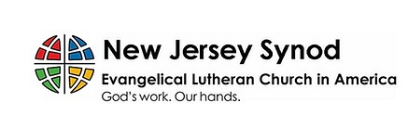

**WHAT IS THE NEW JERSEY SYNOD?**

The New Jersey Synod is a geographical grouping of Evangelical Lutheran Church in America (ELCA) congregations that share the mission and ministry of the Church on the New Jersey territory. It is one of 65 synods in the ELCA. The NJ Synod is comprised of 146 congregations, which include over 45,000 baptized members.