One of the nearby places to find cool rocks and fossils is the Oyster Beds in the Yuha Basin in Imperial County. Brian Lorenz said he could guide us since he had been there before so on 5/20/17 seventeen of us hit the road looking for oysters in the middle of the desert. Yuha Basin used to be under water in ancient times under ancient fresh water Lake Cahuilla as well as the Sea of Cortez. Victor points the way on the map.
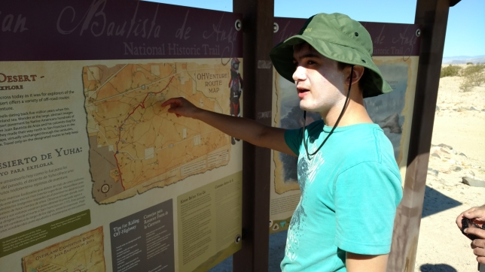
Take that hill rockhounds!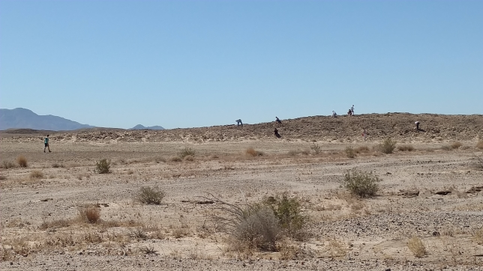
The first stop was Site “A” from the Gen Trails of Southern California book. This was a series of low hills where we found small clam, scallop and oyster shells as well as selenite sheets and crystals. Lots of shells were on the surface so it was a bit like walking on a rocky beach. Shell pieces were everywhere on certain hills. Complete shells were easy to find if you looked and gentle digging unearthed more complete shells. These shells did not seem very fossilized.
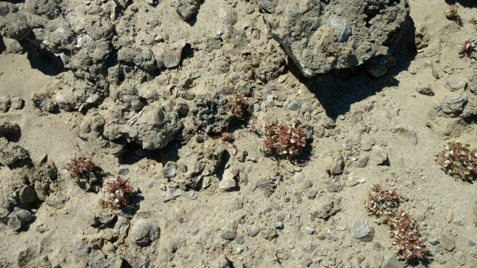
Lots of shells and shell pieces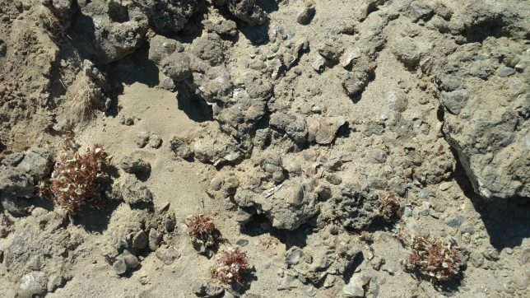
Look but don’ t touch, bristly langloisia among the shell fragments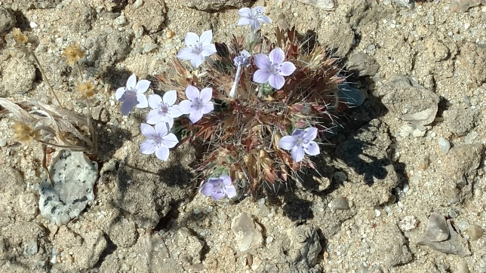
Katelyn and Sandra look for shells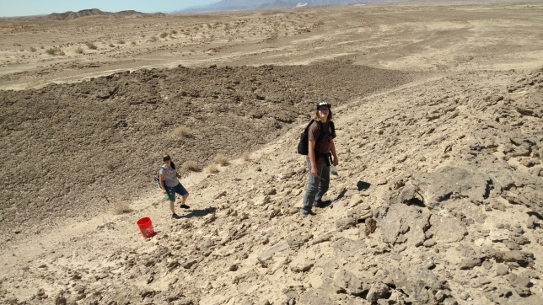
Small selenite sheets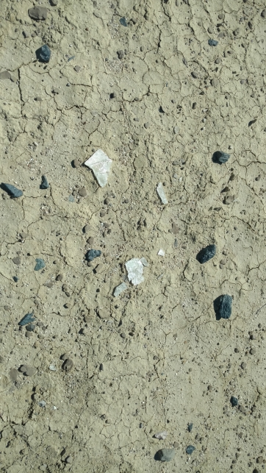
Large selenite sheet (photo by Brian Lorenz)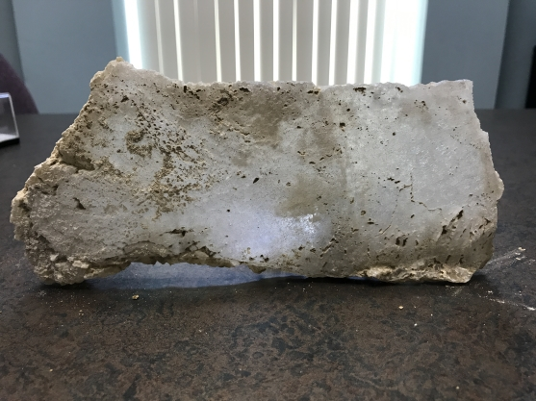
We did not spend a lot of time at Site A because the “main event” is the hills of giant oyster shells further in the Yuha Basin. (Photo by Katelyn Gaglio). The hills were “alive” with oyster shells. Everything dark brown is an oyster shell. The oyster shells were 4” – 6” across, some were close to 2” thick.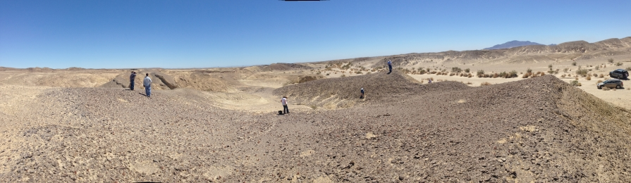
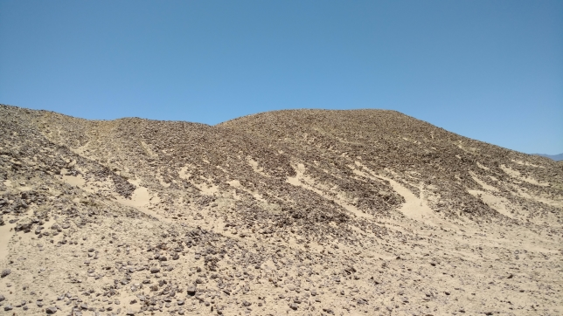
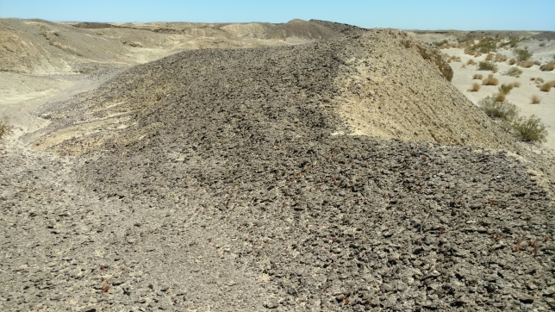
Another oyster lover (desert iguana)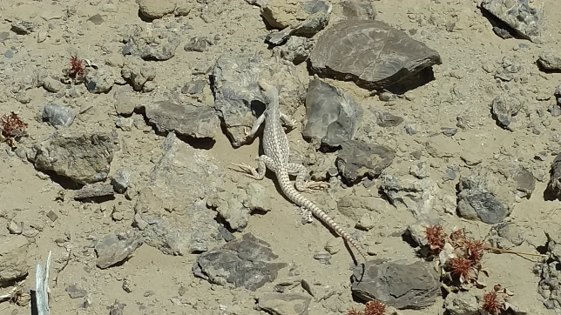
So many shells!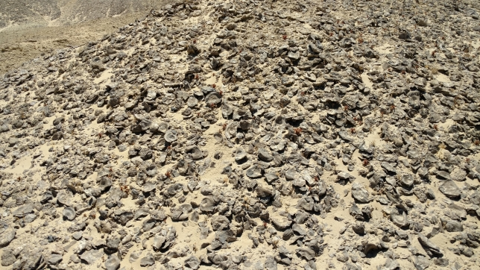
Diego sorting through a mountain of oyster shells.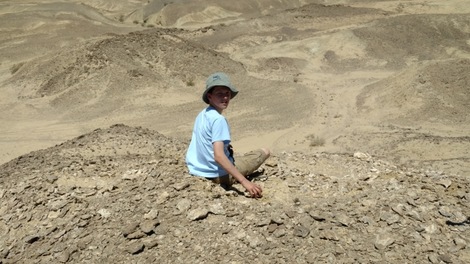
Selenite crystals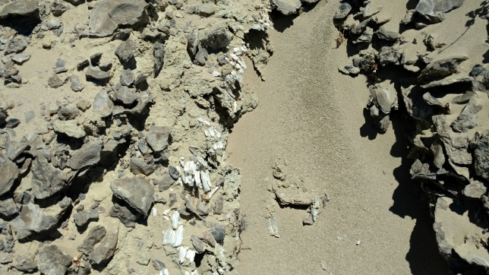
And now for the cleaned-up goodies. Dog tooth calcite (photo by Brian Lorenz)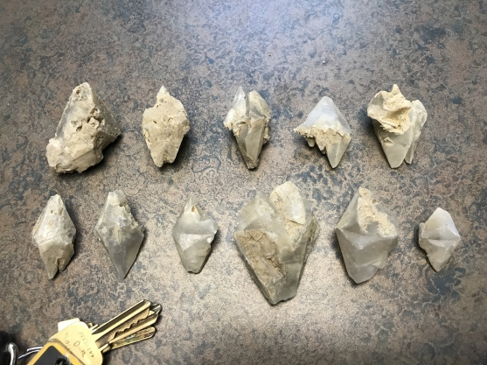
Quartz (photo by Veronica Saucedo)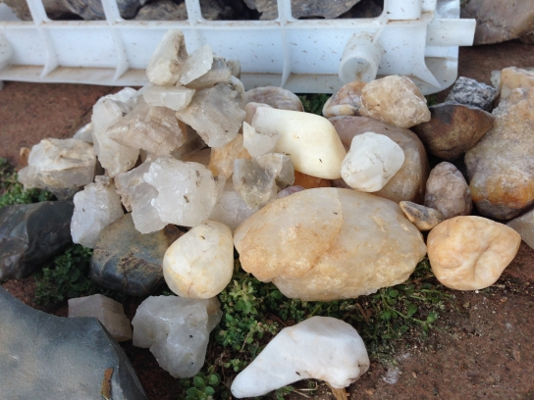
Small Site A smooth oyster shells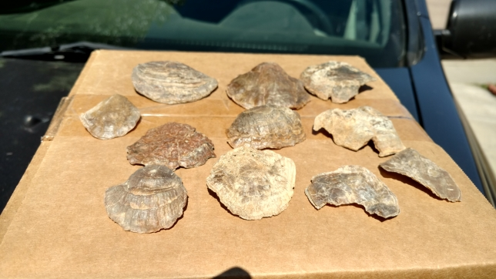
My favorite small oyster shell, lovely golden color.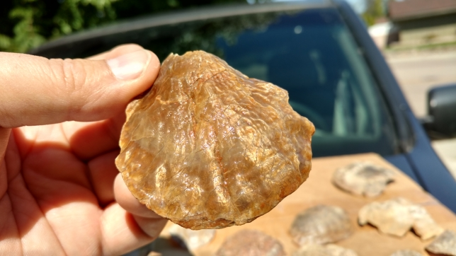
Site A small wavy oyster shells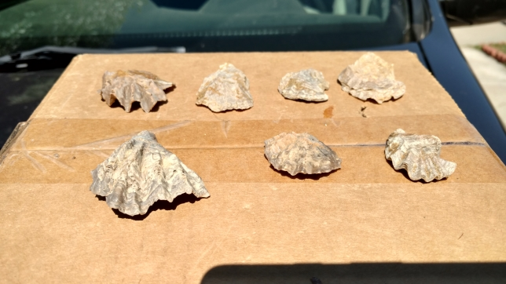
Variety of shells (photo by Terri Nowlen)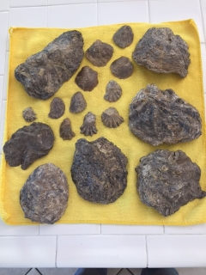
Large oyster shells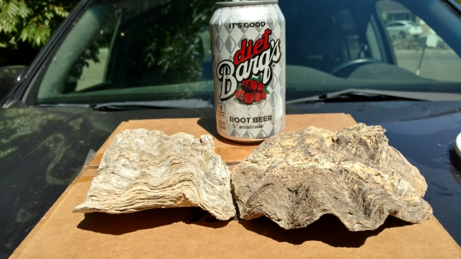
Dacite is a type of lava. Since it is composed of differing amounts of several minerals it is a “rock”. To me dacite with a true green body and lots of crystals is more interesting than darker or olive green bodies with fewer crystals. I found several pieces of it here, on our field trip to Ogilby Rd and around the Salton Sea. The green comes from hornblende and the stubby white crystals are feldspar. To me it looks like the Army’s digital camouflage. The lighter pieces have more quartz in them. If the feldspar crystals are not too degraded the stones take a good polish. I made a pocket knife with dacite handles and the first person I showed it to purchased it so items made from dacite sell.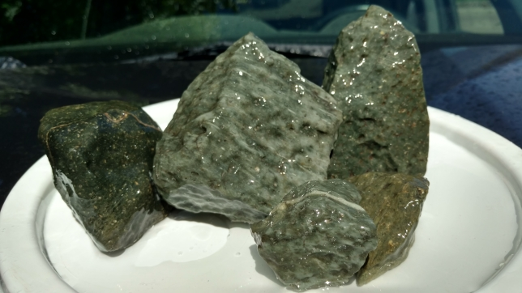

Dacite with larger feldspar crystals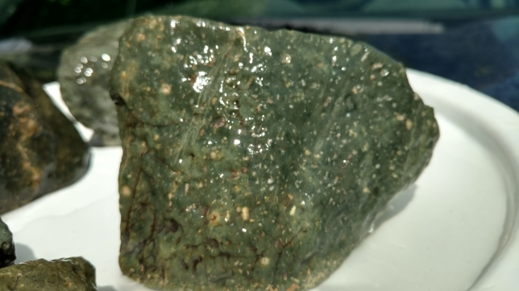
Dacite with more quartz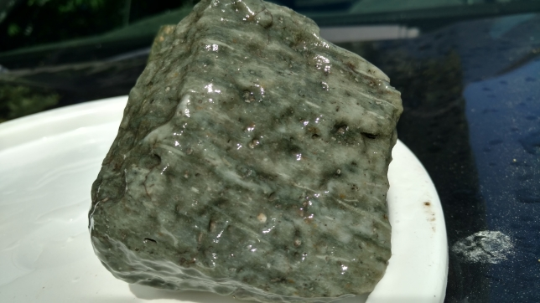

Here are a couple of quick test pieces. I picked up a few fragments of the large oyster shells to see how they would work as cabochons. I was hoping for a more bullseye pattern from the shell. It worked pretty fast and took an ok polish. Unfortunately, it cracked while it was in my pocket so I think the layers of the shell may not be well bonded to each other. It has the appearance of wood, but I was hoping for more of an iridescent sea shell like look. Maybe one of the lighter colored shells would have more of a shell-like appearance.
On the right side is a test cab of dacite from the trip. The exterior of the rock was a more olive green, but once I got through the oxidized outer layer the green brightened up. The white feldspar crystals with rust staining I believe were connected to the surface of the stone. The crystals deeper in the stone have a much purer white color.

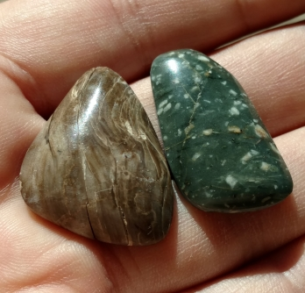
The End

