April 2017 Newsletter
Driver of the Month ~
The April Driver of the month is Judy Dickinson! Thank you for your prompt,
on-time paperwork. You are mindful and proactive; we appreciate all you do! Congratulations!

Distracted Driving ~
Do not answer your phone while
driving! This is why we call once, hang-up and call you again right away to leave a voicemail. This way, you know it is important to return the call once you have found a safe and legal location to park. You need to log each time you stop to listen to voicemail or make a phone call. This is crucial! If we discover you are driving, we will simply hang up. If drivers refuse to comply with AAT’s no cell phone use policy, their contracts will terminate.

Duty Status ~
Remember to keep your log current to the last change of duty status. You need to be updating your log throughout the day. Failure to do so is a violation in itself. Note: The “last change of duty status” should be logged as it happens, (fueling, returning from break, your most recent walk around inspection). You will receive a CSA Violation if this is not accurate and potentially be placed out of service.

Inspection Reports ~
Violations or not, all inspections must be reported to dispatch and turned in with your paperwork immediately. The DOT requires that we respond to all roadside inspections and keep the original document on file at our office.
~ AAT awards drivers with clean inspections – see Stacie along with your document.

Rental Car Reminders ~
Please inspect all rental cars for any damage before you accept it, note all damages. Inconsistent inspections are leading to claims for damages that were likely pre-existing. Have an agent sign at pickup and drop off.

Atlanta Bridge Collapse ~Repair timetable unknown
All lanes of I-85 North and South are closed indefinitely from the downtown connector to Georgia Highway 400. While most trucks are required to use I-285 to go around the city, the closure of one of the main thoroughfares out of Atlanta will cause backups on other routes.

Welcome aboard new drivers ~
John H ~ Kevin G ~ James W ~ Dan V Thank you to our drivers who train and offer other assistance!
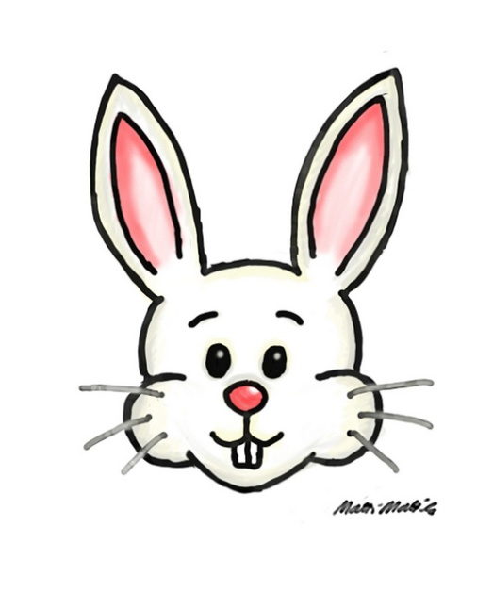 Happy Easter!

