Public Aquarium California Specimen List
Marine Aquaria Receiver’s Lis. 84973

Mollusca SPECIMEN LIST
Robert Burhans: (858) 774-2806 or email: Bob@matsucollections.com

**Special order specimens are those which are infrequently encountered or pose specific collecting challenges.
Example | Common Name  Latin Name | Comments* | Size & Distribution | Price
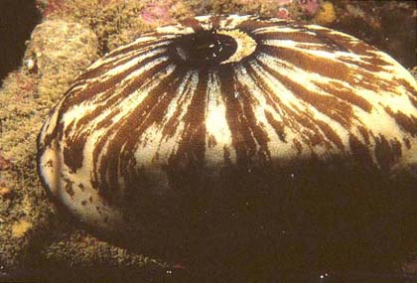 | Keyhole Limpet  Megathura crenulata | Rocky substrate | To 5 inches (12.5cm)  Mendocino, Ca. to Baja California Sur | 12.00
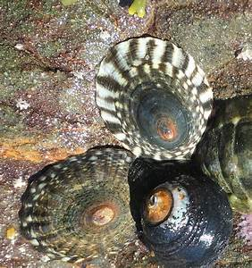 | Shield Limpet  Collisella pelta | Common along rocky reefs. | To: 40mm | 5.00
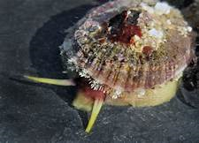 | Rough Keyhole Limpet  Diodora aspera | Low intertidal to 50’ | To: 3 inches  (75mm)  Alaska to Baja | 10:00
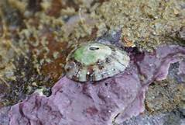 | Volcano Limpet  Fissurella volcano |  | To: ½ inch  (24mm)  Oregon to Baja | 7.50
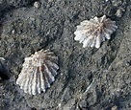 | Rough Limpet  Collisella scabra | High intertidal zone on rocks | To: ½ inch  (24mm)  Oregon to Baja | 5.00
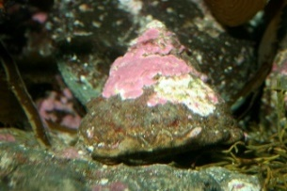 | Wavy Top Turban Snail  Lithopoma undosum | On algae covered rocks, usually in kelp beds. | To 5 inches (12.5cm)  British Columbia to Baja California Sur | 10.00
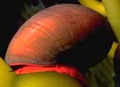 | Norris’s Topsnail  Norrisia norrisi | On rocks and kelp | To 2.5 inches (6 cm)  Point Conception to Baja | 7.50
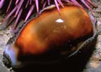 | Chestnut Cowry  Cypraea spadicea | On and under rocks, usually in kelp beds. | To 3 inches (7.5cm)  Monterey, California to Baja | 20.00
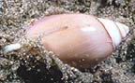 | Purple Olive Snail  Olivella biplicata | Sandy bottoms | To 1.25” (3cm) | 3.00
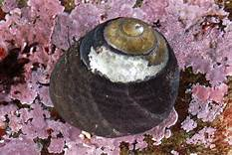 | Black Turban Snail  Tegula funebralis | On rocky or soft bottoms in kelp beds or tidal pools. | To 1 inch (2.5cm) | 2.00
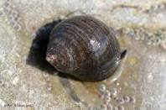 | Common Periwinkle  Littorina littorea | Rocky shores, littoral zone | To (12mm)  Widespread | 12 for 5.00
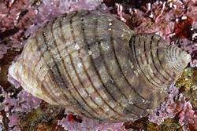 | Dogwinkle  Nucella lamellosa | Rocky shores, littoral zone |  | 3.00
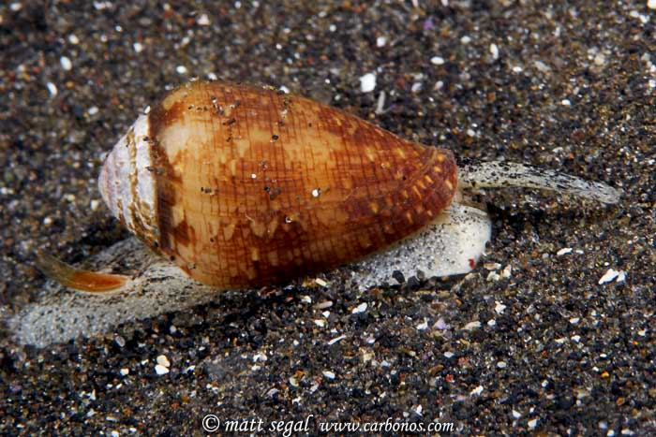 | California Cone Snail  Conus californicus | Found on sandy and rocky bottoms. Like all cones it does use a poison spear. | To: 1.5 inches  (40mm)  San Fran to Baja | 5.00
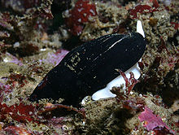 | Ida’s Miter  Miter Idae | Low intertidal on rocks | To: 3 inches  (75mm)  Crescent City, CA to Baja | 5.00
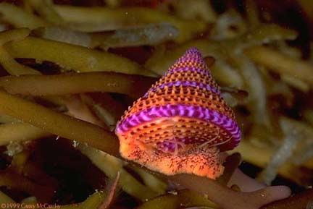 | Blue-Ring Topsnail  Calliostoma annulata | Feed on hydroids, bryzoan, diatoms, detritous, and copepods, as well as kelp | To:1.2” (2.7cm)  Range: Alaska to Baja | 20.00
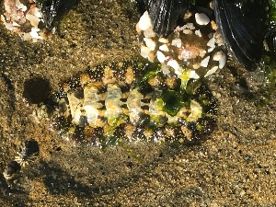 | Spiny Chiton  Acanthopleura spinosa | Found in the mid to lower tidal areas. The girdle or fleshy part on the rim of the animal is frequently covered by algae.. | To 2” (5cm)  Aleutian Islands to San Diego | 5.00
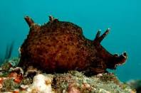 | California Sea Hare  Aplysia Californica | Eel grass and Surfgrass beds | To: 1 foot (30cm) | 15.00
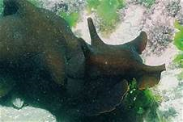 | Black Sea Hare  Aplysia vaccaria | Eel grass and Surfgrass beds | To: 30” (90cm) | 30.00
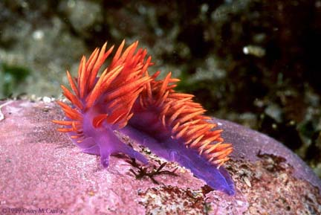 | Spanish Shawl  Flabellina iodinea |  | To: 4” (10cm)  Range: BC to Mexico | 10.00
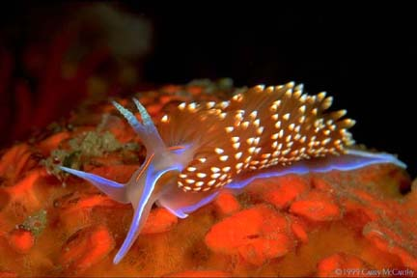 | Hermissenda crassicornis | Feeds on hydroids, sponges, corals, and many other invertebrates | To: 3” (7.5cm)  Range: Kodiak Alaska to Baja | 10.00
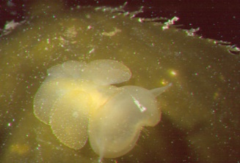 | Lion Nudibranch  Melibe leonina | This nudibranch is a filter feeder. It does quite well on artemia. | To: 4” (10cm)  Range: Alaska - Baja | 20.00
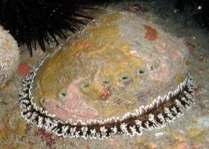 | Red Abalone  Haliotus rubescens  Cultured Only! | Avail. 3-5” size  Prefers to eat Macrocystus kelp. May eat Nori. | Size: to 10”  Range: Pt. Conception to Baja | 40.00
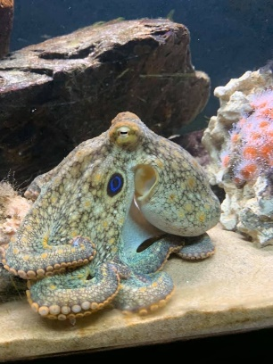 | Two-spot Octopus  Octopus bimaculoides  Collected on a Tidal Invertebrate Permit | Has circular blue eyespots on each side of its head. | To: 7” (17.5mm)  Range: Coast of California | 125.00
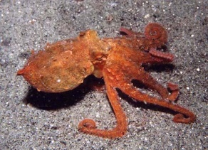 | Red Octopus  Octopus rubescens | Shallow water to 300M | To: 10 cm (body)  Range: North America West Coast | 125.00
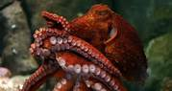 | Giant Pacific Octopus  Enteroctopus dofleini | Cold, Oxygen rich waters. The largest species of octopus. | To: Over 100 lbs.  Coastal North Pacific | Seasonal  Rare

