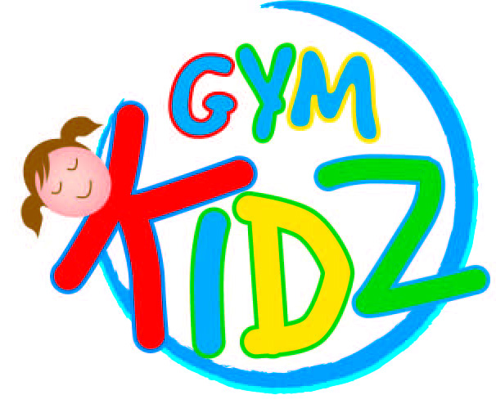

2038 Ne 155 St
North miami Beach
305-944-4277
www.GYMKIDZGYMNZASTICS.COM
info@GYMKIDZGYMNASTICS.COM

Gymnastics Summer
Class schedule

Session: 7 weeks (June 19th-August 4th)

Preschool (45 minutes)
Super Stars (26month-36month)
Wednesday 4:00pm
Tiny Tumblers (3yr & 4yrs)
Tuesday 4:00pm & Thursday 4:00pm

Recreational (5yr & up) – 55 min.
Red/Orange - Beginners
Wednesday 4:00pm
Blue/Green & Purple/Gold -Intermediate&Advance
Tuesday 4:00pm & Thursday 4:00pm

Pricing (7 weeks)
1 class/week $147
2 class/week $280
$28.00 per class

